The ARRIVE guidelines 2.0: author checklist

Item | Recommendation | Section/line number, or reason for not reporting
Study design | 1  For each experiment, provide brief details of study design including:  a. The groups being compared, including control groups. If no control group has  been used, the rationale should be stated.  b. The experimental unit (e.g. a single animal, litter, or cage of animals). | a. lines 183-189.  In all experiment, groups being compared including: Auto, PL, PLC PLGBC, PLGBCF groups (Autograft (Auto), P (PLGA), L (Laminin), G (AuNPs), B (BDNF), C (Cell), F(Fibrin)). The autograft as control group because it is for the gold standard for peripheral nerve repair.  b. line 174. 40 Wistar male rats in 40 cages of animal.
Sample size | 2  a. Specify the exact number of experimental units allocated to each group, and the  total number in each experiment. Also indicate the total number of animals used.  b. Explain how the sample size was decided. Provide details of any a priori sample size calculation, if done. | a. line 174. 40 mature Wistar male rats, and in this study comparing five groups (n=8).  b. According to previous study  In Pinprick, SFI tests, wet weight of gastrocnemius muscle: 6 rats in each group.  -In diameter of the muscle fibers: 8 rats in each group.  -In electrophysiological, IHC test: 6 rats in each group  -In nerve histology: 6 rats in each group.  -In real time RT-PCR: 4 rats in each group.
Inclusion and  exclusion  criteria | 3  a. Describe any criteria used for including and excluding animals (or experimental units) during the experiment, and data points during the analysis. Specify if these  criteria were established a priori. If no criteria were set, state this explicitly.  b. For each experimental group, report any animals, experimental units or data points not included in the analysis and explain why. If there were no exclusions, state so.  c. For each analysis, report the exact value of n in each experimental group. | a. Including criteria: mature and health male rat  Exclude criteria: Infectious animal  b. No complications arose during the  suturing of the grafts to the proximal and distal nerve stumps with the exception for one rat  (autograft, 8 weeks), which was not included for statistical analysis.  c. In different groups, the number of rats was the same and according to the following:  -In Pinprick, SFI tests, wet weight of gastrocnemius muscle: 6 rats in each group.  -In diameter of the muscle fibers: 8 rats in each group.  -In electrophysiological, IHC, test:6 rats in each group  -In nerve histology: 6 rats in each group.  -In real time RT-PCR: 4 rats in each group.
Randomisation | 4  a. State whether randomisation was used to allocate experimental units to control  and treatment groups. If done, provide the method used to generate the randomisation sequence.  b. Describe the strategy used to minimise potential confounders such as the order of treatments and measurements, or animal/cage location. If confounders were not controlled, state this explicitly. | a. line 183. In this study, we hadn’t any specific methods for randomization of animals.  b. Assessment of nerve regeneration was carried out after determining of coefficient of variation.  .
Blinding | 5  Describe who was aware of the group allocation at the different stages of the experiment (during the allocation, the conduct of the experiment, the outcome assessment, and the data analysis). | The first, second authors and correspondence knew all the stages of the experiment.
Outcome  measures | 6  a. Clearly define all outcome measures assessed (e.g. cell death, molecular markers,or behavioural changes).  b. For hypothesis-testing studies, specify the primary outcome measure, i.e. the outcome measure that was used to determine the sample size. | a. lines 324-342, 397-399, 420-421.  b. The sample size was determinted based on previous studies: Evaluation of the Functional Recovery in Sciatic Nerve Injury following the Co-transplantation of Schwann and Bone Marrow Stromal Stem Cells in Rat. Sam Zarbakhsh et all, Basic and clinical neuroscience, 2013
Statistical  methods | 7  a. Provide details of the statistical methods used for each analysis, including software used.  b. Describe any methods used to assess whether the data met the assumptions of the statistical approach, and what was done if the assumptions were not met. | a. -Histology analysis: Digimizer software (lines 252).  -Electrophysiology test: eProbe software (lines 237).  - IHC: Image-j software (lines 281).  - RT-PCR: Step One Plus™ quantitative Real Time PCR Detection System (lines 289).  b.-lines 293-297, The data met the assumptions of the statistical approach (one ANOVA).
Experimental  animals | 8  a. Provide species-appropriate details of the animals used, including species, strain and substrain, sex, age, or developmental stage, and, if relevant, weight.  b. Provide further relevant information on the provenance of animals, health/immune  status, genetic modification status, genotype, and any previous procedures. | a. lines 174.  b. Healthy rats without genetic modification were selected for conduite implantation.
Experimental  procedures | 9  For each experimental group, including controls, describe the procedures in enough detail to allow others to replicate them, including:  a. What was done, how it was done and what was used.  b. When and how often.  c. Where (including detail of any acclimatisation periods).  d. Why (provide rationale for procedures). | Lines 122-297.  - We provide one proper reference for each procedure were used in this work.  - Lines 177-178
Results | 10  For each experiment conducted, including independent replications, report:  a. Summary/descriptive statistics for each experimental group, with a measure of variability where applicable (e.g. mean and SD, or median and range).  b. If applicable, the effect size with a confidence interval. | -Experiments for all tests were repeated three times.  a. SFI: 331,332,334  - Pinprick test: 340,342  - Electrophysiological assessment: 353,354  -Histology of muscle and nerve:  362-365, 376-390.  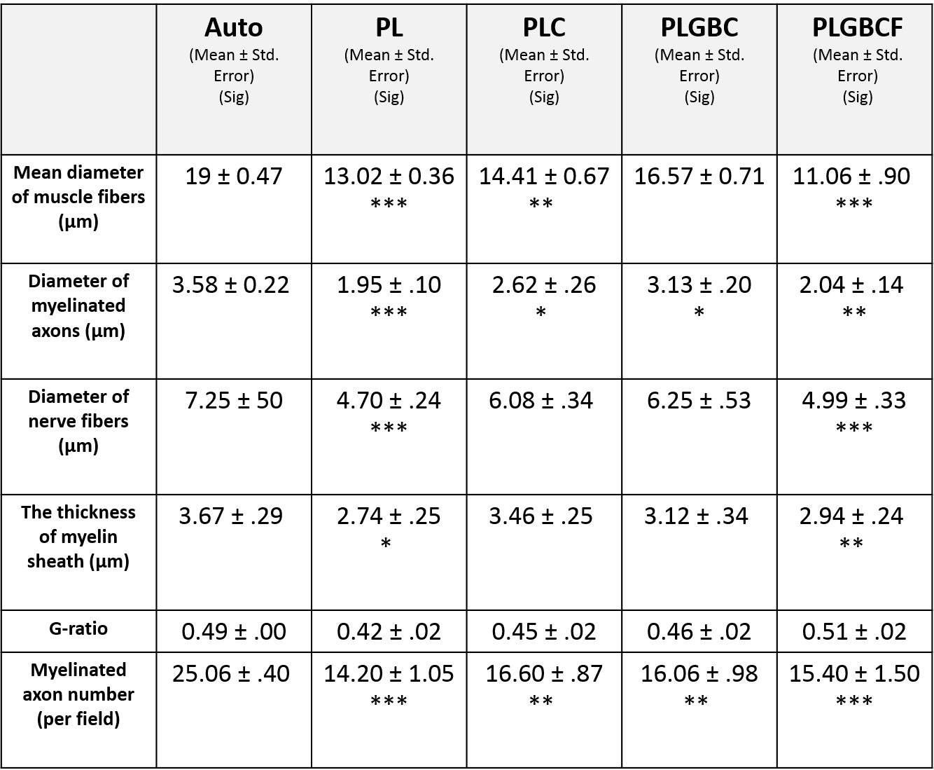  -IHC: Table 2  -RT-RT-PCR:  S100  MBP  Nestin
  Auto | PL | PLC | PLGBC | GFAP  PLGBCF
  0.985 | 0.84 | 0.955 | 0.905 | 0.285 | GFAP
  0.115 | 0.06 | 0.045 | 0.035 | 0.075
  Auto | PL | PLC | PLGBC | PLGBCF
  1.125 | 0.765 | 0.755 | 0.78 | 0.235 | S100
  0.005 | 0.035 | 0.045 | 0.17 | 0.085
  Auto | PL | PLC | PLGBC | PLGBCF
  1.39 | 0.365 | 0.505 | 0.865 | 0.205 | MBP
  0.12 | 0.015 | 0.245 | 0.045 | 0.095
  Auto | PL | PLC | PLGBC | PLGBCF
  2.765 | 1.17 | 1.215 | 0.7 | 0.095 | Nestin
  0.285 | 0.05 | 0.005 | 0.15 | 0.015

The ARRIVE guidelines 2.0: author checklist
Item | Recommendation | Section/line  number, or reason  for not reporting
Abstract | Provide an accurate summary of the research objectives, animal species, strain and sex, key methods, principal findings, and study conclusions. | Line 531-537 and 26-45. the inner surface electrospun poly (lactic-co-glycolic acid) (PLGA) nanofibrous conduit was biofunctionalized with laminin containing brain derived neurotrophic factor (BDNF) and gold nanoparticles in chitosan nanoparticle. In this study, 40 mature (12-week-old) Wistar male rats (weighing ~200–250 g). The rats were randomly divided into five groups (each, n = 8), including autograft group as the positive control, PLGA conduit coated by laminin and filled with DMEM/F12, PLGA conduit coated by laminin and filled with adipose-derived stem cells (rADSCs) , PLGA conduit coated by laminin containing gold-chitosan nanoparticles (AuNPs-CNPs), BDNF-chitosan nanoparticles (BDNF-CNPs) and filled with rADSCs or filled with rADSCs suspended in fibrin matrix, and they were implanted to bridge a 10 mm rat sciatic nerve gap. Eventually, axonal regeneration and functional recovery were assessed with IHC, behavioral tests, histology and real time RT-PCR after 12 weeks. Overall, we found that laminin-coated PLGA conduit could improve axonal regeneration in peripheral nerve using some exogenous factors such as BDNF, AuNPs, and ADSCs in fibrin matrix. Although there was some evidence that fibrin matrix promoted peripheral nerve regeneration, but distinctive effect of fibrin was not observed in this study. It should be noted that fibrin matrix may interfere with other exogenous factors. It is recommended that future works determine the molecular mechanism of fibrin matrix in peripheral nerve regeneration and its clinical outcomes following injury.
Background | a. Include sufficient scientific background to understand the rationale and  context for the study, and explain the experimental approach.  b. Explain how the animal species and model used address the scientific objectives and, where appropriate, the relevance to human biology. | a.  b. Rats are the most popular laboratory animals widely used as an experimental model for the  assessment of the potency of synthetic scaffolds in regeneration of PNI (Angius et al., 2012).  Moreover, according to PubMed analysis of a random sample of 1,500 research articles on  nerve repair, more than 90% of them selected rat animal models (Tos et al., 2009). There are  some advantages regarding the use of rats, as animal models, in studying nerve degenerating  diseases including their small size, their resistance to complications of surgery and infection,  better nerve restoration, the availability of different species and low prices (Gordon &  Borschel, 2017; Varejão et al., 2004). A large number of nerve regeneration assays such as  electrophysiology, sciatic functional index, histology, muscle mass and other assessments can  be used to examine the peripheral nerve regeneration in the experimental rat models  (Vleggeert-Lankamp, 2007). However, there is a disadvantage in using rat models for  studying the peripheral nerve injury; thus, rats are usually used for studying nerve  regeneration in the nerve gaps less than 10 mm (Angius et al., 2012). It should be noted that  peripheral nerve damage in humans is normally greater than 10 mm and nerve regeneration in  humans is much slower than rats (Buchthal & Kuhl, 1979)
Objectives | Clearly describe the research question, research objectives and, where appropriate, specific hypotheses being tested. | Lines 101-104.  - Does synergistic effects of ADSCs encapsulated in alginate and combination controlled release of BDNF and Gold nanoparticles with on sciatic nerve regeneration?  - Our hypothesis is ADSCs in fibrin matrix with combination BDNF and Gold nanoparticles are useful to regenerate transected nerve.
Ethical  statement | Provide the name of the ethical review committee or equivalent that has approved the use of animals in this study, and any relevant licence or protocol numbers (if applicable). If ethical approval was not sought or granted, provide a justification. | Lines 179-183.  No: IR.MUI.REC.1396.3.207
Housing and  husbandry | Provide details of housing and husbandry conditions, including any environmental  enrichment. | Lines 175-178.
Animal care and  monitoring | a. Describe any interventions or steps taken in the experimental protocols to reduce pain, suffering and distress.  b. Report any expected or unexpected adverse events.  c. Describe the humane endpoints established for the study, the signs that were monitored and the frequency of monitoring. If the study did not have humane endpoints, state this. | a. Analgesic treatment for pain relief was not performed during the postoperative period.  b. No  c. In the most severe form of injury is a full transection of the axons and myelin sheaths wherein complete discontinuity or gap of the nerve is observed
Interpretation/  scientific  implications | a. Interpret the results, taking into account the study objectives and hypotheses,  current theory and other relevant studies in the literature.  b. Comment on the study limitations including potential sources of bias,  limitations of the animal model, and imprecision associated with the results. | a. lines 430-529. Our hypothesis was that strategies of using the PLGA conduit containing with ADSCs were useful to regenerate transected nerve. It is shown that, the ADSCs results increase growth factor secretion, axonal myelination and finally nerve repairment might be effective in peripheral nerve regeneration. Furthermore, exogenous factors such as AuNPs and BDNF were used for more recovery in nerve repairing  b. There are some factors that influence recovery following a nerve injury and regeneration such as time elapsed, proximity of the lesion to distal targets age and associated vascular or soft tissue damages.
Generalisability/  translation | Comment on whether, and how, the findings of this study are likely to generalize to other species or experimental conditions, including any relevance to human  biology (where appropriate). | Efforts to find strategies to achieve the appropriate polymer scaffold for damaged neural tissue still needs to be continued. There are some issues to be considered in the future for obtaining maximal benefit from these types of biomaterials. The possible risk of using such novel biomaterial on individual’s health needs to be studied for patients who suffer from neurological disorders.
Protocol  registration | Provide a statement indicating whether a protocol (including the research question, key design features, and analysis plan) was prepared before the study, and if and where this protocol was registered. | These protocols are recorded in the proposal.
Data access | Provide a statement describing if and where study data are available. | study data on request are available.
Declaration of  interests | a. Declare any potential conflicts of interest, including financial and non-financial.  If none exist, this should be stated.  b. List all funding sources (including grant identifier) and the role of the funder(s)  in the design, analysis and reporting of the study. | a. The authors declare that they have no conflict of interest.  b. This study was supported by Isfahan University of Medical Sciences, Isfahan, Iran.
www.ARRIVEguidelines.org

