Supporting information

Spatial Distribution of multielements including technology critical elements in sediments of the Danube River

Otilia Ana Culicov^{1,2}, TatjanaTrtić-Petrović^{3*}, Roman Balvanović³, Anđelka Petković⁴, Slavica Ražić⁵

¹Frank Laboratory of Neutron Physics, Joint Institute for Nuclear Research, Dubna, Russian Federation
²National Institute for R&D in Electrical Engineering ICPE-CA, Bucharest, Romania
³Laboratory of Physics, Vinča Institute of Nuclear Sciences, National Institute of the Republic of Serbia, University of Belgrade, Belgrade, Serbia
⁴“Jaroslav Černi” Institute for the Development of Water Resources, Belgrade, Serbia
⁵University of Belgrade, Faculty of Pharmacy - Department of Analytical Chemistry, Belgrade, Serbia

*Corresponding author address:
Laboratory of Physics, Vinča Institute of Nuclear Sciences, National Institute of the Republic of Serbia, University of Belgrade, P.O. Box 522, 11001 Belgrade, Serbia, ttrtic@vin.bg.ac.rs

Table S1(a). Experimental (in mg kg⁻¹ and in %) and statistic data (mean concentration, standard deviation (SD) and relative standard deviation (RSD)) of the quantified major elements and total organic carbon (TOC) in the sediments at 13 monitoring sites along the River Danube and three tributaries.
Sample  code | Concentration of major elements, mg kg⁻¹(%) |  |  |  |  |  |  |  | TOC, %
Sample  code | Al | Ca | Fe | K | Na | Ti | Mg | Mn | TOC, %
1-Rit | 56900 (5.7) | 70800 (7.1) | 33100 (3.31) | 16200 (1.6) | 9090 (0.9) | 5050 (0.51) | 3110 (0.31) | 1250 (0.13) | 4.41
2-SmedDS | 64700 (6.5) | 52300 (5.2) | 33300 (3.33) | 14100 (1.4) | 5940 (0.60) | 4320 (0.43) | 5330 (0.53) | 704 (0.07) | 3.20
3-SmedRB | 48800 (4.9) | 99500 (9.9) | 33500 (3.35) | 13400 (1.3) | 5880 (0.59) | 3310 (0.33) | 4190 (0.42) | 1460 (0.15) | 8.29
4-Smed | 68400 (6.8) | 60600 (6.1) | 43400 (4.34) | 20300 (2.0) | 7870 (0.8) | 5300 (0.53) | 3210 (0.32) | 1220 (0.12) | 6.15
5-Ram | 75500 (7.6) | 53200 (5.3) | 47100 (4.71) | 21100 (2.1) | 7370 (0.7) | 5380 (0.54) | 3470 (0.35) | 1650 (0.17) | 7.77
6-VelGrad | 99400 (9.9) | 68700 (6.9) | 42200 (4.22) | 20100 (2.0) | 9310 (0.9) | 8270 (0.83) | 4680 (0.47) | 1890 (0.19) | 7.54
7-DoMil | 90100 (9.8) | 53000 (5.3) | 48400 (4.84) | 20500 (2.1) | 6920 (0.7) | 6660 (0.67) | 3740 (0.37) | 1930 (0.20) | 7.03
8-Tek | 75200 (7.5) | 55300 (5.5) | 48200 (4.82) | 21400 (2.1) | 7340 (0.7) | 5720 (0.57) | 3740 (0.37) | 1540 (0.15) | 7.94
9-Klad | 70500 (7.1) | 51300 (5.1) | 46600 (4.66) | 20100 (2.0) | 6890 (0.7) | 5060 (0.51) | 3340 (0.33) | 1570 (0.16) | 5.77
10-Kus | 69100 (6.9) | 36800 (3.7) | 48000 (4.80) | 21500 (2.2) | 7340 (0.7) | 4770 (0.48) | 3040 (0.30) | 1310 (0.13) | 4.38
11-Sava | 66300 (6.6) | 73600 (7.4) | 41200 (4.12) | 15200 (1.5) | 7000 (0.7) | 5440 (0.54) | 3220 (0.32) | 1810 (0.18) | 1.95
12-VelMor | 67600 (6.8) | 37300 (3.7) | 44700 (4.47) | 18100 (1.8) | 13000 (1.3) | 5900 (0.59) | 3110 (0.31) | 1560 (0.16) | 5.12
13-Pek | 68900 (6.9) | 22900 (2.3) | 30900 (3.09) | 14800 (1.5) | 17500 (1.8) | 5880 (0.59) | 2360 (0.24) | 3627 (0.36) | 2.49
Average | 70877 (7.2) | 56562 (5.7) | 41585 (4.2) | 18215 (1.8) | 8573 (8.6) | 5466 (5.5) | 3580 (0.36) | 1477 (0.15) | 5.38
SD | 12875 | 19293 | 6587 | 3040 | 3257 | 1174 | 777 | 330 | 2.16
RSD | 18.2 | 34.1 | 15.8 | 16.7 | 38.0 | 21.5 | 21.7 | 22.3 | 40.1
Table S1(b). Experimental (in mg kg⁻¹) and statistic data of the quantified minor and trace elements in the River Danube’s sediments by INAA
Sample  code | Concentration of minor and trace elements, mg kg⁻¹
Sample  code | Ba | Zn | Cr | Sr | V | Rb | Ni | Cu | Co | As | Sc | Th | Cs | Hf | Sb | U | W | Ta
1-Rit | 420.0 | 226 | 109 | 131.0 | 90.2 | 95.9 | 47 | 54.6 | 15 | 11.5 | 12.1 | 11.0 | 6.3 | 4.7 | 2.0 | 2.1 | 1.8 | 0.9
2-SmedDS | 503.0 | 67 | 149 | 168.0 | 98.5 | 92.6 | 86 | 67.9 | 16 | 16.1 | 12.1 | 10.5 | 6.2 | 5.8 | 1.4 | 2.6 | 1.8 | 1.0
3-SmedRB | 368.0 | 62 | 153 | 158.0 | 77.0 | 75.6 | 87 | 40.4 | 14 | 4.2 | 10.7 | 7.8 | 5.1 | 4.3 | 1.4 | 2.7 | 1.3 | 0.7
4-Smed | 559.0 | 647 | 254 | 178.0 | 111.0 | 112.0 | 98 | 49.4 | 21 | 26.2 | 14.9 | 14.7 | 8.7 | 5.5 | 10.1 | 2.5 | 2.4 | 1.0
5-Ram | 505.0 | 371 | 193 | 174.0 | 135.0 | 127.0 | 113 | 41.1 | 24 | 21.1 | 16.7 | 13.9 | 10.2 | 4.9 | 3.4 | 2.4 | 2.4 | 1.0
6-VelGrad | 487.0 | 261 | 191 | 183.0 | 174.0 | 111.0 | 108 | 45.5 | 23 | 17.2 | 15.0 | 11.9 | 9.0 | 5.7 | 2.8 | 2.3 | 2.0 | 1.0
7-DoMil | 503.0 | 292 | 184 | 168.0 | 160.0 | 129.0 | 121 | 74.6 | 24 | 21.4 | 17.5 | 13.5 | 10.9 | 4.8 | 3.3 | 2.3 | 2.3 | 1.0
8-Tek | 535.0 | 299 | 185 | 167.0 | 136.0 | 132.0 | 110 | 78.7 | 25 | 19.0 | 17.3 | 13.4 | 10.8 | 5.1 | 3.5 | 2.4 | 2.3 | 1.0
9-Klad | 518.0 | 297 | 168 | 169.0 | 124.0 | 125.0 | 90 | 66.2 | 23 | 21.4 | 16.4 | 14.9 | 9.8 | 4.8 | 3.1 | 2.2 | 2.2 | 1.0
10-Kus | 545.0 | 329 | 175 | 162.0 | 119.0 | 130.0 | 107 | 55.9 | 24 | 19.9 | 17.3 | 15.4 | 10.3 | 4.8 | 4.4 | 2.3 | 2.2 | 1.0
11-Sava | 397.0 | 307 | 294 | 162.0 | 118.0 | 88.5 | 146 | 44.9 | 25 | 21.6 | 13.2 | 11.8 | 7.3 | 5.1 | 5.1 | 1.9 | 1.9 | 0.8
12-VelMor | 556.0 | 666 | 363 | 218.0 | 120.0 | 101.0 | 174 | 51.3 | 29 | 24.4 | 15.8 | 12.1 | 10.0 | 6.9 | 4.7 | 2.3 | 2.1 | 1.0
13-Pek | 459.0 | 425 | 75 | 219.0 | 114.0 | 58.6 | 24 | 512.6 | 15 | 11.0 | 12.9 | 7.7 | 2.3 | 4.6 | 5.2 | 1.4 | 1.9 | 0.7
Average | 488.8 | 327 | 192 | 173.6 | 121.3 | 106.0 | 101 | 91 | 21 | 18 | 14.8 | 12.2 | 8.2 | 5.2 | 3.9 | 2.2 | 2.1 | 0.9
SD | 61.2 | 179 | 76 | 23.4 | 26.3 | 23.1 | 38 | 127.3 | 5 | 6 | 2.3 | 2.5 | 2.6 | 0.7 | 2.2 | 0.3 | 0.3 | 0.1
RSD | 12.5 | 55 | 39 | 13.5 | 21.7 | 21.8 | 38 | 140 | 22 | 34 | 15.7 | 20.3 | 31.8 | 13.2 | 57.9 | 14.7 | 14.7 | 13.3

Table S1(c). Experimental (in mg kg⁻¹) and statistic data of the quantified lanthanide elements in the River Danube’s sediments by INAA

Sample  code | Concentration of lanthanide elements, mg kg⁻¹
Sample  code | La | Ce | Nd | Sm | Eu | Gd | Tb | Dy | Tm | Yb | ΣLn
1-Rit | 31.6 | 56.6 | 37.3 | 3.8 | 1.5 | 3.9 | 0.7 | 4.1 | 0.3 | 2.5 | 142.31
2-SmedDS | 33.0 | 71.5 | 26.9 | 5.4 | 1.1 | 5.7 | 0.8 | 4.2 | 0.4 | 2.7 | 151.63
3-SmedRB | 24.4 | 55.5 | 16.2 | 4.2 | 1.2 | 4.1 | 0.7 | 2.9 | 0.5 | 2.6 | 112.23
4-Smed | 36.5 | 64.2 | 46.6 | 5.4 | 1.6 | 6.4 | 0.8 | 7.1 | 0.5 | 2.8 | 171.95
5-Ram | 36.1 | 63.1 | 39.7 | 3.6 | 1.9 | 4.7 | 0.8 | 6.5 | 0.4 | 3.0 | 160.03
6-VelGrad | 34.4 | 60.3 | 34.0 | 5.0 | 1.6 | 4.9 | 0.7 | 9.2 | 0.4 | 2.5 | 152.94
7-DoMil | 36.9 | 65.2 | 43.1 | 3.6 | 1.6 | 4.8 | 0.8 | 6.1 | 0.4 | 2.7 | 165.19
8-Tek | 36.8 | 65.2 | 35.2 | 4.9 | 1.8 | 4.6 | 0.9 | 5.7 | 0.4 | 3.3 | 158.60
9-Klad | 34.3 | 59.7 | 36.9 | 4.2 | 1.8 | 4.7 | 0.8 | 6.1 | 0.4 | 2.6 | 151.56
10-Kus | 35.7 | 63.7 | 37.9 | 3.2 | 1.9 | 4.2 | 0.8 | 5.5 | 0.4 | 2.8 | 156.11
11-Sava | 29.1 | 49.5 | 28.8 | 2.5 | 1.6 | 3.9 | 0.6 | 3.4 | 0.4 | 2.4 | 122.21
12-VelMor | 33.9 | 59.6 | 30.5 | 5.1 | 1.5 | 4.8 | 0.8 | 6.6 | 0.5 | 2.7 | 145.92
13-Pek | 21.7 | 37.5 | 31.9 | 3.5 | 1.5 | 4.0 | 0.6 | 5.9 | 0.3 | 2.2 | 108.97
Average | 32.6 | 59.4 | 34.2 | 4.2 | 1.6 | 4.7 | 0.7 | 5.6 | 0.4 | 2.7 | 146.13
SD | 4.8 | 8.5 | 7.7 | 0.9 | 0.2 | 0.7 | 0.1 | 1.7 | 0.1 | 0.3 | 20.6
RSD | 14.8 | 14.3 | 22.6 | 21.6 | 15.5 | 15.5 | 12.5 | 29.6 | 16.9 | 10.5 | 14.1

Table S2. Limit values (in mg kg⁻¹) for assessing the status and trend of sediment quality according Regulation on limit values of pollutants in surface and groundwater and sediment and deadlines for reaching them, “Sl. glasnik RS", br. 50/2012

Element | Target Value | Maximum allowed concentration | Remediation value
As | 29 | 42 | 55
Cd | 0.8 | 6.4 | 12
Cr | 100 | 240 | 380
Cu | 36 | 110 | 190
Hg | 0.3 | 1.6 | 10
Pb | 85 | 310 | 530
Ni | 35 | 44 | 210
Zn | 140 | 430 | 720

Table S3. Concentrations of the selected elements in the Danube sediments quantified in 1985*, 2002* and 2016**.

Sample location | Fe, g kg⁻¹ |  |  | Mn, g kg⁻¹ |  |  | Zn, mg kg⁻¹ |  |  | Cr, mg kg⁻¹ |  |  | Ni, mg kg⁻¹ |  |  | Cu, mg kg⁻¹
Sample location | 1985 | 2002 | 2016 | 1985 | 2002 | 2016 | 1985 | 2002 | 2016 | 1985 | 2002 | 2016 | 1985 | 2002 | 2016 | 1985 | 2002 | 2016
4-Smed | - | 18.0 | 43.4 | - | 0.75 | 1.22 | - | 219.1 | 647 | - | 51.8 | 254 | - | 46.8 | 98 | - | 23.9 | 49.4
5-Ram | - | 29.9 | 47.1 | - | 1.12 | 1.65 | - | 328.4 | 371 | - | 112.5 | 193 | - | 116.4 | 113 | - | 36.8 | 41.1
6-VelGrad | 17.62 | 32.0 | 42.2 | 0.65 | 0.93 | 1.89 | 230 | 389.5 | 261 | 54 | 105.9 | 191 | 39.0 | 99.9 | 108 | 25 | 41.0 | 45.5
7-DoMil | - | 25.3 | 48.4 | - | 0.90 | 1.93 | - | 285.7 | 292 | - | 68.0 | 184 | - | 69.9 | 121 | - | 45.3 | 74.6
8-Tek | 22.59 | 29.5 | 48.2 | 0.54 | 0.88 | 1.54 | 210 | 307.8 | 299 | 50 | 93.3 | 185 | 34.0 | 74.5 | 110 | 35 | 57.6 | 78.7
9-Klad | - | 22.0 | 46.6 | - | 0.52 | 1.57 | - | 197.5 | 297 | - | 71.1 | 168 | - | 59.2 | 90 | - | 31.6 | 66.2

*M.R.N. Milenkovic, M. Damjanovic, M. Ristić, Study of heavy metal pollution in sediments from the Iron Gate (, Danube River), Serbia Montenegro. Polish J Env. Stud. 14 (2005) 781–787.
***This study.

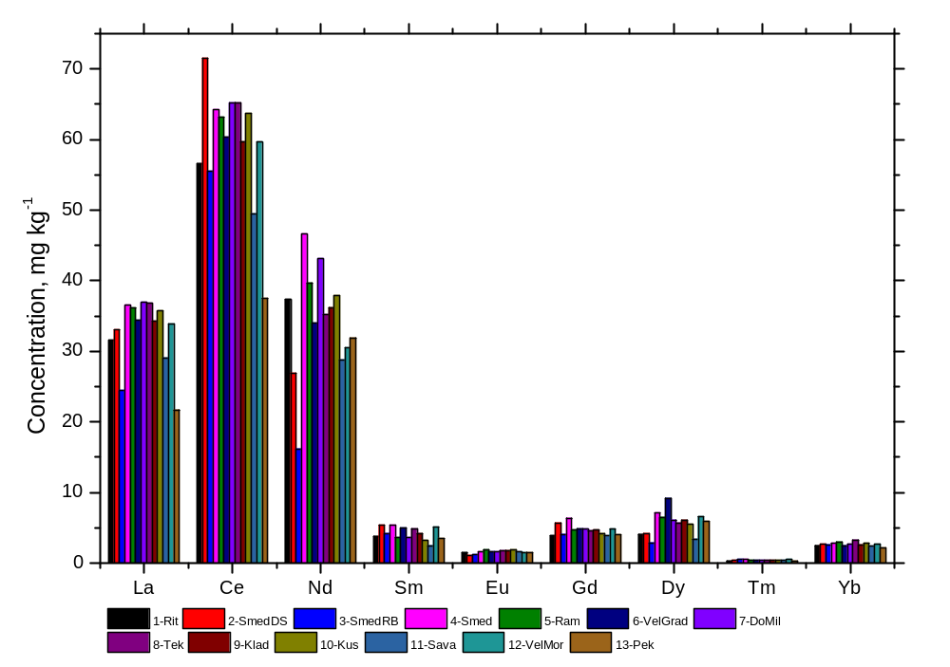
Figure S1. Spatial distribution of the studied lanthanides.

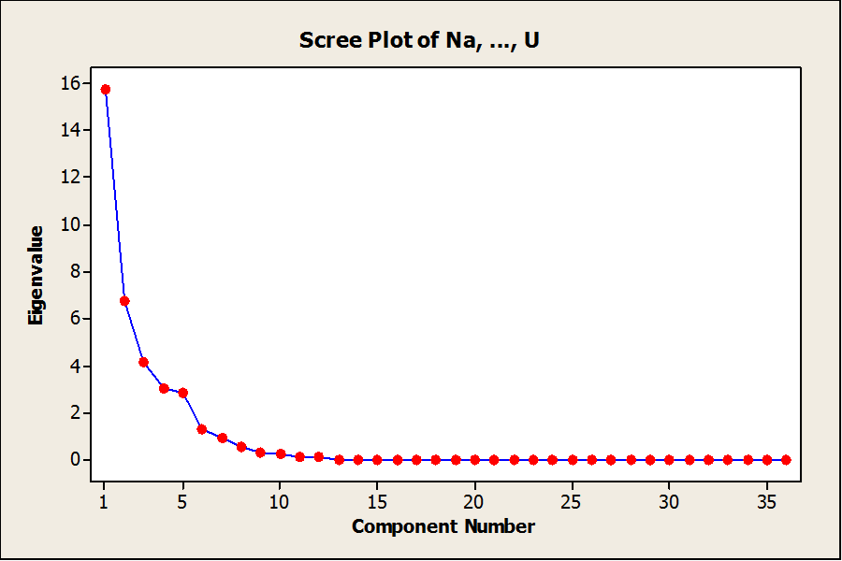
Figure S2. Component Eigen values, Na - U

Table S4. Eigen analysis of the Correlation Matrix
Eigenvalue | 15.704 | 6.765 | 4.153 | 2.997 | 2.844 | 1.295 | 0.896 | 0.575 | 0.293
Proportion | 0.436 | 0.188 | 0.115 | 0.083 | 0.079 | 0.036 | 0.025 | 0.016 | 0.008
Cumulative | 0.436 | 0.624 | 0.740 | 0.823 | 0.902 | 0.938 | 0.963 | 0.979 | 0.987

Table S5. Rotated component matrixª
 | Component
 | 1 | 2 | 3 | 4 | 5 | 6
Rb | 0.937
Th | 0.857 |  |  |  |  | 0.376
Tb | 0.857 |  |  | 0.455
La | 0.854
Ta | 0.847 |  |  | 0.336
K | 0.837 | 0.419
Cs | 0.828 |  | 0.421
Sc | 0.811 | 0.389
Fe | 0.806 | 0.302 | 0.430
Yb | 0.791
Br | 0.786 |  |  |  | -0.323 | -0.305
W | 0.758 | 0.329 |  |  |  | 0.457
Ba | 0.695 |  |  | 0.431 | 0.445
Ce | 0.690 |  |  | 0.566 | -0.352
Eu | 0.690 |  |  | -0.495
As | 0.558 |  | 0.469 |  |  | 0.527
Ti |  | 0.963
Al | 0.310 | 0.911
V | 0.367 | 0.890
Mg | 0.407 | 0.758 |  |  |  | 0.331
Dy |  | 0.756 |  | 0.315 | 0.310
Mn |  | 0.672 | 0.408 | -0.500
Cr |  |  | 0.929
Ni |  |  | 0.923
Co | 0.531 | 0.362 | 0.719
Tm | 0.336 |  | 0.628 | 0.545
Sm |  |  |  | 0.934
Gd |  |  |  | 0.841 |  | 0.379
Hf |  |  | 0.607 | 0.610
U | 0.384 |  |  | 0.563 | -0.538
Ca |  |  |  |  | -0.898
Sr |  |  | 0.327 |  | 0.815
Na | -0.433 |  |  |  | 0.811
Cu | -0.427 |  | -0.425 |  | 0.732
Sb |  |  |  |  |  | 0.925
Zn |  |  | 0.406 |  | 0.487 | 0.696
Nd | 0.621 | 0.348 |  |  |  | 0.623
ªExtraction Method: Principal Component Analysis, Rotation Method: Varimax with Kaiser Normalization.
ªRotation converged in 16 iterations.
Normalization.
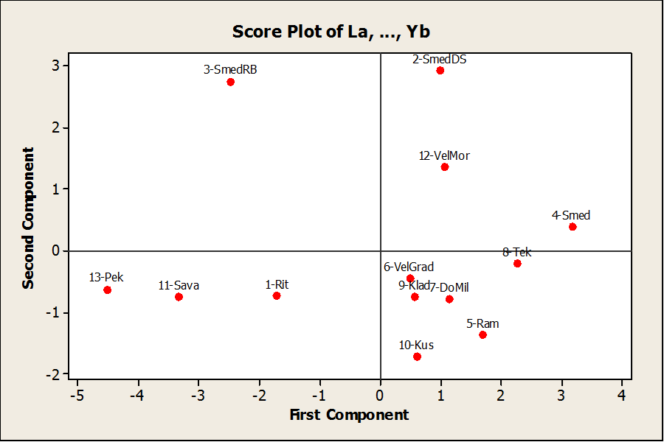
Figure S3. Principal component analysis of the studied lanthanides.

