Supplementary Material
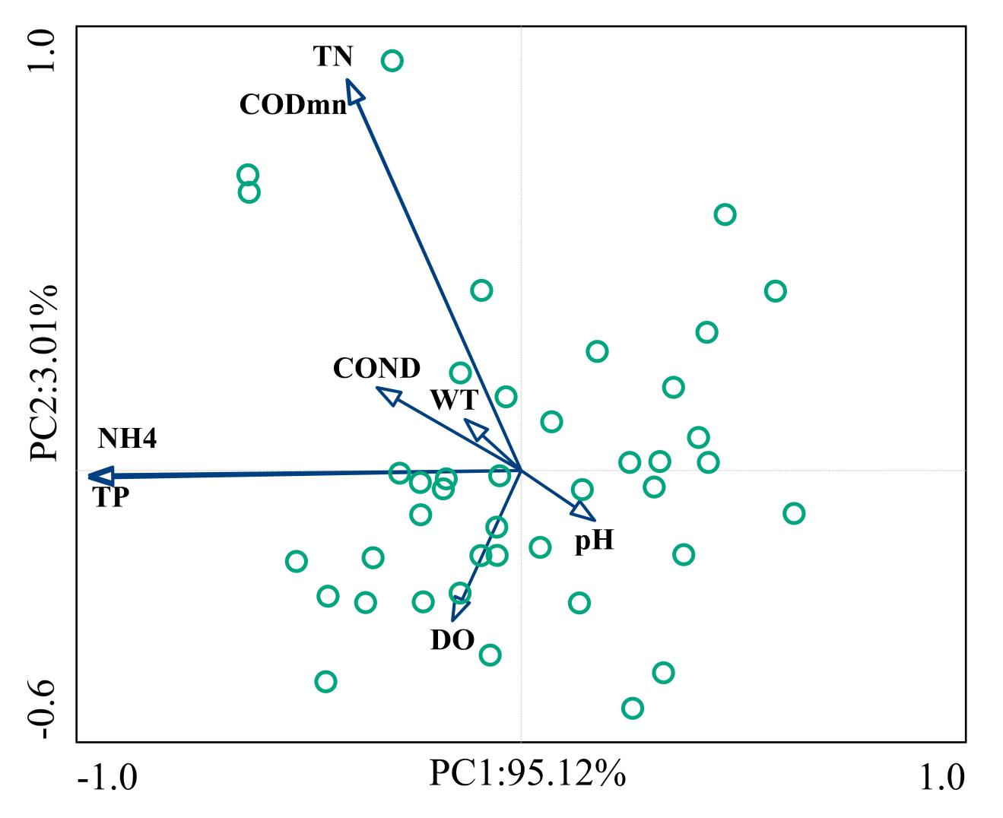Supplementary Figure 1. Principal component analysis results. Physical and chemical factors of water: TP, TN, ammonia nitrogen (NH4+-N), dissolved oxygen (DO), pH, transparency (COND), potassium permanganate (CODmn), water temperature (WT).
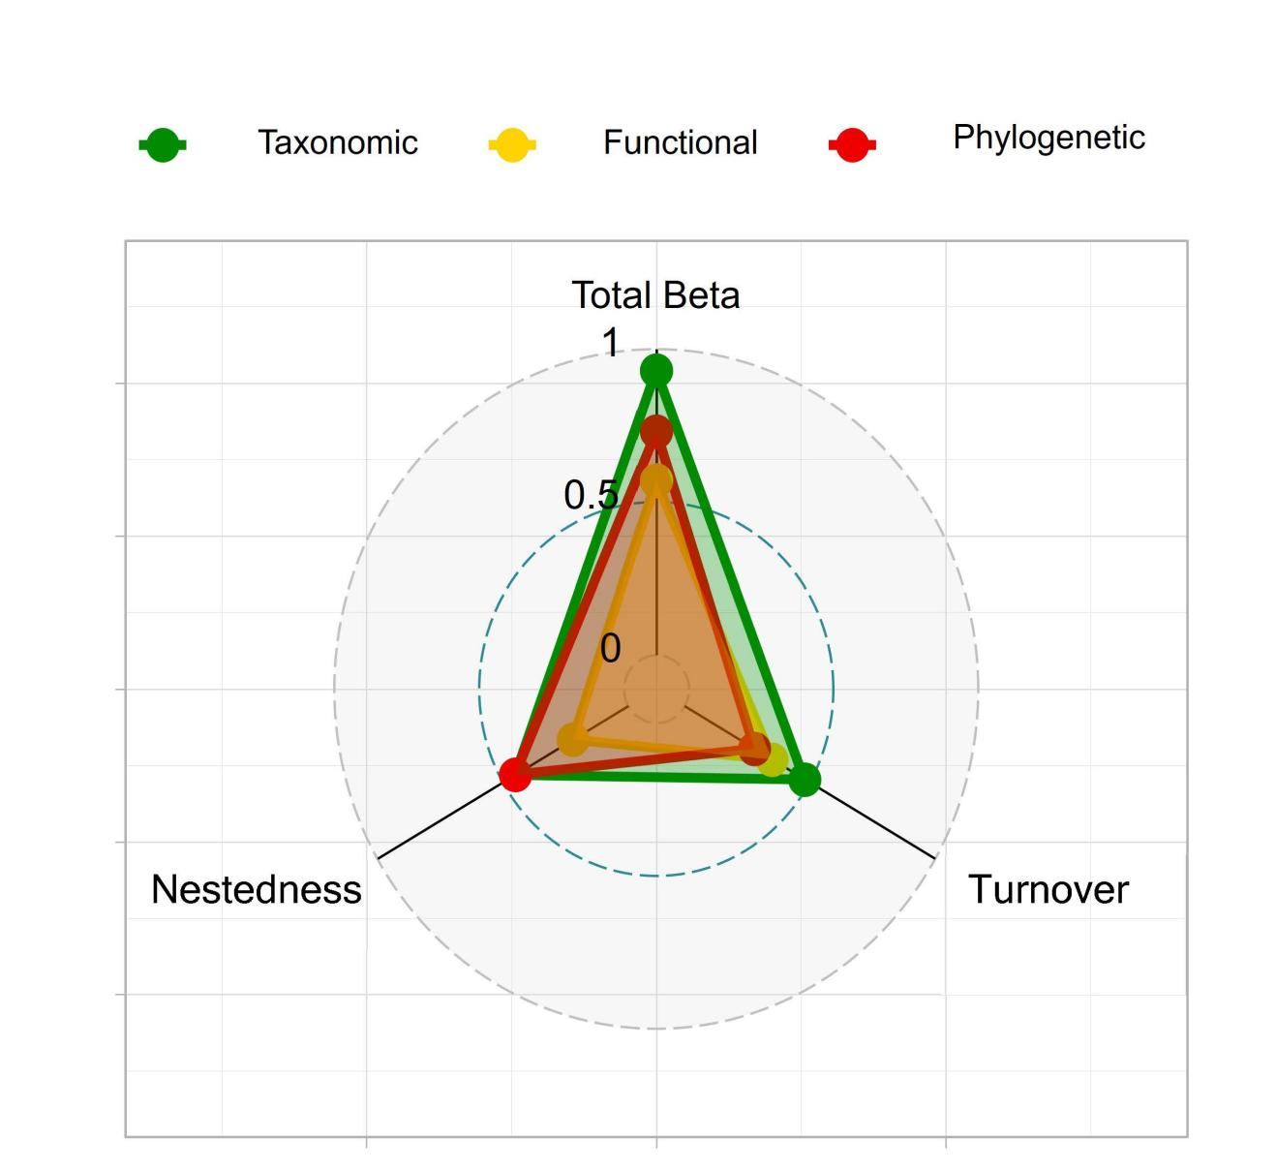 Supplementary Figure 2. Macroinvertebrate total beta diversity and its turnover, nestedness components.

