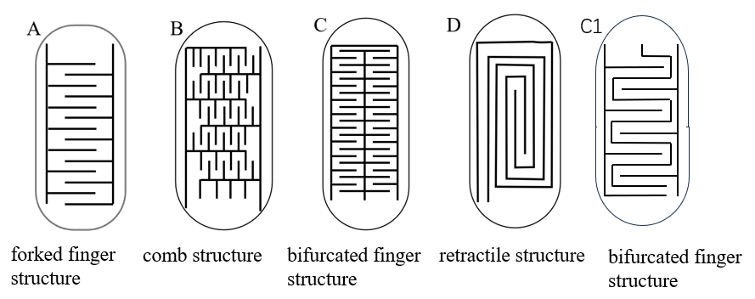
Fig. 1 Design of urine leakage frequency sensing electrode patterns
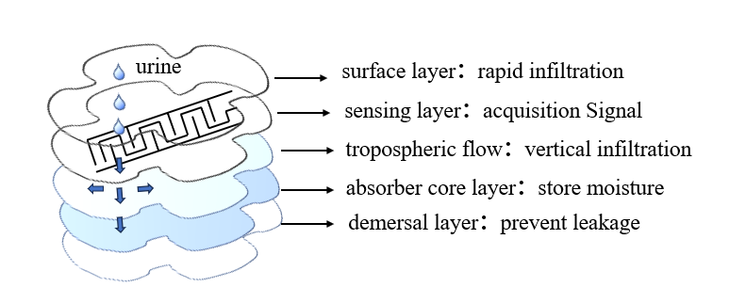
Fig. 2 Schematic diagram of the structure of the sensing diaper and liquid absorption (as an example of pattern A)
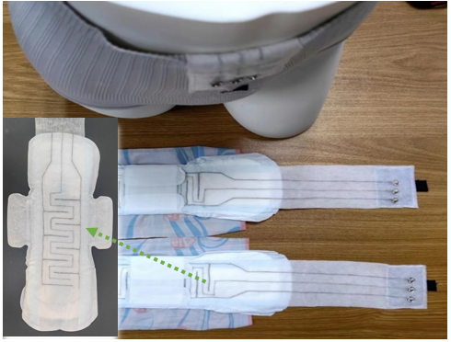
Fig. 3 Physical drawing of the sensing diaper (taking pattern C1 as an example)
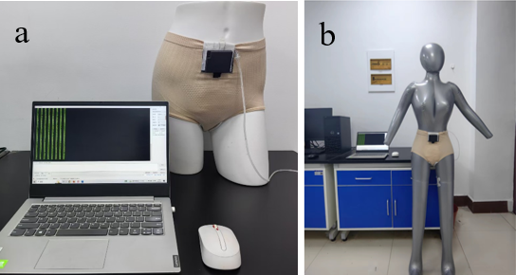
Fig. 4 a Static model upper body test plot; b Static model upper body test plot
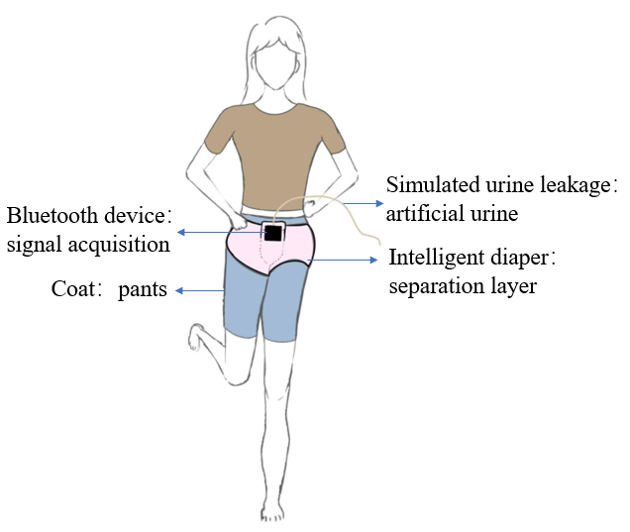
Fig. 5 Volunteer outerwear schematic
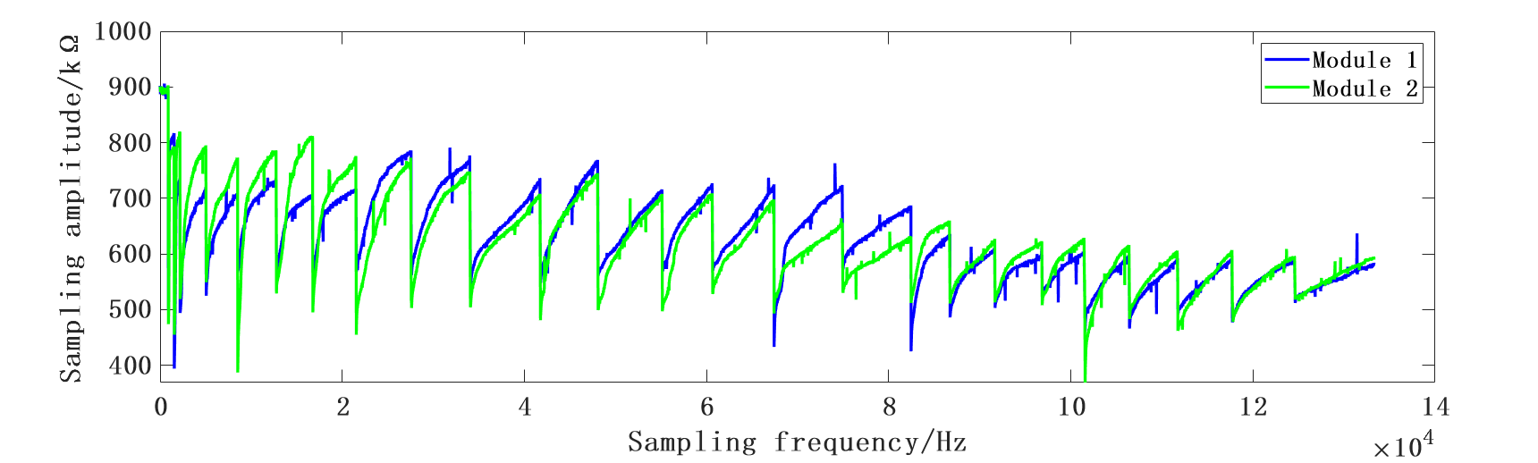
Fig. 6 Waveform variation of experimental data for simulated mild urine leakage
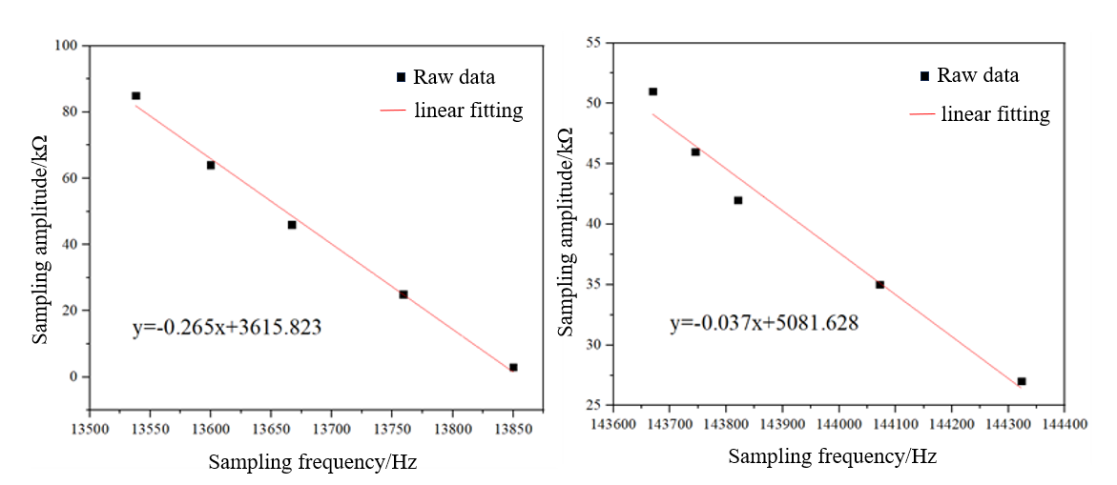
Fig. 7 Linear fit of normal and abnormal urine leakage waveforms
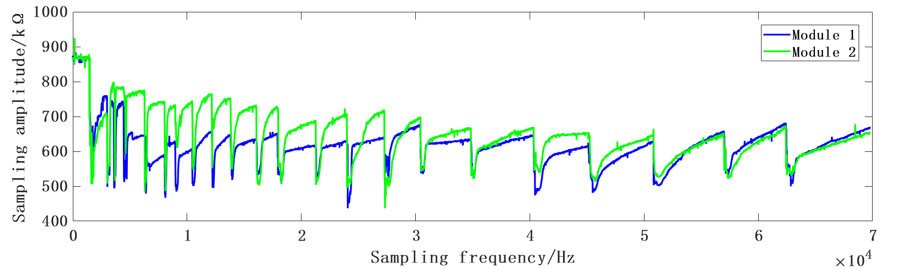
Fig. 8 Waveform variation of experimental data for simulated moderate urine leakage
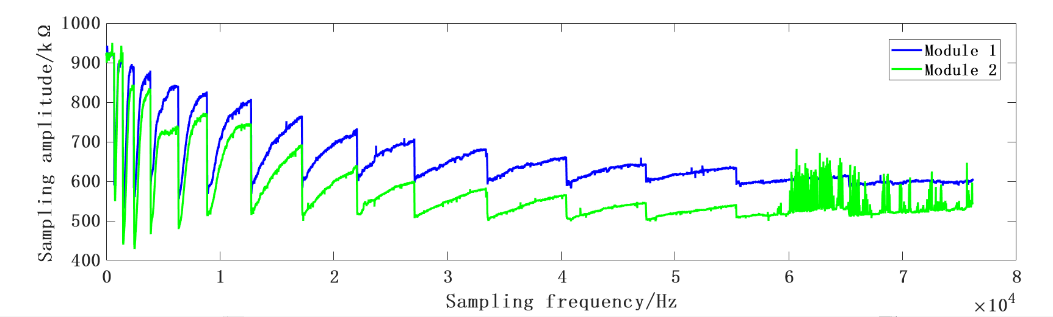
Fig. 9 Waveform variation of experimental data for simulated heavy urine leakage
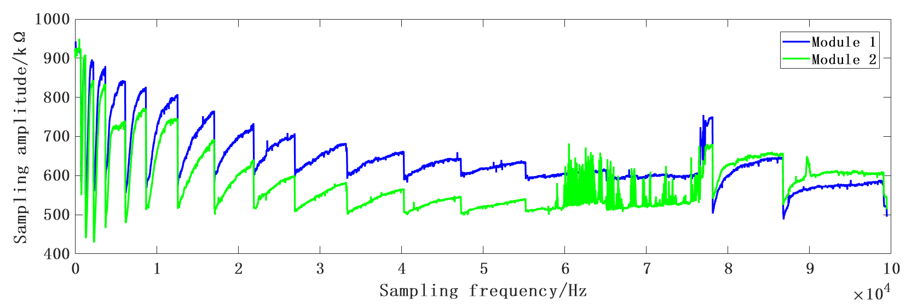
Fig. 10 Variation of waveforms of randomized drop test data for mild, moderate, and severe urine leakage
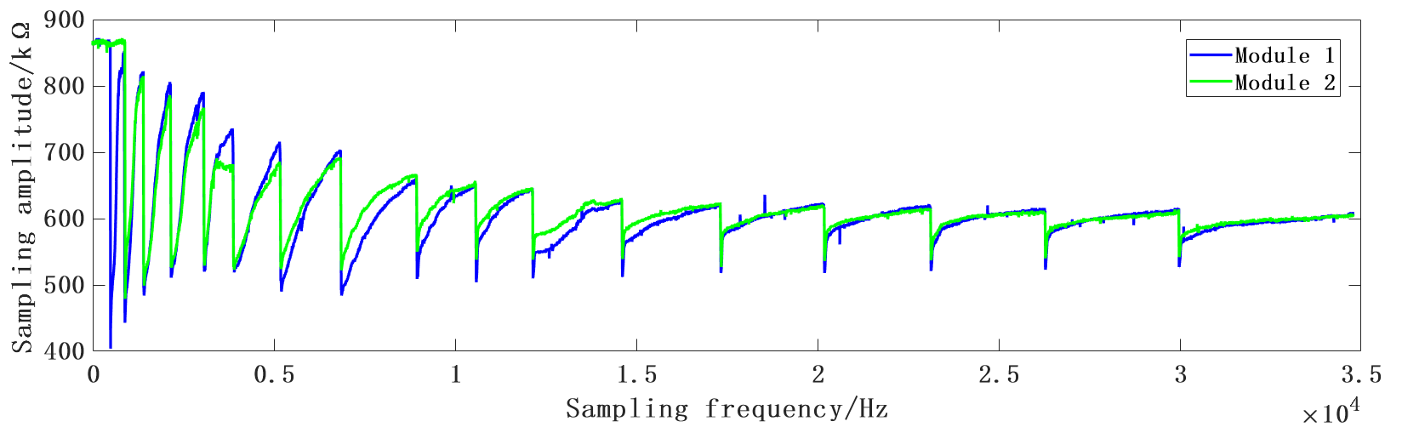
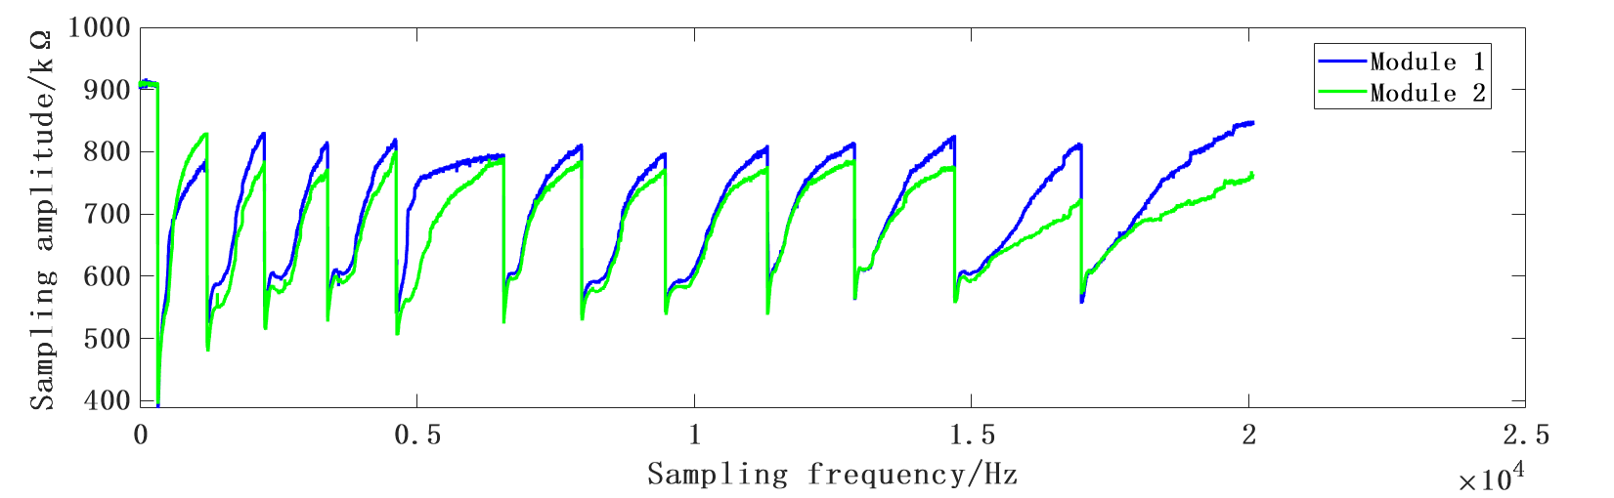
Fig. 11 Simulation modeling dynamic test data waveform changes
(a) First round (b) Second round
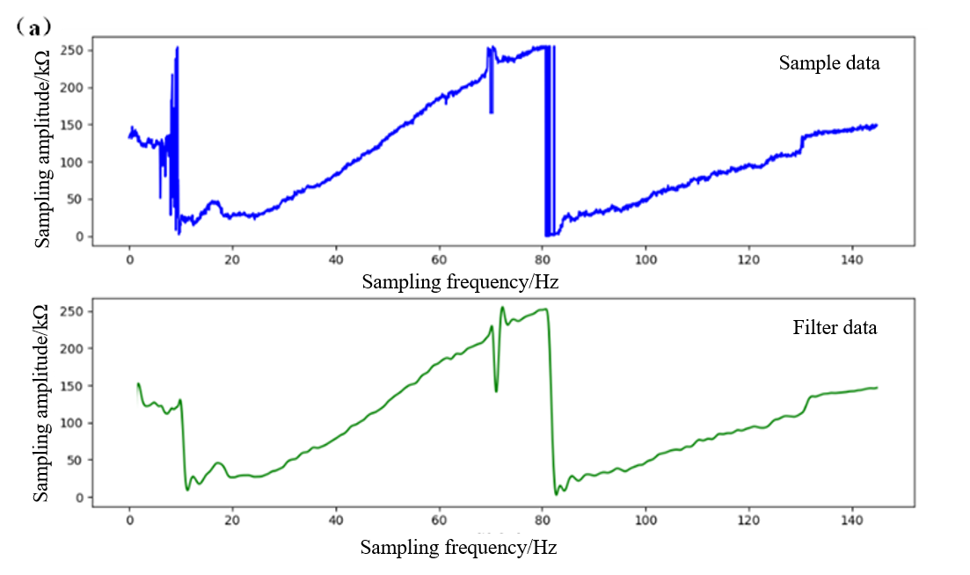
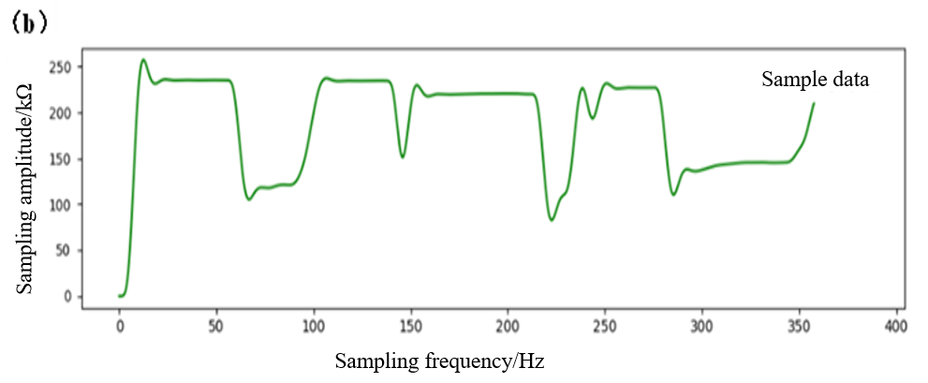
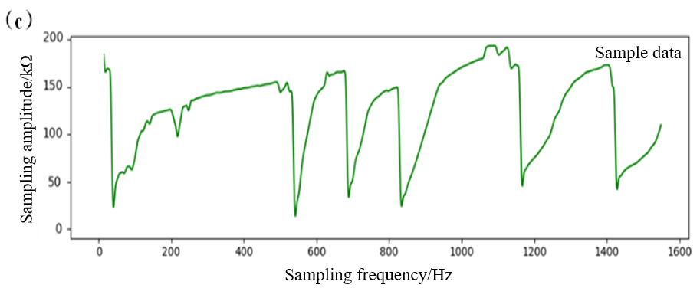

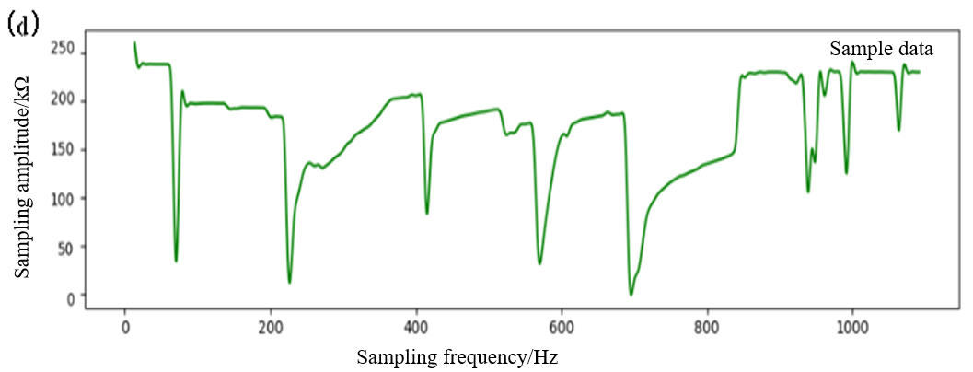
Fig. 12 Volunteer static analog wear test data waveform variation graphs
(a) leakage of urine 2 times; (b) leakage of urine 4 times; (b) leakage of urine 6 times; (d) leakage of urine 8 times
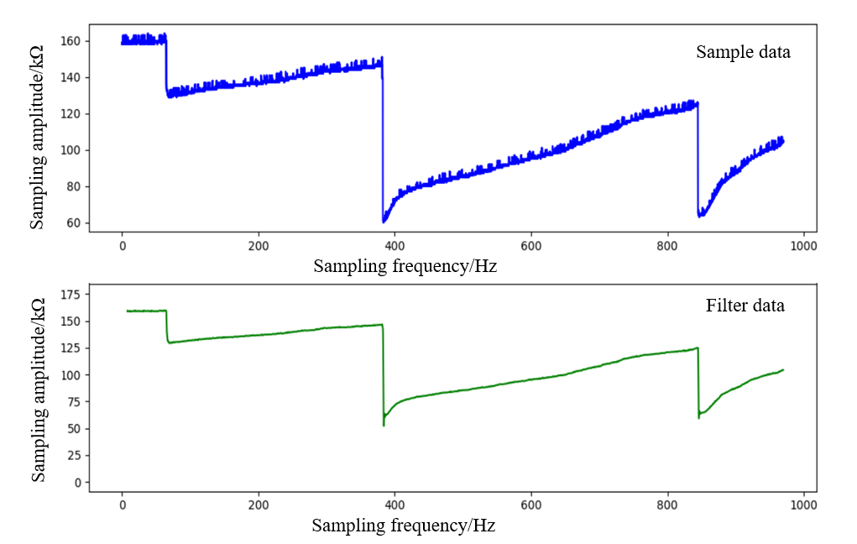
Fig. 13 Waveform variation of dynamic first round test data
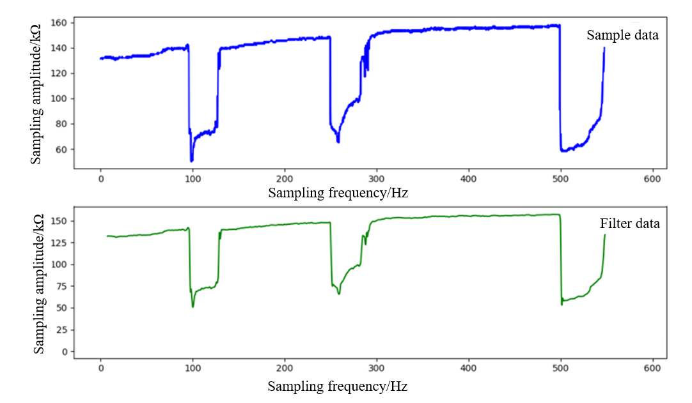
Fig. 14 Dynamic second round of test data waveform variations
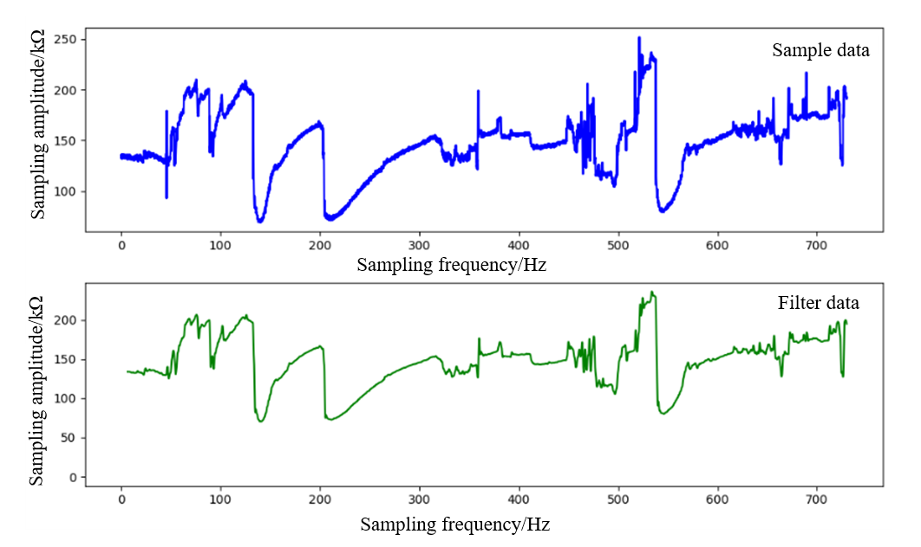
Fig. 15 Waveform variation of dynamic third round test data

