Functional role of hedgerows and landscape composition in controlling a forest insect pest
Landscape Ecology
Nattan Platª, Yohan Charbonnier^{b}, Irene Garcia-Celada^{b}, Mathieu Sannier^{b}, Olivier Bonnardª, Jean-Baptiste Rivoalª, Thomas Ribotª, Thibaud Coupartª, Inge van Halderª, Hervé Jactelª
Affiliations:
ªUniv. Bordeaux, INRAE, BIOGECO, F-33610, Cestas, France
^{b}Ligue pour la Protection des Oiseaux, Bourrou, France
Corresponding author: Nattan Plat, +33638390540, nattan.plat@inrae.fr

Supplementary material
Table S1: Summary of LM, GLM and GLMM testing the effect of the connectivity of the hedgerow to a broadleaved stand on the number of PPM nests per pine edge (H1) and on bird and bat natural enemies of PPM (H2a-e). For each model, connected hedgerows constitute the reference modality compared to isolated hedgerows. The effect of the year was included in model H1 to account for the temporal repetition of PPM nest counts. Significant variables are indicated in bold. R2m and R2c correspond to the variance explained by fixed effects and fixed + random effects respectively. Values of n indicate sample size (only pine border adjacent to hedgerows are included in the dataset).
 | H | Response variable | Predictors | x2 | Df | Coeff. ± SE | P | R2m (R2c) | n
 | H1 | Number of PPM nests per pine edge | Isolated hedgerows | 0.56 | 1 | 0.36 ± 0.48 | 0.965 | 0.09 (0.96) | 48
 |  |  | Year | 70.2 | 1 | 0.64 ± 0.08 | <0.001
 | H2a | Great tit activity | Isolated hedgerows | 0.04 | 1 | -0.07 ± 0.38 | 0.851 | 0.01 | 24
 | H2b | Common cuckoo activity | Isolated hedgerows | 3.12 | 1 | 0.48 ± 0.27 | 0.079 | 0.12 | 24
 | H2c | Species richness of PPM bird predators | Isolated hedgerows | 0.73 | 1 | 0.29 ± 0.34 | 0.391 | 0.03 | 24
 | H2d | Bat activity | Isolated hedgerows | 0.29 | 1 | 0.22 ± 0.53 | 0.683 | 0.04 | 24
 | H2e | Bat feeding buzzes | Isolated hedgerows | 0.01 | 1 | 0.01 ± 0.01 | 0.998 | 0.12 | 24

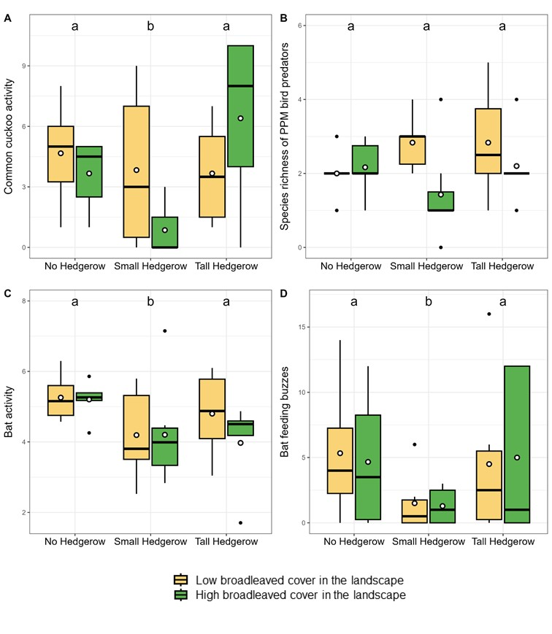
Figure S1 : Boxplots showing the effect of edge type (absence of hedgerows or presence of small or tall hedgerows) and broadleaved cover on (A) common cuckoo activity, (B) Species richness of PPM bird predators, (C) Bat activity (average between two nights, log transformed) and (D) Bat feeding buzzes (number of feeding buzzes among two nights). Boxes indicate the lower and upper quartiles. Thick horizontal lines represent the median, white dots indicate the mean value. The sample size was n=36 for each figure. Black dots show extreme values. Different letters show significant differences between edge types according to the models (Table 1). Broadleaved cover had no significant effect on represented variable (Table 1).

