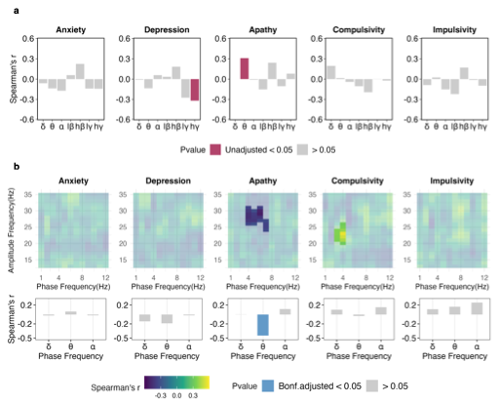
Extended Data Fig. 1 Spectral connectivity across psychiatric symptoms in PD patients. a. Correlational histogram between anxiety (BAI), depression (BDI-2), apathy (AES-PD), impulsivity (UPPS-P), compulsivity (OCI-R) severity and EEG-STN power coherence. Red indicates unadjusted p < 0.05. b. Top: Phase-amplitude per-frequency co-modulogram illustrating the correlation matrix between symptom severity—anxiety (BAI), depression (BDI-2), apathy (AES-PD), impulsivity (UPPS-P), and compulsivity (OCI-R)—and Frontal EEG to STN phase-amplitude coupling (PAC). Deep colors indicate significant correlations identified through cluster-based permutation testing. Bottom: Correlational histogram between delta (1–4Hz), theta (4–8Hz), and alpha (8–12Hz) phase-averaged PAC and anxiety (BAI), depression (BDI-2), apathy (AES-PD), impulsivity (UPPS-P), compulsivity (OCI-R) severity. Blue indicate Bonferroni-adjusted p < 0.05.

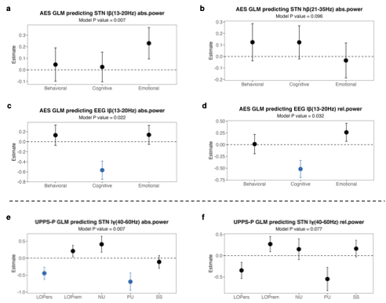
Extended Data Fig. 2 Robust generalized linear model linking PD neuropsychiatric constructs to STN physiology. a & b. Robust generalized linear model predicting STN absolute low beta (a) and high beta (b) power included apathy behavioral, cognitive, and emotional subscores as predictors. c & d. Robust generalized linear model predicting EEG absolute (c) and (d) relative low beta power included apathy behavioral, cognitive, and emotional subscores as predictors. e & f. Robust generalized linear model predicting STN absolute (e) and (f) relative low gamma power with positive urgency (PU), negative urgency (NU), lack of perseverance (LOPers), lack of premeditation (LOPrem), and sensation seeking (SS) as predictors. Blue indicates significant predictors.

Extended Data Table 1 Demographic information
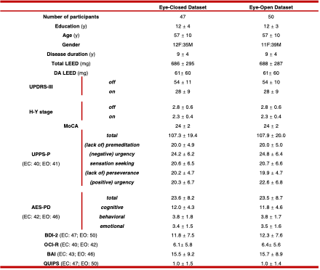
Abbreviations: EC, eye-closed dataset; EO, eye-open dataset; LEED, levodopa equivalent daily doses; DA, dopamine agonist; H-Y stage, Hohen Yahr stage; UPDRS, Unified Parkinson's Disease Rating Scale; MoCA, Montreal Cognitive Assessment; AES-PD, Apathy Evaluation Scale for Parkinson Disease; BDI, Beck Depression Inventory; OCI-R, Obsessive Compulsive Inventory; BAI, Beck Anxiety Inventory; QUIPS, Questionnaire for Impulsive-Compulsive Disorders in Parkinson disease.

Extended Table 2 Questionnaires and cutoffs for neuropsychiatric assessment in Parkinson’s disease
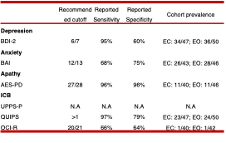
Abbreviations: EC, eye-closed dataset; EO, eye-open dataset; AES-PD, Apathy Evaluation Scale for Parkinson Disease; BDI, Beck Depression Inventory; OCI-R, Obsessive Compulsive Inventory; BAI, Beck Anxiety Inventory; QUIPS, Questionnaire for Impulsive-Compulsive Disorders in Parkinson disease.

