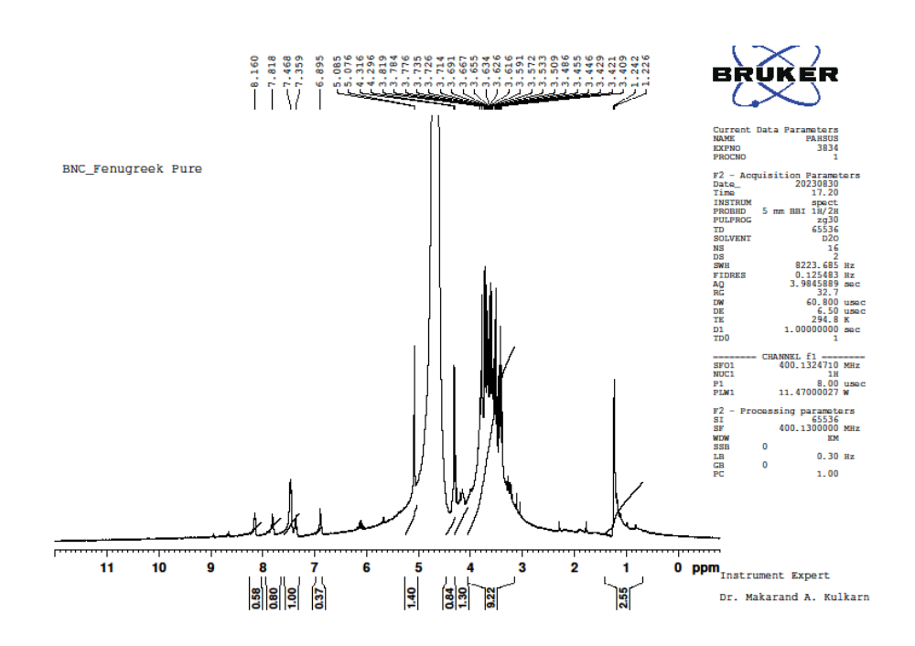Supplementary figures:

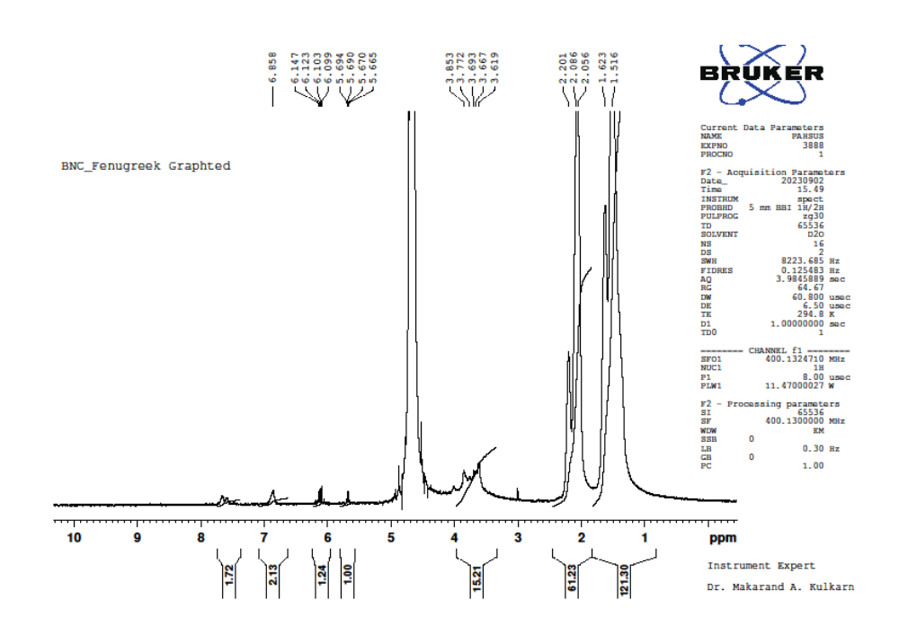Figure S1. ¹H NMR of pure FG
Figure S2. ¹H NMR of Aam-g-FG

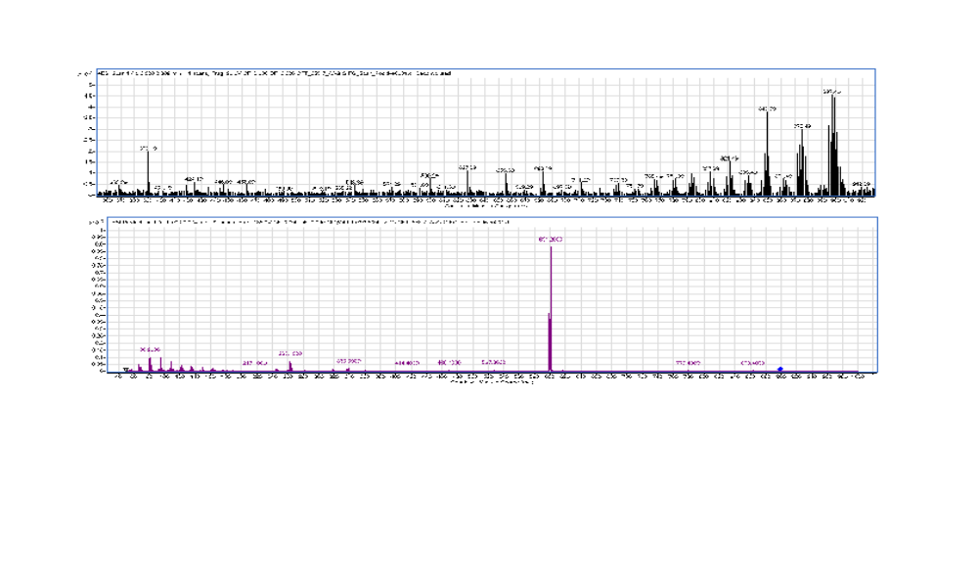
Figure S3: Depicts the mass spectrometry data of Aam-g-FG

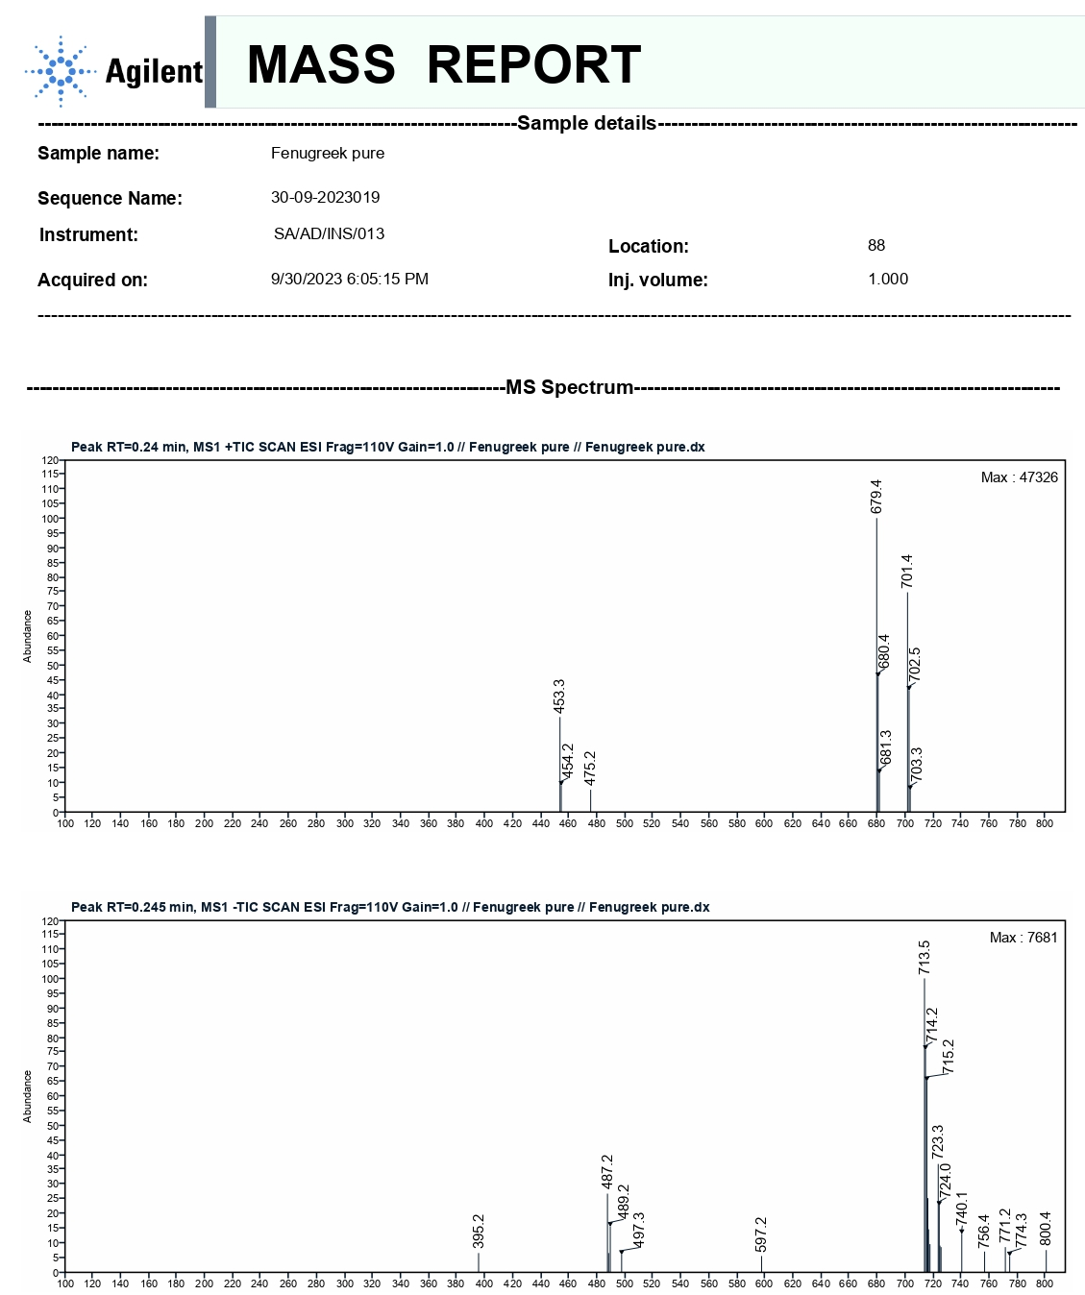
Figure S4: Depicts the mass spectrometry data of FG

