Supplemental Figure 1. The excess DALYs of survivors after 50 years of exposure to famine.
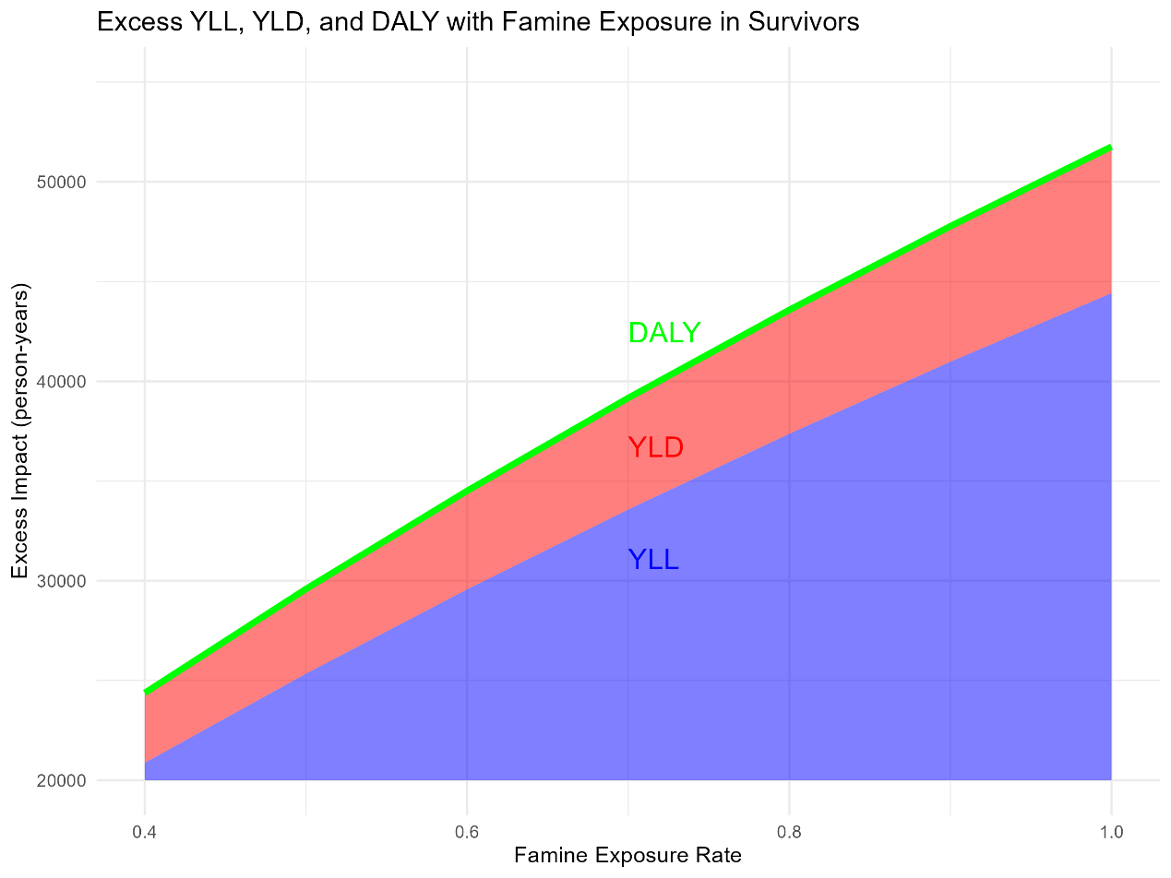
For the Gaza population under 20 years old, under 50% famine exposure, the additional total DALYs after 50 years of exposure to famine are displayed. DALY: disability-adjusted life years; YLD: years lived with disability; YLL: years of life lost.

