Supplemental Figure 2. Tornado diagram.
Male
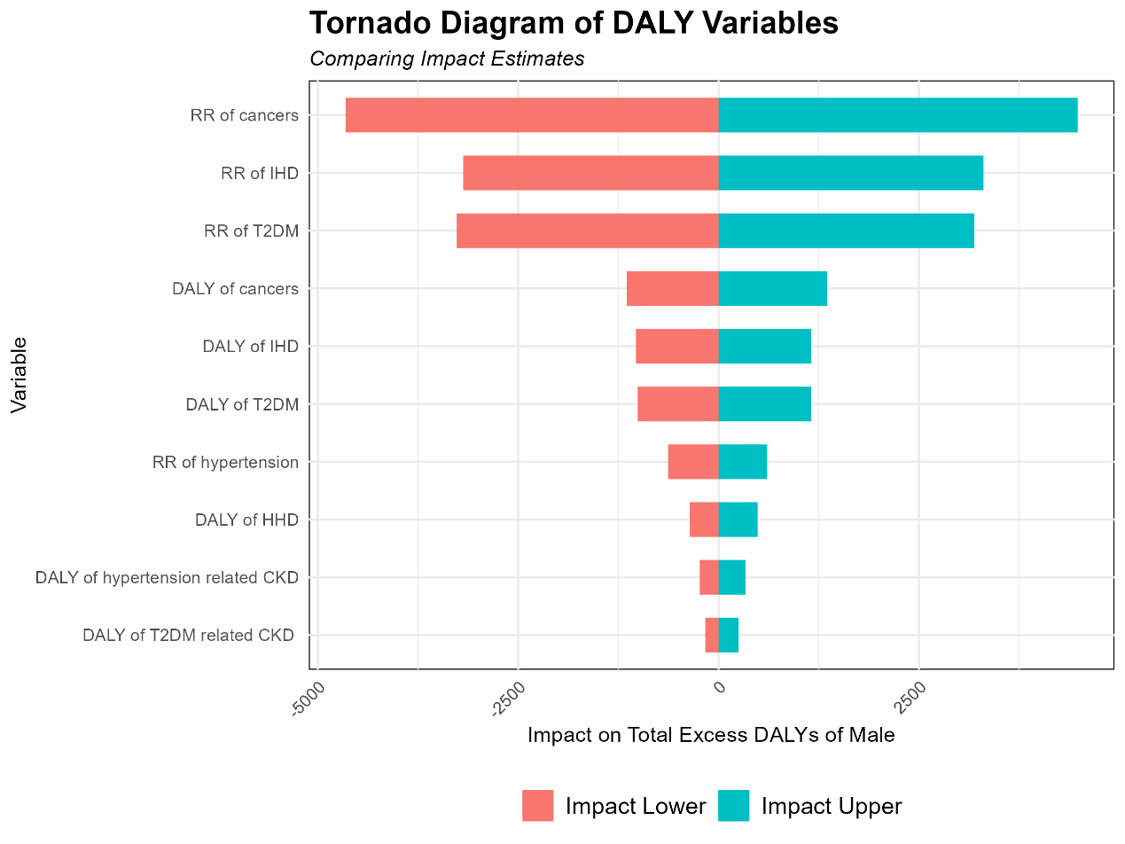
Female
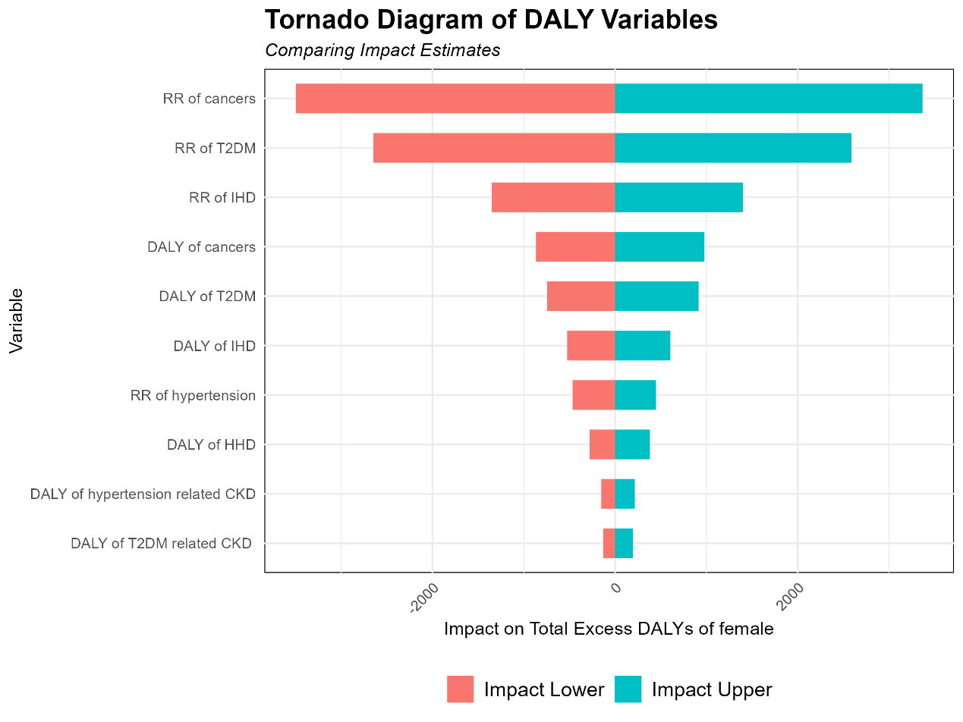
Both
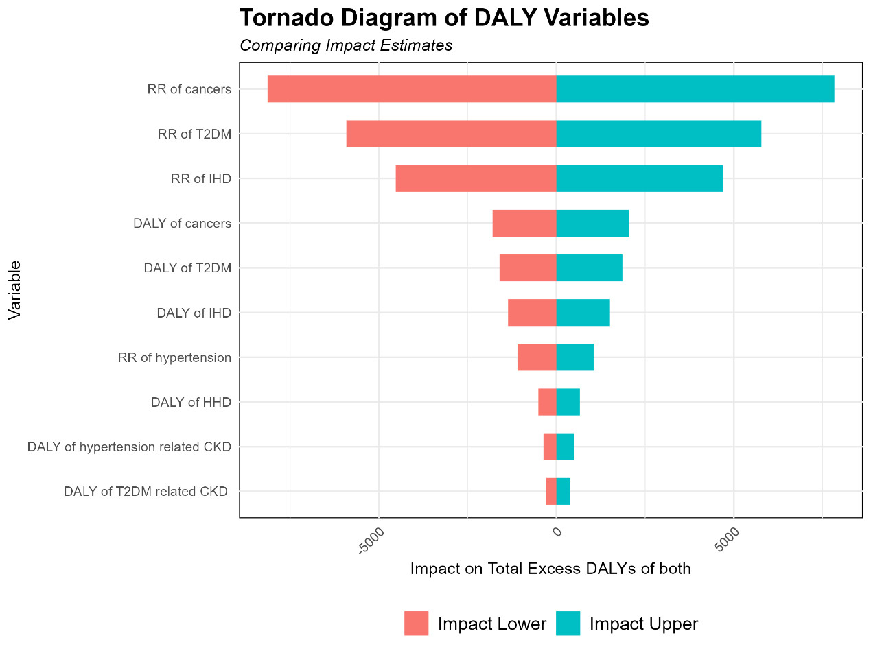
The Tornado Diagram illustrates the related variables that influence DALYs under 50% famine exposure. DALYs: disability-adjusted life years; RR: risk ratio; T2DM: type 2 diabetes mellitus; IHD: ischemic heart disease; HHD: hypertension related heart disease; CKD: chronic kidney disease.

