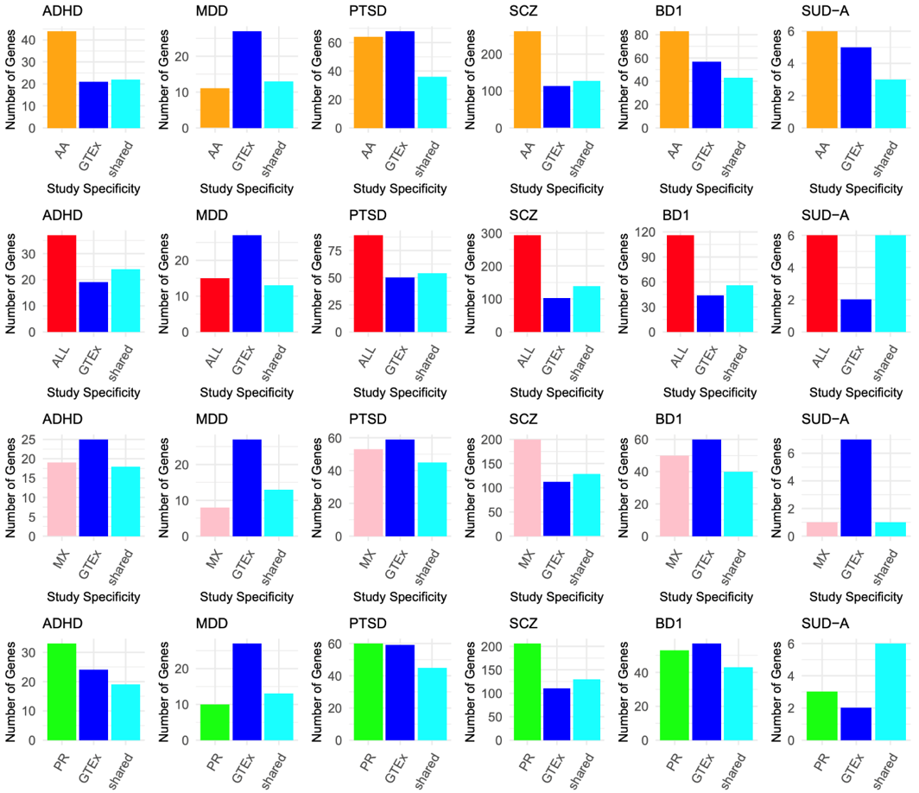
Figure S1: Distribution of FDR significant TWAS results across G2S models compared with GTEx. Each row represents a G2S model and each column represents a psychiatric disease. The light blue bar represents the number of TWAS genes shared across both GTEx and G2S. The blue bar represents the number of GTEx specific associations and the colored bar represents the G2S-specific associations.
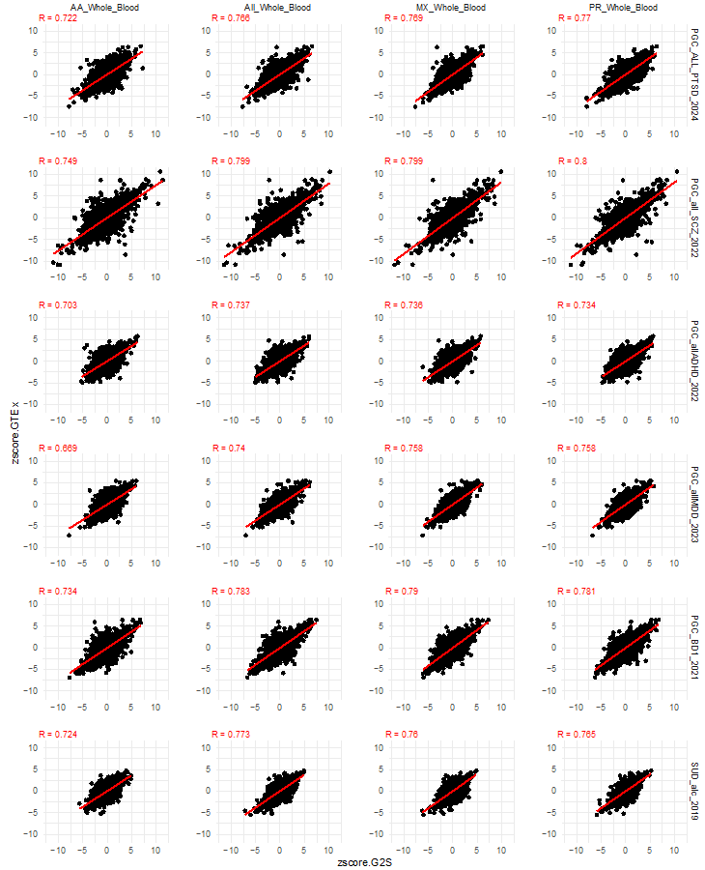
Figure S2: Comparison of GReX-Disease effect size estimates as called by the G2S and GTEx models. The x axis details the normalized effect size estimate of GReX on disease risk in G2S. The y axis position of a point represents the normalized effect size estimate of that same gene-disease association as identified in the GTEx model. The trendline represents a linear regression with the correlation of points across the two models recorded in the upper left quadrant. Rows represent diseases and columns represent G2S models. These associations are not filtered for significance.

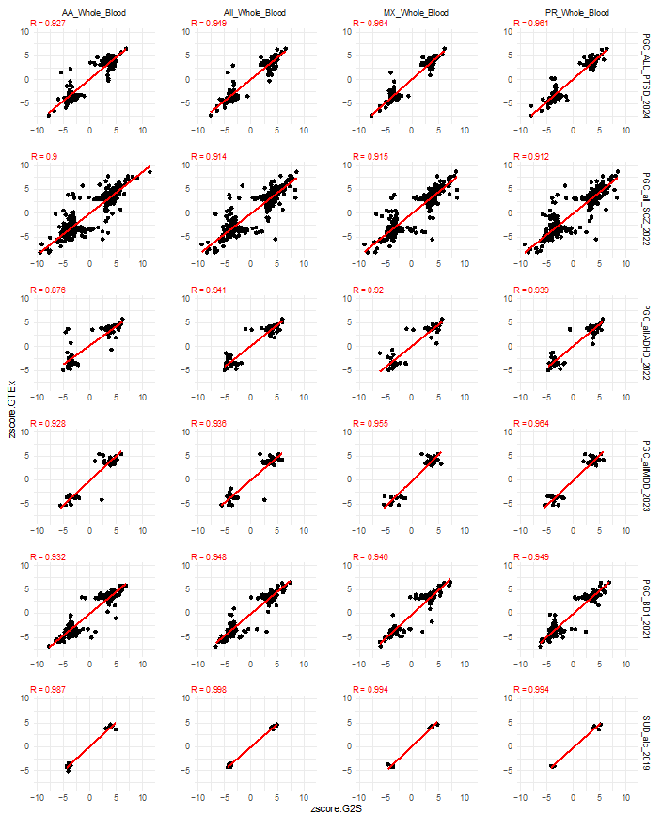
Figure S3: Comparison of GReX-Disease effect size estimates as called by the G2S and GTEx models. The x axis details the normalized effect size estimate of GReX on disease risk in G2S. The y axis position of a point represents the normalized effect size estimate of that same gene-disease association as identified in the GTEx model. The trendline represents a linear regression with the correlation of points across the two models recorded in the upper left quadrant. Rows represent diseases and columns represent G2S models. These associations are filtered for significance using GReX-disease associations that surpass a False-discovery rate threshold of 0.05 in either GTEx or G2S.
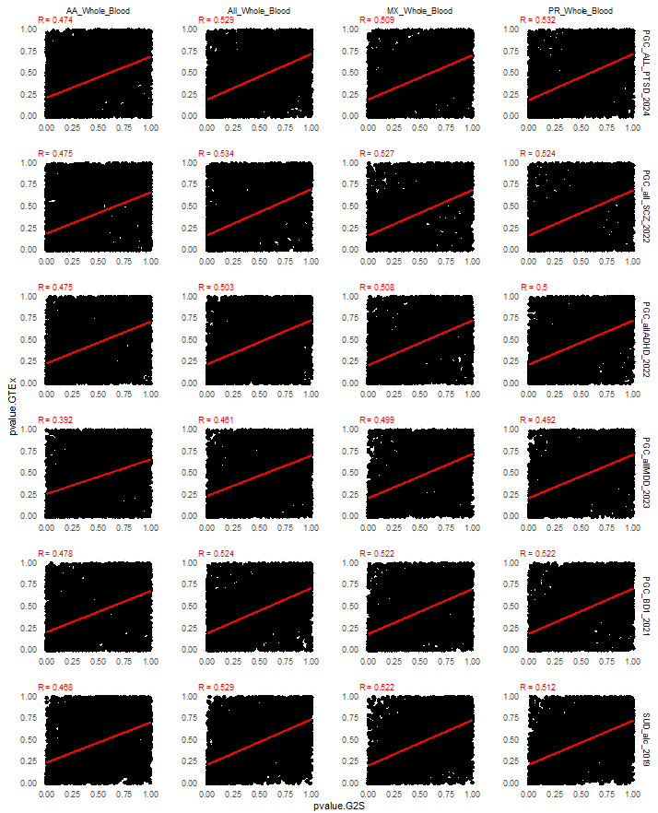
Figure S4: Comparison of GReX-Disease p-values as called by the G2S and GTEx models. The x axis details the effect size estimate p-value for G2S. The y axis position of a point represents the p-value of that same gene-disease association as identified in the GTEx model. The trendline represents a linear regression with the correlation of points across the two models recorded in the upper left quadrant. Rows represent diseases and columns represent G2S models. These associations are not filtered for significance.
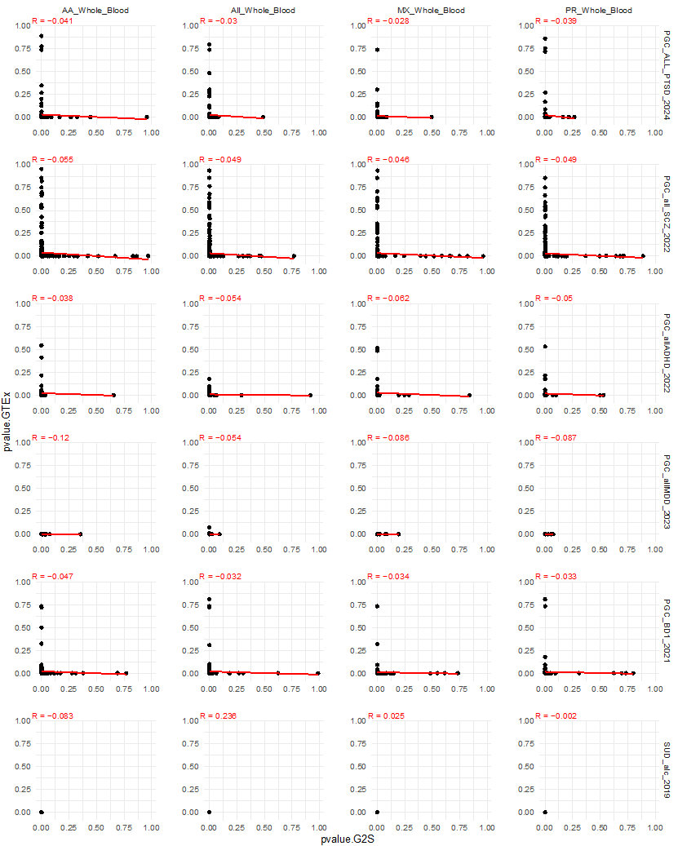
Figure S5: Comparison of GReX-Disease p-values as called by the G2S and GTEx models. The x axis details the effect size estimate p-value for G2S. The y axis position of a point represents the p-value of that same gene-disease association as identified in the GTEx model. The trendline represents a linear regression with the correlation of points across the two models recorded in the upper left quadrant. Rows represent diseases and columns represent G2S models. These associations are filtered for significance using GReX-disease associations that surpass a false-discovery rate threshold of 0.05 in either GTEx or G2S.

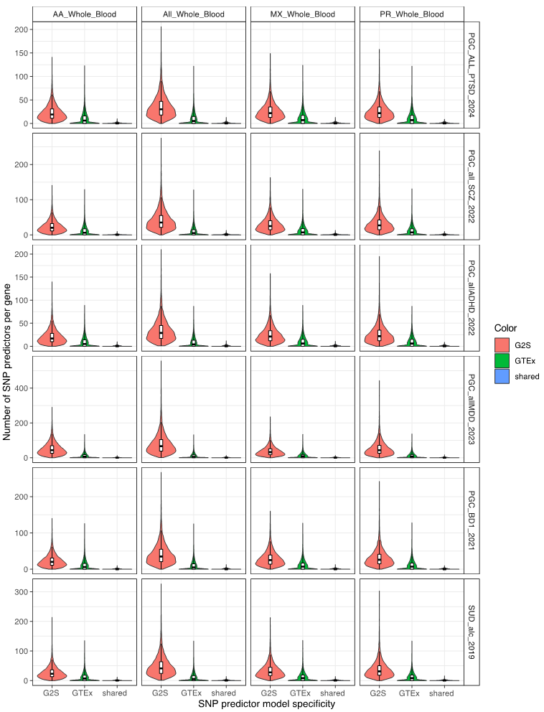Figure S6: Distribution of the number of SNP features per gene unique to the G2S training model in red, GTEx training model in green, and those that are shared in blue. Boxplots represent median values and the interquartile range. Columns represent G2S models and rows represent psychiatric diseases.

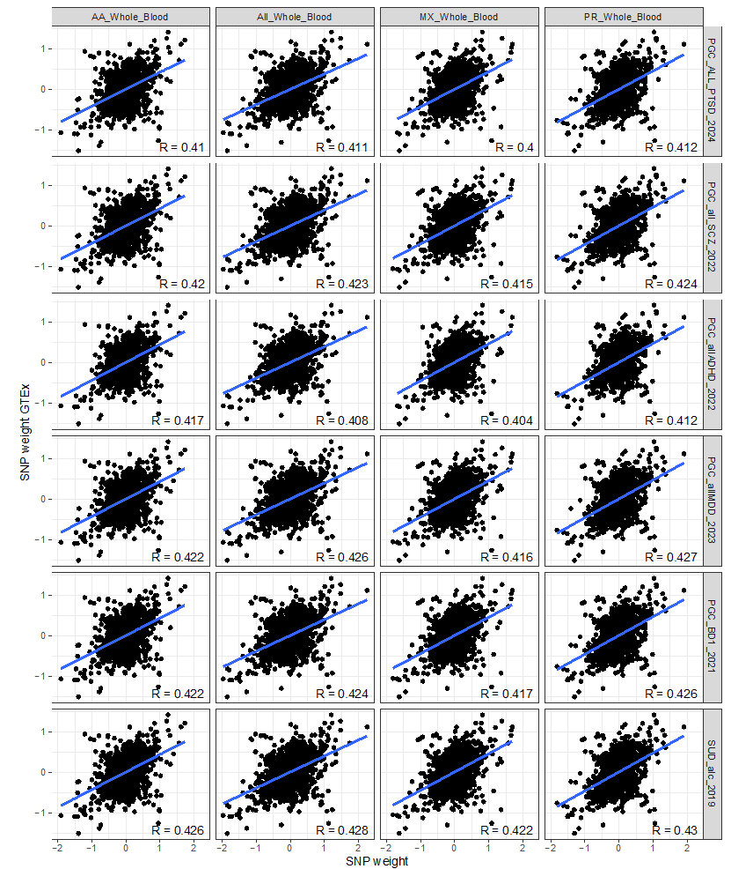
Figure S7: Comparative distribution of SNP feature weights matched by gene across the G2S and GTEx models. The x axis details the weight of a SNP feature on gene expression in G2S. The y axis position of a point represents the weight of that same SNP-gene association as identified in the GTEx model. The trendline represents a linear regression with the correlation value recorded in the lower right quadrant. Columns represent G2S models and the rows represent different psychiatric diseases.

Figure S8: Comparison of prediction performance of SNP features on gene expression in SCZ analysis between the African American G2S model and GTEx. Each box plot shows the median and the interquartile range. Rows represent psychiatric diseases and columns represent G2S models.
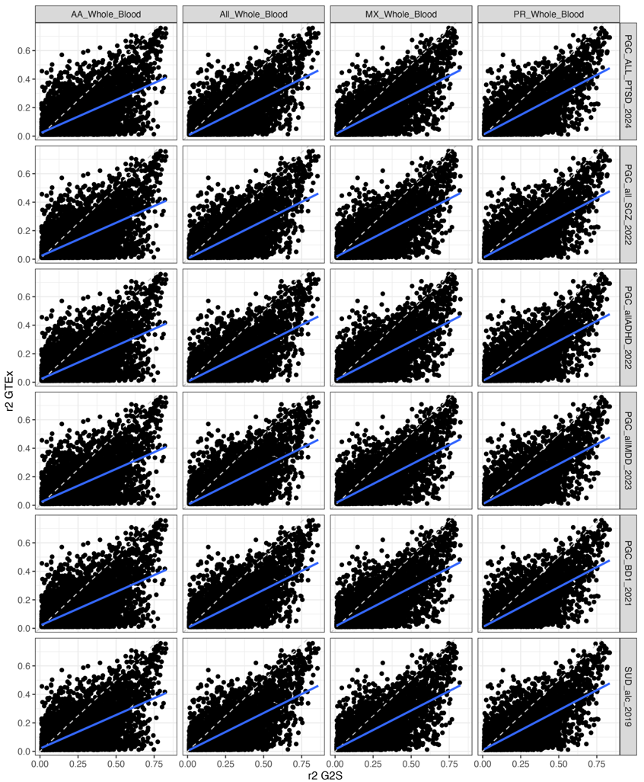
Figure S9: Comparison of prediction performance r2 values between shared genes across G2S and GTEx models. The dotted line represents y=x. The blue line represents a linear regression of all points. Panel rows represent diseases while columns represent the different G2S models.
Figure S10: Comparison of weight magnitudes of SNP features on gene expression in TWAS analyses across G2S models and GTEx. Each box plot shows the median and the interquartile range. Rows represent psychiatric diseases and columns represent G2S models.

Figure S11: We plot the correlation in effect size estimates for gene level associations according to which models called the gene-level association as significant (FDR < 0.05) and if they included shared SNP features. SNP prediction data are colored according to the categories of shared_distinct and shared_overlapping. Data points represent the Pearson correlation and error bars represent the 95% confidence interval. Rows represent psychiatric diseases and columns represent G2S models.

Figure S12: We plot the correlation in effect size estimate p-values for gene level associations according to which models called the gene-level association as significant (FDR < 0.05) and if they included shared SNP features. SNP prediction data are colored according to the categories of shared_distinct and shared_overlapping. Data points represent the Pearson correlation and error bars represent the 95% confidence interval. Rows represent psychiatric diseases and columns represent G2S models.

Figure S13: Distribution of the prediction performance statistics (r2) per gene according to the SNP feature source for the G2S models and the GTEx model. The prediction performance statistics are presented both for the G2S model and the G2S GTEx model along the x axis. Genes with SNP features only in the G2S model are presented in red. Genes with non-overlapping SNP features in both G2S and GTEx models are shown in green. The genes with at least one shared SNP feature across both G2S AA and GTEx models are shown in blue. Rows represent psychiatric diseases and columns represent G2S models.
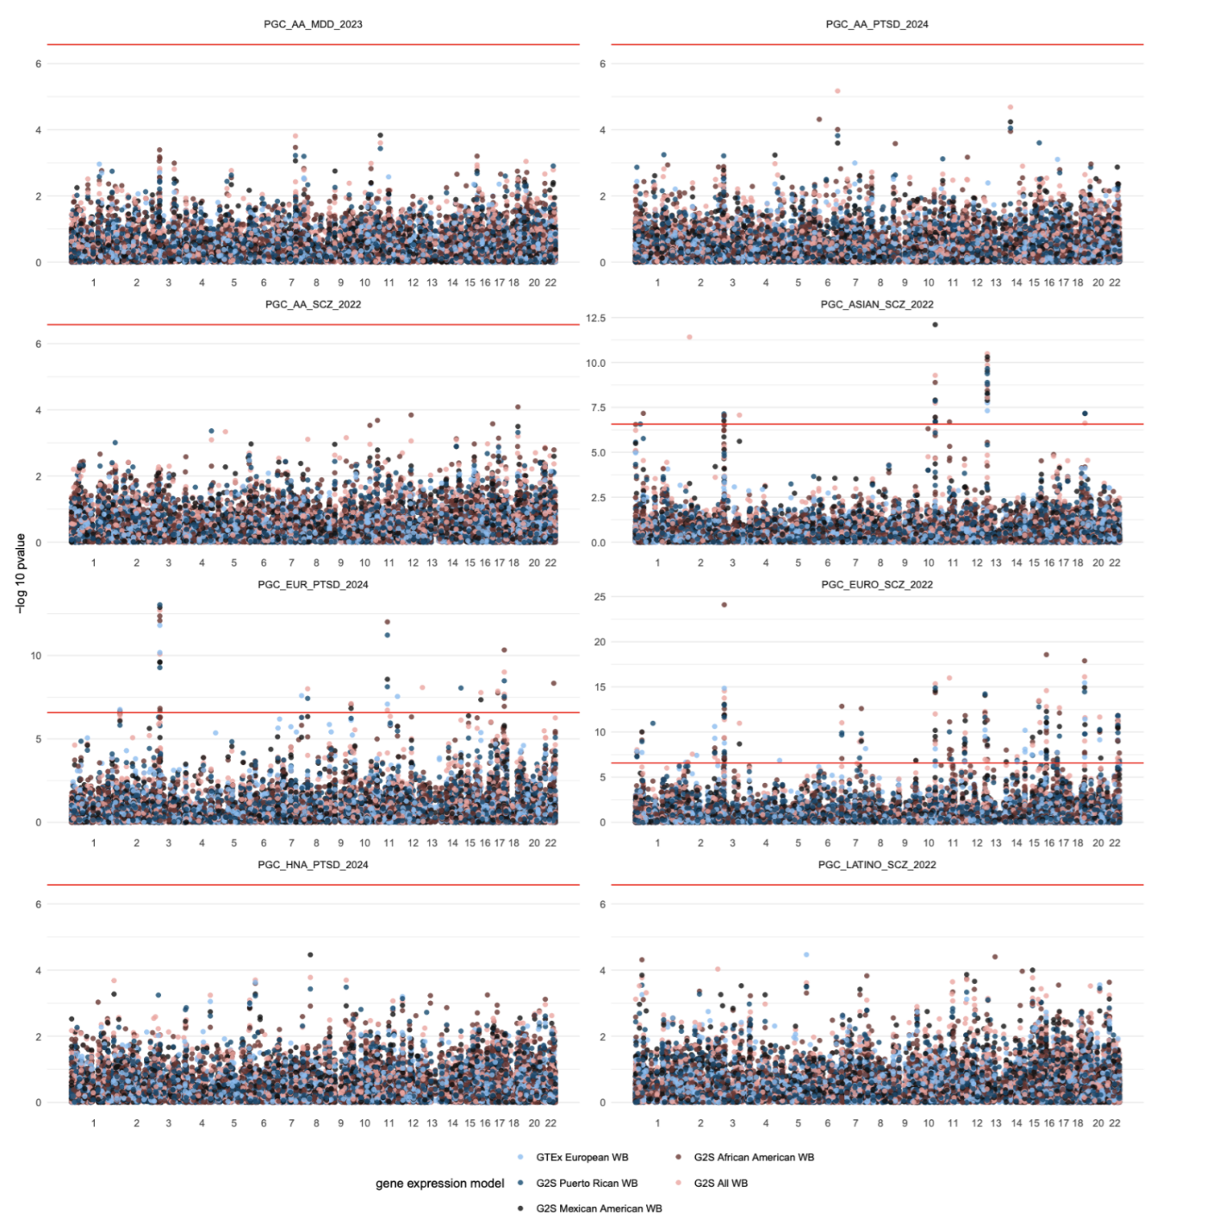Figure S14: These Manhattan style plots represent the transcript level associations for all subsets of the Schizophrenia, PTSD, and MDD GWAS meta-analyses from the PGC performed using individuals of a single described ancestry. Plots are labeled with the trait and the population as well as the study publication year. The red line represents a Bonferroni significant threshold.

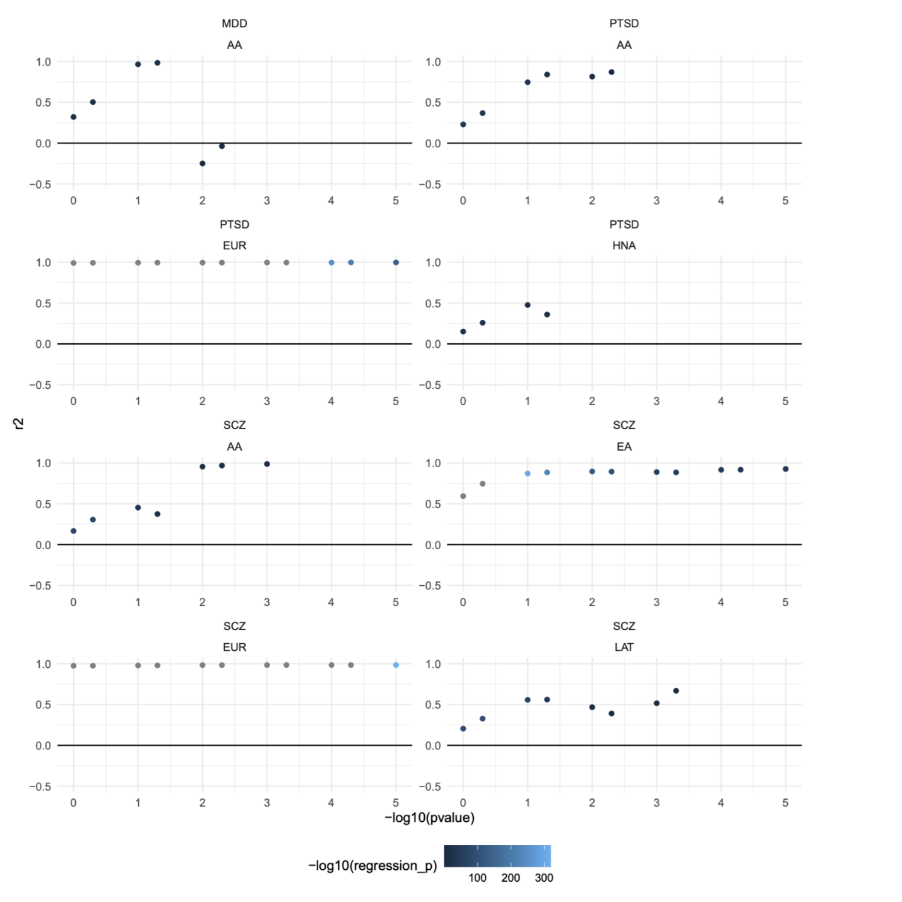
Figure S15: Across a range of p-value significance thresholds from 1 to 1e-5, we calculate the transcriptomic correlation between GReX-disease association from the TWAS in Figure S12 and the GReX-disease associations from the full TWAS study. The significance threshold is displayed along the x axis while the r2 is presented along the y axis. Points are colored according to the statistical significance of the r2 calculation. A minimum of 5 GReX-Disease associations were required to assess correlation leading to incomplete data below certain p-value thresholds.

Supplementary Note:

Power limitations hamper single-ancestry TWAS analyses
The use of ancestry informed gene expression prediction models holds promise for multi ancestry GWAS as well as single ancestry GWAS. Three of the PGC studies stratify their initial cohorts according to ancestry and present GWAS summary statistics for these ancestry specific cohorts (Table S1). We apply the G2S models to these ancestry-specific GWAS to assess the performance of the TWAS approach across ancestries and models. The Schizophrenia meta-analysis includes GWAS summary statistics for European, East Asian, African American, and Latino cohorts. There are only two subpopulations in which gene level associations from the TWAS surpass an FDR < 0.05 significant threshold: East Asian and European.

None of the G2S or GTeX models identify significant gene level associations in the African American or Latino subsets. We suspect that this is a result of low power given the reduced sample size of these two cohorts relative to the European and East Asian cohorts (Table S1). To assess the effect of low power by identifying the top genes in each TWAS according to sequentially less stringent p-value thresholds. These represent genes that were highly relevant in the subpopulation but may have failed to reach study wide statistical significance. We then quantify the degree to which the effect size estimates of these selected gene-level associations correlate with the effect size estimates of the matching associations derived from the FDR-significant full data analysis (Figure S12).

The trend in effect-size correlations between ancestry subset genes and the discovery TWAS genes reflects the ancestry proportions in the Schizophrenia meta-analysis. The TWAS of individuals of African American ancestry achieved a maximum correlation of ~95% with the discovery at a p-value threshold of 0.005. There was additionally a notable increase in effect size estimate correlation from 0.40 to 0.92 moving from a p-value threshold of 0.05 to 0.001. For TWAS findings from both Latino and African Americans subsets, the correlation in effect size estimates with the discovery TWAS increases as the p-values become more stringent. In Europeans, the correlation in effect size estimates with the discovery TWAS remains near 100 even at a p-value threshold of 1. The TWAS findings from individuals of East Asian descent lay in between with a minimum correlation of ~50% and exceeding 90% at a threshold of 0.01.

 | SCZ |  | PTSD |  | MDD
Ancestry | Cases | Control | Cases | Control | Cases | Control
European | 53,386 | 77,258 | 137,136 | 1,085,746 | 0 | 0
East Asian | 14,004 | 16,757 | 0 | 0 | 21,980 | 360,956
South Asian | 0 | 0 | 0 | 0 | 4,505 | 27,176
African American | 6,152 | 3,918 | 11,560 | 39,474 | 36,818 | 161,679
Latino | 1,234 | 3,090 | 0 | 0 | 25,013 | 352,946
American Indigenous | 0 (0%) | 0 (0%) | 2,046 | 4,953 | 0 | 0
Table S1: Study participant statistics for the multi-ancestry GWAS analyses for SCZ, PTSD, and MDD.

G2S Significance | GTEx Significance | N | z-score correlation | z-score correlation p-value | p-value correlation | p-value correlation p-value
P<1 | P<1 | 1552469 | 0.760 | ~0 | 0.506 | ~0
P<0.05 | P<1 | 2330 | 0.949 | ~0 | 0.104 | 4.66E-07
P<1 | P<0.05 | 1944 | 0.945 | ~0 | 0.111 | 9.33E-07
P_{G2S} < 0.05 OR P_{GTEx} < 0.05 |  | 3227 | 0.926 | ~0 | -0.0411 | 0.0194
P_{G2S} < 0.05 AND P_{GTEx} < 0.05 |  | 1047 | 0.988 | ~0 | 0.489 | 6.61E-64
P_{G2S} < 0.05 XOR P_{GTEx} < 0.05 |  | 2180 | 0.884 | ~0 | -0.0634 | 0.00307
Table S2: Correlation coefficients of normalized effect size estimates and p-values for genes tested in both models grouped according to significance.

