Table 1. Species raw counts, ordered from most to least total detections. Totals and minimum/maximum detections are then broken down by focal city.
Species | Total Metro-Area Detections | Seattle Total | Tacoma Total | Seattle Min | Seattle Max | Tacoma Min | Tacoma Max
Eastern gray squirrel | 7,646 | 2,350 | 5,296 | 1 | 189 | 1 | 297
Raccoon | 2,503 | 580 | 1,923 | 1 | 55 | 1 | 65
Black-tailed deer | 1,638 | 317 | 1,321 | 1 | 31 | 1 | 54
Eastern cottontail rabbit | 1,614 | 473 | 1,141 | 1 | 76 | 1 | 125
Coyote | 1,203 | 422 | 781 | 1 | 165 | 1 | 81
Virginia opossum | 911 | 148 | 763 | 1 | 15 | 1 | 70
Douglas squirrel | 293 | 0 | 293 | NA | NA | 1 | 52
Striped skunk | 188 | 1 | 187 | 1 | 1 | 1 | 41
Elk | 121 | 0 | 121 | NA | NA | 1 | 27
Western chipmunk | 57 | 0 | 57 | NA | NA | 1 | 21
Bobcat | 31 | 13 | 18 | 1 | 2 | 1 | 4
Black bear | 10 | 9 | 1 | 1 | 4 | 1 | 1
Western gray squirrel | 4 | 0 | 4 | NA | NA | 4 | 4
Weasel (cannot ID) | 3 | 0 | 3 | NA | NA | 1 | 1
Mountain lion | 2 | 0 | 2 | NA | NA | 2 | 2
Fox squirrel | 1 | 0 | 1 | NA | NA | 1 | 1
River otter | 1 | 1 | 0 | 1 | 1 | NA | NA

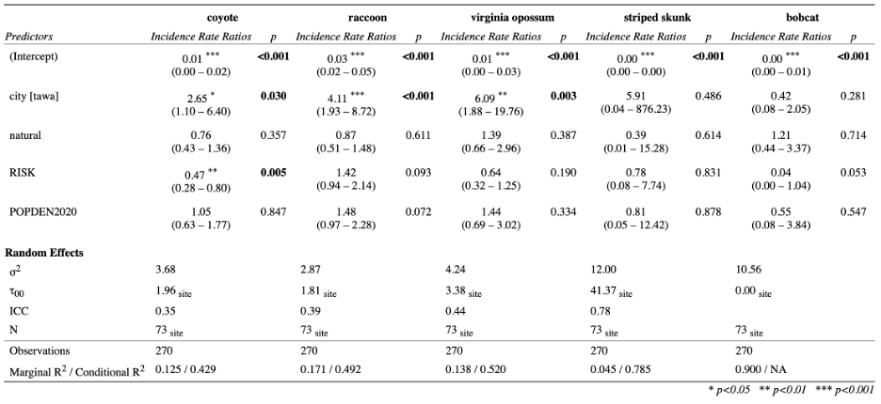
Table 2. Mesocarnivore activity models results table (metro-area).

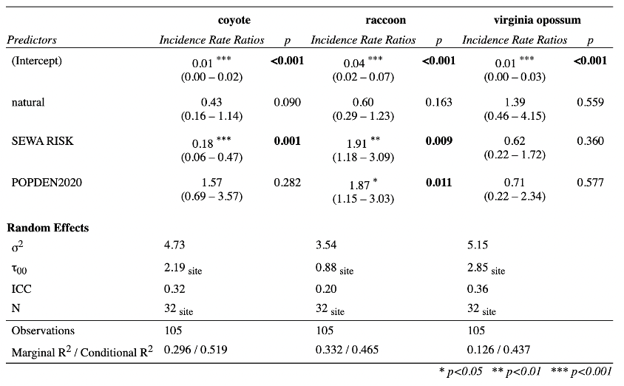
Table 3. Mesocarnivore activity models results table (Seattle).

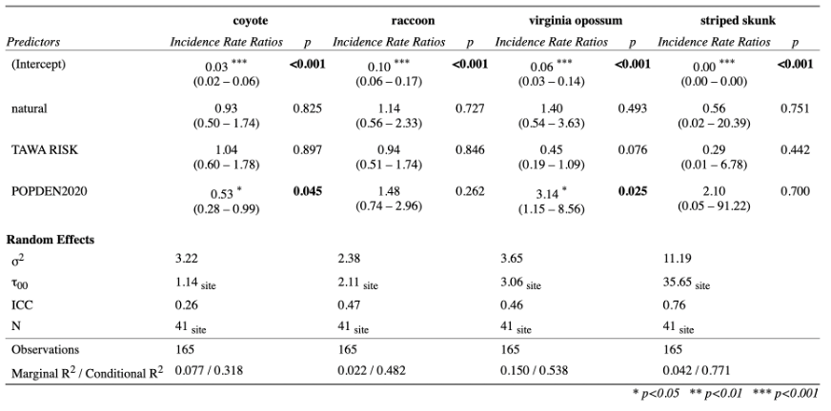
Table 4. Mesocarnivore activity models results table (Tacoma).

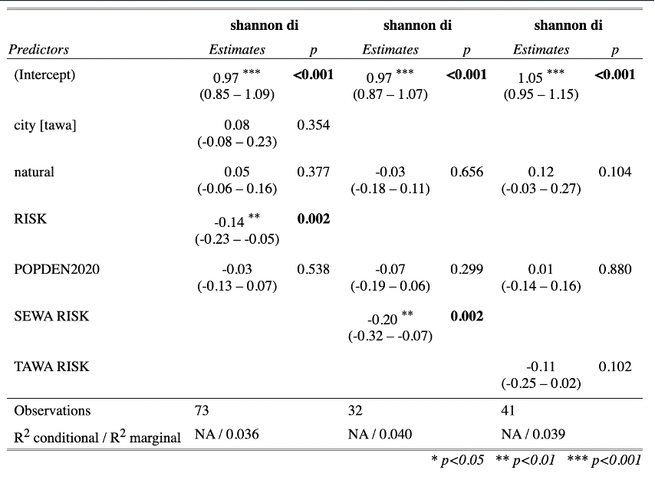
Table 5. Mammal community diversity model results table (from left to right: metro-area, Seattle, Tacoma).

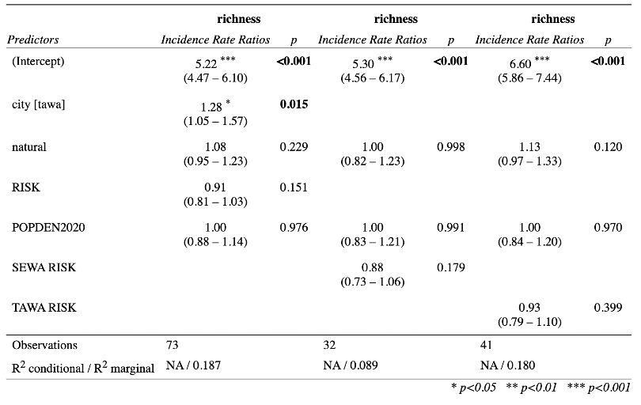
Table 6. Mammal community richness model results table (from left to right: metro-area, Seattle, Tacoma).

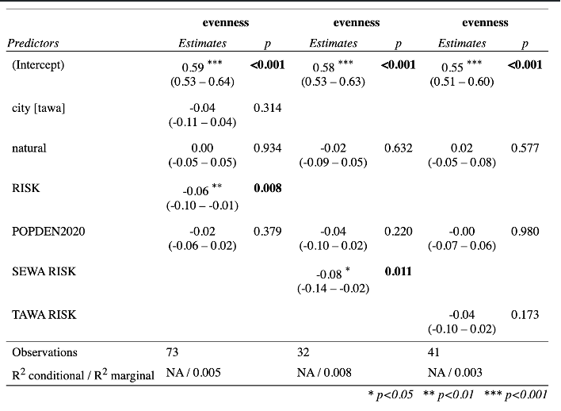
Table 7. Mammal community evenness model results table (from left to right: metro-area, Seattle, Tacoma).

