Coffee and Cigarettes: Global Stimulant Consumption Drives Biodiversity Loss in Key Ecoregions
Elisha Wilson¹*, Konstantin Stadler¹, Francesca Verones¹, Martin Bruckner²
¹Industrial Ecology Programme, Department of Energy and Process Engineering, Norwegian University of Science and Technology (NTNU), 7491 Trondheim, Norway
² Institute for Ecological Economics, Vienna University of Business and Economics, 1020 Vienna, Austria
*Corresponding author

Supporting Information

Contents
Figure S1: Top producers of stimulant products based on the expanded FABIO data. 2
Figure S2: Top consumers of stimulant products based on the expanded FABIO data 3
Figure S3: Validation of expanded FABIO production data for unprocessed stimulant commodities in the highest-production countries. 4
Figure S4: Land use footprint from global consumption of stimulant products following disaggregation to 5 x 5 km grid scale. 5
Figure S5: Global biodiversity footprint (PDF) by terrestrial ecoregion from the global consumption of stimulant commodities. 6
Figure S6: Biodiversity impacts embodied in trade between regions and income classifications in 2020 for coffee and tobacco products. 7
References 8

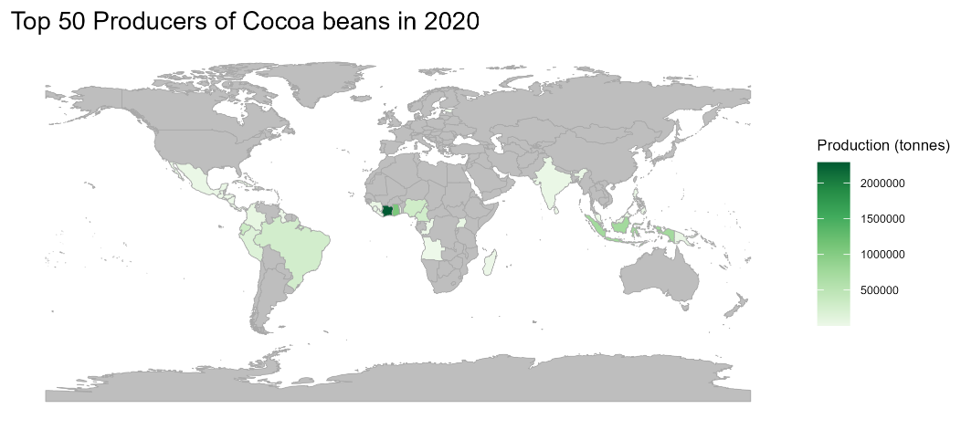  a | 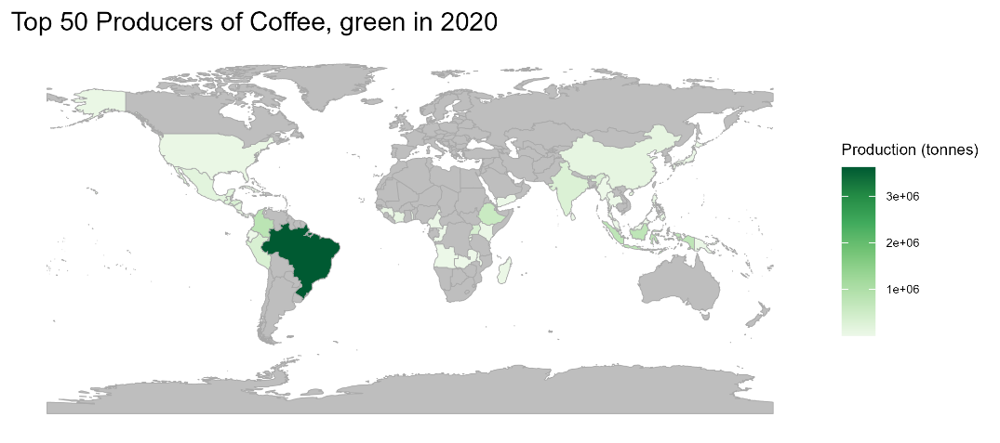  b
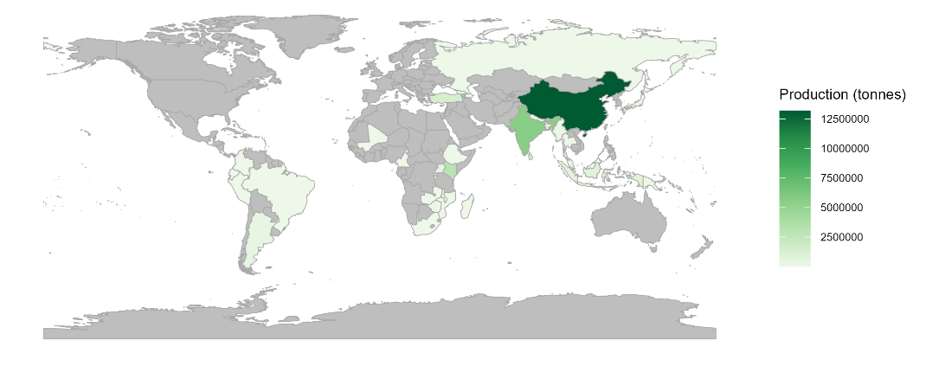  c | 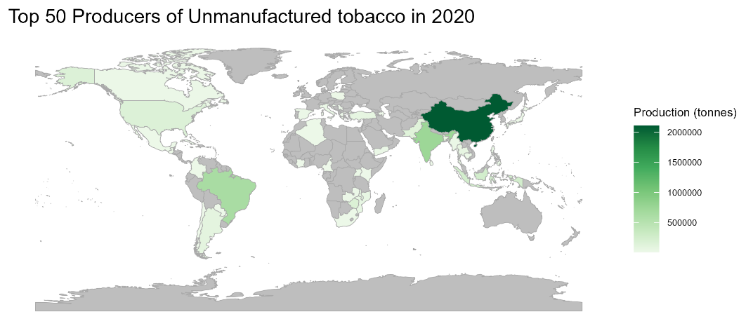  d
Figure S1: Top 50 producers of unprocessed stimulant commodities based on the expanded FABIO input output tables, for a) cocoa, b) coffee, c) tea, and d) tobacco products. Darker colors correspond to countries with higher production rates. Countries shaded in grey are not included in the top 50.

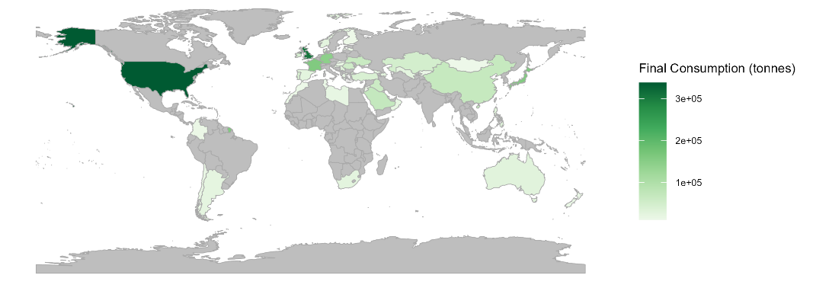  a | 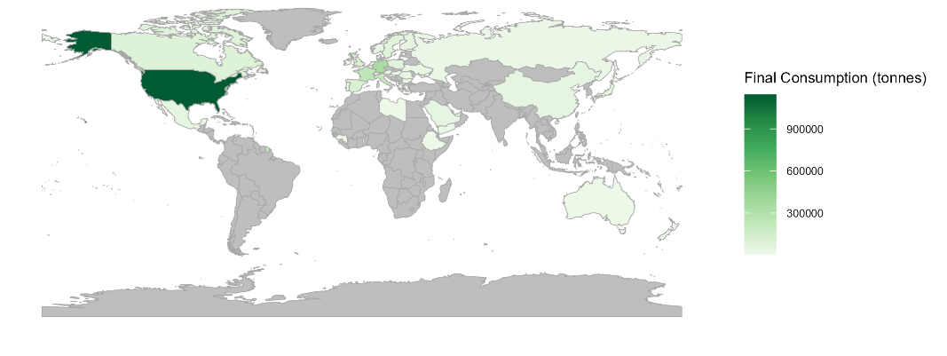  b
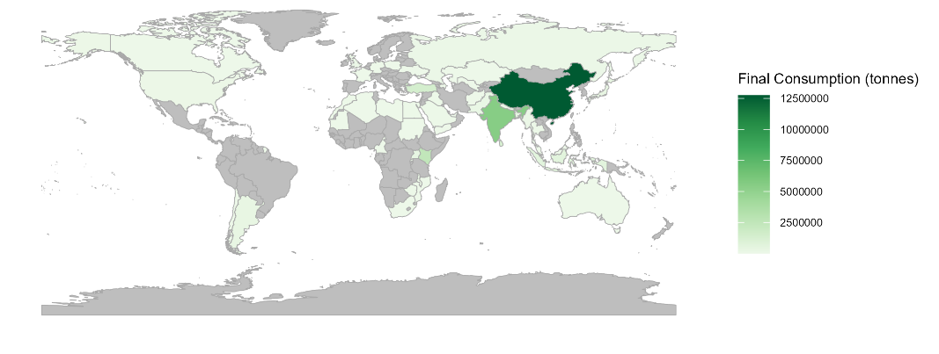  c | 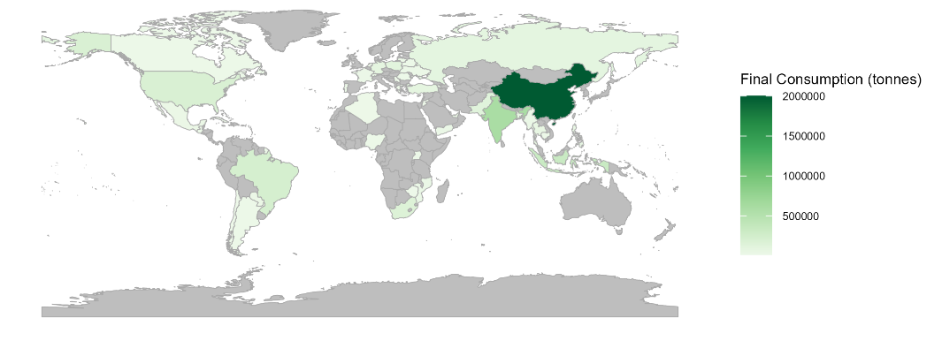  d
Figure S2: Top 50 consumers of processed stimulant commodities based on the expanded FABIO input output tables for a) chocolate, b) coffee, c) tea, and d) tobacco products. Darker colors correspond to countries with higher consumption rates. Countries shaded in grey are not included in the top 50.

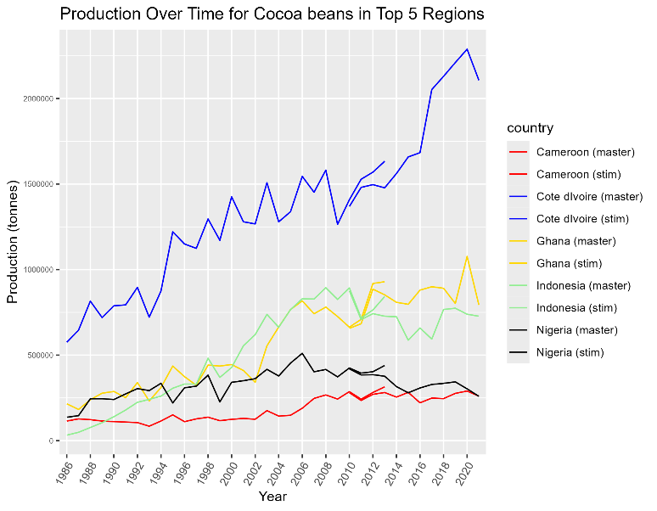  a | 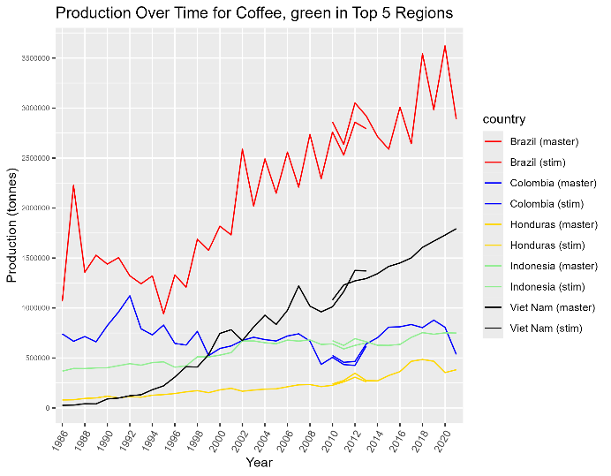  b
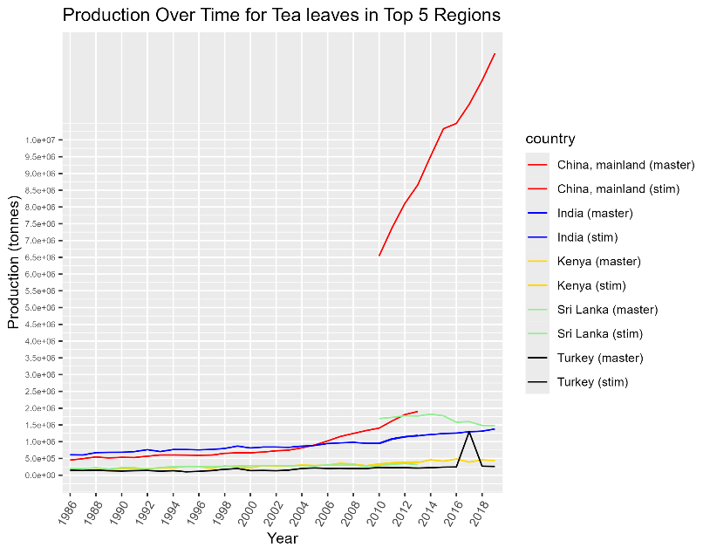  c | 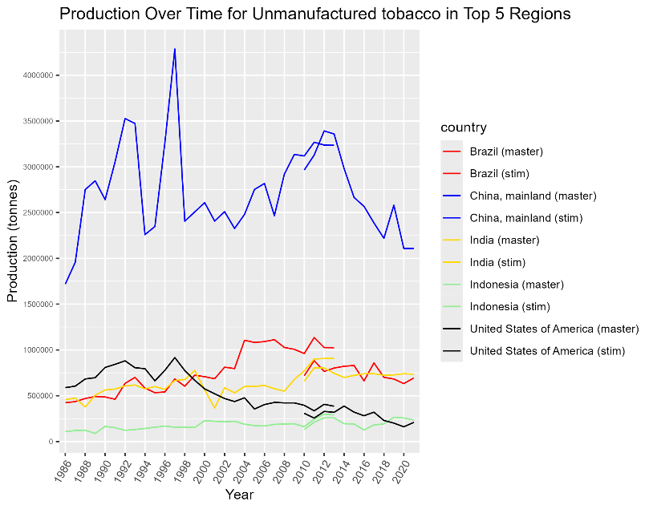  d
Figure S3: Validation of production data for unprocessed stimulant commodities in the 5 highest-production countries of a) chocolate, b) coffee, c) tea, and d) tobacco across all time periods modelled in FABIO. The “master” label represents the standard, unexpanded FABIO model, with timescale ending in 2013. The “stim” version represents the version of FABIO included in this study, updated and expanded to include a longer time series and a wider range of stimulant products. Differences in values are due primarily to mass balancing optimization in the calculation of new input output tables.
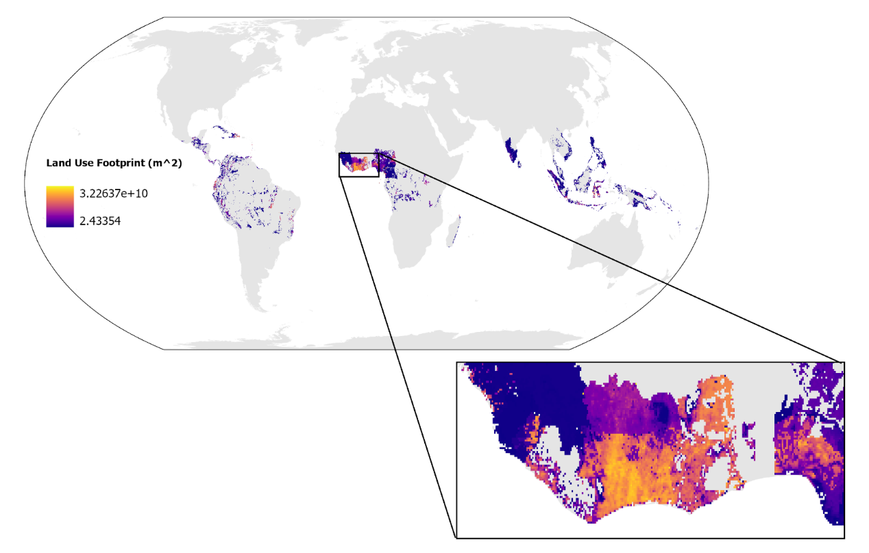
a
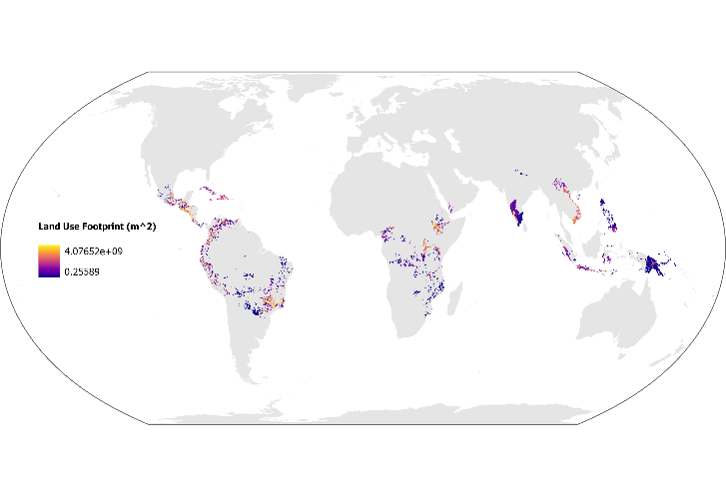  b | 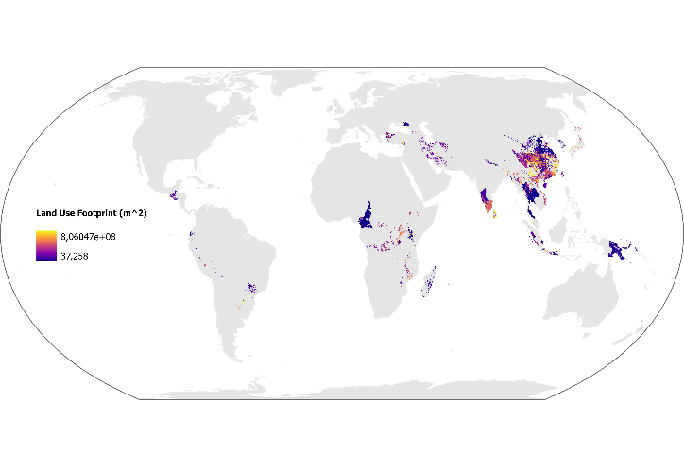  c | 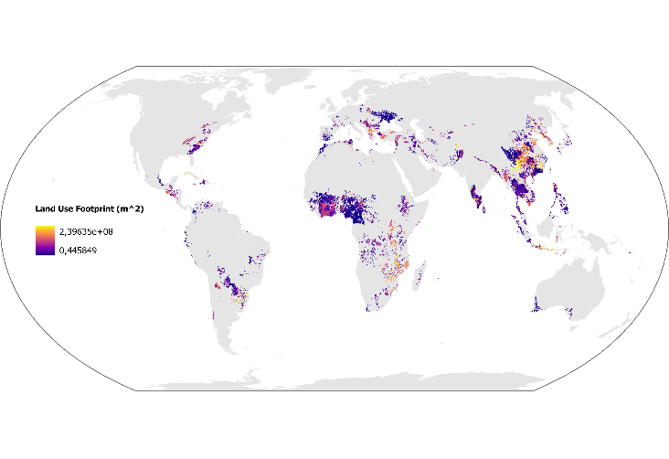  d
Figure S4: Land use footprint from global consumption of a) cocoa, b) coffee, c) tea, and d) tobacco products following disaggregation to 5 x 5 km grid scale via MAPSPAM crop maps, based on the share of national production occurring in each grid cell. These grid scale footprints were subsequently aggregated to ecoregion scale, then multiplied with land use characterization factors to calculate biodiversity loss.

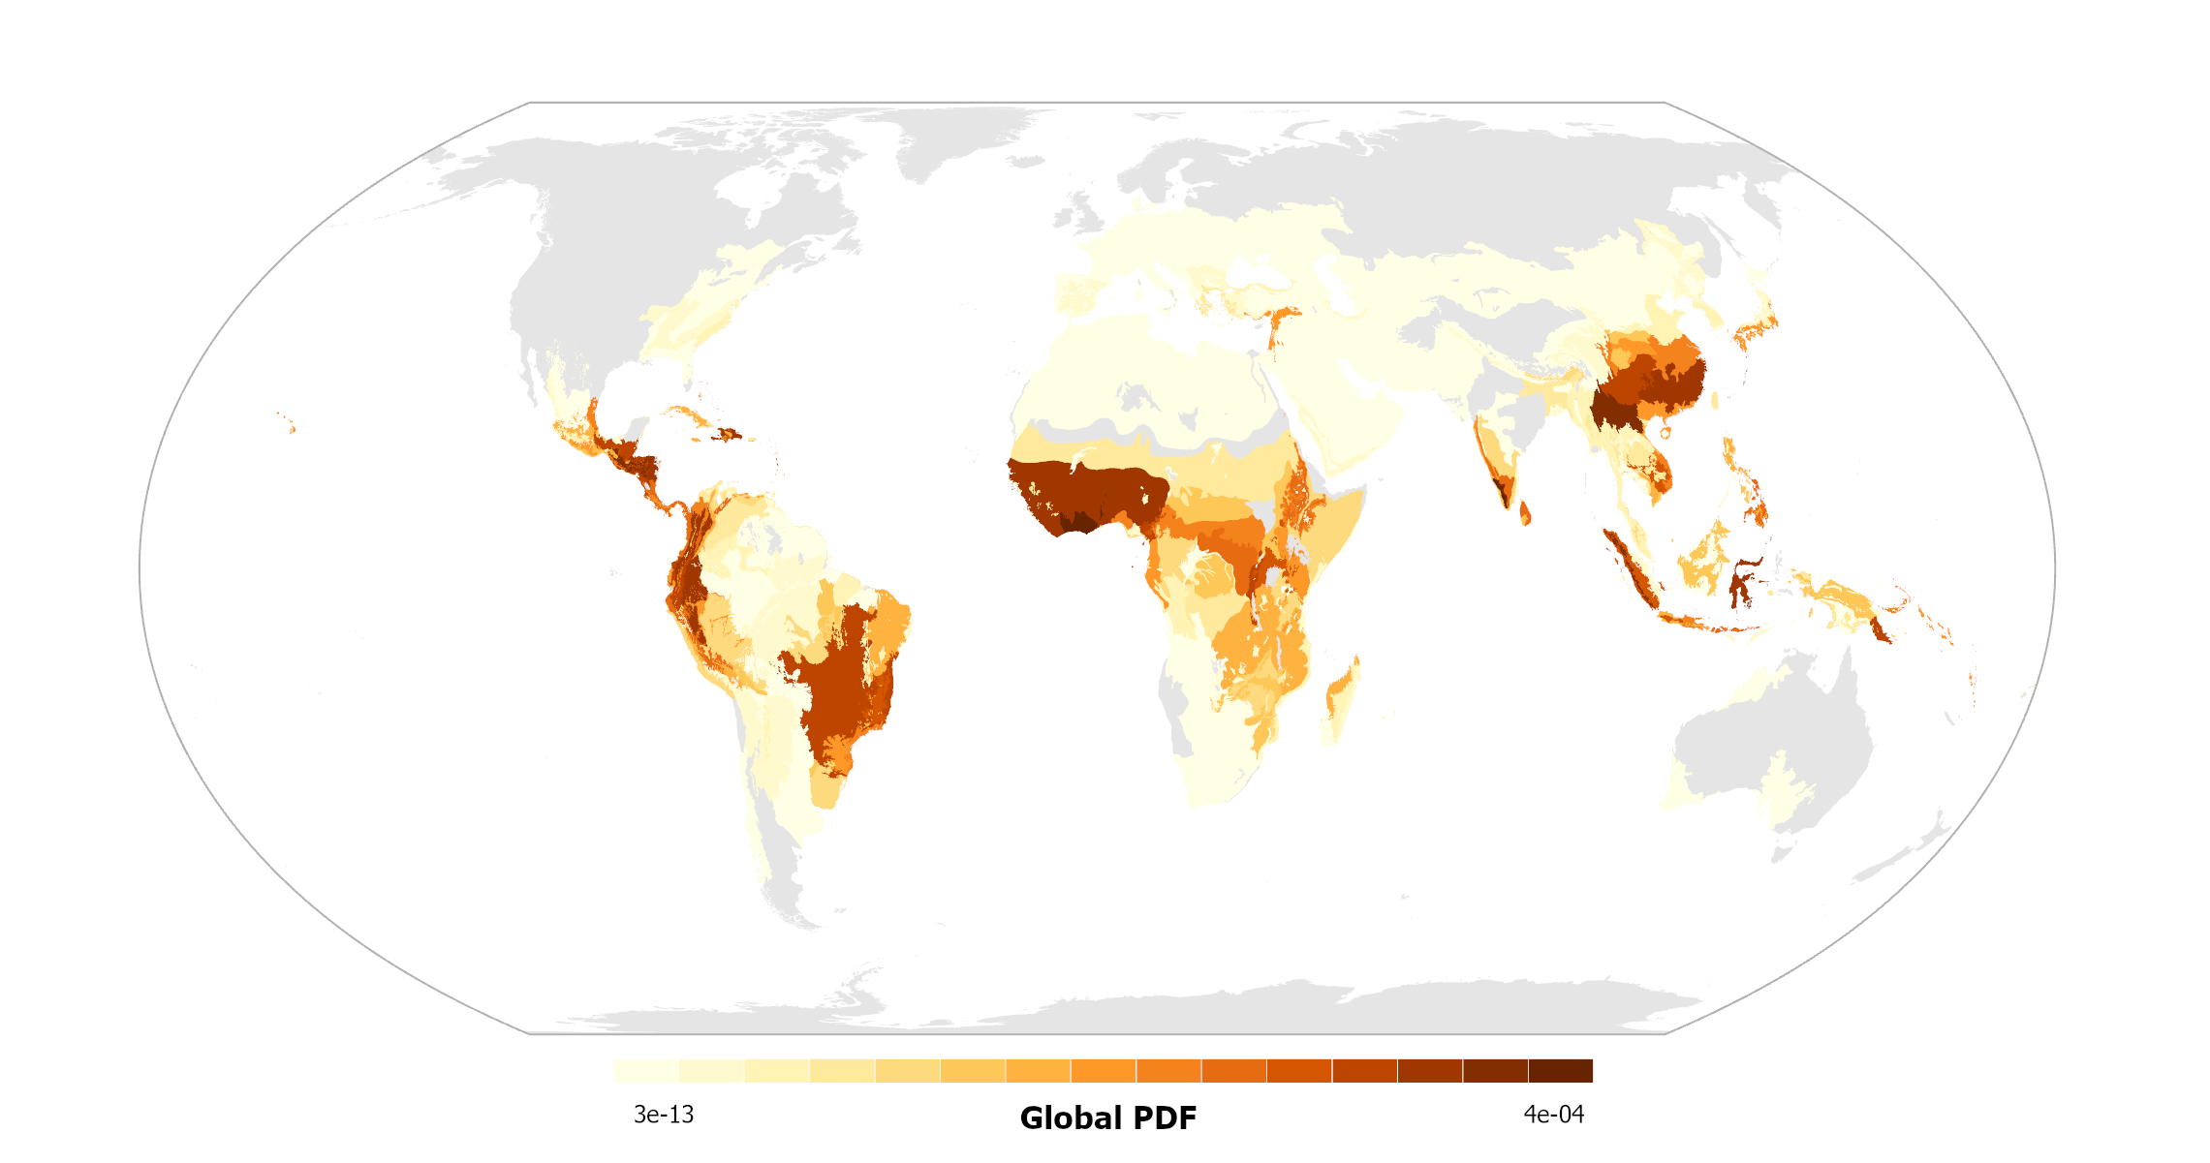
Figure S5: Global biodiversity footprint (PDF) by terrestrial ecoregion from the global consumption of stimulant commodities. All stimulant product categories are mapped together, with impacts summed by ecoregion. Darker color indicates higher biodiversity impacts. Ecoregions shaded in grey exhibit zero biodiversity loss from stimulant products.
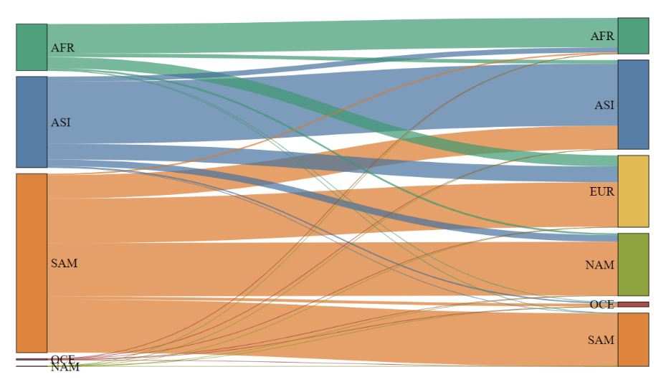  a | 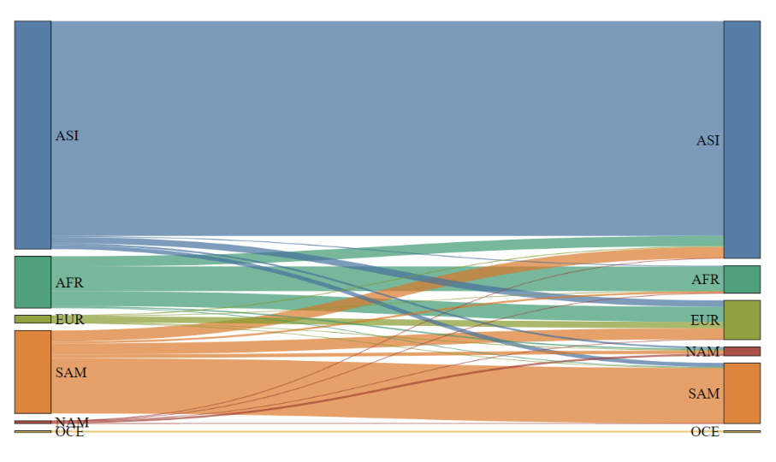  b
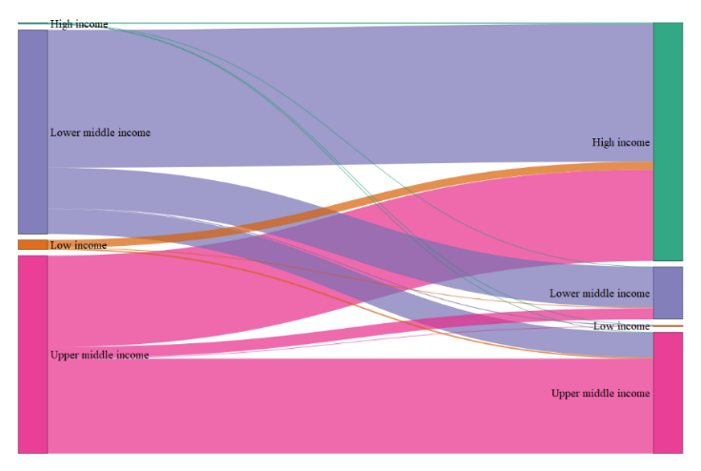  c | 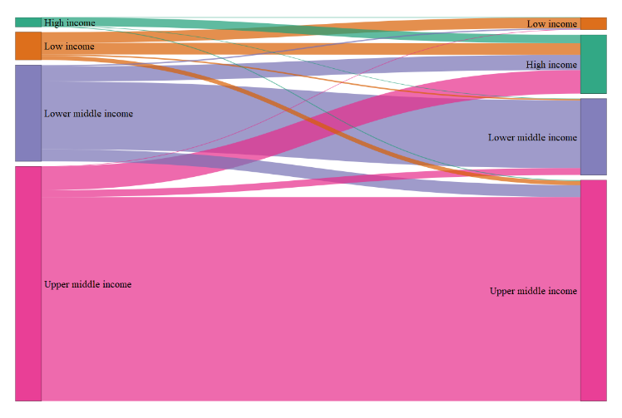  d
Figure S6: Biodiversity impacts (PDF) embodied in trade between producers (left side of diagrams) and consumers (right side of diagrams) in 2020 for each stimulant commodity group. Figures a and b present the biodiversity impacts embodied in trade between continents for coffee and tobacco products respectively, while figures c and d show impact flows across country-level income classifications for coffee and tobacco products, respectively. Biodiversity impacts are relative for each diagram. Includes impacts from land use, freshwater use, and freshwater eutrophication. AFR = Africa, ASI = Asia, SAM = South America, NAM = North America, EUR = Europe, and OCE = Oceania.

References

FAOSTAT. Food and Agriculture Organization of the United Nations. FAOSTAT Statistics Database. 2024; http://www.fao.org/ faostat/.
Bruckner, M., Wood, R., Moran, D., Kuschnig, N., Wieland, H., Maus, V., & Börner, J. (2019). FABIO—The Construction of the Food and Agriculture Biomass Input–Output Model. Environmental Science & Technology, 53(19), 11302–11312. https://doi.org/10.1021/acs.est.9b03554
Institute (IFPRI), I. F. P. R. (2024). Global Spatially-Disaggregated Crop Production Statistics Data for 2020 Version 1.0 (Version 3) [Dataset]. Harvard Dataverse. https://doi.org/10.7910/DVN/SWPENT
Metreau, E., Young, K. E., & Eapen, S. G. (2024). World Bank country classifications by income level for 2024-2025. World Bank, 1.

