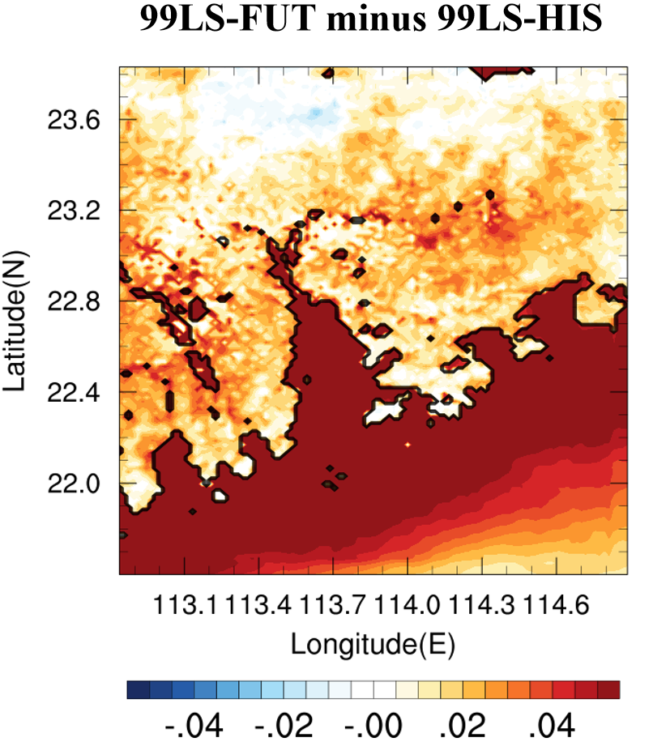
Figure S1 Surface evaporation difference (units: g/m²/s) between 99LS-FUT and 99LS-HIS, computed by averaging over entire integrations for all selected extreme cases.

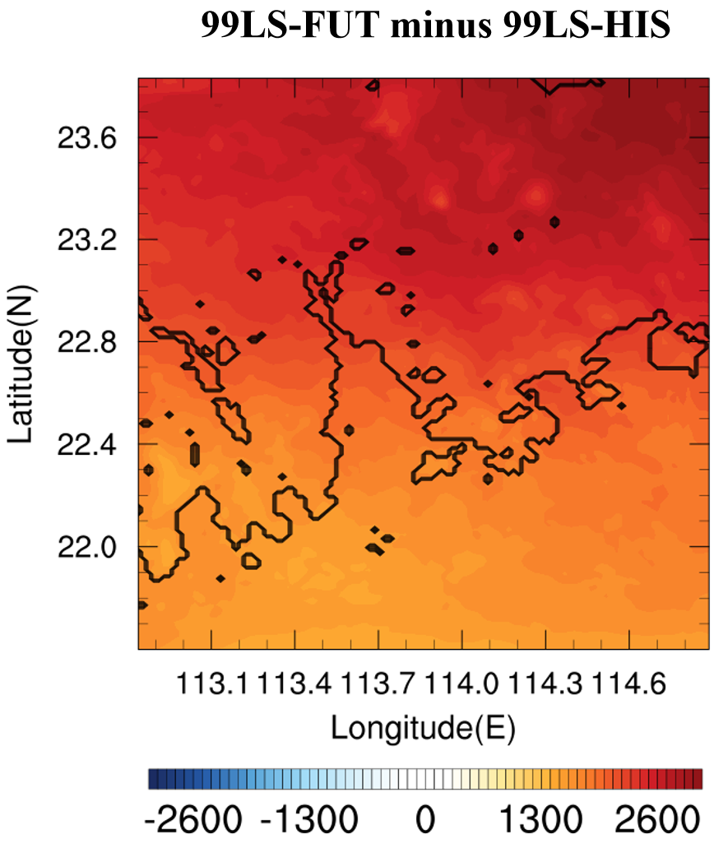
Figure S2 Same as Figure S1 except for precipitable water (units: g/m²).

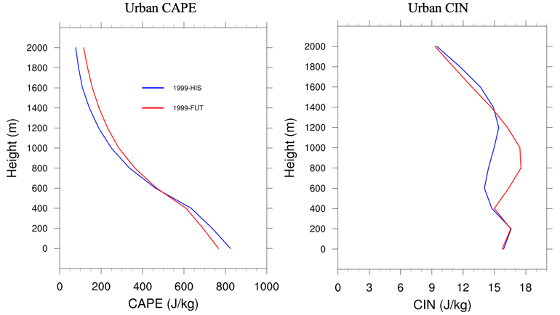
Figure S3 Vertical CIN profile averaged over urban grids in d03 (units: J/kg) from 99LS-HIS (blue) and 99LS-FUT (red), computed by averaging over entire integrations for all selected extreme cases.

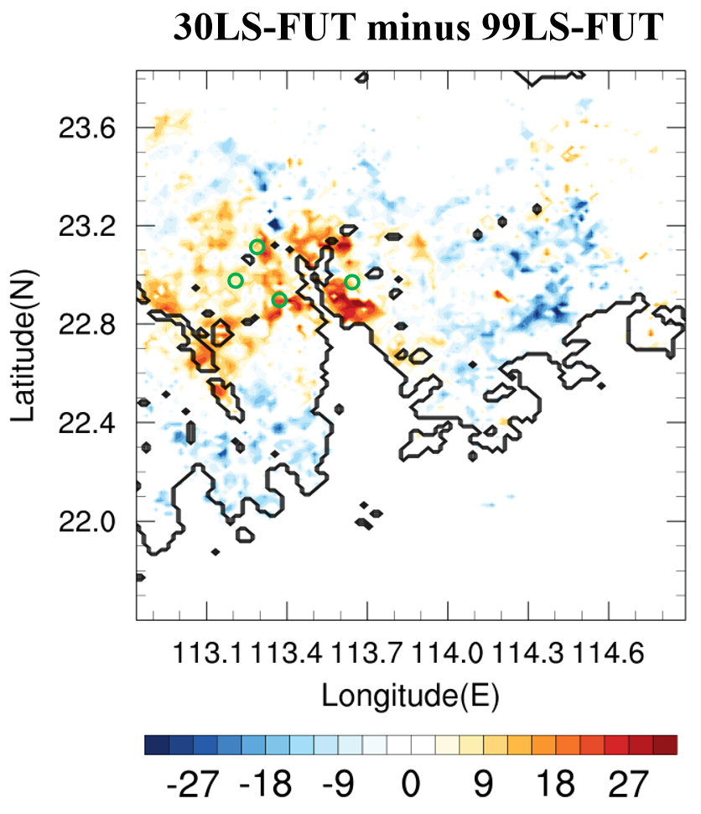
Figure S4 Same as Figure 2b except for difference of CAPE of parcels being lifted at 1000m (units: J/kg) between 30LS-FUT and 99LS-FUT.

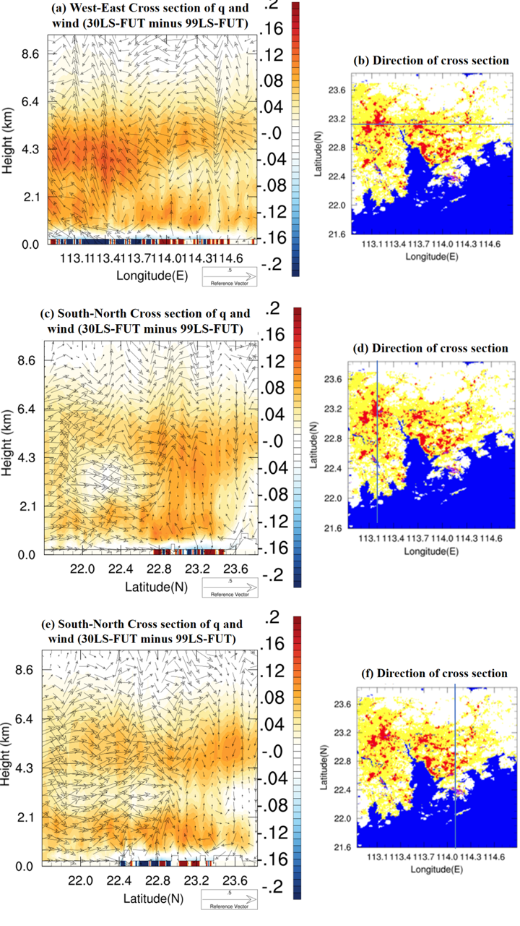
Figure S5 Same as Figure 4 except for (a,b) north-south cross sections centered as Guangzhou, (c,d) east-west cross section centered as Guangzhou, and (e,f) north-south cross sections centered as Shenzhen and Hong Kong.

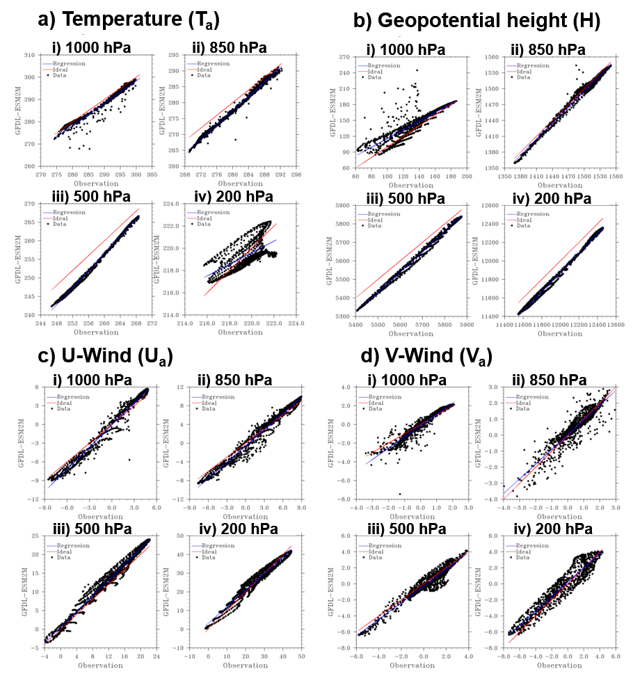
Figure S6 Scatter plots for (a) temperature (Ta), (b) geopotential height (H), (c) U-wind (Ua), and (d) V-wind (Va) for MJJAS climatology, at the (i) 1000 hPa, (ii) 850 hPa, (iii) 500 hPa and (iv) 200 hPa levels, with reanalysis (ERA-Interim) and GFDL-ESM2M values plotted along the y- and x- axis respectively. Diagonals represent the lines along which GFDM-ESM2M results and reanalysis are identical. Units of temperature: K, geopotential height: m, U- and V-wind: m s⁻¹.

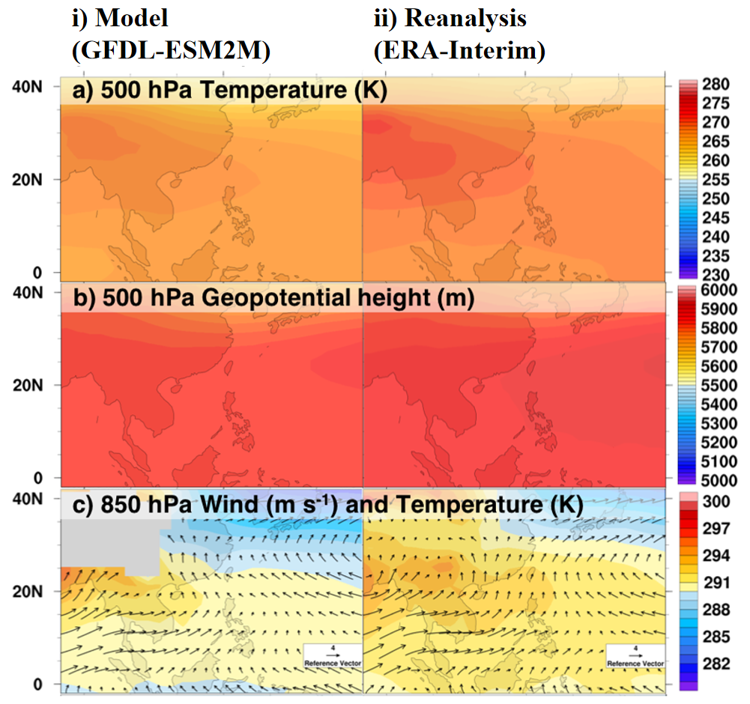
Figure S7 MJJAS climatological mean values of (a) 500 hPa temperature, (b) 500 hPa geopotential height, (c) 850 hPa wind circulation overlaid on 850 hPa temperature based on (i) GFDL-ESM2M historical run and (ii) reanalysis (ERA-Interim).

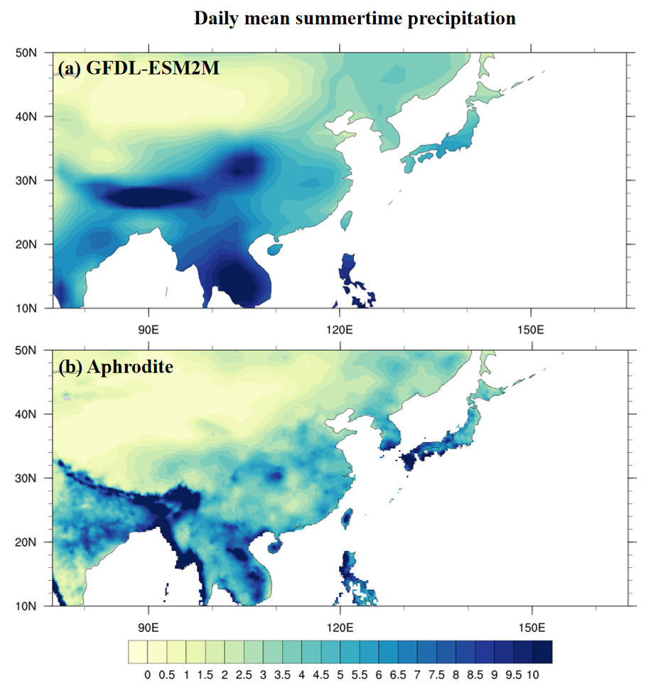
Figure S8 Climatological daily mean precipitation intensity (MJJAS) from 1951 to 2007 based on (i) GFDL-ESM2M historical and (ii) APHRODITE data.

