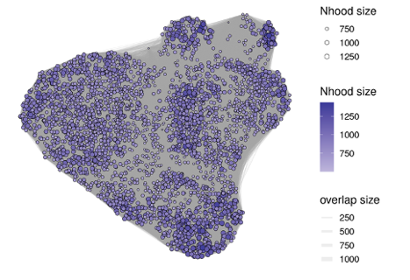
Supplementary Figure 1. Cell neighborhood groupings used for differential abundance testing of T-IELs.
Cell neighborhoods used for differential abundance testing overlayed onto UMAP coordinates. Size and fill correspond to the number of cells in a neighborhood. Grey lines connect neighborhoods and have widths corresponding to the number of cells found in both of two connected neighborhoods.
Abbreviations: T-IEL (intraepithelial T lymphocyte); UMAP (uniform manifold approximation projection)

Supplementary Figure 2. Robust Aitchison PCA ordination of jejunal mucosa bacterial communities collected at different time points after weaning from SW (a) and LW (b) pigs.

