Supplementary Materials
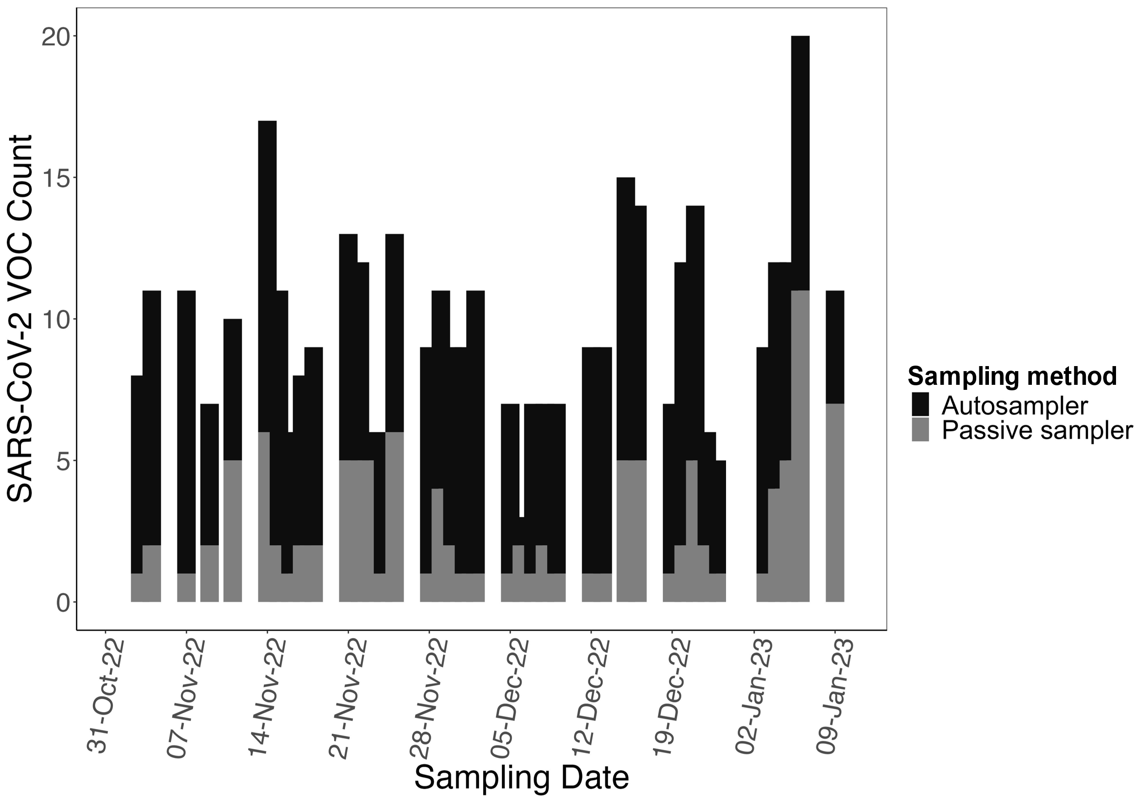

Supplementary Figure 1 - Comparative SARS-CoV-2 lineages identified in aircraft sewage samples by sampling methods. Autosampling (black) captured significantly higher lineage diversity relative to passive sampling (grey).

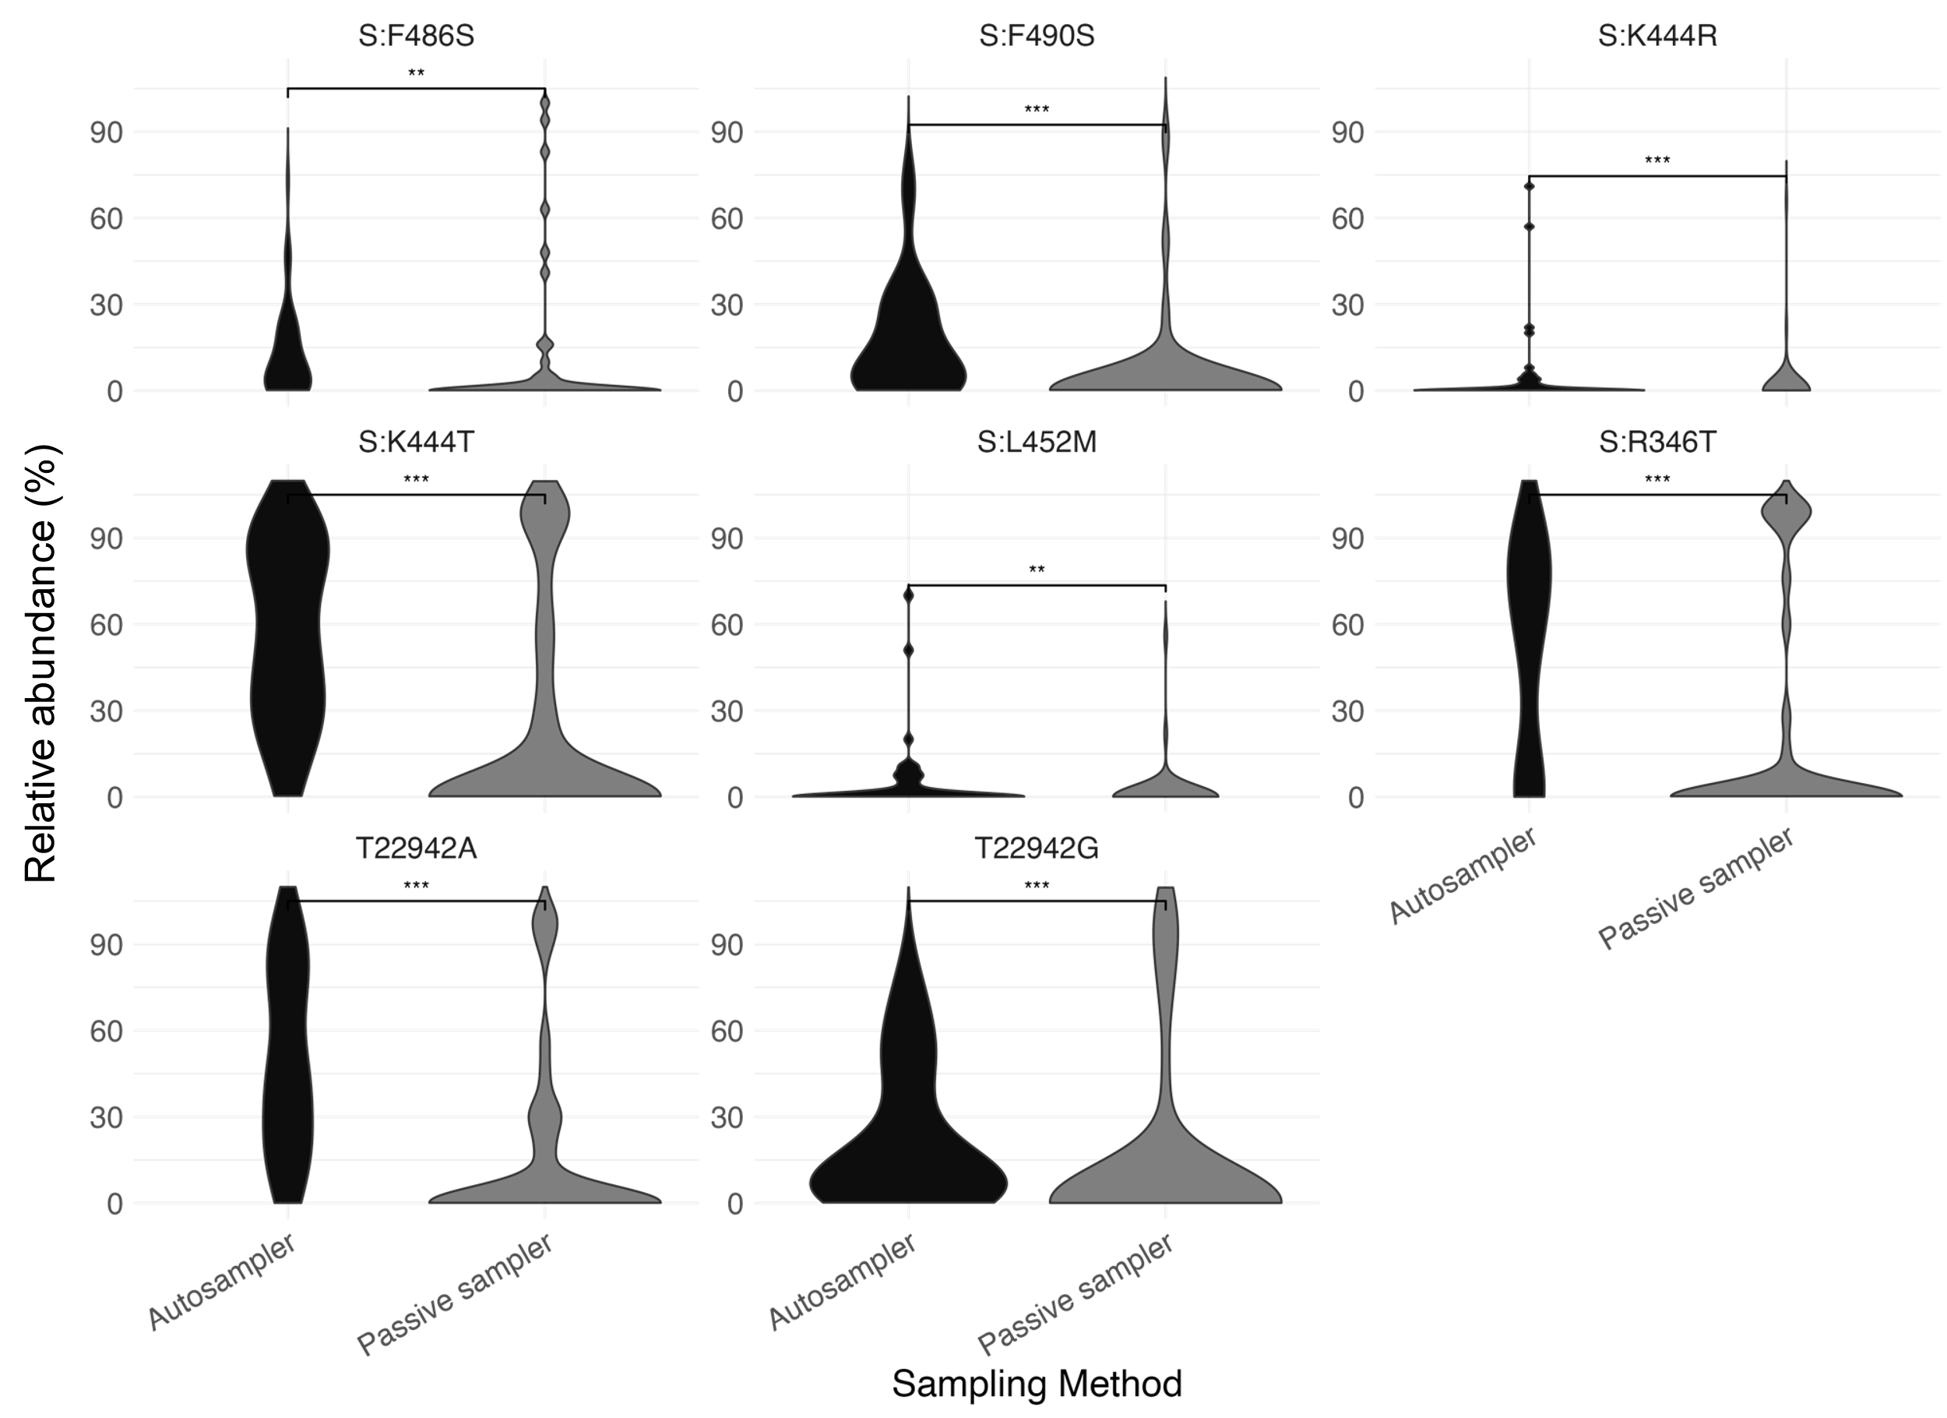

Supplementary Figure 2 - Differential mutation frequencies by sampling method. Autosampling (black) captured more and higher frequencies of variant of concern diagnostic and FLiRT mutations that are of clinical significance relative to passive sampling (grey). Asterisks indicate the level of statistical significance for the differences observed in the data, with “*” denoting a p-value < 0.05, “**” represent a p-value < 0.01, while “***” denote a p-value < 0.001.
Supplementary Table 1 - Summary of sequence metrics from the sequencing of the wastewater samples in this study.
Link to Supplementary Table 1.xlsx

