Table 1: Contents of Neuro 9 PCR kit
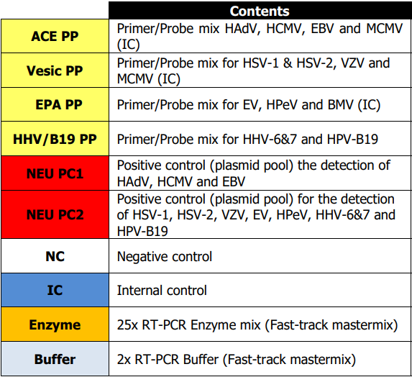

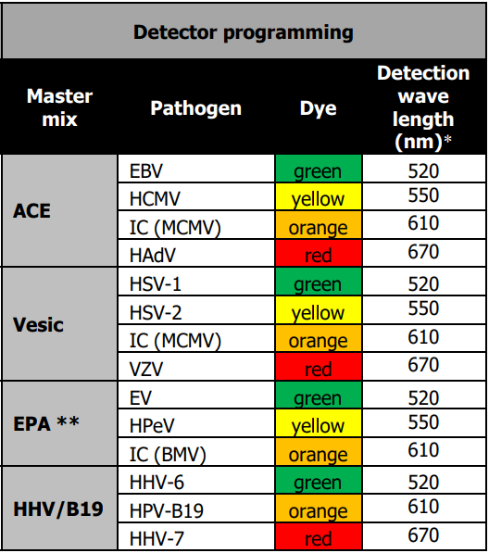
Table 2: Detector programming

