Additional material

Withholding and withdrawal of life support in mechanically ventilated stroke patients

Authors
Etienne de Montmollin; Carole Schwebel; Claire Dupuis; Maité Garrouste-Orgeas; Daniel da Silva; Elie Azoulay; Virginie Laurent; Guillaume Thiéry; Alexandra Grinea; Guillaume Marcotte; Johanna Oziel; Marc Gainnier; Shidasp Siami; Jean Reignier; Benjamin Sztrymf; Christophe Adrie; Stephane Ruckly; Romain Sonneville; and Jean-François Timsit for the OUTCOMEREA Study Group

Additional file 1. Study flow diagram

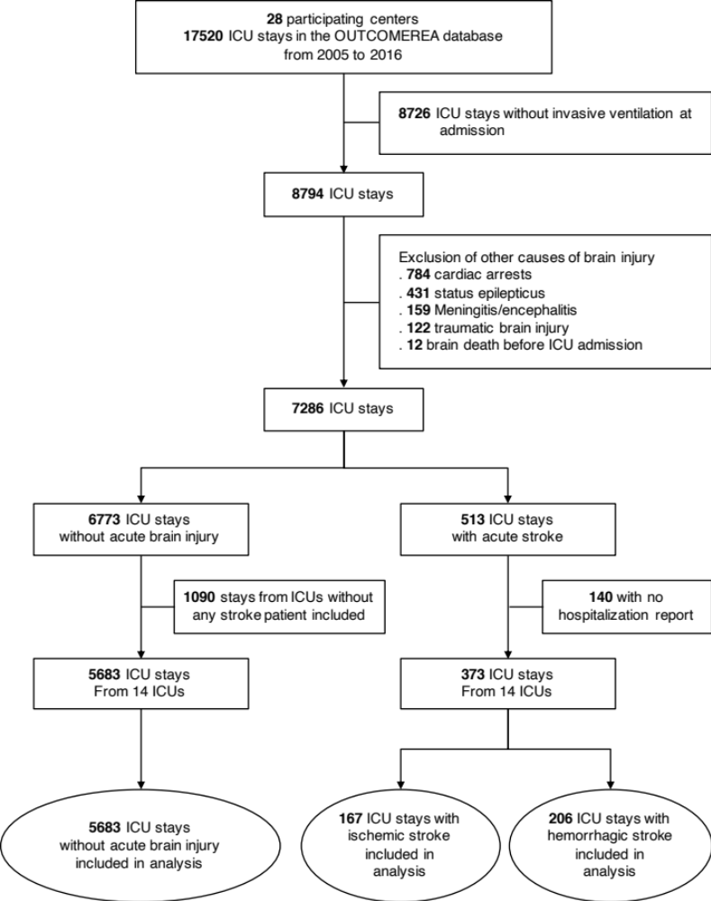

Additional file 2. Multivariate Fine & Gray competing risk analysis in the complete population for the occurrence of life support limitation, and death without limitation as the competing event

Variable | sHR | 95% CI | p
Stroke class |  |  | <.01
No stroke | Ref | - | .
Hemorrhagic stroke* | 3.9 | [2.97 - 5.11] | .
Acute ischemic stroke | 3.59 | [2.78 - 4.65] | .
Age > 60 years | 2.12 | [1.77 - 2.53] | <.01
Charlson comorbidity index ≥ 1 | 1.66 | [1.43 - 1.94] | <.01
Admission SOFA, per point | 1.09 | [1.07 - 1.11] | <.01
Abbreviations: ICU, Intensive Care Unit; sHR, subdistribution Hazard Ratio; CI, Confidence Interval; SOFA, Sequential Organ Failure Assessment.
* Intracranial hemorrhage or subarachnoid hemorrhage

Additional file 3. Effect of the period of inclusion on the occurrence of life support limitation in the subset of ischemic stroke patients (Fine & Gray model)

Variable | sHR | 95% CI | p
Period of ICU admission
2005-2008 | Ref | . | 0.78
2009-2012 | 1.24 | [0.67 - 2.3] | .
2013-2016 | 1.03 | [0.55 - 1.93] | .
Vertebrobasilar location* | 1.61 | [1 - 2.60] | 0.05
Acute-phase stroke therapy | 0.45 | [0.21 - 0.99] | 0.05
Glasgow coma score < 8 | 1.48 | [0.92 - 2.36] | 0.1
Multivariate competing risk analysis, with death without limitation as the competing event
Abbreviations: ICU, Intensive Care Unit; sHR, subdistribution Hazard Ratio; CI, Confidence Interval; SOFA, Sequential Organ Failure Assessment.
* vs anterior circulation location

Additional file 4. Effect of the period of inclusion on the occurrence of life support limitation in the subset of hemorrhagic stroke patients (Fine & Gray model)

Variable | sHR | 95% CI | p
Period of ICU admission
2005-2008 | Ref | . | 0.14
2009-2012 | 0.77 | [0.42 - 1.41] | .
2013-2016 | 1.47 | [0.71 - 3.04] | .
Age > 70 years | 2.25 | [1.39 - 3.65] | <.01
Male sex | 1.50 | [0.96 - 2.36] | 0.08
Glasgow coma score < 8 | 2.2 | [1.09 - 4.44] | 0.02
Admission non-neurologic SOFA, per point | 0.90 | [0.82 - 0.99] | 0.02
Multivariate competing risk analysis, with death without limitation as the competing event
Abbreviations: ICU, Intensive Care Unit; sHR, subdistribution Hazard Ratio; CI, Confidence Interval; SOFA, Sequential Organ Failure Assessment.

