Additional file for
The Chemosensory Toolkit of a Cursorial Spider
Authors: Mohammad Belal Talukder^{1*}, Carsten H. G. Müller¹, Andreas Fischer¹, Vedanti Mahimkar¹, Jonas O. Wolff², and Gabriele B. Uhl^{1*}
Affiliations:
¹General and Systematic Zoology, University of Greifswald; Greifswald, 17489, MV, Germany
²Evolutionary Biomechanics, University of Greifswald; Greifswald, 17489, MV, Germany
Email addresses of all authors:
Mohammad Belal Talukder: talukderm@uni-greifswald.de
Carsten H. G. Müller: carstmue@uni-greifswald.de
Andreas Fischer: andreas.fischer@uni-greifswald.de
Vedanti Mahimkar: vedanti.mahimkar@stud.uni-greifswald.de
Jonas O. Wolff: j.wolff@uni-greifswald.de
Gabriele B. Uhl: gabriele.uhl@uni-greifswald.de
*Corresponding authors: Email: gabriele.uhl@uni-greifswald.de (GBU), talukderm@uni-greifswald.de (MBT)
Figure S1. Distribution of chemosensilla on the 2nd, 3rd, and 4th walking legs of Pisaura mirabilis. A 2nd walking leg of a male (upper panels) and a female (lower panels). B 3rd walking leg of a male (upper panels) and a female (lower panels). C 4th walking leg (hind leg) of a male (upper panels) and a female (lower panels). Each panel shows four perspectives from top to bottom: dorsal, prolateral, ventral, and retrolateral. Notably, wall-pore sensilla are present only in males. Scale bars: 1 mm.

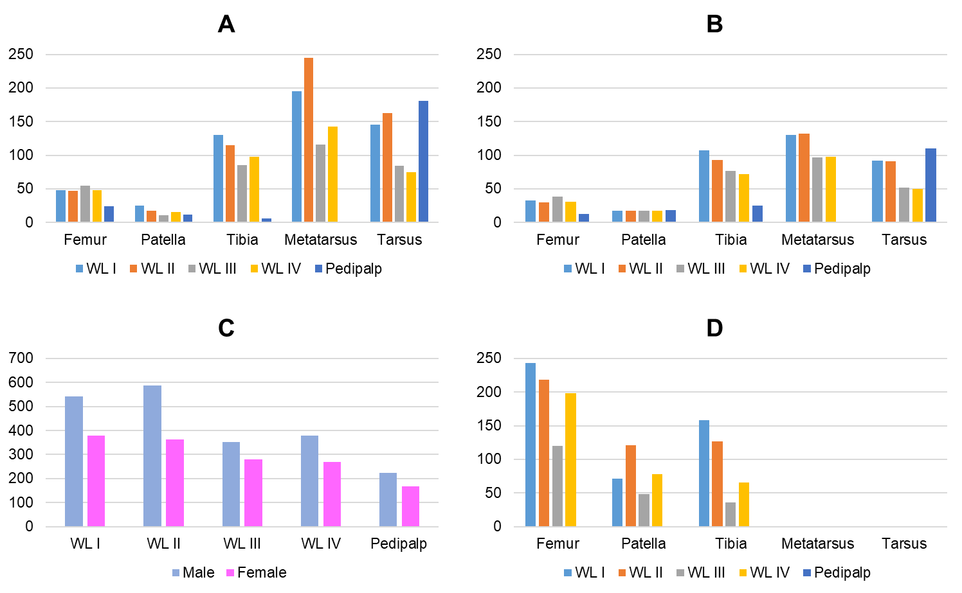
Figure S2: Number and distribution of chemosensilla on the appendages of a male and a female Pisaura mirabilis. A Number and distribution of tip-pore sensilla on the appendages of a male and B a female. Note that there is no metatarsus in the pedipalp. C Comparison of the number of tip-pore sensilla on the appendages of a male and a female. D Number and distribution of wall-pore sensilla on the segments of walking legs of a male. The labels WL I-WL IV represent the first to fourth walking legs. Note that wall-pore sensilla are absent on the pedipalp, and none are present on the metatarsus or tarsus. See also Figure S1.
Figure S3. The wall-pore sensilla occur exclusively in adult male Pisaura mirabilis. SEM overview of the femur region of the first walking leg of A an adult male, B a subadult male, and C an adult female. Five wall-pore sensilla are marked with white arrows on the femur of the adult male.

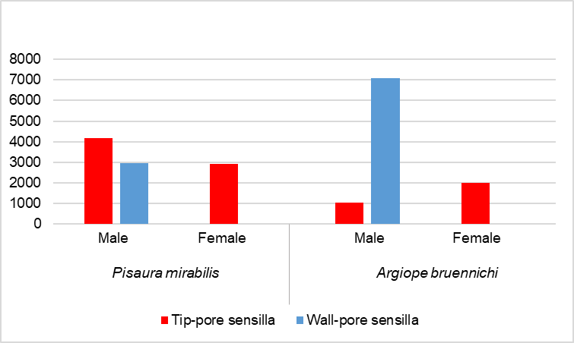
Figure S4: Comparison of the total number of chemosensilla (tip-pore and wall-pore sensilla) between the cursorial spider Pisaura mirabilis (N=1) and the orb-weaver Argiope bruennichi (N=1). Notably, wall-pore sensilla are present only in males.

Leg  segment | N | Sensillum length  (µm) |  | Sensillum shaft diameter (µm) |  | Sensillum insertion angle  (°) |  | Pore diameter  (nm)
 |  | Male | Female | Male | Female | Male | Female | Male | Female
Femur | 6 | 180.57±40.46 | 201.60±16.63 | 5.75±0.44 | 6.72±0.79 | 63.68±09.90 | 72.75±7.72 | N=10 pores | N=10 pores
Patella | 6 | 143.17±20.55 | 136.12±17.30 | 5.72±0.29 | 6.05±0.24 | 51.32±13.74 | 71.18±7.27 | N=10 pores | N=10 pores
Tibia | 6 | 202.85±31.03 | 230.07±22.09 | 6.22±0.16 | 6.47±0.98 | 48.81±07.95 | 56.57±2.22 | N=10 pores | N=10 pores
Metatarsus | 6 | 199.13±25.23 | 215.48±16.60 | 6.85±0.71 | 6.90±0.37 | 53.12±03.35 | 59.13±1.96 | N=10 pores | N=10 pores
Tarsus | 6 | 150.05±07.75 | 157.45±19.33 | 6.68±0.37 | 6.75±0.49 | 49.05±07.48 | 46.27±5.54 | N=10 pores | N=10 pores
x̄±SD |  | 175.15±37.39 | 188.14±40.80 | 6.24±0.65 | 6.58±0.71 | 53.20±10.83 | 61.18±11.45 | 599.1±150.26 | 561±106.06

Table S1: Measurements of tip-pore sensilla on segments of the 1st walking leg (1 male and 1 female). The values for each leg segment represent the average and standard deviation of six sensilla. Pore diameters were measured from 10 randomly selected tip-pores distributed along the leg.

Leg segment | N | Sensilla length  (µm) | Sensilla diameter  (µm) | Pore diameter  (nm)
Femur | 5 | 148.62±09.94 | 2.18±0.10 | 42.60±1.85
Patella | 5 | 136.26±07.51 | 2.08±0.23 | 40.20±2.56
Tibia | 5 | 140.48±11.43 | 2.10±0.60 | 43.00±3.90
x̄±SD | 15 | 141.79±11.41 | 2.12±0.16 | 41.93±3.26

Table S2: Measurements of wall-pore sensilla on the segments of the 1st walking leg (male; N=1). The values for each leg segment represent the average and standard deviation of five sensilla. For the average pore diameter, three pores from each sensillum were measured.

Supplemental text
Contact area versus non-contact area of body appendages
Using high-speed video recording, we analyzed the contact and non-contact regions of the body appendages of P. mirabilis males and females during locomotion on various surfaces, prey capture, silk probing, and mating. During locomotion, the tarsi of all walking legs always contacted the substrate. The metatarsus occasionally contacted the substrate, with frequencies ranging from 8% to 20%. The proximal leg segments, namely, the tibia-patella and femur, did not contact the substrate during any of our locomotion trials (Table S3A). When males probed the dragline silk left behind by females, the tarsus of the 1st and 2nd walking legs, along with the cymbium (first segment of the male’s pedipalp) of the pedipalps, frequently contacted the silk (83%-100%). The tarsi of the 3rd and 4th walking legs occasionally contacted the silk (16%) (Table S3B). The remaining segments, other than the tarsus of the walking legs and the cymbium of the pedipalps, did not contact the silk. During prey capture, both sexes frequently use the tarsus and metatarsus (contact frequencies: 58%-100%) to form a "prey basket." The tibia was rarely in contact with the prey (1%-16%), whereas the femur did not contact the prey (Table S3C). During mating, the tarsus and metatarsus of the first three leg pairs in males and the first two leg pairs in females frequently contacted the mating partner (83%-100%). The tibia-patella occasionally contacted the mating partner of both sexes, with frequencies ranging from 16% to 33%, whereas the femur did not contact the mating partner in either sex (Table S3D). The pedipalps of both sexes were always in contact with the mating partner or during the handling of the nuptial gift. We observed that in the walking legs, substrate contact occurs predominantly on the ventral and lateral surfaces, with little to no contact on the dorsal side. In contrast, substrate contact on pedipalps is limited primarily to the dorsal and lateral surfaces.

 |  | Male |  |  |  | Female
 |  | ta | mt | ti+pt | fe | ta | mt | ti+pt | fe
A)  Locomotion | Leg I | 100 | 25 | 0 | 0 | 100 | 12 | 0 | 0
A)  Locomotion | Leg II | 100 | 20 | 0 | 0 | 100 | 8 | 0 | 0
A)  Locomotion | Leg III | 100 | 8 | 0 | 0 | 100 | 8 | 0 | 0
A)  Locomotion | Leg IV | 100 | 0 | 0 | 0 | 100 | 8 | 0 | 0
A)  Locomotion | pedipalp | 62 | n.a | 0 | 0 | 79 | n.a | 8 | 0
B)  Male probes female-produced dragline-silk | Leg I | 100 | 0 | 0 | 0 | -
B)  Male probes female-produced dragline-silk | Leg II | 83 | 0 | 0 | 0
B)  Male probes female-produced dragline-silk | Leg III | 16 | 0 | 0 | 0
B)  Male probes female-produced dragline-silk | Leg IV | 16 | 0 | 0 | 0
B)  Male probes female-produced dragline-silk | pedipalp | 83 | n.a | 0 | 0
C)  Prey capture | Leg I | 100 | 100 | 8 | 0 | 100 | 83 | 16 | 0
C)  Prey capture | Leg II | 100 | 91 | 8 | 0 | 91 | 58 | 16 | 0
C)  Prey capture | Leg III | 100 | 91 | 0 | 0 | 83 | 58 | 8 | 0
C)  Prey capture | Leg IV | 91 | 100 | 1 | 0 | 58 | 58 | 1 | 0
C)  Prey capture | pedipalp | 100 | n.a | 0 | 0 | 100 | n.a | 0 | 0
D)  Mating | Leg I | 100 | 83 | 33 | 0 | 83 | 66 | 16 | 0
D)  Mating | Leg II | 100 | 83 | 33 | 0 | 83 | 66 | 16 | 0
D)  Mating | Leg III | 83 | 16 | 16 | 0 | 83 | 16 | 16 | 0
D)  Mating | Leg IV | 33 | 0 | 0 | 0 | 16 | 16 | 0 | 0
D)  Mating | pedipalp | 100 | n.a | 0 | 0 | 100 | n.a | 0 | 0

Table S3: Probability (%) that body appendages of Pisaura mirabilis males and females come into contact with substrates. A During locomotion on 4 substrates (natural leaves, bundles of natural grass, flat surfaces, and horizontal skewers). Six males and six females were allowed to walk on all four substrates (N=6*4=24 trials for each sex). B During female-produced dragline silk probing by males. Six males were exposed to dragline silk left by females (N=6 trials). Note that female-produced dragline-silk probing trials were performed only for males. C During prey capture. Six males and six females were filmed during prey (cricket and housefly) capture (N=6*2 prey item =12 trials for each sex). D Contact with a mating partner during mating. Six couples were filmed immediately after their first touch with their mating partner (N=6 trials). In A-D: Data are specified for the segments (tarsus to femur) of the walking legs and the pedipalps (n.a. = lacking metatarsus). ta: tarsus, mt: metatarsus, ti: tibia, pt: patella, fe: femur.
 | tarsus |  | metatarsus |  | tibia+patella |  | femur
WL/Pod | male | female | male | female | male | female | male | female
Leg I | 100 | 95 | 52 | 53 | 10 | 11 | 0 | 0
Leg II | 96 | 92 | 53 | 44 | 10 | 11 | 0 | 0
Leg III | 75 | 87 | 29 | 28 | 4 | 8 | 0 | 0
Leg IV | 60 | 55 | 25 | 28 | 1 | 1 | 0 | 0
PP | 86 | 90 | n.a | n.a | 0 | 3 | 0 | 0

Table S4: Probability (%) that body appendages of Pisaura mirabilis males and females come into contact with substrates when all the contexts are pooled (locomotion, silk probing by males, prey capture, and mating). We averaged all percentages across all contexts; see Table S3. For each sex, we analyzed 24 footage samples for locomotion on four different substrates, six footage samples for female-produced dragline silk probing by males, 12 footage samples for two types of prey (cricket and housefly) capture, and six footage samples for mating. Data are specified for the segments (tarsus to femur) of the walking legs and the pedipalps (n.a. = lacking metatarsus). WL: walking leg, Pod: podomeres, and PP: pedipalp.

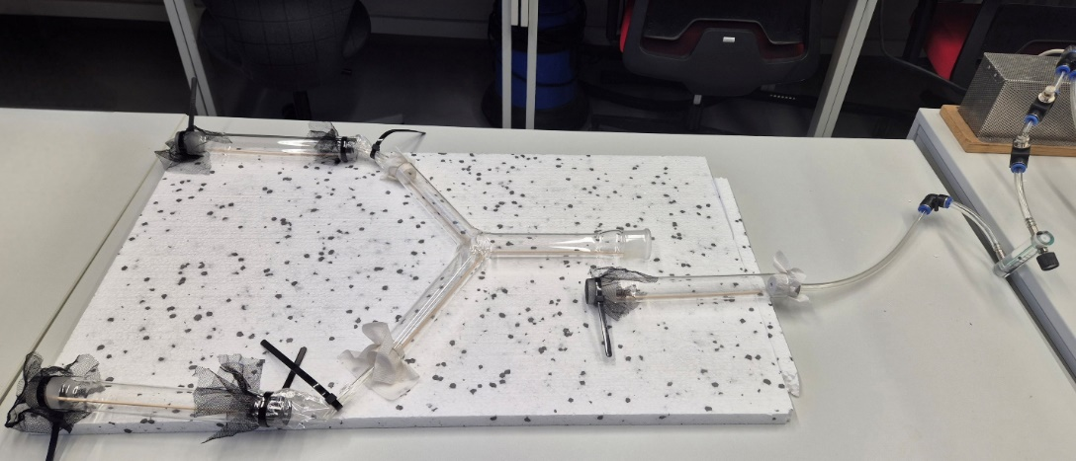
Figure S5: Olfactometer used to test for attraction of male Pisaura mirabilis to female scent versus a stimulus-free control. Tubing connected each arm with stimulus chambers that held a female or not. Males were introduced to a holding tube connected to a pump drawing 0.4 L/min air for two min prior to connection to the Y-tube. A choice was considered when a male reached the end of a Y-arm.

