High-Flow Nasal Oxygen Setting Post Extubation based on Inspiratory Flow during a Spontaneous Breathing Trial

ONLINE SUPPLEMENT

Sophia Butt¹*, Laura Pistidda^{1,3}*, Leda Floris^{1,3}, Corrado Liperi^{,3}, Francesco Vasques¹, Guy Glover¹, Nicholas A. Barrett¹, Barnaby Sanderson¹, Salvatore Grasso^{,2}, Manu Shankar-Hari^{,1,4}, Luigi Camporota¹.
To be considered ’First authors’

Institutions
- Department of Adult Critical Care, Guy’s and St Thomas’ NHS Foundation Trust, King’s Health Partners, and Division of Centre of Human Applied Physiological Sciences, King’s College London, London, UK
- Department of Emergency and Organ Transplants (DETO), Anesthesiology and Intensive Care, Università degli Studi di Bari “Aldo Moro”, Bari, Italy
- Department of SCIENZE MEDICHE CHIRURGICHE E SPERIMENTALI, Sassari University – Sassari - Italy
- Peter Gorer Department of Immunobiology, School of Immunology & Microbial Sciences, Kings College London, UK

Corresponding author:

Luigi Camporota; luigi.camporota@gstt.nhs.uk

Department of Adult Critical Care, Guy’s and St Thomas’ NHS Foundation Trust, King’s Health Partners, London, UK; St Thomas’ Hospital, 1st Floor East Wing, Westminster Bridge Road, London SE1 7EH, United Kingdom

Declaration of interests: The authors declare that they have no conflict of interests.

Online supplement 1: Pre- extubation assessments
Readiness testing has the double purpose of identifying patients who are ready to be liberated from mechanical ventilation – avoiding extubation delays – but also to identify patients who are unable to be liberated, thereby avoiding the risks of premature extubation.

Before initiating the ‘liberation process’ the patient must satisfy the following conditions
- Improvement or resolution of the underlying cause of acute respiratory failure
- Patient cooperative and pain free
- Able to sustain spontaneous breathing
- Able to cough, minimal secretions (defined as the need for suctioning >2 h)
- PEEP ≤ 8 cmH2 O, pressure support ≤ 8-10 cmH2 O ; FiO₂ ≤ 0.4 with SaO₂ >90% and a PaO₂ >8-9 kPa; PaO₂ /FiO₂ >20-26.6 kPa
- Stable haemodynamics. No or minimal vasopressor support
- No uncorrected metabolic abnormalities
- Fluid balance optimised
- Consider measuring NT-pro BNP for patients with left ventricular dysfunction – this may guide fluid management
- Tympanic temperature between 36 o and 38 °C,
- No relevant electrolyte disorder and haemoglobin level 70-80 g/L

Patients who fulfil the readiness to wean criteria, if not already receiving pressure support (PS) ventilation, can be started on a trial of pressure support ventilation. The level of PS will be titrated to patient comfort to achieve tidal volumes of 6-8ml kg-1 ideal body weight and a respiratory rate < 30 breaths min⁻¹.

A weaning predictor or index is a criterion that evaluates an aspect of the respiratory function with the objective of identifying patients who might tolerate the weaning trial (generally known as spontaneous breathing trial or SBT).
Weaning indices should be evaluated before the SBT, which functions as a diagnostic test to determine the probability of successful extubation. Integrative weaning indices evaluate more than one aspect of respiratory function. Although few of the weaning indices are predictive per se, the following indices should be routinely measured in clinical practice. Weaning index criteria can be particularly useful in situations in which the decision to liberate from mechanical ventilation is problematic.

ETable 1: SBT indices
Indices | Significance | Cut-off value
P 0.1 | The negative pressure that occurs 100 ms (or 0.1s) after a spontaneous inspiratory effort has been detected. Test of respiratory drive, not volitional. < -5 (i.e., more negative) indicates increased WOB. | < -5.0 cmH2 O(*) ⁸⁸
MIP  (Maximum  inspiratory  pressure)  or  NIF (Negative  inspiratory force) | The negative deflection in the pressure tracing during the patient’s active & maximal effort to breathe during an expiratory hold manoeuvre at the end of a relaxed or forced expiration. It is a global assessment of the strength of the inspiratory muscles. The MIP tends to be underestimated because of insufficient patient effort. This can be improved keeping the valve occluded up to 20 seconds - this will move the patient to a maximal effort. | <-30 cmH2 O (i.e., the more negative the better) > − 15 cmH2 O (**) ⁸⁹
P0.1/NIF Ratio | The relationship between P0.1 and MIP. Relates the work of breathing to the inspiratory muscle power. A higher P0.1 with a lower MIP would imply raised WOB with poor inspiratory muscle power and likelihood of pump failure if extubated. | <0.09-0.14 cmH2O ^{88,90}
Rapid shallow  breathing index  (RSBI) = f/VT | According to the Otis et al ⁹¹ model, an increase in RSBI is exponentially related to the work of breathing;  [WOB= 4035 e ((0.0017 • (f/VT))).  This means that high RSBI values can signify substantial work of breathing | <105 breaths • min⁻¹ • L⁻¹ ⁸⁹

ETable 2: Variables collected
Background assessment | - Time on Ventilator.  - Type of Admission  - Scheduled surgical  - Medical  - Unscheduled surgical
Baseline assessments | - Vital Signs: heart rate (b/min), systolic and diastolic blood pressure (mmHg), body temperature (C°), total respiratory rate.  - Ventilator Parameters: peak inspiratory flow (PIF), mean inspiratory flow (MIF), respiratory rate, tidal volume, FiO₂, PEEP, Respiratory drive (P0.1), negative inspiratory force (NIF), rapid shallow breathing index (RSBI), P0.1/NIF, ventilator manufacturer and model.  - HFNC parameters: FiO₂, flow, temperature.  - Arterial PO₂, PCO₂, pH, SaO₂, SpO₂.  - Glasgow coma score (GCS)/RASS score
Reference Measurements | The following conditions were ensured prior to measurements: semi-recumbent position for ≥ 15 minutes; SpO₂ sensors checked for optimal position, cleanliness, and consistent readings with satisfactory waveforms, if displayed. SpO₂ values observed for 1 minute and a representative value recorded. All vascular pressures zero-referenced to the mid-axillary line.

ETable 3: Previous studies HFNC setting post-extubation and discontinuation data
HFNC SETTINGS POST-EXTUBATION
 | Reference | Flow setting | Discontinuation
CARDIAC SURGERY | CORLEY et al. ⁶⁸ | from 35 L/min up then tritate to comfort | no data
CARDIAC SURGERY | PARKE et al ⁵¹ | from 35 L/min up then tritate to comfort | no data
CARDIAC SURGERY | PARKE et al ⁶⁶ | 45 L/min | no data
CARDIAC SURGERY | CORLEY et al. ⁶⁷ | from 35 L/min up then tritate to comfort | no data
CARDIAC SURGERY | STEPHAN et al ⁶ | 50 L/min | 6/414 (1.45%)
POST - EXTUBATION | Maggiore et al. ⁵ | 50 L/min | 0.4 displacement per patient
POST - EXTUBATION | Rittayamai et al. ⁹ | 36.8 L/min (mean) | 2/17 (11.8%)
POST - EXTUBATION | Tiruvoipati et al. ⁸³ | 30 L/min | 3/50 (6%)
POST - EXTUBATION | OPERA trial ⁸⁶ | 50-60 L/min | 8/108 (7.4%)
POST - EXTUBATION | Hernandez et Al. ⁷ | from 10 L/min up then tritate to comfort | 0
POST - EXTUBATION | Hernandez et Al. ⁸⁴ | from 10 L/min up then tritate to comfort | 2/290 (0.7%)
POST - EXTUBATION | Hernandez et Al. ⁸⁵ | From 40 L/min up then tritate to comfort | no data

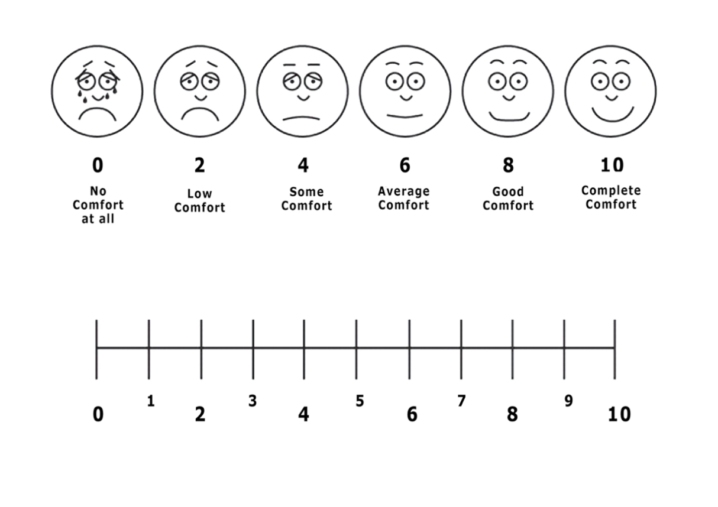
Figure 1: Visual analogue scale of comfort breathing

Figure 2: Study Flow chart. SBT, spontaneous breathing trial; PEEP, positive end-expiratory pressure; PS, pressure support; Vt, tidal volume; Ti, inspiratory time; P0.1, airway pressure at 0.1 second of inspiration; VAS, visual analogue scare; HFNC, high-flow nasal cannulae.

