TITLE: March2 suppresses odontoblast differentiation by polyubiquitinating Ptprd
RUNNING TITLE: March2 suppresses odontoblast differentiation

AUTHORS：
Hao Feng^{1,2,3}, Jiaxin Niu^{1,2,3}, Zhi Chen¹, Guobin Yang¹, Guohua Yuan^{1,2,3*}

AFFILIATION:
¹State Key Laboratory of Oral & Maxillofacial Reconstruction and Regeneration, Key Laboratory of Oral Biomedicine Ministry of Education, Hubei Key Laboratory of Stomatology, School & Hospital of Stomatology, Wuhan University, Wuhan 430079, China.
²Frontier Science Center for Immunology and Metabolism, Wuhan University, Wuhan 430079, China.
³Hubei Provincial Key Laboratory of Developmentally Originated Disease, Wuhan University, Wuhan 430071, China.
*Corresponding author: Guohua Yuan (yuanguohua@whu.edu.cn)

SUPPLEMENTARY INFORMATION
SUPPLEMENTARY TABLES
Supplementary Table 1. Animal samples details.
The transgenic mice used were of the C57BL/6 strain, and all selected postnatal mice were male. The mice included in our experiment were selected based on the genotypes and time points specified in the Appendix Table 1. Phenotyping data were collected from age-matched control littermates and March2 deficient mice of the same genetic background at the same time per group in order to minimize the potential confounders. The time points for tissue collection in mice effectively encompass the period of odontoblast differentiation and dentinogenesis¹. A computer-based random number generator was used to generate the randomization sequence. The number of mice used in this study was determined based on the sample sizes reported in previous literature ². Researchers were aware of group allocation at all stages of the experiment, including during allocation, conduct, outcome assessment, and data analysis. There are no important adverse events in each experimental group. We made every effort to minimize the pain and stress that animals suffered in this study.
Genotype | Age | Experiments | Sample number  (n=) | Total number
Kunming mice | E18.5 | Primary mDPCs isolation | 400 | 400
Kunming mice | E18.5,  PN2, PN3，PN7，PN10 | Histological analysis | 3 for each age | 15
March2^{+/+}  (Control littermates) | PN7 | Histological analysis | 3 | 3
 | PN10 | Micro-CT, histological analysis | 5 | 5
 | PN14 | Micro-CT, histological and Calcein labeling analysis | 10 | 10
March2^{-/-}  (March2 Deficient) | PN7 | Histological analysis | 3 | 3
March2^{-/-}  (March2 Deficient) | PN10 | Micro-CT, histological analysis | 5 | 5
March2^{-/-}  (March2 Deficient) | PN14 | Micro-CT, histological and Calcein labeling analysis | 10 | 10

Supplementary Table 2. Primer and siRNA sequences used in this study.
Gene | Primer or siRNA Sequences
mDmp1 | forward: 5’-ACCACAATACTGAATCTGAAAGCTC-3’
mDmp1 | reverse: 5’-TGCTGTCCGTGTGGTCACTA-3’
mDspp | forward: 5’-TAGCACCAACCATGAGGCTG-3’
mDspp | reverse: 5’-TGTTGCCTTTGTTGGGACCT-3’
mCol1a1 | forward: 5’-TTCGTGACCGTGACCTTGAG-3’
mCol1a1 | reverse: 5’-CGATCTCGTTGGATCCCTGG-3’
mPtprd | forward: 5’-AATGGACCCCACTCAGCATG-3’
mPtprd | reverse: 5’-ATCTCCCAAGACAGCAGAGCAC-3’
mGAPDH | forward: 5’-TGTGTCCGTCGTGGATCTGA-3’
mGAPDH | reverse: 5’-TTGCTGTTGAAGTCGCAGGAG-3’
mMarch1 | forward: 5’-AAAACTGGTTGTGGTGGCTATT-3’
mMarch1 | reverse: 5’-ACAAAGATCACACGGTTGTAGG-3’
mMarch2 | forward: 5’-GCCCTCTTTACCATCTATGTGC-3’
mMarch2 | reverse: 5’-TCAGGCGGACTTTCTGATTTG-3’
mMarch3 | forward: 5’-TGAAGACGGTGGAGGATTGTG-3’
mMarch3 | reverse: 5’-GAGTCCGCACTACTGTTGACA-3’
mMarch4 | forward: 5’-GCCGCTGTCGAATGCTCTT-3’
mMarch4 | reverse: 5’-GCCGGAAGGGTGTTGTTGT-3’
mMarch5 | forward: 5’-GACCAAGCCCTTCAACAGATG-3’
mMarch5 | reverse: 5’-TGGTGAACCCACTTAGTAGATCC-3’
mMarch6 | forward: 5’-CTCAGTGGTGGTTGAAAACTGT-3’
mMarch6 | reverse: 5’-GCGCCAGAAGCTATGACATAC-3’
mMarch7 | forward: 5’-TTGCTGTCACGGATAGCTTCT-3’
mMarch7 | reverse: 5’-GGTTCCATTATTCCGAGACTGTG-3’
mMarch8 | forward: 5’-TCTCTCGCACTTCTGTCACAC-3’
mMarch8 | reverse: 5’-GCAAGCCTGATGCACGAAATG-3’
mMarch9 | forward: 5’-CGCTGTGGTTATACGATCCTG-3’
mMarch9 | reverse: 5’-ACAACCTCTCGACCAGAATGA-3’
mMarch10 | forward: 5’-CAAGATACCAGGTTACCCAGTGA-3’
mMarch10 | reverse: 5’-GGATAACACCATCAGATTTCGCA-3’
mMarch11 | forward: 5’-CGAAACACGCTCCGTATGTAG-3’
mMarch11 | reverse: 5’-GGATTTAACAACTCACCCTGCT-3’
siMarch2 | (1)5’-3’ GCUUGGGCCACCUCAAUAUTT
siMarch2 | (1)3’-5’ AUAUUGAGGUGGCCCAAGCTT
siMarch2 | (2)5’-3’ GGAAGCUGUAGGUCUCAUUTT
siMarch2 | (2)3’-5’ AAUGAGACCUACAGCUUCCTT
siPtprd | (1)5’-3’ CCGGACAUUUGCACUUUAUTT
siPtprd | (1)3’-5’ AUAAAGUGCAAAUGUCCGGTT
siPtprd | (2)5’-3’ CUGGCUGCUUCAUUGUAAUTT
siPtprd | (2)3’-5’ AUUACAAUGAAGCAGCCAGTT
Scramble siRNA | 5’-3’ UUCUCCGAACGUGUCACGUTT
Scramble siRNA | 3’-5’ ACGUGACACGUUCGGAGAATT
Supplementary Table 3. Antibodies used in this study.
Antibody specificity | Species | Brands | Catalog# | Usages | Concentrations
March2 | Rabbit | ImmunoWay | WT2643 | IHC ICC | 1:200
March2 | Rabbit | Zenbio | 823811 | WB | 1:2000
Ptprd | Rabbit | Proteintech | 27941-1-AP | WB | 1:1000
Ptprd | Rabbit | Proteintech | 27941-1-AP | IHC IF ICC | 1:200
Dmp1 | Rabbit | Abcolnol | A16832 | WB | 1:2000
Dmp1 | Rabbit | Abcolnol | A16832 | IF | 1:200
Dspp | Rabbit | Novus | NBP2-92546 | WB | 1:2000
Dspp | Rabbit | Novus | NBP2-92546 | IF | 1:200
Col I | Rabbit | proteintech | 14695-1-AP | WB | 1:2000
Col I | Rabbit | proteintech | 14695-1-AP | IF | 1:200
β-actin | Rabbit | Abcolnol | AC038 | WB | 1:10000
Flag | Mouse | Abcolnol | AE005 | WB | 1:3000
HA | Mouse | Abcolnol | AE008 | WB | 1:3000
Myc | Mouse | proteintech | 60003-2-IG | WB | 1:3000
Myc | Mouse | proteintech | 60003-2-IG | ICC | 1:400
Myc | Rabbit | Abcolnol | AE092 | ICC | 1:400
Ub | Mouse | ImmunoWay | YM3636 | ICC | 1:200

SUPPLEMENTARY FIGURES AND FIGURE LEGENDS
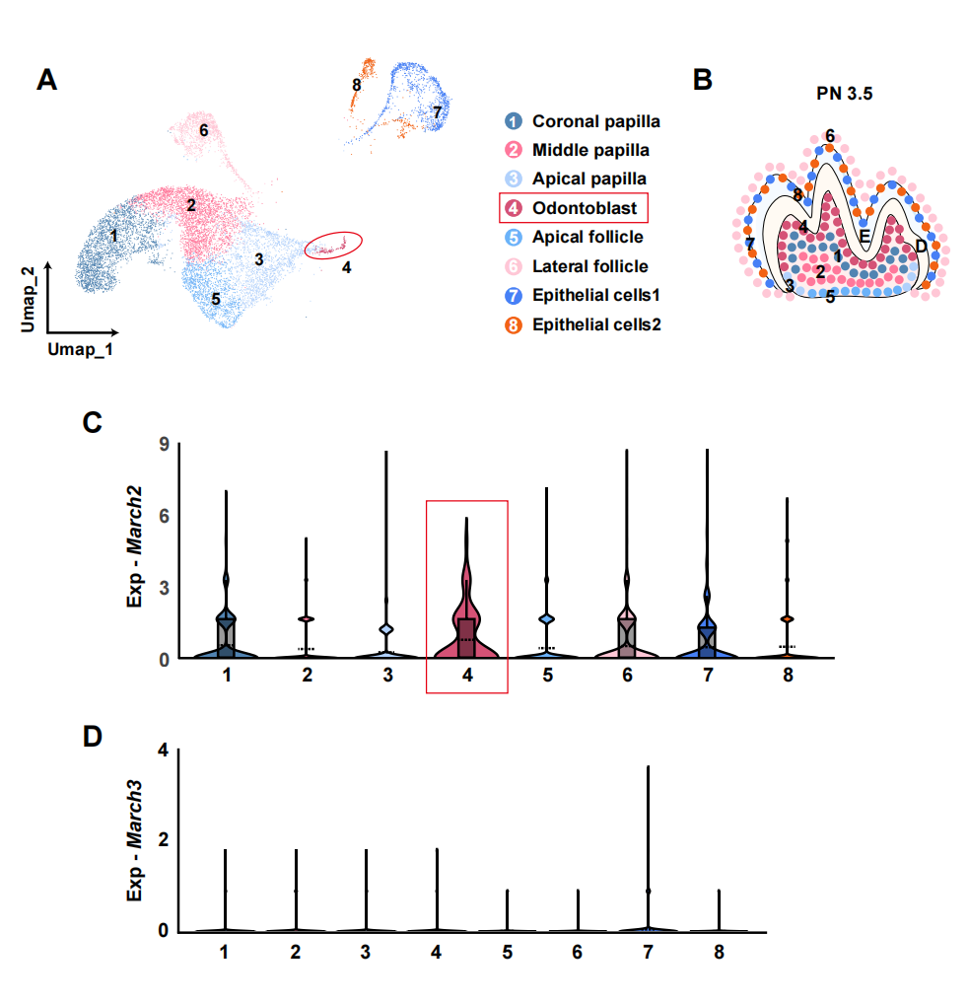
Supplementary Figure 1. The expression of March2 and March3 in dental cell subpopulations. a Umap plot of cell clusters in PN3.5 mouse molar. b Schematic representation of cell clustering in the mouse molar in (a). c The violin plot displays the expression level of March2 in the subpopulations of mouse molar at PN3.5. d The violin plot displays the expression level of March3 in the subpopulations of mouse molar at PN3.5.

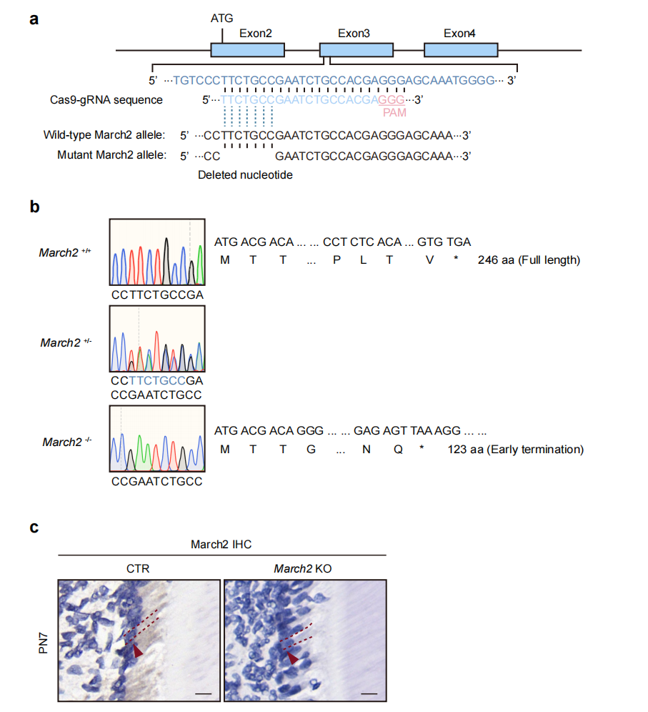
Supplementary Figure 2. Construction of March2 deficient mice and validation of the knockout efficiency. a A schematic diagram illustrating the targeting strategy used for generating March2 deficient mice. b Sanger sequencing of the indicated genotypes revealed a 7 bp deletion in the genome of the March2 deficient mice, resulting in a frameshift and premature termination of March2 protein translation. c IHC shows that different from control littermate mice, March2 deficient mice showed no March2 expression in the odontoblast layer. Red arrows and red dashed lines indicate odontoblasts. CTR, control littermates; March2 KO, March2 deficient; Scale bar, 10 µm.
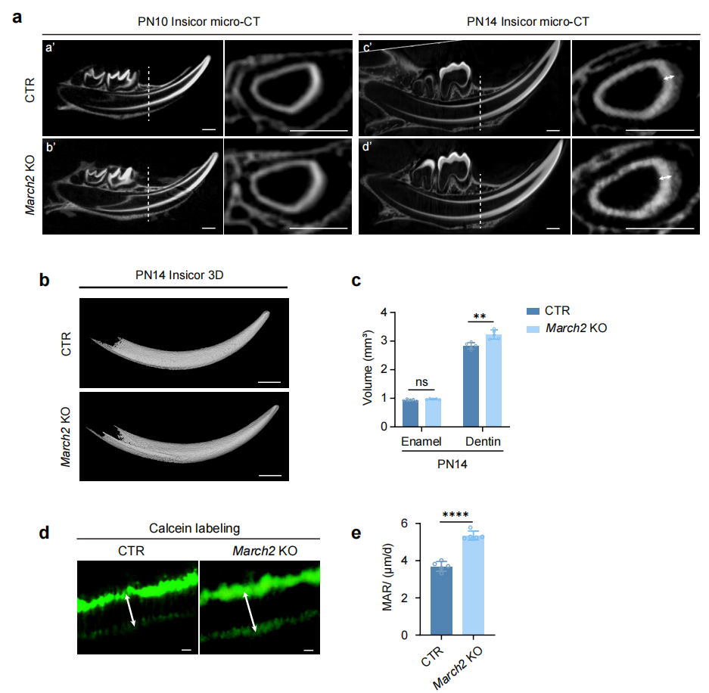
Supplementary Figure 3. The incisors of March2 deficient mice exhibit increased dentin volume and accelerated dentin deposition rate. a Micro-computed tomography (Micro-CT) images of the mandibular incisors in control littermates and March2 deficient mice at PN10 (a’, b’) and PN14 (c’, d’). White arrows denoting the dentin layer. Scale bar, 500 μm. b Three-dimensional (3D) reconstruction of the first mandibular incisors in control littermates and March2 deficient mice at PN14. Scale bar, 1 mm. c Quantification of enamel and dentin volumes in the first mandibular incisors of control littermates and March2 deficient mice at PN14 (n = 5). d Calcein labeling was used to compare the dentin deposition rate in the mandibular incisors between control littermates and March2 deficient mice. The white arrows indicate the dentin deposited in the period between drug administrations. Scale bar, 10 μm. e Quantification of the mineral apposition rates of control littermates and March2 deficient mice in (d) (n = 5). CTR, control littermates; March2 KO, March2 deficient; The statistical difference was analyzed by two-tailed unpaired Student’ s t-test (c, e), where ns denotes not significant; **P<0.01; ****P<0.000 1.

REFERENCES
1 Jing, J. J. et al. Spatiotemporal single-cell regulatory atlas reveals neural crest lineage diversification and cellular function during tooth morphogenesis. Nat. Commun. 13, 14 (2022). https://doi.org:10.1038/s41467-022-32490-y
2 Zheng, H., Fu, J., Chen, Z., Yang, G. & Yuan, G. Dlx3 Ubiquitination by Nuclear Mdm2 Is Essential for Dentinogenesis in Mice. J. Dent. Res. 101, 1064-1074 (2022). https://doi.org:10.1177/00220345221077202

