Supporting Information

Exosomes/MoS₂ complex for targeting and effective photothermal therapy

Liyan Wang^{#,1}, Huizhi Chen^{#,1,2}, Haiyan Qiu¹, Zhenyu Xie¹, Shah Zada¹, Jianbo Sun¹, Chengyu Lu^{1,2}, Zhan Zhou³, Xinsheng Peng^{1,*}, Ruizheng Liang^{1,4,*}, Yubin Zhou^{1,2,*}

¹Dongguan Key Laboratory of Advanced Drug Delivery and Biosensing Research and Development, The First Dongguan Affiliated Hospital, School of Pharmacy, Guangdong Medical University, Dongguan, 523808, China
²Research Center of Nano Technology and Application Engineering, Dongguan Innovation Institute, Guangdong Medical University, Dongguan, 523808, China
³College of Chemistry and Chemical Engineering, Henan Key Laboratory of Function-Oriented Porous Materials, Luoyang Normal University, Luoyang, 471934, China
⁴State Key Laboratory of Chemical Resource Engineering, Beijing Advanced Innovation Center for Soft Matter Science and Engineering, Beijing University of Chemical Technology, Beijing, 100029, China

# These authors contributed equally to this work.

* Corresponding authors.
Email address: xspeng@gdmu.edu.cn (Xinsheng Peng), liangrz@buct.edu.cn (Ruizheng Liang), zhouyb@gdmu.edu.cn/ zybresearch@126.com (Yubin Zhou)

Fig. S1 (A) TEM and (B) HRTEM images of the MoS₂ nanodots. Inset of (B) is the expanded section of the dashed box area.

Fig. S2 XPS (A) survey spectra and high-resolution (B) S 2p, (C) Mo 3d spectra of the MoS₂ nanodots.

Fig. S3 The appearance of MoS₂-PVP in ultrapure water (UPW) and PBS.

Fig. S4 Characterization of ME (MCF-7 exosomes). (A) The morphology of ME analyzed by TEM (Scale bar = 100 nm). (B) The size distribution of ME measured by DLS, and (C) corresponding NTA measurement.

Fig. S5 The exosomal proteins of ME detected by (A) Western Blot, (B) FCM, and (C) SDS-PAGE.

Fig. S6 The storage stability of MoS₂@ME at 4℃. (A) The appearance. (B) The major proteins analyzed by SDS-PAGE. (C) The particle sizes of MoS₂ and MoS₂@ME.

Fig. S7 The photothermal performance of MoS₂ and MoS₂@ME after storage for 7 days.

Fig. S8 The morphology of red blood cells after treatment with MoS₂@ME.

Fig. S9 Photos (A) of free DiR, DiR-labelled exosomes and DiR-labelled MoS₂@ME. (B) Corresponding fluorescence intensity.

Fig. S10 Impact of the treatment on the main organs (A), body weights (B) and survival function (C) of the model mice.

Fig. S11 Changes of main indicators of liver and kidney in mice after various treatments.

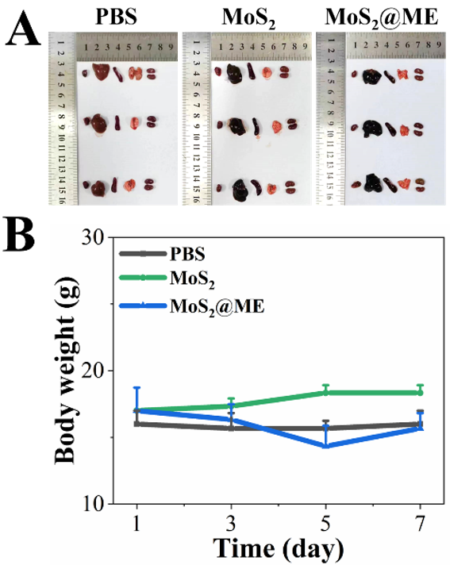
Fig. S12 Biosafety evaluation of MoS₂@ME in normal mice. (A) Picture of the main organs. (B) The body weight changes of mice after different treatments during 7 days.

Fig. S13 H&E staining results of main organs in normal mice treated with PBS, MoS₂ and MoS₂@ME, respectively (Scale bar = 100 μm).

