Supplement Information

Near-Infrared Photon-Triggered CH₄-to-CH₃OH Conversion over Plasmonic Oxyselenides

Xiuming Zhang,⁺¹ Yuheng Jiang,^{+2,3} Hongfei Gu,⁺⁴ Haoqing Zhang,¹ Yuemei Li,¹ Zexuan Lu,¹ Shuping Zhang,⁵ Jia Liu,^{1*} Jiatao Zhang^{1*} and Zhiyong Tang³

¹ School of Materials Science and Engineering, School of Chemistry and Chemical Engineering, Beijing Key Laboratory of Construction-Tailorable Advanced Functional Materials and Green Applications, Beijing Institute of Technology, Beijing 100081, China.
² Laboratory of Industrial Chemistry, Ruhr University Bochum, 44780 Bochum, Germany.
³ Chinese Academy of Science (CAS) Key Laboratory of Nanosystem and Hierarchy Fabrication, CAS Center for Excellence in Nanoscience, National Center for Nanoscience and Technology, Beijing 100190, China.
⁴ School of Chemistry, Beijing Advanced Innovation Center for Biomedical Engineering, Key Laboratory of Bio-Inspired Smart Interfacial Science and Technology, Beihang University, Beijing 100191, China.
⁵ Institute of Materials, Henan Key Laboratory of Advanced Conductor Materials, Henan Academy of Sciences, Zhengzhou 450046, China.
* E-mail: liujia86@bit.edu.cn; zhangjt@bit.edu.cn

1. Supplementary Methods
Materials
Copper (II) chloride dihydrate 2H₂O (CuCl₂·2H₂O, 99.99%), chloroauric acid hydrate (HAuCl₄, Au≥47.5%), silver nitrate (AgNO₃, 99.8%), chloroplatinic (IV) acid (H₂PtCl₆, 40% Pt), and anhydrous sodium sulfate (Na₂SO₄, 99%) were purchased from Aladdin Reagent Co., Ltd. Iron (III) nitrate nonahydrate (Fe(NO₃)₃·9H₂O, 98.5%) was obtained from Sinopharm Group Chemical Reagent Co., Ltd. Sodium selenite (Na₂SeO₃) was purchased from Alfa Aesar Reagents Co., Ltd. Other chemicals, including anhydrous ethanol, were purchased from Beijing Tong Guang Fine Chemicals Company. All reagents were used without further purification. Deionized water was prepared using a Merck Direct-Q3 pure water system (18.2 Ω).
Characterization
Low-resolution transmission electron microscopy (TEM) images were obtained using a HITACHI H-7650 electron microscope with an accelerating voltage of 80 kV. High-resolution transmission electron microscopy (HRTEM) images were performed on a FEI Tecnai G2 F20 S-Twin microscope operating at 200 kV. The dielectric constant (ε_{r}) was measured using a parallel plate capacitor with the four-probe method, following the standard GB/T 5594.4-2015. X-ray diffraction (XRD) patterns were acquired using a Bruker D8 X-ray diffractometer (5° min⁻¹). UV-visible-NIR diffuse reflectance spectra (DRS) spectra were recorded on a Shimadzu UV-3600i plus spectrophotometer at room temperature. X-ray photoelectron spectroscopy (XPS) spectra were obtained using a PerkinElmer PHI 5300 spectrometer with monochromatic Al Kα radiation (1486.7 eV). All binding energies were corrected based on the C 1s peak (284.8 eV). In situ solid-state (electron paramagnetic resonance) EPR curves were collected on the ELEXSYS II EPR instrument. The X-ray absorption fine structure spectra data (XAFS, Cu K-edge) were measured at the BL14W1 beamlines at Shanghai Synchrotron Radiation Facility (SSRF) (Shanghai, China). The XAFS data of all the samples were measured at room temperature in transmission mode. All samples were prepared as plates of 10 mm diameter with 1mm thickness with the addition of graphite powder as a binder.
Photoelectrochemical measurements
The working electrode was prepared by uniformly coating a mixture of photocatalyst, isopropyl alcohol (IPA), and Nafion solution onto ITO conductive glass. Ag/AgCl electrode and platinum plate was used as the reference electrode and counter electrode, respectively, and 0.5 M Na₂SO₄ aqueous solution was used as the electrolyte. The CHI760E electrochemistry workstation (Chenhua, Shanghai, China) was used to record the photocurrent-time curves and open-circuit potential (OCP) under light on/off cycles using a 300 W xenon lamp (PLS-FX300HU, Beijing Perfectlight Technology Co., Ltd). The electrochemical impedance spectroscopy (EIS) Nyquist plots were recorded under illumination with an amplitude of 5 mV and a frequency range of 0.01 Hz to 1.0 kHz. The Mott-Schottky curves were measured in the dark at a frequency of 1.0 kHz.
Computational method
We performed spin-polarized density functional theory (DFT) calculations using the Vienna Ab Initio Simulation Package (VASP)^{1,2} with the generalized gradient approximation (GGA) under the PBE framework³. Projected augmented wave (PAW) potentials^{4,5} were used for ionic cores, while valence electrons were treated via a plane wave basis set with a kinetic energy cutoff of 400 eV. The Kohn-Sham orbital partial occupancies were managed using Gaussian smearing with a width of 0.05 eV. Electronic energy was considered self-consistent with an energy change below 10⁻⁵ eV. Geometry optimization was achieved when force changes were less than 0.02 eV/Å. Grimme’s DFT-D3 method⁶ was used for dispersion interactions. The equilibrium lattice parameters of the triclinic CuSeO₃ unit cell were optimized as follows: a=4.725 Å, b=8.256 Å, c=10.292 Å, α=111.8°, β=92.2°, γ=89.2°. Based on these values, we created a CuSeO₃(111) surface model (Model 1) with p(1×1) periodicity in both the X and Y directions, and two stoichiometric layers along the Z axis, separated by a 15 Å vacuum layer to prevent interactions between periodic images of the surface slab. Model 1 contained 12 Cu, 12 Se, and 36 O atoms. Model 2 was derived from Model 1 by removing one oxygen atom from the outermost layer. For structural optimizations, a 2×2×1 k-point grid in the Brillouin zone was used for k-point sampling, with the bottom stoichiometric layer fixed and the top layer allowed to relax.
The adsorption energy (E_{ads}) of adsorbate A was defined as
$$E_{ads}=E_{A/surf}-E_{surf}-E_{A(g)}$$
where E_{A/surf} is the energy of adsorbate A on the surface, E_{surf} is the energy of the clean surface, and E_{A(g)} is the energy of the isolated A molecule in a cubic periodic box with a side length of 20 Å and a 1×1×1 Monkhorst-Pack k-point grid for Brillouin zone sampling.

2. Supplementary Tables
Supplementary Table S1 | ICP-MS results of prepared CuSeO_{3-x} samples
Samples | Molar ratio of  Cu : Se precursors | Mass percentage (%) |  |  | O_{v} density  (%)
Samples | Molar ratio of  Cu : Se precursors | Cu | Se | O | O_{v} density  (%)
CuSeO_{2.98} | 1.000 | 33.5667 | 41.4546 | 24.9787 | 0.67
CuSeO_{2.94} | 1.030 | 33.6034 | 41.6546 | 24.7420 | 2.00
CuSeO_{2.90} | 1.061 | 33.6398 | 41.9360 | 24.4242 | 3.33
CuSeO_{2.82} | 1.095 | 33.9426 | 42.1240 | 23.9298 | 6.00
CuSeO_{2.72}-H₂ª | 1.095 | 34.6945 | 41.8718 | 23.4337 | 9.66
ª obtained by treating CuSeO_{2.82} in a 5% H₂/Ar atmosphere at 300 ºC for 2h.
Supplementary Table S2 | Hall effect measurement to determine the relative dielectric constant (ε_{r}) for CuSeO_{2.82}.
Frequency (Hz) | Thickness (m) | Diameter (m) | Area (m²)
1.00×10⁶ | 1.40×10⁻³ | 1.31×10⁻² | 1.35×10⁻⁴
Capacitance (pF) | ε (F m⁻¹) | ε_{r} | tanδ
5.16 | 8.47×10⁻¹¹ | 6.05 | 0.02

Supplementary Table S3 | Hall effect measurements to determine the conductivity of the prepared CuSeO_{3-x}. The negative Hall coefficients suggest the n-type conductivity of the samples.
Sample | Hall coefficients (cm³ C⁻¹)
CuSeO_{2.82} | -4.74×10⁶
CuSeO_{2.98} | -4.17×10⁶

Supplementary Table S4 | Calculated carrier concentrations in CuSeO_{3-x} derived from the Mott-Schottky measurements.
Sample | Slope | N (cm⁻³)
CuSeO_{2.82} | 1.0×10¹⁰ | 2.3×10²¹
CuSeO_{2.90} | 1.4×10¹⁰ | 1.7×10²¹
CuSeO_{2.94} | 1.7×10¹⁰ | 1.4×10²¹
CuSeO_{2.98} | 2.5×10¹⁰ | 1.0×10²¹

Supplementary Table S5 | AQY values determined for Au/CuSeO_{2.82} at various wavelengths under ambient and elevated pressure conditions.
Wavelength (nm) | AQY (0.1 MPa) | AQY (2.0 MPa)
405 | 1.10% | 2.70 %
420 | 0.70% | 2.49 %
550 | 0.25% | 0.51 %
700 | 0.40% | 0.77 %
800 | 0.71% | 1.54 %

Supplementary Table S6 | Benchmarking of photocatalysts for methane oxidation to methanol by O₂ as reported in recent literatures.
Catalysts | Conditions | Wavelength (nm) | AQY (CH₃OH) | Selectivity | References
Ni−NC/TiO₂ | 2.0 MPa CH₄ 0.1 MPa O₂ 25 ºC | 360 | 0.23% | 20% | Angew. Chem. Int. Ed. 2023, 62, 202215057
AuCu–ZnO | 2.0 MPa CH₄ 0.1 MPa O₂ 25 ºC | 365 | 4.1% | 52% | J. Am. Chem. Soc. 2022, 144, 740-750
Au-ZnO | 2.0 MPa CH₄ 0.1 MPa O₂ 25 ºC | 368 | 3.95% | 40% | J. Am. Chem. Soc. 2019, 141, 20507−20515
Quantum-sized BiVO₄ | 2.0 MPa (CH₄+O₂) 25 ºC | 365 | 3.07% | 62.8% | Nat. Sustain. 2021, 4, 509-515
Ag-CoO_{x}/TiO₂ | 2.0 MPa CH₄ 0.1 MPa O₂ 25 ºC | 368 | 0.94% | 85% | ACS Catal. 2020, 10, 14318−14326
Pd-def-In₂O₃ | 1.9 MPa CH₄ 0.1 MPa O₂ 25 ºC | 420 | 0.84% | 16% | Nat. Commun. 2022, 13, 2930
Au₁/BP nanosheets | 3.0 MPa CH₄ 0.3 MPa O₂ RT | 450 | 1.3% | 99% | Nat. Commun. 2021, 12, 1218
SC-Co₁/PCN | 0.8 MPa CH₄ 25 ºC | 420 | 2.3% | 87.2% | Chem 2023, 9, 1017-1035
N-doped TiO₂ | 1.9 MPa CH₄ 0.1 MPa O₂ 25 ºC | 380 | 0.71% | 19.2% | ACS Nano 2024,18, 12994-13005
Au-Pd/TiO₂ | CH₄/O₂ (v/v = 1/1, 1 atm 25 ºC | 400 | 7% | 100% | Nat. Mater. 2022, 21, 932-938
Fe@PCN-222 | 2 MPa CH₄ 25 ºC | 400 | 0.45% | 33% | ACS Catal. 2023, 13, 15351-15359
Au-Pd/ZnO | 29 bar CH₄  1 bar O₂ 25 ºC | 365 | 6.4% | 88.5% | ACS Catal. 2024, 14, 955-964
Au NPs/In₂O₃ | 10 bar O₂ 20 bar CH₄ 25 ºC | 365 | 1.36% | 89.4% | J. Am. Chem. Soc. 2023, 145, 2698-2707

3. Supplementary Figures

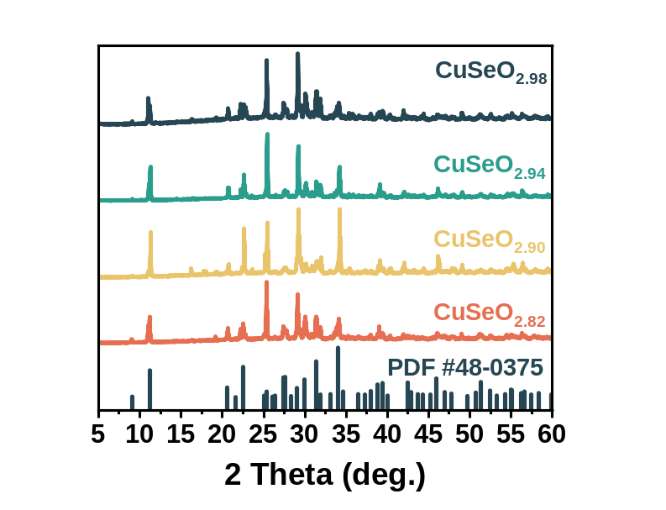
Supplementary Figure S1 | XRD patterns of CuSeO_{3-x} crystals.

Supplementary Figure S2 | TEM image of CuSeO_{2.82}.

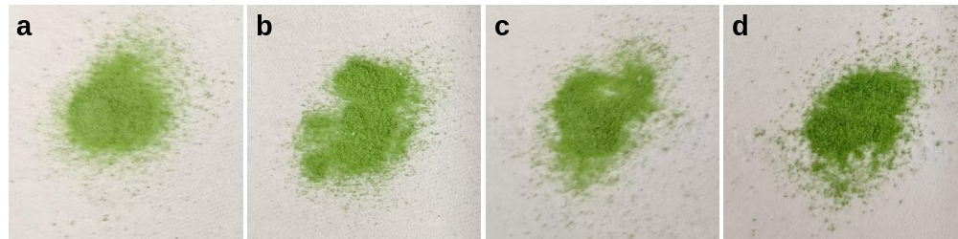
Supplementary Figure S3 | Digital photographs of (a) CuSeO_{2.82}, (b) CuSeO_{2.90}, (c) CuSeO_{2.94}, and (d) CuSeO_{2.98} crystals.

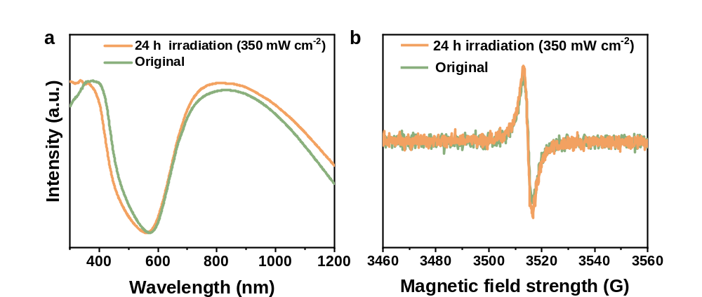
Supplementary Figure S4 | Comparison of the (a) UV-vis-NIR DRS and (b) in situ solid-state EPR spectra for CuSeO_{2.82} before and after irradiation with a xenon lamp (350 mW cm⁻²) for 24 h.

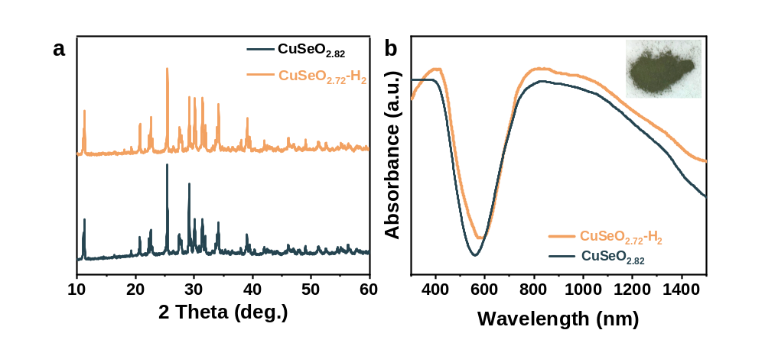
Supplementary Figure S5 | Comparison of the (a) XRD patterns and (b) UV-vis-NIR DRS spectra for CuSeO_{2.72}-H₂ and CuSeO_{2.82}. Inset in (b): digital photograph of CuSeO_{2.72}-H₂.

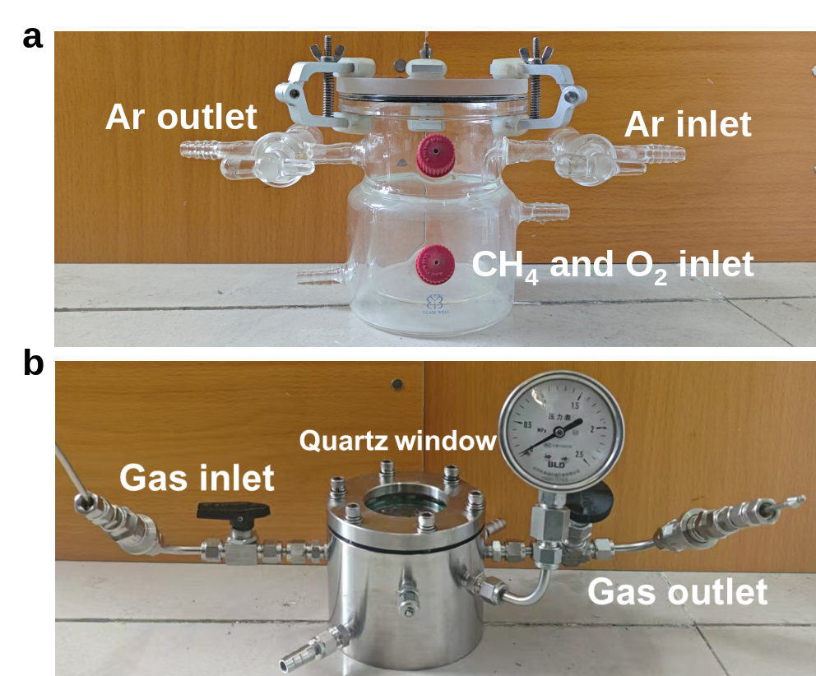
Supplementary Figure S6 | Digital photographs of (a) the glass reactor and (b) autoclave reactor used for photocatalytic methane oxidation under atmospheric and high-pressure conditions, respectively.

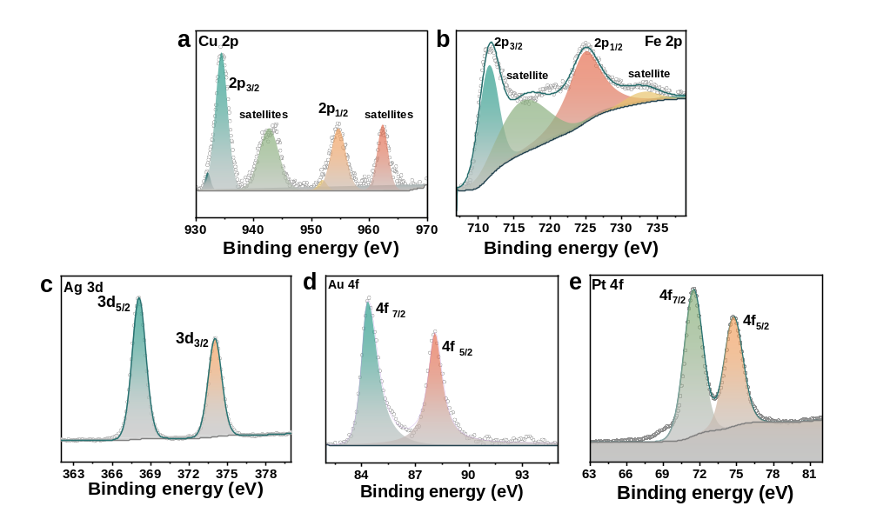
Supplementary Figure S7 | XPS spectra for (a) CuO_{x}, (b) FeO_{x}, (c) Ag, (d) Au and (e) Pt cocatalyts modified on CuSeO_{2.90}.

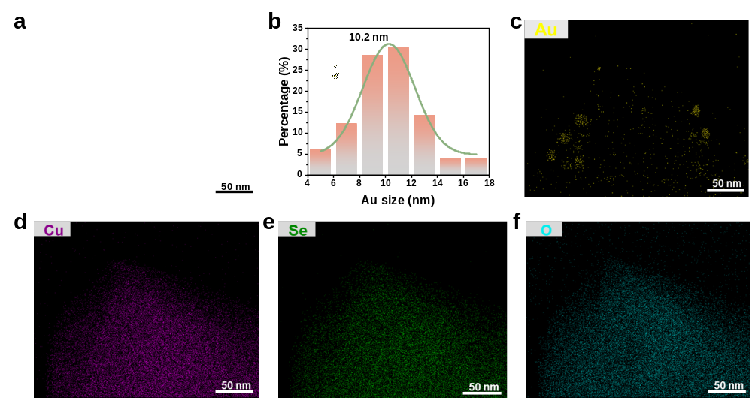
Supplementary Figure S8 | (a) HAADF-STEM image of Au/CuSeO_{2.82}. (b) Particle size distribution of Au cocatalysts for Au/CuSeO_{2.82}. (c-e) EDS-mapping images for Au/CuSeO_{2.82}. Yellow, purple, green and blue colors represent Au (c), Cu (d), Se (e) and O (f) elements, respectively.

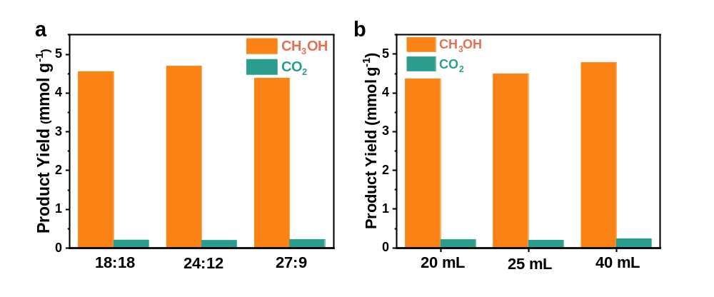
Supplementary Figure S9 | Investigation on the impacts of (a) the molar ratio between CH₄ and O₂, and (b) the amount of H₂O used during the photocatalytic methane oxidation reaction over Au/CuSeO_{2.82} under ambient conditions.

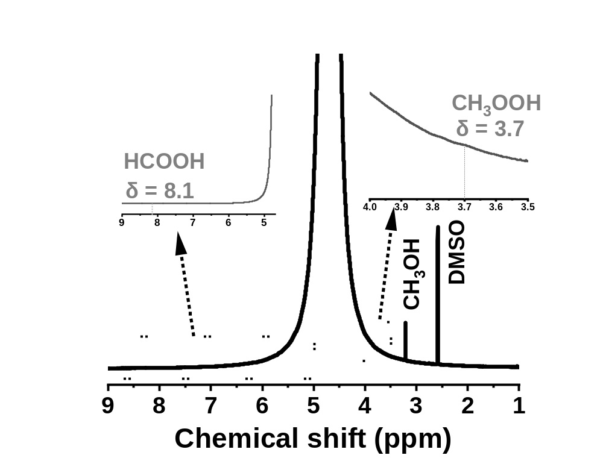
Supplementary Figure S10 | The typical ¹H NMR spectrum determined for the liquid products collected after the photocatalytic methane oxidation reaction over Au/CuSeO_{2.82} under ambient conditions. The result clearly confirmed the existence of CH₃OH and the absence of CH₃OOH and HCOOH in the products.

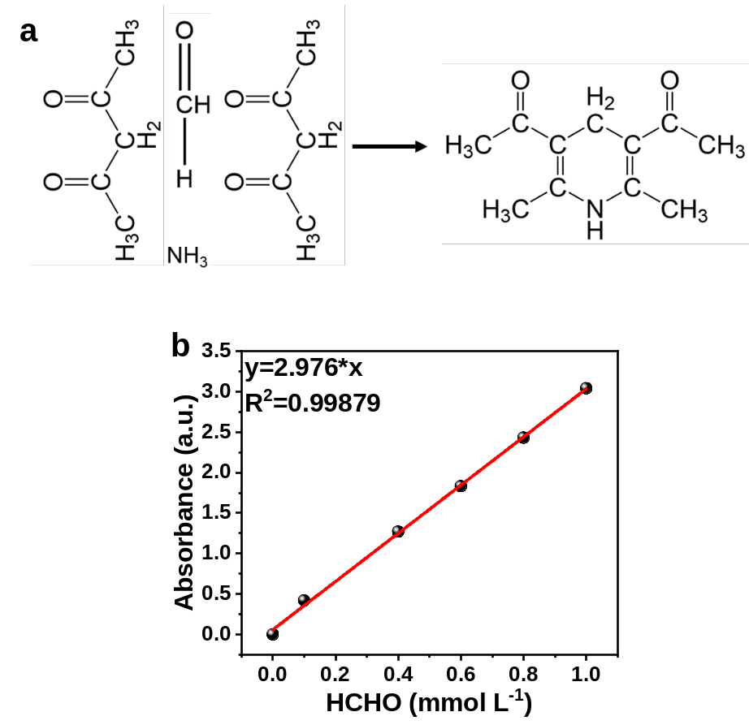
Supplementary Figure S11 | (a) Mechanism of acetylacetone color-developing method. (b) Measured calibration curve for quantification of HCHO by the colorimetric method.

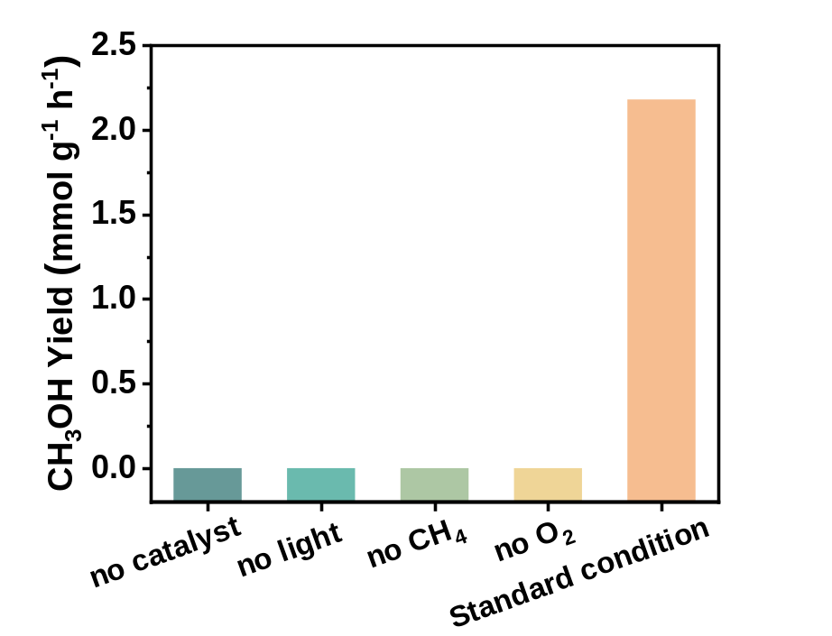
Supplementary Figure S12 | Comparison of the methanol yields across different control experiments in photocatalytic methane oxidation reaction. Standard condition: 20 mg of Au/CuSeO_{2.82} dispersed in 40 mL of distilled water in presence of 12 mL of O₂ and 24 mL of CH₄ (0.1 MPa), followed by irradiation with a xenon lamp for 2 hours.

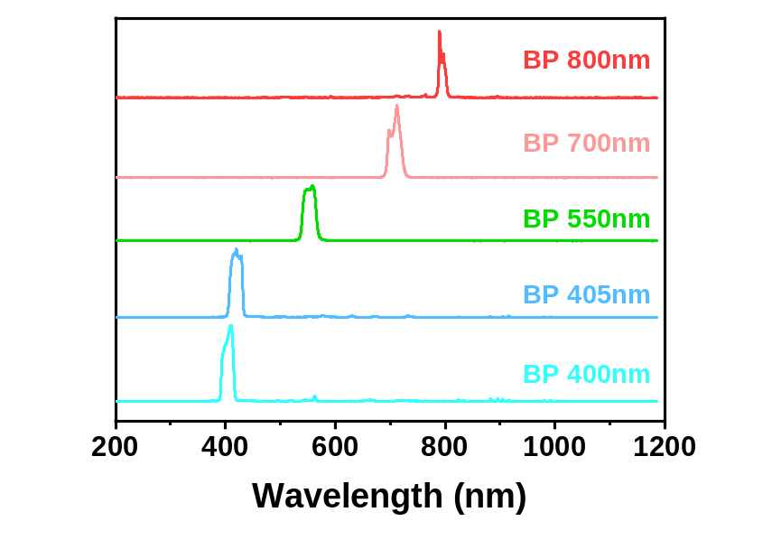
Supplementary Figure S13 | Spectra of the light source used in AQY measurements. The desired incident light wavelength was achieved by using a xenon lamp equipped with 405 nm, 420 nm, 550 nm, 700 nm or 800 nm band-pass filter. The measurement was performed by using an optical fiber spectrometer (Ideaoptics, FX4000-EX) with measuring range of 193-1186 nm.

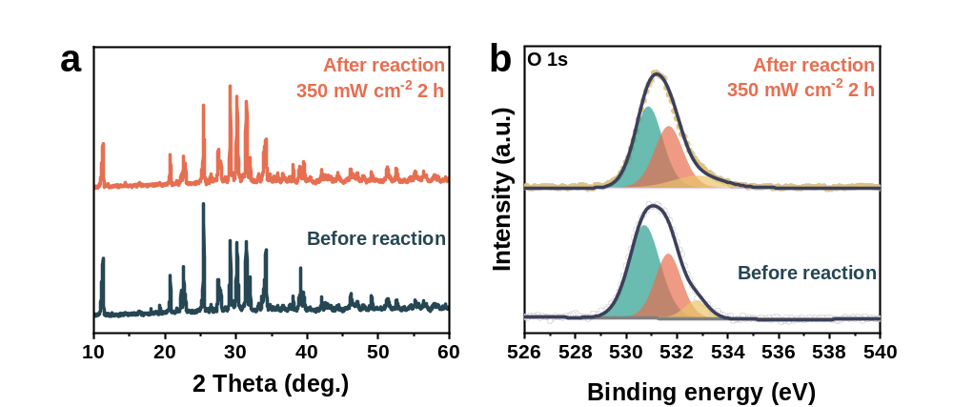
Supplementary Figure S14 | (a) XRD patterns and (b) XPS spectra of Au/CuSeO_{2.82} before and after the photocatalytic methane oxidation reaction, which was performed under irradiation of a xenon lamp for 2 hours.

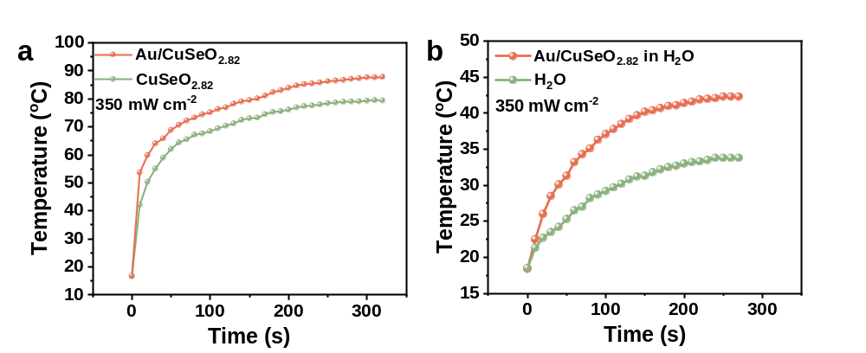
Supplementary Figure S15 | (a) Temperature-time curves of CuSeO_{2.82} and Au/CuSeO_{2.82} in powder form under irradiation of a xenon lamp (350 mW cm⁻²). (b) Temperature-time curve for Au/CuSeO_{2.82} dispersed in deionized water under irradiation of a xenon lamp (350 mW cm⁻²), in comparison with that in the absence of the material.

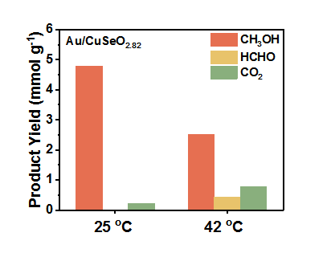
Supplementary Figure S16 | Performances of Au/CuSeO_{2.82} in the photocatalytic methane oxidation reaction performed under ambient pressure at different temperatures. The results of 25 ºC were obtained from the photocatalytic system using a circulating water bath to control the reaction temperature, while those at 42 ºC represent the performance in a photocatalytic system without eliminating the thermal heating effect brought about by illumination with a xenon lamp (350 mW cm⁻²).

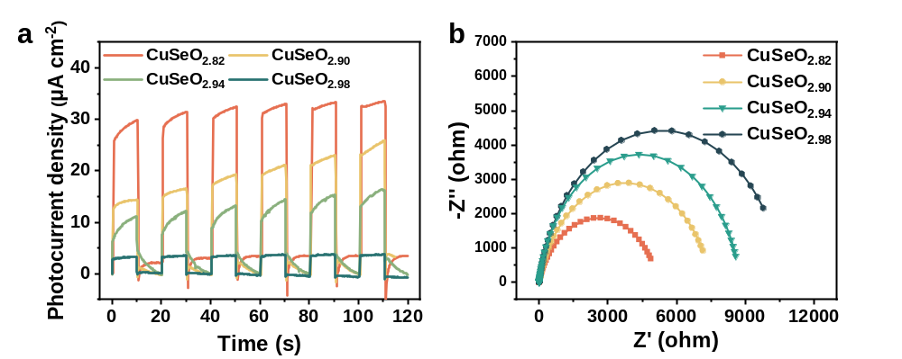
Supplementary Figure S17 | (a) Photocurrent density-time curves (at 0.29 V vs. RHE) of CuSeO_{3-x} under light on/off cycles. (b) EIS Nyquist plots of CuSeO_{3-x} under light illumination.

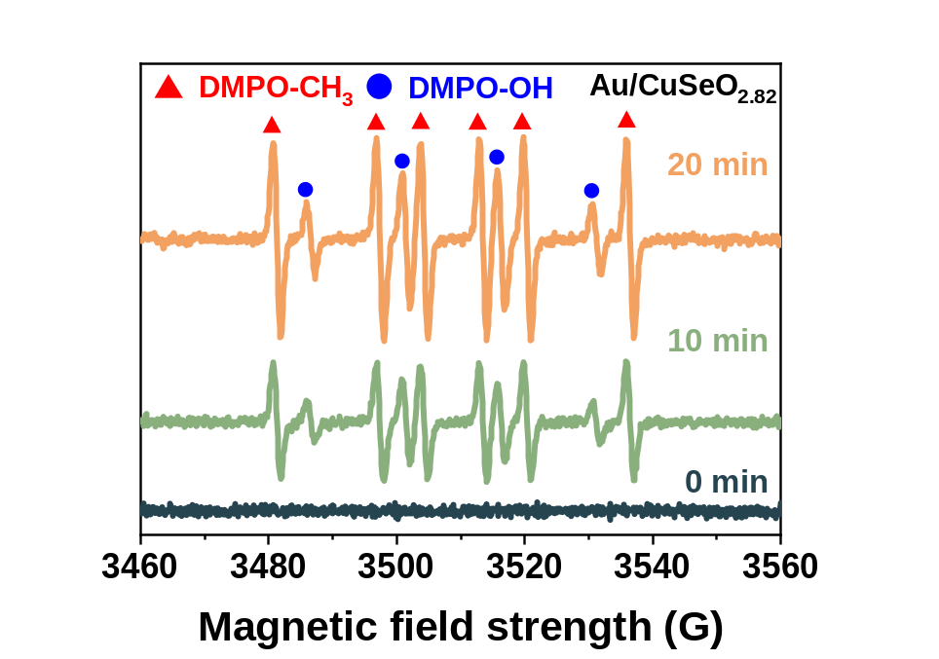
Supplementary Figure S18 | In situ EPR spectra for Au/CuSeO_{2.82} dispersed in deionized water in the presence of CH₄ and O₂ gases, either in the dark or under light illumination for different time periods.

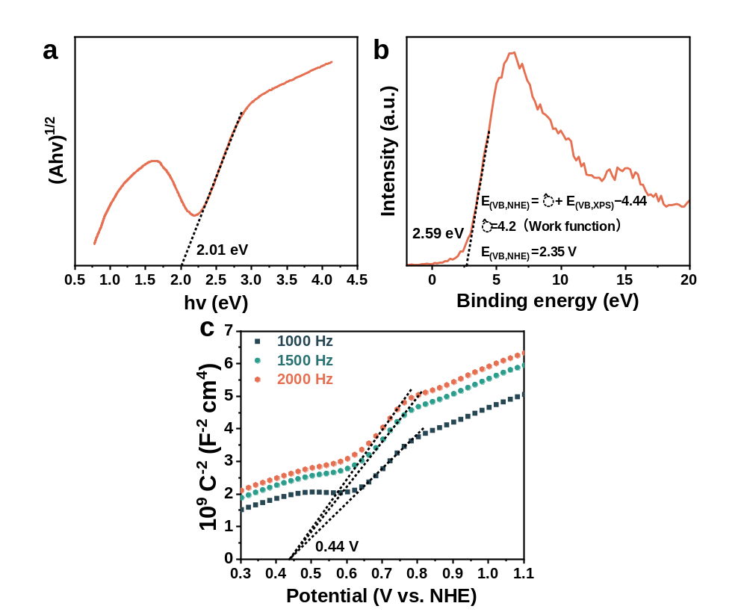
Supplementary Figure S19 | (a) Tauc plot, (b) VB-XPS spectrum and (c) Mott-Schottky plots at different frequencies for Au/CuSeO_{2.82}. Materials Project indicates that CuSeO₃ is an indirect semiconductor.

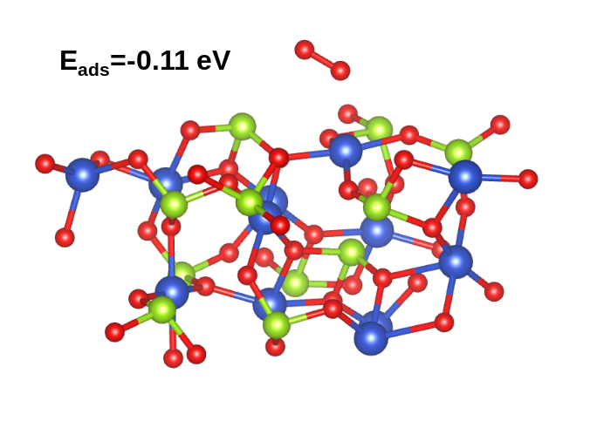
Supplementary Figure S20 | The optimized adsorption configuration of O₂ on the (111) facet of CuSeO₃ in the absence of oxygen vacancies.

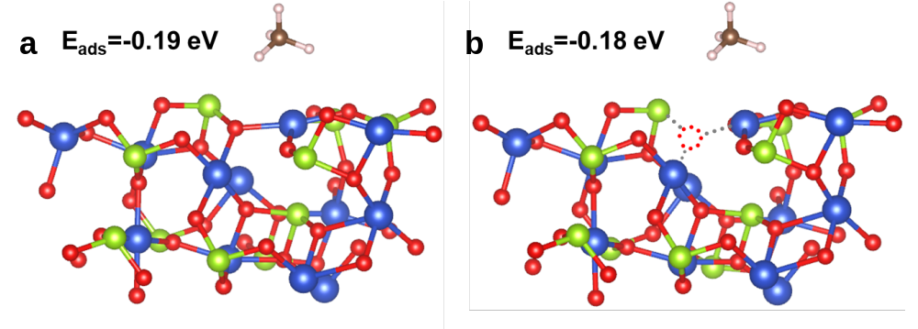
Supplementary Figure S21 | The optimized adsorption configurations of CH₄ on the (111) facet of (a) CuSeO₃ and (b) CuSeO_{3-x}.

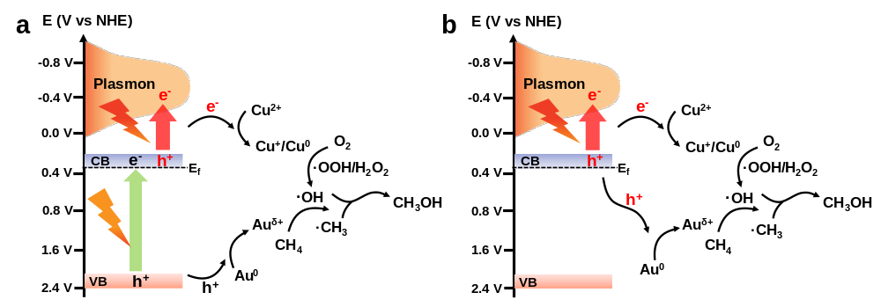
Supplementary Figure S22 | The overall mechanism proposed for photocatalytic methane oxidation by O₂ over Au/CuSeO_{3-x} under irradiation with (a) UV-vis-NIR light and (b) NIR light.

Supplementary References
1. Kresse, G.; Furthmüller, J. Efficiency of Ab-initio total energy calculations for metals and semiconductors using a plane-wave basis set. Comput. Mater. Sci. 6, 15−50 (1996).
2. Kresse, G.; Furthmüller, J. Efficient iterative schemes for Ab initio total-energy calculations using a plane-wave basis set. Phys. Rev. B 54, 11169−11186 (1996).
3. Perdew, J. P.; Burke, K.; Ernzerhof, M. Generalized Gradient Approximation Made Simple. Phys. Rev. Lett. 77, 3865−3868 (1996).
4. Kresse, G.; Joubert, D. From Ultrasoft Pseudopotentials to the Projector Augmented-Wave Method. Phys. Rev. B 59, 1758-1775 (1999).
5. Blöchl, P. E. Projector Augmented-Wave Method. Phys. Rev. B 50, 17953−17979 (1994).
6. Grimme, S.; Antony, J.; Ehrlich, S.; Krieg, H. J. Chem. Phys. 132, 154104 (2010).

