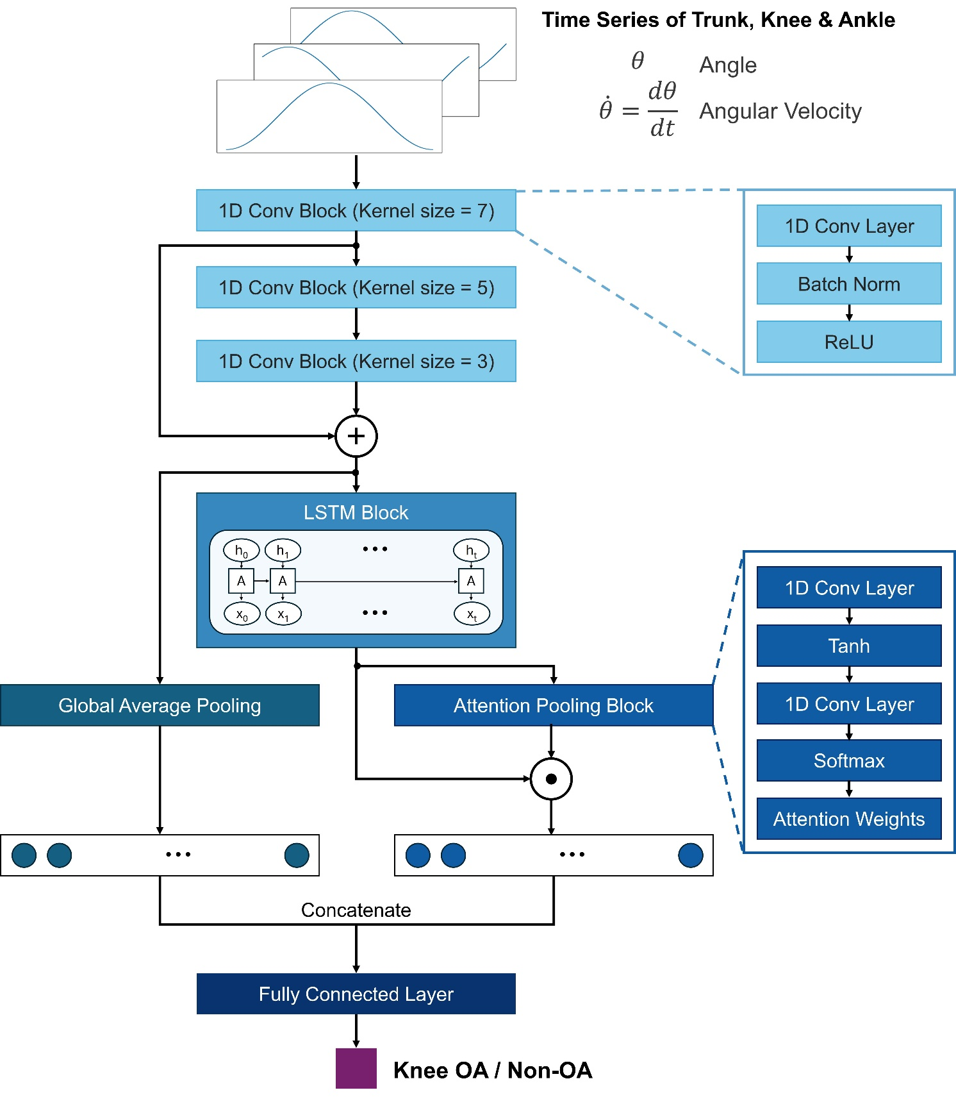
Supplementary Figure 1. Network architecture of the proposed STS-Dynamics Net for multivariate time series classification of the sit-to-stand motion.

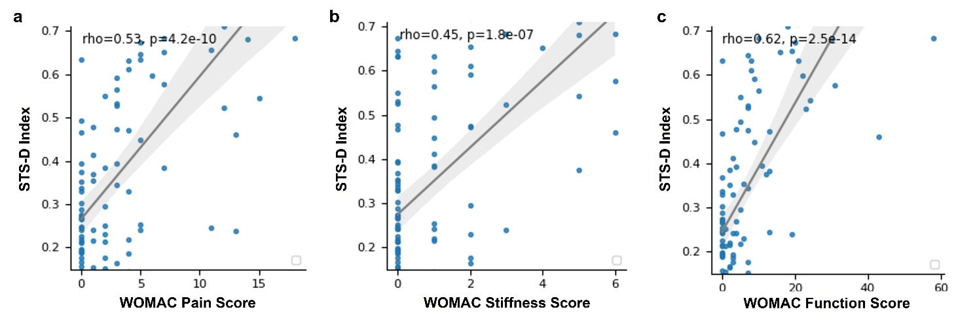
Supplementary Figure 2. Association between the STS-D Index and WOMAC sub-scores. Scatter plots illustrate the correlation between predicted knee OA risk scores and (a) pain, (b) stiffness, and (c) function scores. Spearman's correlation coefficient (rho) is used to quantify the strength and direction of the relationships, with corresponding p-values indicating statistical significance.

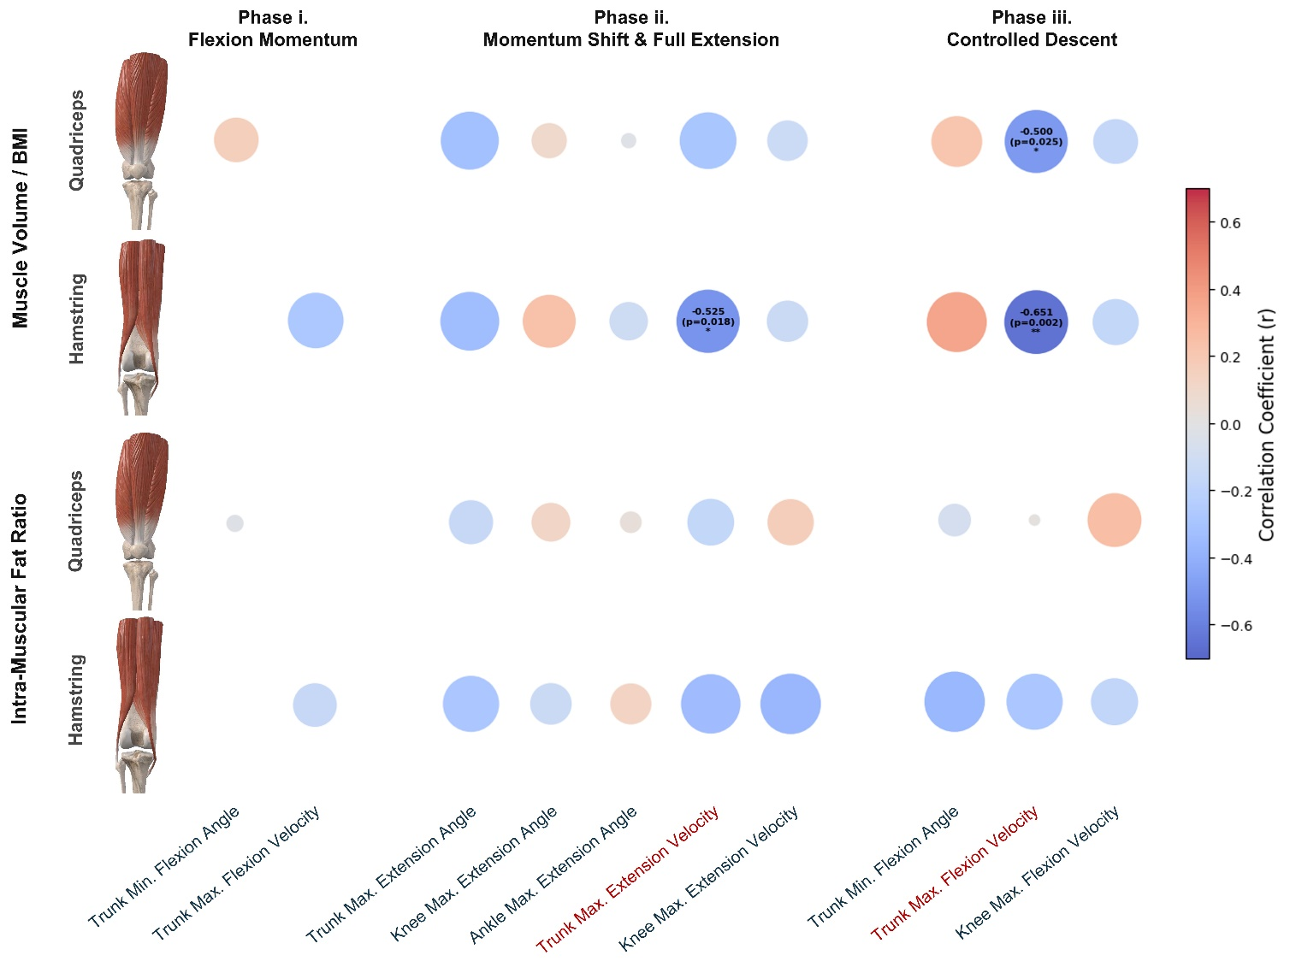
Supplementary Figure 3. Association analysis of joint kinematic parameters and muscle morphometry in the thigh. Correlation matrices were constructed to investigate the relationships between joint kinematic parameters and (a) muscle volumes, as well as (b) intra-muscular fat-to-muscle volume ratios in the Quadriceps and Hamstring, derived from T1-weighted Double-Echo Steady-State (DESS) magnetic resonance imaging (MRI) of the thigh. Pearson's correlation coefficients were used to quantify the strength and direction of these relationships. The results are visualized as heatmaps, where the color intensity represents the magnitude of the correlation, with red and blue indicating positive and negative correlations, while size of the bubbles represents the degree of statistical significance, respectively. Statistical significance is denoted by *p < 0.05 and **p < 0.01.

Supplementary Table 1. Performance comparison of different neural network architectures on testing set based on full dynamics of joint angles and angular velocities. Area under receiver-operating characteristic curve (AUC-ROC) and Area under precision-recall curve (AUC-PR) were adopted as the classification performance metrics.
Model | AUC-ROC | AUC-PR
FCN | 0.7793 ± 0.0558 | 0.7942 ± 0.0482
FCN-LSTM | 0.7964 ± 0.0828 | 0.8211 ± 0.0806
STS Dynamics Net (Ours) | 0.8484 ± 0.0324 | 0.8513 ± 0.0297

Supplementary Table 2. Performance comparison of different temporal joint kinematic inputs. Area under receiver-operating characteristic curve (AUC-ROC) and Area under precision-recall curve (AUC-PR) were adopted as the classification performance metrics.
Model | AUC-ROC | AUC-PR
Joint Angles | 0.8106 ± 0.0246 | 0.8234 ± 0.0233
Joint Angles + Angular Velocities | 0.8484 ± 0.0324 | 0.8513 ± 0.0297
Joint Angles + Angular Velocities +  Angular Accelerations | 0.8403 ± 0.0425 | 0.8489 ± 0.0446

Supplementary Table 3. Univariate and multivariate association analysis results of STS-D Index and WOMAC sub-scores
WOMAC  Sub-scores | Univariate (Spearman’s Correlation) |  | Multivariate (Linear Regression)
WOMAC  Sub-scores | Coefficient | p-value | Coefficient | p-value
Pain Score | 0.531 | < 0.001 | -0.038 | 0.765
Stiffness Score | 0.453 | < 0.001 | 0.101 | 0.230
Function Score | 0.620 | < 0.001 | 0.767 | < 0.001

