Supplementary document
Diattenuation and retardance signature of plasmonic gold nanorods in turbid media revealed by Mueller matrix polarimetry.
Subir Kumar Ray^{1,2*}, Nirmalya Ghosh³, Alex Vitkin^{1,2,4*}
¹Division of Biophysics and Bioimaging, Princess Margaret Research Institute, Toronto, Canada,
²Department of Medical Biophysics, University of Toronto, Toronto, Canada
³Indian Institute of Science Education and Research (IISER) Kolkata. Mohanpur, 741246, India
⁴Department of Radiation Oncology, University of Toronto, Toronto, Canada

- Generalize T-matrix formalism.
In a T-matrix framework, the incident, and the scattered fields from a long cylindrical scatterer (length >> diameter) can be expressed as [1]
$\left(\begin{matrix}E_{∥s} \\ E_{⊥s}\end{matrix}\right)=e^{{i3π}/4}\sqrt{\frac{2}{πkr\sin{ξ}}}e^{ik(r\sin{ξ}-z\cos{ξ})}\left(\begin{matrix}T^{11} & T^{12} \\ T^{21} & T^{22}\end{matrix}\right)\left(\begin{matrix}E_{∥i} \\ E_{⊥i}\end{matrix}\right)$ (S1)
where, the T-matrix elements can be expressed as,
$T^{11}=\sum_{-∞}^{+∞}{b_{nI}}e^{-inθ}$; $T^{12}=\sum_{-∞}^{+∞}{a_{nII}}e^{-inθ}$;
$T^{21}=\sum_{-∞}^{+∞}{a_{nI}}e^{-inθ}$; $T^{22}=\sum_{-∞}^{+∞}{b_{nII}}e^{-inθ}$;
And the coefficients are.
$a_{nI}=\frac{C_{n}V_{n}-B_{n}D_{n}}{w_{n}V_{N}+iD_{n}^{2}}$ $a_{nII}=\frac{A_{n}V_{n}-C_{n}D_{n}}{w_{n}V_{N}+iD_{n}^{2}}$ ; $B_{nI}=\frac{W_{n}B_{n}+iD_{n}C_{n}}{w_{n}V_{N}+iD_{n}^{2}}$ ; $B_{nII}=\frac{{-iC}_{n}W_{n}+A_{n}D_{n}}{w_{n}V_{N}+iD_{n}^{2}}$
where $A_{n}=iζ[ζJ_{n}^{'}\left(n\right)J_{n}\left(ζ\right)-ηJ_{n}\left(η\right)J_{n}^{'}\left(ζ\right)]$ ; $B_{n}=ζ[m^{2}ζJ_{n}^{'}\left(n\right)J_{n}\left(ζ\right)-ηJ_{n}\left(η\right)J_{n}^{'}\left(ζ\right)]$
$C_{n}=ncosζnJ_{n}\left(ζ\right)J_{n}(ζ)\left(\frac{ζ^{2}}{η^{2}}-1\right)$ ; $D_{n}=ncosζnJ_{n}\left(ζ\right)H_{n}^{1}(ζ)\left(\frac{ζ^{2}}{η^{2}}-1\right)$
$W_{n}=iζ[ηJ_{n}^{'}\left(η\right)H_{n}^{1'}\left(ζ\right)-ζJ_{n}^{'}\left(η\right)H_{n}^{1}(ζ)]$; $V_{n}=ζ[m^{2}{ζJ}_{n}^{'}\left(η\right)H_{n}^{1}\left(ζ\right)-ηJ_{n}\left(η\right)H_{n}^{1'}(ζ)]$
$ζ=x\sin{ζ}$ ; $η=x\sqrt{\left(m^{2}-\cos^{2}ζ\right)}$ ; $x=ka$
$J_{n}$ is Bessel function; $H_{n}^{1}=J_{n}+iY_{n}$ is the Hankel function.
Now consider a finite scattering object of single homogeneous body occupied by a region $V_{INT}$ bounded by a closed surface $S$ and imbedded in an infinitely extended homogeneous, isotropic, nonmagnetic, and non-absorbing medium. The infinite region exterior to the particle is denoted by $V_{EXT}$. The electric field for $r^{'}∈V_{EXT}$ can be related as [1-2]
$E\left(r\right)=E^{inc}\left(r^{'}\right)+E^{Scat}\left(r^{'}\right)$ (S2)
The known incident electric field can be express in terms of spherical harmonics as [1-2]
$E^{inc}\left(r^{'}\right)=\sum_{n=1}^{∞}{\sum_{m=-n}^{n}{\left[a_{mn}RgM_{mn}\left(k_{1}r'\right)+b_{mn}RgN_{mn}\left(k_{1}r'\right)\right]}}$ (S3)
Where, $a_{mn}=k_{1}{\left(-1\right)}^{m}\int{ds\left\{ωμ_{0}\left[\left(\hat{n}×H_{+}\left(r\right)\right)\right]M_{-mn}\left(k_{1}r,θ,φ\right)-ik_{1}\left[\left(\hat{n}×E_{+}\left(r\right)\right)\right]N_{-mn}\left(k_{1}r,θ,φ\right)\right\}}$ (S4)
and $b_{mn}=k_{1}{\left(-1\right)}^{m}\int{ds\left\{ωμ_{0}\left[\left(\hat{n}×H_{+}\left(r\right)\right)\right]N_{-mn}\left(k_{1}r,θ,φ\right)-ik_{1}\left[\left(\hat{n}×E_{+}\left(r\right)\right)\right]M_{-mn}\left(k_{1}r,θ,φ\right)\right\}}$ (S5)

similarly, scattered electric field can be express in terms of spherical harmonics as
$E^{Scat}\left(r^{'}\right)=\sum_{n=1}^{∞}{\sum_{m=-n}^{n}{\left[p_{mn}M_{mn}\left(k_{1}r'\right)+q_{mn}N_{mn}\left(k_{1}r'\right)\right]}}$ (S6)
Where,
$p_{mn}={-k}_{1}{\left(-1\right)}^{m}\int{ds\left\{ωμ_{0}\left[\left(\hat{n}×H_{+}\left(r\right)\right)\right]{RgM}_{-mn}\left(k_{1}r,θ,φ\right)-ik_{1}\left[\left(\hat{n}×E_{+}\left(r\right)\right)\right]{RgN}_{-mn}\left(k_{1}r,θ,φ\right)\right\}}$ (S7)
$q_{mn}={-k}_{1}{\left(-1\right)}^{m}\int{ds\left\{ωμ_{0}\left[\left(\hat{n}×H_{+}\left(r\right)\right)\right]{RgN}_{-mn}\left(k_{1}r,θ,φ\right)-ik_{1}\left[\left(\hat{n}×E_{+}\left(r\right)\right)\right]{RgM}_{-mn}\left(k_{1}r,θ,φ\right)\right\}}$ (S8)
The expansion coefficients of the scattered fields in eq. (S7 & S8) can be calculated by assuming the electric field at each point inside the scattering object can be expressed in a regular vector spherical wave functions of the interior wave equation and can be obtained from eq. (S4 & S5) as
$E\left(r\right)=\sum_{n'=1}^{∞}{\sum_{m'=-n'}^{n'}{\left[C_{m'n'}RgM_{m'n'}\left(k_{2}r\right)+D_{m'n'}RgN_{m'n'}\left(k_{2}r\right)\right] } r∈ V_{INT}}$ ; (S9)
$k_{2}$ wave number in the interior region. And the magnetic field expansion becomes,
$H\left(r\right)=\frac{k_{2}}{iωμ_{0}}\sum_{n'=1}^{∞}{\sum_{m'=-n'}^{n'}{\left[D_{m'n'}RgM_{m'n'}\left(k_{2}r\right)+C_{m'n'}RgN_{m'n'}\left(k_{2}r\right)\right] } r∈ V_{INT}}$ (S10)
Using continuity of tangential components of the electromagnetic fields
$\hat{n}×E_{+}\left(r\right)=\hat{n}×E_{-}\left(r\right)$
$r∈ S$ (S11)
$$\hat{n}×H_{+}\left(r\right)=\hat{n}×H_{-}\left(r\right)$$
Therefore substituting eq. (S9, S10 &S11) into eq. (S4 &S5) we get
$\left[\begin{matrix}a \\ b\end{matrix}\right]=\left[\begin{matrix}Q^{11} & Q^{12} \\ Q^{21} & Q^{22}\end{matrix}\right]\left[\begin{matrix}c \\ d\end{matrix}\right]$ (S12)
Where
$${ Q}_{mnm^{'}n^{'}}^{11}=-ik_{1}k_{2}J_{mn{m^{'}n}^{'}}^{21}-ik_{1}^{2}J_{mn{m^{'}n}^{'}}^{12}$$
$$Q_{mnm^{'}n^{'}}^{12}=-ik_{1}k_{2}J_{mn{m^{'}n}^{'}}^{11}-ik_{1}^{2}J_{mn{m^{'}n}^{'}}^{22}$$
$$Q_{mnm^{'}n^{'}}^{21}=-ik_{1}k_{2}J_{mn{m^{'}n}^{'}}^{22}-ik_{1}^{2}J_{mn{m^{'}n}^{'}}^{11}$$
$$Q_{mnm^{'}n^{'}}^{22}=-ik_{1}k_{2}J_{mn{m^{'}n}^{'}}^{12}-ik_{1}^{2}J_{mn{m^{'}n}^{'}}^{21}$$
And
$\left[\begin{matrix}\begin{matrix}J_{mn{m^{'}n}^{'}}^{11} \\ J_{mn{m^{'}n}^{'}}^{12}\end{matrix} \\ \begin{matrix}J_{mn{m^{'}n}^{'}}^{21} \\ J_{mn{m^{'}n}^{'}}^{22}\end{matrix}\end{matrix}\right]={\left(-1\right)}^{m}\int{ds\hat{n}.\left[\begin{matrix}\begin{matrix}RgM_{m'n'}\left(k_{2}r,θ,φ\right)×M_{-mn}\left(k_{1}r,θ,φ\right) \\ RgM_{m'n'}\left(k_{2}r,θ,φ\right)×N_{-mn}\left(k_{2}r,θ,φ\right)\end{matrix} \\ \begin{matrix}RgN_{m'n'}\left(k_{2}r,θ,φ\right)×M_{-mn}\left(k_{2}r,θ,φ\right) \\ RgN_{m'n'}\left(k_{2}r,θ,φ\right)×N_{-mn}\left(k_{2}r,θ,φ\right)\end{matrix}\end{matrix}\right]}$
Similarly, substituting eq. (S9, S10 &S11) into eq. (S4 &S5) we get
$\left[\begin{matrix}p \\ q\end{matrix}\right]=-\left[\begin{matrix}{RgQ}^{11} & {RgQ}^{12} \\ RgQ^{21} & {RgQ}^{22}\end{matrix}\right]\left[\begin{matrix}c \\ d\end{matrix}\right]$ (S13)
Where , $RgQ_{mnm^{'}n^{'}}^{11}=-ik_{1}k_{2}RgJ_{mn{m^{'}n}^{'}}^{21}-ik_{1}^{2}{RgJ}_{mn{m^{'}n}^{'}}^{12}$
${RgQ}_{mnm^{'}n^{'}}^{12}=-ik_{1}k_{2}RgJ_{mn{m^{'}n}^{'}}^{11}-ik_{1}^{2}RgJ_{mn{m^{'}n}^{'}}^{22}$
${RgQ}_{mnm^{'}n^{'}}^{21}=-ik_{1}k_{2}RgJ_{mn{m^{'}n}^{'}}^{22}-ik_{1}^{2}{RgJ}_{mn{m^{'}n}^{'}}^{11}$
${RgQ}_{mnm^{'}n^{'}}^{22}=-ik_{1}k_{2}RgJ_{mn{m^{'}n}^{'}}^{12}-ik_{1}^{2}{RgJ}_{mn{m^{'}n}^{'}}^{21}$
And $$\left[\begin{matrix}\begin{matrix}{RgJ}_{mn{m^{'}n}^{'}}^{11} \\ RgJ_{mn{m^{'}n}^{'}}^{12}\end{matrix} \\ \begin{matrix}{RgJ}_{mn{m^{'}n}^{'}}^{21} \\ RgJ_{mn{m^{'}n}^{'}}^{22}\end{matrix}\end{matrix}\right]={\left(-1\right)}^{m}\int{ds\hat{n.}\left[\begin{matrix}\begin{matrix}RgM_{m'n'}\left(k_{2}r,θ,φ\right)×{RgM}_{-mn}\left(k_{1}r,θ,φ\right) \\ RgM_{m'n'}\left(k_{2}r,θ,φ\right)×RgN_{-mn}\left(k_{2}r,θ,φ\right)\end{matrix} \\ \begin{matrix}RgN_{m'n'}\left(k_{2}r,θ,φ\right)×{RgM}_{-mn}\left(k_{2}r,θ,φ\right) \\ RgN_{m'n'}\left(k_{2}r,θ,φ\right)×{RgN}_{-mn}\left(k_{2}r,θ,φ\right)\end{matrix}\end{matrix}\right]}$$
Comparing eq. (3A), eq. (S12) and eq. (S13) we get
${ T}^{ij}=-(RgQ_{mnm'n'}^{ij}(kr,ϑ,φ)){Q_{mnm'n'}^{ij}(kr,ϑ,φ)}^{-1}$ (S14)
Here, $Q_{mn}\left(kr,ϑ,φ\right)=h_{n}^{1}(kr)({-1)}^{m}\sqrt{{\left(n+m\right)!}/{\left(n-m\right)!}}d_{0m}^{n}\left(ϑ\right)e^{imφ}$ and $RgQ_{mn}\left(kr,ϑ,φ\right)=j_{n}(kr)({-1)}^{m}\sqrt{{\left(n+m\right)!}/{\left(n-m\right)!}}d_{0m}^{n}(ϑ)e^{imφ}$; $j_{n}$&$d_{0m}^{n}$are Bessel and Wigner d-functions functions with $n=0,1,2,…; m=0, ±1, ±2, ….$.$Q_{mnm^{'}n^{'}}^{ij}$ were calculated using numerical integral $J_{mn{m^{'}n}^{'}}^{ij}$of the matrix elements as [3]:
For a rotationally symmetric scattering particle (GNR) and if the z-axis of the particle reference frame is directed along the axis of rotation then, it can be expressed in the form of
$r\left(θ,φ\right)=r(ϑ)\hat{r}$ and $ds\hat{ n}(r)=r^{2}\sin{ϑ}\left(\hat{r}-\frac{r_{ϑ}}{r}\hat{ϑ}\right)dϑdφ$
However, in our experimental case we have used a dog bone shaped GNR whose geometrical shape is defined by five parameters, the length $l$, central diameter $d$, end cape diameter $d_{1}=d(1+χ_{d})$, elliptical end-cap thickness $b_{1}=χ_{1}(d_{1}/2)$, and the shape of the generating line between the endcaps. Generating line is defined by the x-shifted circle ${\left(x-b-R\right)}^{2}+z^{2}=R^{2}$ . Using this approach, the T-matrix elements of an axially symmetric non-ideal finite GNRs (like the ones used in our study) can be determined from the known incident electric field. For a finite GNR with a radius vector r$\left(ϑ\right)$, components of the T matrix can be calculated from the interior scattered field component ($Q_{mnm^{'}n^{'}}^{ij}\left(kr^{'},ϑ,φ\right)$for $r^{'}<r$) and ($RgQ_{mnm'n'}^{ij}(kr^{'},ϑ,φ)$ for $r^{'}>r$) through the expansion of scattered electric fields using the integral
$J_{mn{m^{'}n}^{' =}}^{ij}\int_{-1}^{1}{d\left(\cos{ϑ}\right)}F_{mn{m^{'}n}^{'}}^{ij}\left(ϑ,k\sqrt{ε_{m}}r\left(ϑ\right),k\sqrt{ε}r\left(ϑ\right),r'\left(ϑ\right)\right)$ (S15)
where $i,j=1,2; -n≤m≤n;n=1,2,…$;$k\sqrt{ε_{m}}$ and $k\sqrt{ε}$ are the wave numbers in the external medium and inside the GNRs$,$the radius vector $r\left(ϑ\right)$defines the shape of the GNRs as a function of polar angle which incorporates central diameter, end-cap diameter, end-cap elliptical thickness and the shape of the generating line between the end caps; the function $F_{mn{m^{'}n}^{'}}^{ij}$is defined through the vector spherical harmonics and its derivatives [3]. Note that to incorporate the above model, the standard T matrix code [1-3] has been modified to determine the radius vector $r_{1}(ϑ) and r_{2}(ϑ)$ and their logarithmic derivatives accordingly.
- Polar Decomposition
To get quantitative polarization information from the experimentally recorded Mueller matrices, require some mathematical decomposition. Lu and Chipman prescribed one popular Polar Decomposition Method (PDM) by extracting three sequential polarization basis matrices deattenuating $M_{d}$, retarding $M_{R}$ and depolarizing $M_{Δ }$metrices as [4]
$M⟸M_{Δ }.M_{R }.M_{D }$ (S16)
where$M_{D }=\left(\begin{matrix}1 & D \\ D & m_{D}\end{matrix}\right), M_{Δ }=\left(\begin{matrix}1 & 0^{T} \\ P_{Δ } & m_{δ}\end{matrix}\right), M_{R }=\left(\begin{matrix}1 & 0^{T} \\ 0 & m_{R}\end{matrix}\right)$ and $D=\frac{1}{M_{11}}{\left[M_{12}M_{13}M_{14}\right]}^{T}$ is the deattenuating vector. The magnitude of
$\left|D\right|=\frac{1}{M_{11}}\sqrt{M_{12}^{2}+M_{13}^{2}+M_{14}^{2}}$ (S17)
gives the total diattenuation of the system. Similarly, $P=\frac{1}{M_{11}}{\left[M_{21}M_{31}M_{41}\right]}^{T}$ is the polarizance vector. $m_{δ}$ and $m_{R}$ are 3 x 3 sub-matrices of $M_{Δ }$and $M_{R }$ and can be found by solving the eigenvalues of $m^{'}=m_{δ}.m_{R}$. The net retardance can be extracted as $R=\cos^{-1}\left(\frac{Tr(M_{R })}{2}-1\right)$ and the linear retardance as
$δ=\cos^{-1}\left[\sqrt{{{(M}_{R,22}+M_{R,33})}^{2}+{{(M}_{R,32}+M_{R,23})}^{2}}-1\right]$ (S18)

- Spectral dependency of Depolarization
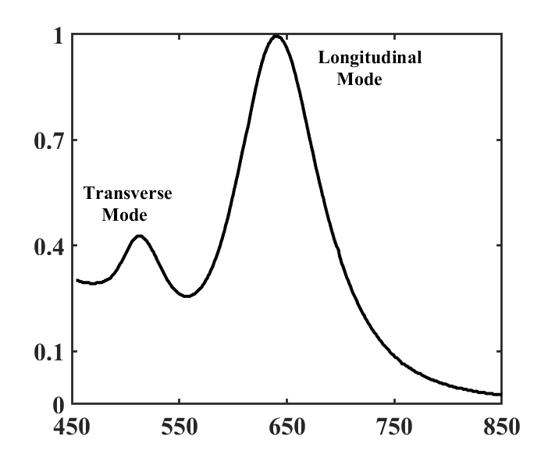
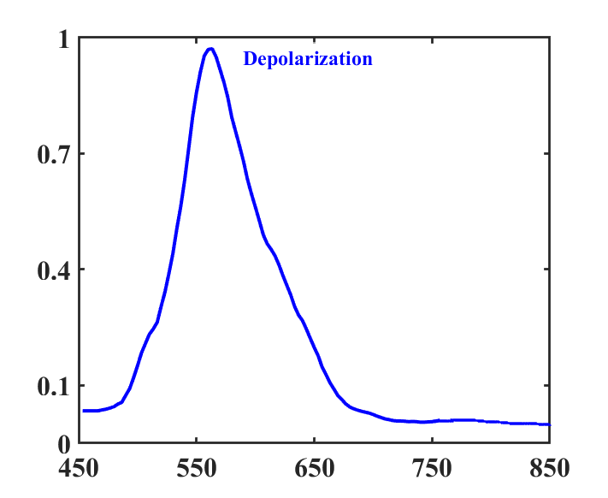
Wavelength (λ) in nm
Wavelength (λ) in nm
Normalized intensity
Normalized intensity
a)
b)

Figure S1: Simulated Wavelength dependency of localized surface plasmon resonance (LSPR) modes (a) and depolarization(b). Parameter chosen for GNR as length 70 nm and diameter 25 nm. Depolarization has maxima near 570 nm which is far away from the longitudinal LSPR mode at 640 nm.
Reference:
- Bohren, C.F. and Huffman, D.R. Absorption and scattering of light by small particles. John Wiley &Sons.(2008).
- Mishchenko, Michael I., Larry D. Travis, and Andrew A. Lacis. Scattering, absorption, and emission of light by small particles. Cambridge university press. (2002).
- Mishchenko, M.I. and Travis, L.D.Capabilities and limitations of a current FORTRAN implementation of the T-matrix method for randomly oriented, rotationally symmetric scatterers. Journal of Quantitative Spectroscopy and Radiative Transfer, 60, 309-324,(1998).
- Lu, S.Y. and Chipman, R.A. Interpretation of Mueller matrices based on polar decomposition. JOSA A, 13, 1106-1113, (1996).

