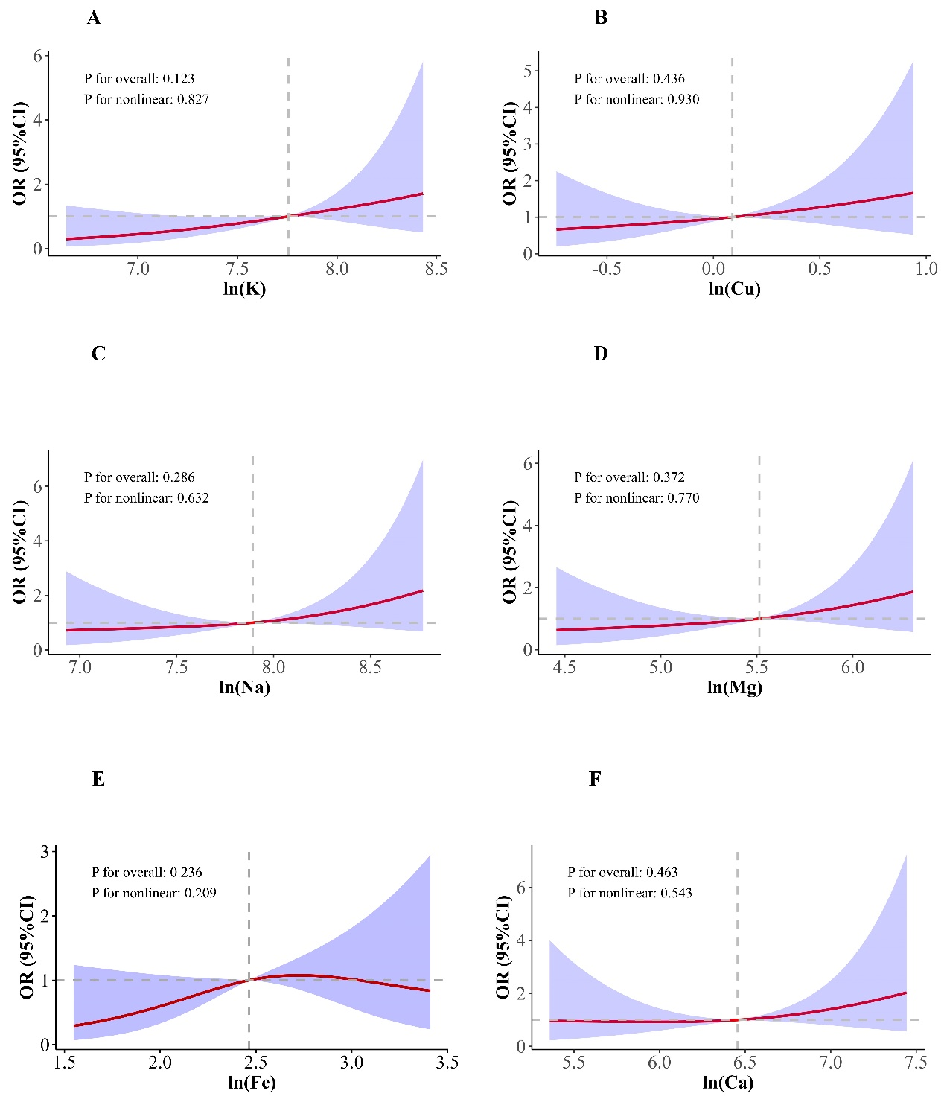
Supplement Figure 1, RCS plots show the OR change in different metallic elements. (A) RCS plot of K, (B) RCS plot of Cu, (C) RCS plot of Na, (D) RCS plot of Mg, (E) RCS plot of Fe, (F) RCS plot of Ca. The red line indicates the odds ratio (OR), while the blue area denotes the 95% confidence interval.

Metallic elements | Model1 |  | Model2 |  | Model3
Metallic elements | OR [95%] | p for trend | OR [95%] | p for trend | OR [95%] | p for trend
Zn | 1.13 [1.06, 1.20] | <0.001 | 1.15 [1.05, 1.25] | 0.005 | 1.13 [1.00, 1.27] | 0.046
Cu | 1.77 [0.65, 4.84] | 0.253 | 1.99 [0.74, 5.35] | 0.156 | 1.52 [0.47, 4.90] | 0.401
Fe | 1.06 [1.00, 1.12] | 0.059 | 1.04 [0.96, 1.13] | 0.251 | 1.03 [0.93, 1.13] | 0.548
Na | 1.00 [1.00, 1.00] | 0.454 | 1.00 [1.00, 1.00] | 0.073 | 1.00 [1.00, 1.00] | 0.12
K | 1.00 [1.00, 1.00] | 0.105 | 1.00 [1.00, 1.00] | 0.132 | 1.00 [1.00, 1.00] | 0.22
Ca | 1.00 [1.00, 1.00] | 0.049 | 1.00 [1.00, 1.00] | 0.165 | 1.00 [1.00, 1.00] | 0.299
Mg | 1.00 [1.00, 1.01] | 0.052 | 1.00 [1.00, 1.01] | 0.111 | 1.00 [1.00, 1.01] | 0.249
Supplement Table 1, the tendency analysis between metallic elements and DR risk.

