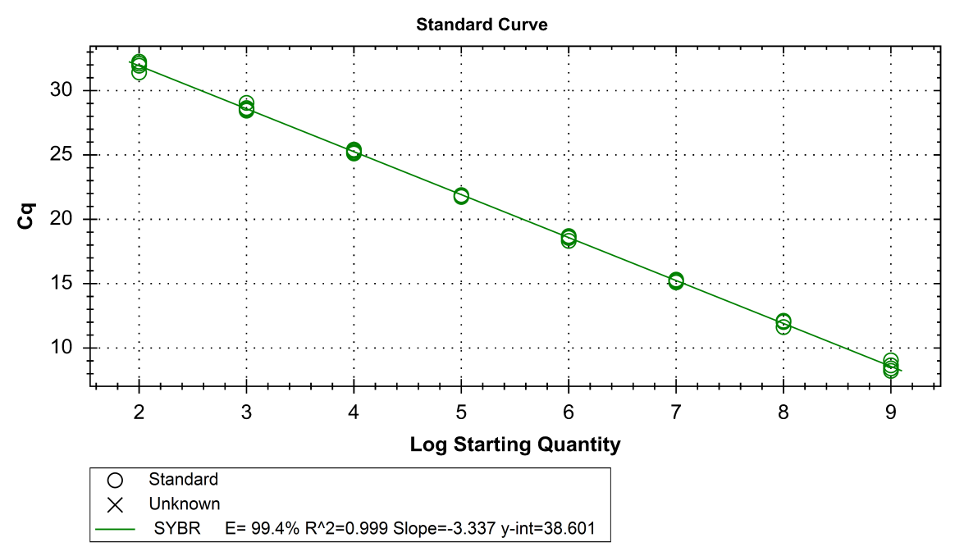
Figure.1 The standard curves of rAAV-CMV-PEDV S1 virus
Y= -3.221log₁₀N+36.441 (E= 104.4%, R²= 0.999)

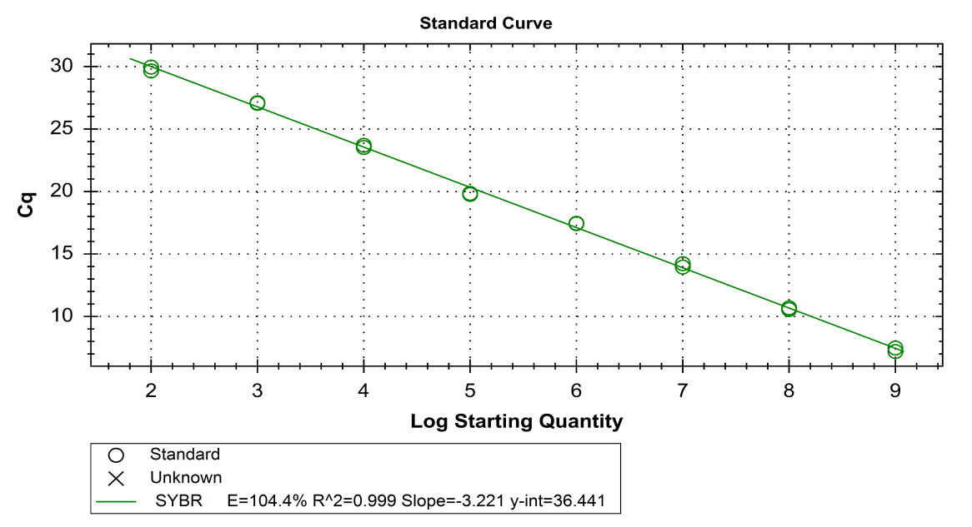
Figure.2 The standard curves of PEDV
Y= -3.337log₁₀N+38.601 (E=99.4%, R²=0.999)

Item | Metric | Score | Item | Metric | Score
Feeding situation | Normal | 2 | Fecal morphology | Normal | 3
Feeding situation | Little | 1 | Fecal morphology | Liquid-solid state | 2
Feeding situation | None | 0 | Fecal morphology | Caked/Liquid | 1
Drinking situation | Normal | 2 | Mental condition | Normal | 1
Drinking situation | Little | 1 | Mental condition | Depressed/Gitated | 0
Table.1 Comprehensive Scoring Table for the Feeding, Drinking, Mental State and Fecal Morphology of Pregnant Sows

Diarrhea Severity | Fecal Appearance Description | Score
Normal | Strip - shaped or granular | 3
Mild diarrhea | Formed, soft feces | 2
Moderate diarrhea | Viscous, no separation of feces and water, loose feces | 1
Severe diarrhea | Liquid, unformed | 0
Table. 2 Score of Diarrhea Severity in Piglets

Item | Index | Score
Score of Feed Intake | Normal feed intake | 2
Score of Feed Intake | Small - amount feed intake | 1
Score of Feed Intake | No feed intake | 0
Table. 3 Score of Feed Intake in Piglets

