Escitalopram intermittent use and brain reactivity to aggressive stimuli in premenstrual dysphoric disorder
Manon Dubol¹, Maria Gröndal², Felix Schmidt¹, Patrick M. Fisher^{3,4}, Vibe G. Frokjaer^{3,5}, Elias Eriksson⁶, Inger Sundström-Poromaa⁷, Erika Comasco¹*
SUPPLEMENT
Table S1. Demographic and clinical characteristics of the participants.
 | Whole sample (N=62) |  | Placebo Group (N=29) |  | Escitalopram Group (N=33)
Characteristic | N | % | N | % | N | %
Age group
20-29 years | 16 | 25.8 | 7 | 24.1 | 9 | 27.3
30-39 years | 31 | 50.0 | 17 | 58.6 | 14 | 42.4
>40 years | 15 | 24.2 | 5 | 17.2 | 10 | 30.3
BMI group
Underweight | 1 | 1.6 | 1 | 3.4 | 0 | -
Normal weight | 39 | 62.9 | 16 | 55.2 | 23 | 69.7
Overweight | 13 | 21.0 | 7 | 24.1 | 6 | 18.2
Obesity | 7 | 3.2 | 4 | 13.8 | 3 | 9.1
Civil status
Married/cohabiting | 42 | 67.7 | 18 | 62.1 | 24 | 72.7
Single living, in a relationship | 7 | 11.3 | 3 | 10.3 | 4 | 12.1
Single | 13 | 21.0 | 8 | 27.6 | 5 | 15.2
Parity
Parous | 35 | 56.5 | 14 | 48.3 | 21 | 63.6
Nulliparous | 27 | 43.5 | 15 | 51.7 | 12 | 36.4
Education level
University degree | 47 | 75.8 | 20 | 69.0 | 27 | 81.8
No University degree | 15 | 24.2 | 9 | 31.0 | 6 | 18.2
Employment
Working | 51 | 82.3 | 27 | 93.1 | 24 | 72.7
Studying | 9 | 14.5 | 1 | 6.9 | 7 | 21.2
Other | 2 | 3,2 | 0 | - | 2 | 6.1
Nicotine user | 14 | 22.6 | 7 | 24.1 | 7 | 21.2
Previous PMDD treatment
Any treatment | 48 | 77.4 | 21 | 72.4 | 27 | 81.8
Antidepressant treatment | 35 | 56.5 | 19 | 65.5 | 16 | 48.5
Hormonal treatment | 22 | 35.5 | 10 | 34.5 | 12 | 36.4
Psychological treatment | 5 | 8.1 | 4 | 13.8 | 1 | 3.0
Psychiatric history
Previous depression | 22 | 35.5 | 11 | 37.9 | 11 | 33.3
Previous anxiety | 10 | 16.1 | 4 | 13.8 | 6 | 18.2
The PSAP aggression score represents the ratio of aggressive responses over provocations, adjusted for the total number of button presses. Abbreviations: BMI, body mass index; PMDD, premenstrual dysphoric disorder.

Table S2. Group difference in PMDD core symptom severity upon intermittent treatment with escitalopram versus placebo
 | Baseline |  | Follow-up |  | Group difference at follow-up
DRSP score | Placebo | Escitalopram | Placebo | Escitalopram | p-value | Cohen’s d
Total | 63.11 ± 17.7 | 66.9 ± 20.6 | 57.06 ± 20.94 | 47.21 ± 19.05 | 0.033* | 0.49
Depression | 9.09 ± 3.01 | 9.84 ± 3.8 | 8.54 ± 3.36 | 6.13 ± 3.39 | 0.004* | 0.71
Anxiety | 3.21 ± 1.31 | 3.45 ± 1.40 | 2.78 ± 1.46 | 2.29 ± 1.19 | 0.265 | 0.36
Irritability | 6.88 ± 2.53 | 6.73 ± 2.14 | 5.98 ± 2.64 | 3.87 ± 1.88 | 0.003* | 0.93
Affective lability | 6.93 ± 2.63 | 7.03 ± 2.38 | 5.76 ± 2.65 | 3.88 ± 2.18 | 0.004* | 0.78
Mean DRSP scores ± standard deviations are given for each treatment group (escitalopram/placebo), at baseline and at the end of trial, including the total DRSP score and the four PMDD core affective symptom scores. Group comparisons of symptom severity at the end of trial are also presented (Independent-Samples Mann-Whitney U Tests). Abbreviations: DRSP, Daily Record of Severity of Problems; PMDD, PreMenstrual Dysphoric Disorder. *p<0.05 after FDR correction.

Table S3 Independent bootstrapped T-tests of behavioral differences in PSAP between the placebo and escitalopram groups.
 | Placebo | Escitalopram | g | 95% CI
Variable | M ± SD | M ± SD | g | 95% CI
 | (n = 19) | (n = 19)
Points earned | 1.63 ± 5.93 | .84 ± 5.12 | .136 | [-.458, .789]
Provocations from the opponent | 14.84 ± 3.13 | 15.05 ± 2.88 | .067 | [-.690, .600]
Earning responses | 1675.11 ± 485.79 | 1634.58 ± 489.62 | .079 | [-.596, .609]
Stealing responses | 213.16 ± 171.4 | 270 ± 269.16 | -.242 | [-.749, .420]
Protective responses | 183.37 ± 155.65 | 174.74 ± 116.05 | .060 | [-.635, .646]
Total buttom presses | 2071.64 ± 423.07 | 2079.84 ± 357.18 | -.020 | [-.638, .645]
Stealing/Provocations | 15.94 ± 13.01 | 19.64 ± 20.1 | -.228 | [-.746, .490]
PSAP aggression score | 7.65 ± 6.06 | 9.83 ± 11.74 | -.222 | [-.699, .570]
The PSAP aggression score represents the ratio of aggressive responses over provocations, adjusted for the total number of button presses. Abbreviations: PSAP, Point Subtraction Aggression Paradigm.

Table S4. Main task effects on brain reactivity within regions of interest over the whole group.
ROI | Cluster size | MNI coordinates for peak voxel |  |  |  | p_{FWE} - peak | Location (AAL)
ROI | Cluster size | x | y | z | T-score | p_{FWE} - peak | Location (AAL)
Prefrontal cortex
Provocation
 | 1730 | 40 | 6 | 32 | 7.37 | 1.31e-4 | Frontal Inf Oper R
 | 1730 | 42 | 36 | 18 | 6.71 | 9.60e-4 | Frontal Mid R
 | 1730 | 52 | 18 | 18 | 6.55 | 1.5e-3 | Frontal Inf Tri R
 | 969 | -38 | 16 | 22 | 7.20 | 2.13e-4 | Frontal Inf Tri L
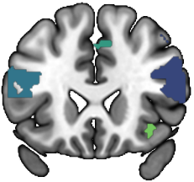 | 969 | -46 | 14 | 22 | 7.16 | 2.46e-4 | Frontal Inf Oper L
 | 969 | -50 | 12 | 38 | 5.90 | 0.012 | Frontal Mid L
 | 155 | 2 | 24 | 44 | 6.57 | 1.5e-3 | Frontal Sup Medial L
 | 155 | 4 | 32 | 46 | 5.01 | 0.144 | Frontal Sup Medial R
 | 46 | 32 | 24 | -6 | 6.50 | 1.8e-3 | Frontal Inf Orb R
Aggressive response
 | 73 | -26 | -8 | 50 | 6.85 | 9.83e-4 | Frontal Mid L
 |  | -26 | -6 | 58 | 3.97 | 0.872 | Frontal Sup L
 | 632 | -38 | 48 | 20 | 6.09 | 0.009 | Frontal Mid L
 |  | -44 | 4 | 26 | 5.41 | 0.066 | Frontal Inf Oper L
 |  | -42 | 28 | 28 | 5.26 | 0.098 | Frontal Inf Tri L
 | 639 | 32 | 2 | 64 | 5.94 | 0.014 | Frontal Sup R
 |  | 30 | 0 | 52 | 5.59 | 0.040 | Frontal Mid R
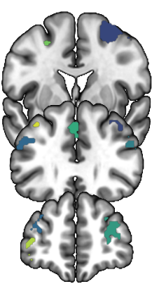 | 325 | 46 | 24 | 30 | 5.89 | 0.016 | Frontal Inf Tri R
 |  | 42 | 12 | 30 | 5.77 | 0.023 | Frontal Inf Oper R
 | 222 | 2 | 42 | 36 | 5.29 | 0.090 | Frontal Sup Medial L
 |  | 6 | 20 | 42 | 4.73 | 0.306 | Frontal Sup Medial R
 | 54 | -40 | 52 | 4 | 5.06 | 0.155 | Frontal Mid L
 |  | -36 | 56 | -2 | 3.92 | 0.900 | Frontal Mid Orb L
 | 246 | 28 | 46 | 8 | 4.85 | 0.243 | Frontal Sup R
 |  | 30 | 52 | 14 | 4.59 | 0.403 | Frontal Mid R
 | 34 | -36 | 26 | 44 | 4.72 | 0.315 | Frontal Mid L
Winning reward
 | 91 | 44 | 10 | 30 | 6.55 | 0.002 | Frontal Inf Oper R
 |  | 46 | 22 | 24 | 3.45 | 0.996 | Frontal Inf Tri R
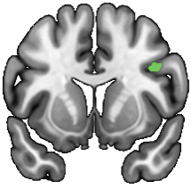
Ant. cingulate cortex
Provocation
 | 108 | 6 | 42 | 16 | 5.66 | 0.003 | Cingulum Ant R
 | 26 | 6 | 4 | 28 | 4.68 | 0.045 | Cingulum Ant R
 |  | -2 | 6 | 26 | 4.54 | 0.063 | Cingulum Ant L
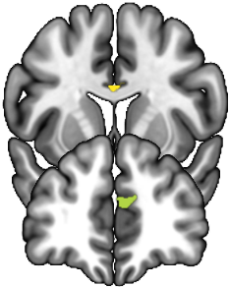
Aggressive response
 | 72 | 8 | 38 | 28 | 4.60 | 0.057 | Cingulum Ant R
 |  | -4 | 30 | 20 | 4.22 | 0.130 | Cingulum Ant L
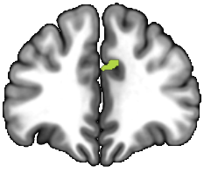
Insula
Provocation
 | 285 | 32 | 24 | -4 | 6.92 | 7.54e-5 | Insula R
 | 286 | -28 | 22 | -6 | 5.46 | 0.006 | Insula L
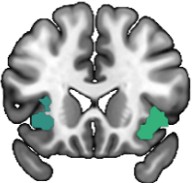
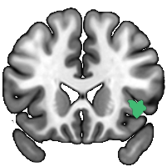
Aggressive response
 | 99 | 38 | 22 | -2 | 5.64 | 0.005 | Insula R
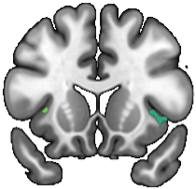
Winning reward
 | 115 | 36 | 20 | 0 | 5.78 | 0.002 | Insula R
 | 16 | -32 | 14 | 2 | 4.64 | 0.064 | Insula L
Amygdala
Provocation
 | 19 | -28 | 2 | -22 | 5.24 | 0.028 | Amygdala L
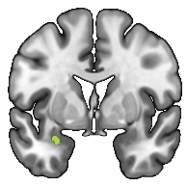
Striatum
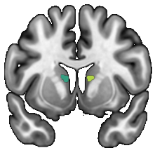
Provocation
 | 36 | -14 | 4 | 12 | 5.12 | 0.019 | Caudate L
 | 33 | 12 | 8 | 10 | 4.63 | 0.072 | Caudate R
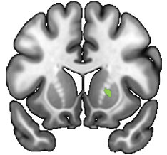
Aggressive response
 | 27 | 20 | 14 | 2 | 6.06 | 0.001 | Putamen R
 |  | 16 | 18 | 4 | 4.23 | 0.182 | Caudate R
Winning reward
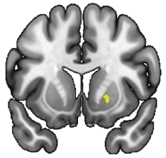 | 19 | 20 | 10 | -2 | 5.05 | 0.024 | Putamen R
The significant clusters resulting from voxel-wise one sample t-tests assessing brain reactivity to the task condition in each ROI, across treatment groups, are presented. The significant clusters (p_{FWE} < 0.05) were overlaid onto coronal brain slices from a standard MRI template in MNI space using MRIcroGL (v1.2.20220720). Clusters’ peak voxel’s location are presented in MNI coordinates (mm). Cluster peak data are presented in bold and local maxima in non-bold. No significant brain reactivity was detected in association to the ‘stealing’ and ‘protecting’ task conditions. Abbreviations: AAL, Automated Anatomical Labeling atlas; Ant., anterior; FWE, Family-Wise Error; L, left; MNI, Montreal Neurological Institute; R, right; ROI, region-of-interest.

Table S5. Group differences in brain reactivity to provocation per, ROI
ROI | Cluster peak location | t-value | p-value | Cohen’s d | 95% CI
PFC | IFGoper R | 0.594 | 0.556 | 0.195 | [-0.45, 0.84]
 | IFGtri L | 0.408 | 0.686 | 0.134 | [-0.51, 0.78]
 | mSFG L | -0.552 | 0.585 | -0.182 | [-0.83, 0.47]
 | IFGorb R | 0.289 | 0.775 | 0.095 | [-0.55, 0.74]
ACC | pACC/MCC | 0.370 | 0.714 | 0.122 | [-0.52, 0.77]
 | dACC | 0.058 | 0.954 | 0.019 | [-0.63, 0.66]
Insula | Insula R | -0.548 | 0.587 | -0.180 | [-0.82, 0.47]
 | Insula L | -2.10ª | 0.036* | -0.345 | [-0.66, -0.02]
Amygdala | Amygdala L | 0.67ª | 0.518 | 0.110 | [-0.21, 0.43]
Striatum | Caudate L | 0.644 | 0.525 | 0.215 | [-0.43, 0.86]
 | Caudate R | 0.625 | 0.536 | 0.206 | [-0.44, 0.85]

ª Standardized Mann-Whitney U test statistic. *p < 0.05, uncorrected for multiple testing.
Table S6. Group differences in brain reactivity during aggressive response, per ROI
ROI | Cluster peak location | t-value | p-value | Cohen’s d | 95% CI
PFC | Sup. MFG L | -0.414 | 0.695 | -0.071 | [-0.41, 0.26]
 | Inf. MFG L | 0.104 | 0.932 | 0.018 | [-0.32, 0.35]
 | SFG R | -1.104 | 0.281 | -0.189 | [-0.52, 0.15]
 | IFGtri R | 0.606 | 0.549 | 0.208 | [-0.47, 0.88]
 | mSFG L | -0.118 | 0.907 | -0.041 | [-0.71, 0.63]
 | Orb. MFG L | -0.932 | 0.365 | -0.16 | [-0.50, 0.18]
 | SFG R | -1.691ª | 0.095 | -0.29 | [-0.63, 0.05]
 | MFG L | 0.035 | 1 | 0.006 | [-0.33, 0.34]
ACC | dACC R | 1.455 | 0.156 | 0.500 | [-0.19, 1.18]
Insula | Insula R | 1.414 | 0.167 | 0.486 | [-0.20, 1.17]
Striatum | Putamen R | -0.573 | 0.571 | -0.197 | [-0.87, 0.48]

ª Standardized Mann-Whitney U test statistic. *p < 0.05, uncorrected for multiple testing.
Table S7. Group differences in brain reactivity to winning reward, per ROI
ROI | Cluster peak location | t-value | p-value | Cohen’s d | 95% CI
PFC | IFGoper R | 1.182 | 0.245 | 0.389 | [-0.26, 1.04]
Insula | Insula R | 0.936 | 0.356 | 0.308 | [-0.34, 0.95]
 | Insula L | 1.418 | 0.165 | 0.466 | [-0.19, 1.12]
Striatum | Putamen R | -1.267 | 0.214 | -0.414 | [-1.06, 0.24]

ª Standardized Mann-Whitney U test statistic. *p < 0.05, uncorrected for multiple testing.

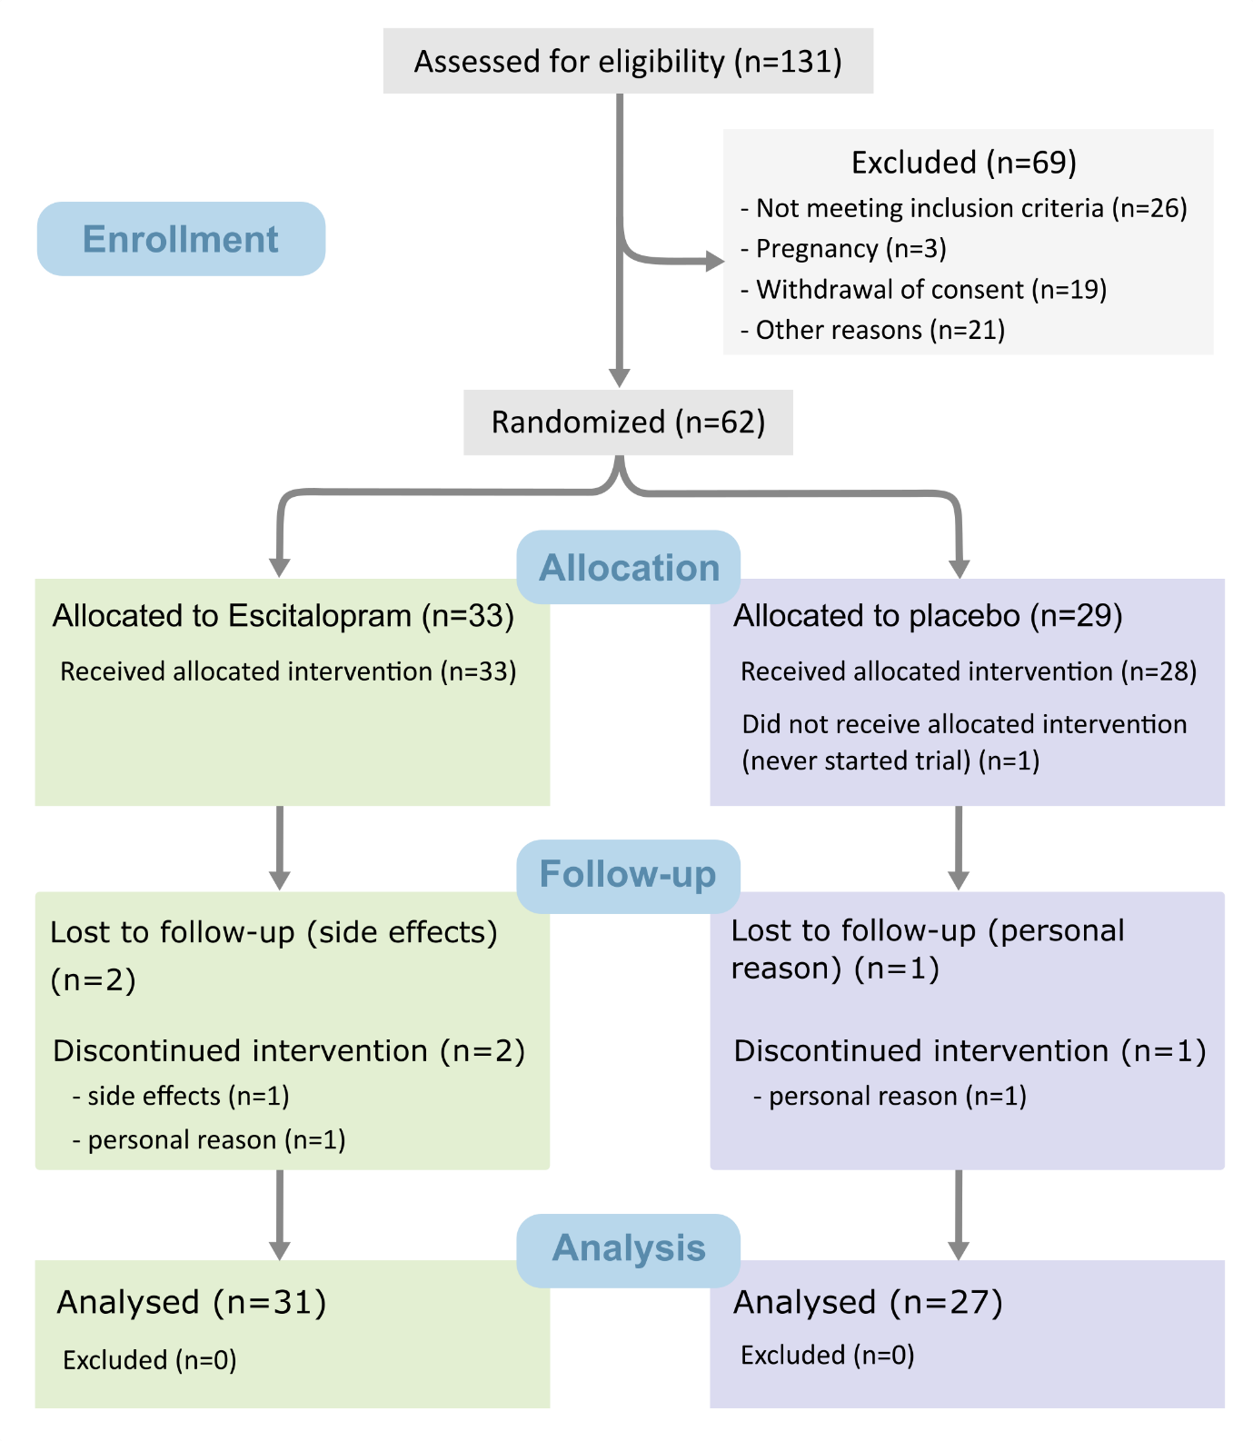Figure S1. CONSORT flow diagram.

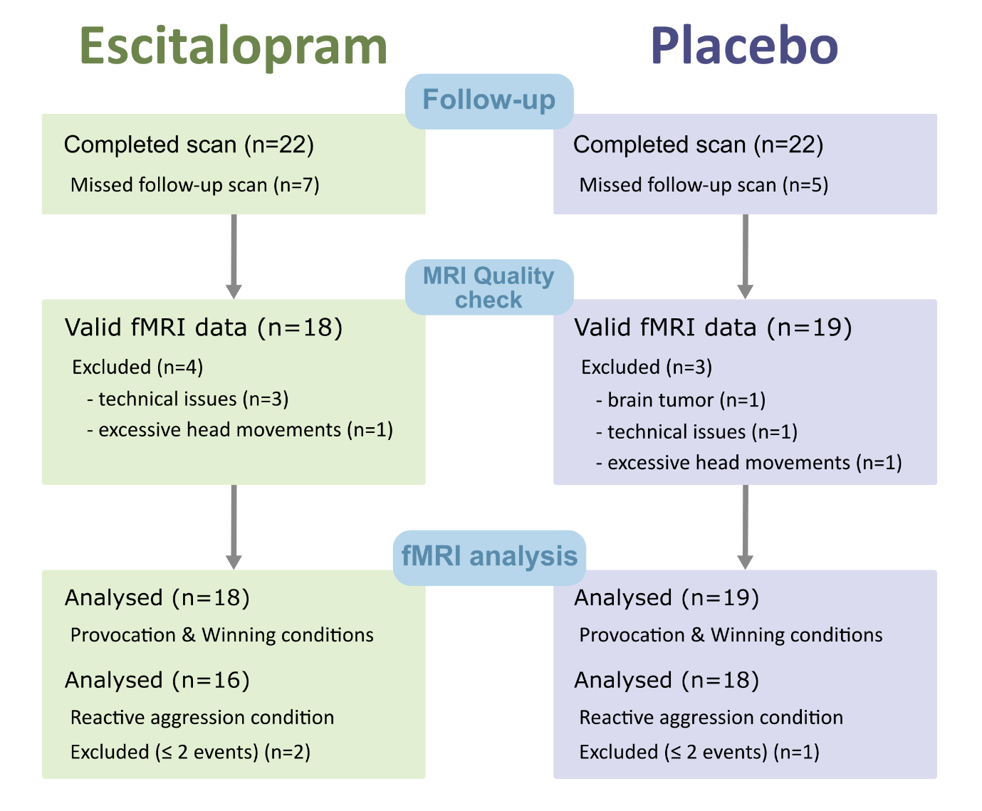
Figure S2. fMRI study flowchart.

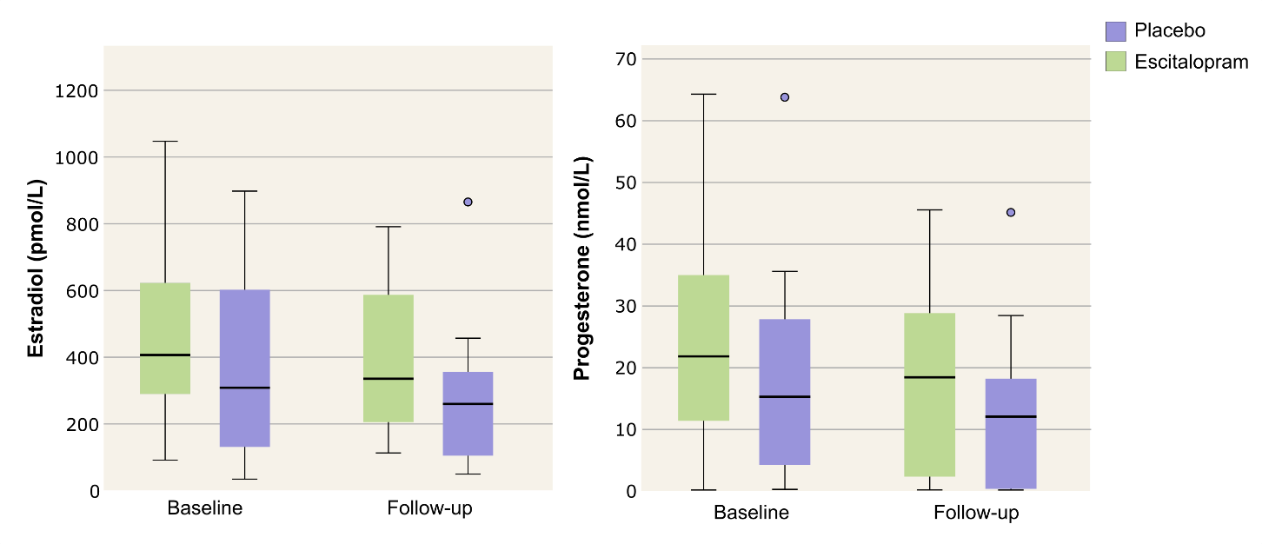Figure S3. Oestradiol and progesterone serum levels. Boxplots showing the serum concentration of oestradiol and progesterone at baseline and follow-up, within the two treatment groups. Outliers are indicated by circles, and defined as: upper quartile + 1.5*interquartile range.
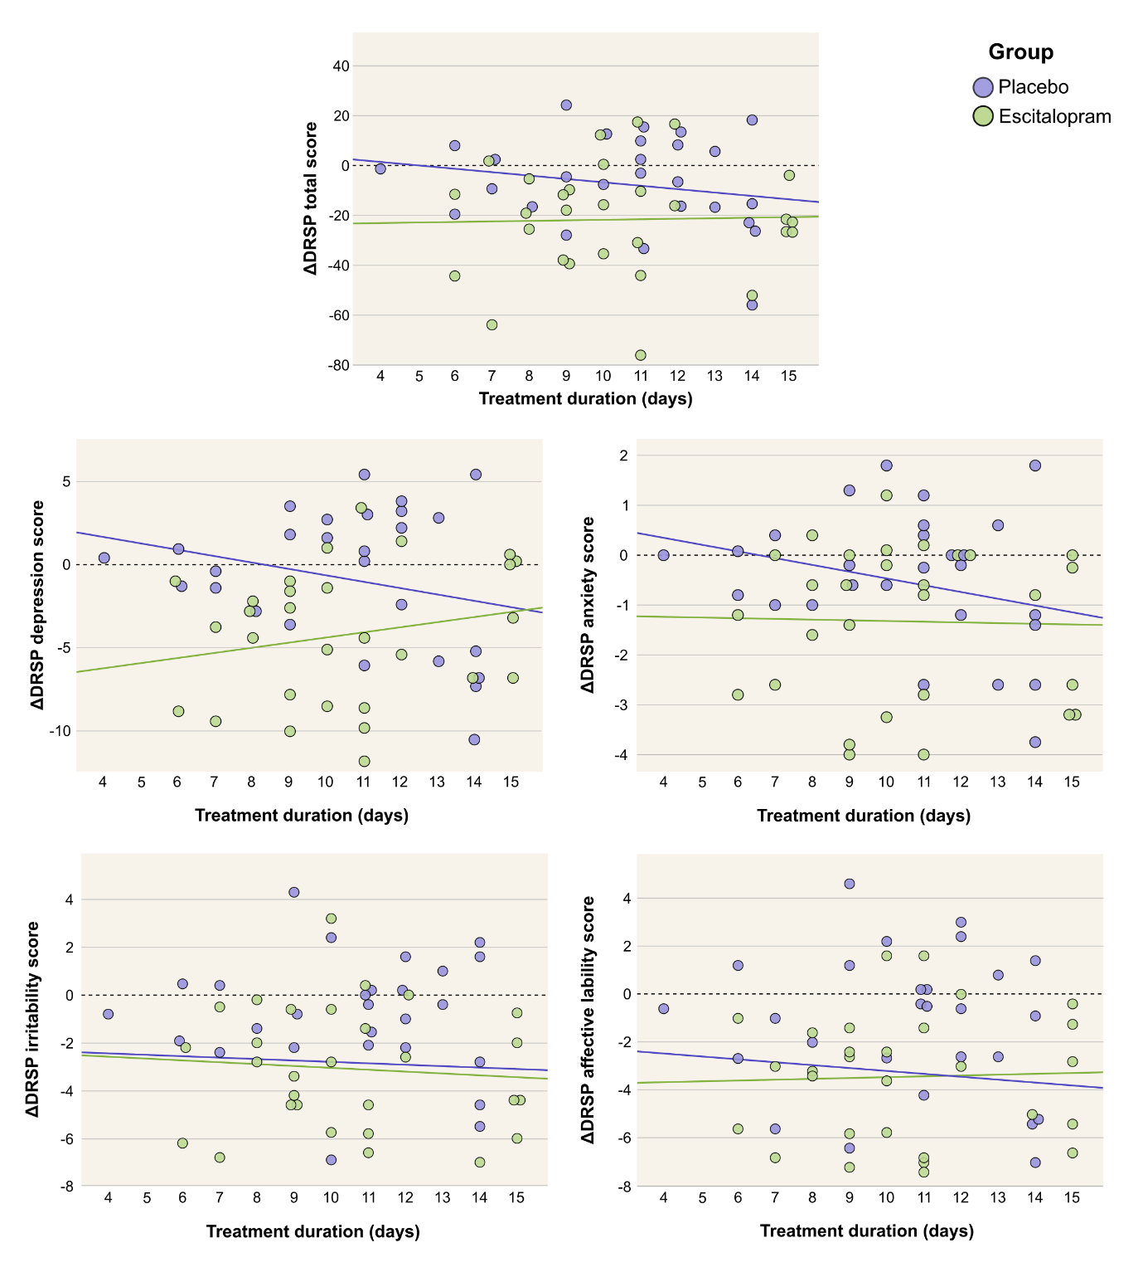
Figure S4. Distribution of treatment duration and change in symptom severity across treatment groups. Scatter plots displaying individual change in DRSP scores as a function of treatment duration. The DRSP total score, and four core PMDD symptoms scores are shown. Two participants who discontinued the treatment after 4 days but continued to provide symptom ratings until the end of the RCT are included. Within the SSRI group, treatment duration was not associated with symptom improvement (Spearman correlations; total DRSP score: ρ=0.0, p=0.99; depression DRSP score: ρ =0.18, p=0.34; anxiety DRSP score: ρ =0.01, p=0.95; irritability DRSP score: ρ =-0.05, p=0.78; affective lability DRSP score: ρ =0.07, p=0.73). Likewise, treatment duration was not associated with symptom improvement within the placebo group (Pearson correlations; total DRSP score: r=-0.19, p=0.34; depression DRSP score: r=-0.24, p=0.23; anxiety DRSP score: r=-0.26, p=0.19; irritability DRSP score: r=-0.06, p=0.75; affective lability DRSP score: r=0.10, p=0.60).

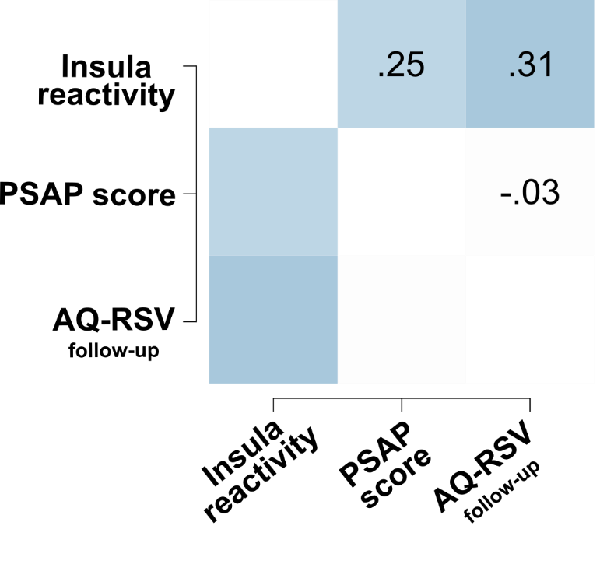
Figure S5. Association between aggression measures and brain reactivity to provocation within the left anterior insula. The heatmap of the correlation matrix between the brain reactivity to provocation within the left insula cluster, the PSAP aggression score, and the total AQ-RSV score at follow-up, shows no significant association, across all participants.

