Supplementary Figure 1.
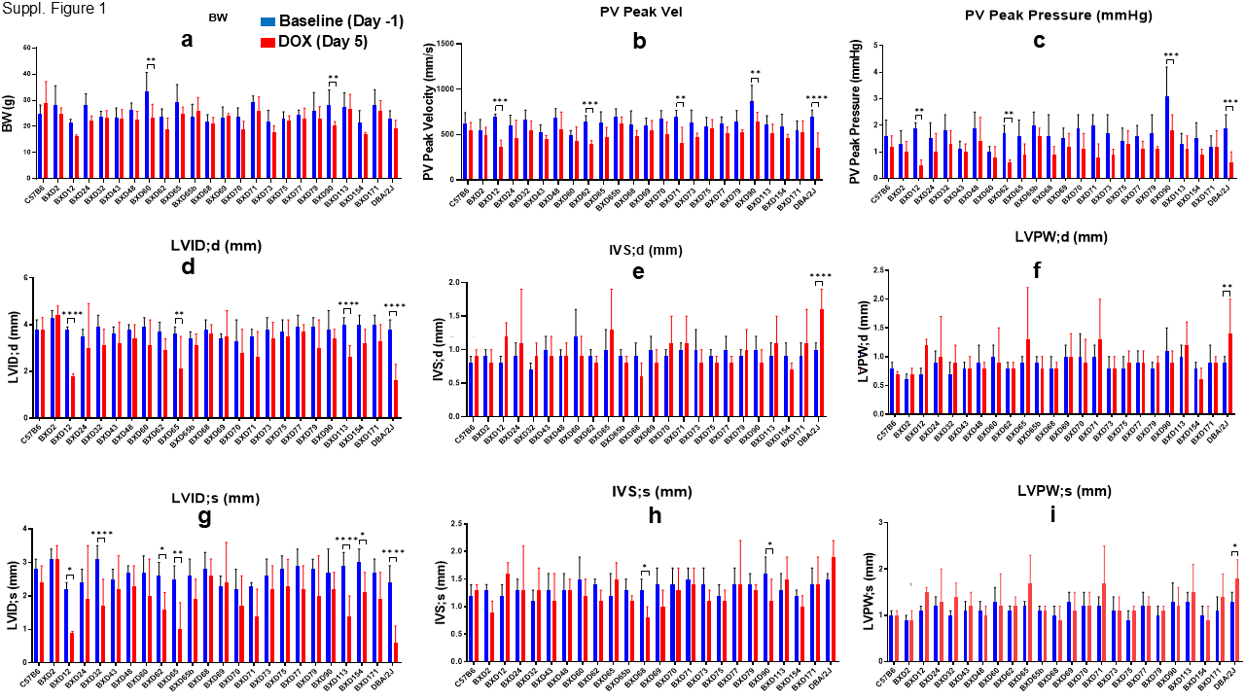
Supplementary Figure 1. Results of echocardiographic assessment of heart function in BXDs treated with DOX.
Values on Y-axis represent: a) mean body weight (BW) in grams (g); b) pulmonary vein (PV) peak velocity (mm/sec); c) PV peak pressure (mmHg); d) left ventricular (LV) internal diameter (ID) (mm); e) interventricular septum (IVS) thickness (mm); f) LV posterior wall (PW) thickness (mm) at diastole (d); g) LVID, h) IVS thickness and i) LVPW thickness at systole (s) among BXDs (X-axis) at baseline (Day -1, blue columns) compared to Day 5 post-DOX treatment (red columns). Asterisks denote significant differences between Day -1 and Day 5.

