Supplementary Material for

Rapid yet reliable: Optimising mobile cognitive assessments tool for older adults
Hyun Jeong Ko^{1†}, Jin Sung Kim^{2,3,7†}, Whani Kim¹, Byung Hun Yun^{1,3}, Dong Han Kim¹, Ui Jun Kwon¹, Sang Kwon Lim¹, Bo Ri Kim⁴, Jee Hang Lee^{2,3,7*}, Geon Ha Kim^{5,*}, Jin Woo Kim^{1,3}
*Co-Correspondence:
Geon Ha Kim (geonha@ewha.ac.kr)
Jee Hang Lee (jeehang@smu.ac.kr)

List of contents
- Four domestic institutions where all participants were recruited
- Brief Introduction to CIST
- Standardization
- Evaluation metrics
- Feature importance
References

Supplementary figures
Figure S1. AUC Mean and Max results for each model
Figure S2. Accuracy Mean and Max results for each model
Figure S3. Confusion matrix of AI models
Figure S4. ROC curve of AI models
Figure S5. SHAP values

Supplementary tables
Table S1. Performance of ten classifiers on the classification of HC and CI
Table S2. Comparison of features between HC and CI groups and importance of each feature
I. Four domestic institutions where all participants were recruited
(1) Suncheon Nonghyup, one of Korea’s financial institutions
https://farmerbank.nonghyup.com/user/indexMain.do?siteId=farmerbank

(2) Yangcheon Center for Dementia, a public facility for dementia prevention in Seoul, Korea
https://yangcheon.seouldementia.or.kr/

(3) Ewha Womans University Mokdong Hospital in Seoul, Korea
https://mokdong.eumc.ac.kr/eng/main.do

(4) Gungdon multipurpose social Welfare Center in Seoul, Korea
http://happykd.or.kr/

II. Brief Introduction to the Cognitive Impairment Screening Test
The Cognitive Impairment Screening Test (CIST) is a neuropsychological assessment tool developed in Republic of Korea in order to detect cognitive impairments, including mild cognitive impairment (MCI) and early stages of dementia [1,2,3]. Recognizing the influence of cultural and linguistic factors on cognitive testing, CIST was specifically tailored to align with the Korean language and cultural context which can enhance its relevance and accuracy for the Korean population [1,2,3].
In clinical settings, the Mini-Mental State Examination (MMSE) is likely to be widely used for cognitive assessment. However, studies have indicated that the MMSE's diagnostic accuracy can be influenced by educational level and cultural differences, potentially limiting its effectiveness in certain populations [4].
To address these limitations, the Korean-Mini Mental State Examination (K-MMSE) was developed as a culturally adapted version of the MMSE. Research comparing CIST with the K-MMSE has demonstrated a significant correlation between the two assessments suggesting that CIST is a reliable means for evaluating cognitive function in Korean patients [1].
In practice, the CIST and the K-MMSE are both used in South Korea to assess cognitive function, particularly for detecting mild cognitive impairment (MCI) and dementia. While both CIST and MMSE aim to assess cognitive function, CIST's cultural and linguistic specificity to the Korean context enhances its utility in detecting cognitive impairments within this population. This cultural adaptation is crucial for the accurate assessment and prevention of dementia and MCI in diverse populations. Nevertheless, their comparative effectiveness has been a subject of academic inquiry.
- Comparison in Korean Populations A study examining the correlation between CIST, K-MMSE (2nd Edition), and the Clinical Dementia Rating (CDR) in stroke patients found significant correlations among these assessments. Specifically, the total scores of CIST and K-MMSE showed a strong positive correlation ($R^{2}$ = .956), and both were inversely correlated with CDR scores (CIST: $R^{2}$ = -.957; K-MMSE: $R^{2}$ = -.971), indicating that as cognitive impairment increased, scores on both screening tests decreased. Additionally, comparisons of total scores between CIST and K-MMSE across different CDR levels revealed no statistically significant differences, suggesting that both tools perform similarly across varying degrees of cognitive impairment [1].
Another study assessed the accuracy of the K-MMSE based on the Seoul Neuropsychological Screening Battery-II (SNSB-II). The findings indicated that the K-MMSE had a sensitivity of 48.7% and a specificity of 89.9% in detecting cognitive impairment. The relatively low sensitivity suggests that the K-MMSE may miss a substantial number of individuals with cognitive impairment, leading to false-negative results. This limitation is particularly concerning in the early stages of cognitive decline, where early detection is crucial for intervention [5].
In contrast, while specific sensitivity and specificity metrics for CIST are not detailed in the provided sources, its strong correlation with both K-MMSE and CDR scores implies that it is a reliable tool for assessing cognitive function. Given the K-MMSE's lower sensitivity, CIST may offer advantages in detecting cognitive impairments, especially in the early stages.

- Applicability to Other Ethnic Groups CIST was developed with cultural and linguistic considerations specific to the Korean population, potentially enhancing its effectiveness in this demographic. The cultural adaptation of cognitive assessment tools is essential, as it ensures that the instruments are measuring cognitive function accurately without cultural bias. This cultural specificity may contribute to CIST's utility in clinical settings within Korea.
However, the applicability and effectiveness of CIST in other ethnic groups have not been extensively studied. Cognitive assessment tools often require cultural and linguistic adaptations to maintain validity across diverse populations. For instance, the Mini-Mental State Examination (MMSE) has been adapted into various versions to suit different cultural contexts, such as the Korean MMSE (K-MMSE) for Korean populations [4].
Therefore, while CIST may be a valuable tool for cognitive assessment in Koreans, its use in other ethnic groups would necessitate careful cultural and linguistic adaptation to ensure accuracy and reliability. Without such adaptations, the effectiveness of CIST in non-Korean populations remains uncertain.
In summary, while both CIST and K-MMSE are valuable tools for cognitive assessment in Korean populations, the evidence suggests that CIST may have certain advantages over K-MMSE, particularly concerning sensitivity in detecting early cognitive impairments. Its cultural specificity further supports its use in the Korean population. However, more direct comparative studies are necessary to conclusively determine the superiority of one tool over the other. Regarding other ethnic groups, the effectiveness of CIST would depend on appropriate cultural and linguistic adaptations, and further research is needed to establish its validity in diverse populations.

III. Standardization
All features were standardized using Equation (1):
$X_{stand} = \frac{x - μ}{σ}$, | (1)
where X_{stand} refers to the standardized value, refers to the original value of the feature, denotes the mean of the feature, and refers to the standard deviation of the feature. We further standardized the training set of the data to prevent data leakage, and subsequently standardized the test set of the data using the distribution of the training set.

IV. Evaluation metrics
To compare the classification performance, we used two distinct measures: the (i) Area Under Curve (AUC) score and (ii) accuracy. The receiver operating characteristic (ROC) curve evaluates the discriminative capacity by presenting the sensitivity (Equation 2), against the 1–specificity (Equation 3) across different probability thresholds. The former refers to the proportion of correctly classified cases of cognitive impairment, and is a measure of the extent to which a test can identify true positives in a confusion matrix. The latter refers to the proportion of healthy controls who were correctly classified, thus quantifying the extent to which a test identifies true negatives. The area under the ROC curve (AUC) quantifies the overall effectiveness of the method in classifying the CI and HC groups.
${Sensitivity}_{}=\frac{True positives}{True positives + False negatives},$  ${Specificity}_{}=\frac{True negatives}{True negatives + False positives}.$ | (2)  (3)
Accuracy was defined as the proportion of all participants correctly classified as either cognitively impaired or healthy controls (Equation 4).
${Accuracy}_{}=\frac{Correctly classified samples}{Total Number of samples }$. | (4)
We adopted the classifier showing the best AUC score based on these evaluation metrics.
V. Feature importance
$feature_importance_{F}=\sum_{trees,leafs_{F}}{}(v_{1}-avr)^{2}⋅c_{1}+(v_{2}-avr)^{2}⋅c_{2,}​᠎​$,  $avr = \frac{v_{1}⋅c_{1}+v_{2}⋅c_{2}}{c_{1}+c_{2}},$​᠎​​᠎​ | (5)  (6)
where $c_{1}$ and $c_{2}$ denote the total weights of the objects in the left and right leaves, respectively, and $v_{1}$ and $v_{2}$ denote the predicted values in the left and right leaves, respectively, calculated after the segmentation of each leaf. The difference between these predicted values and the average predicted value of the leaves $avr$ was squared and then multiplied by the weight of each leaf $c_{1}$ and $c_{2}$, summing across all trees and leaves. Finally, the cumulative value represents the importance of each feature. The larger the value is, the more significant is the impact of the feature on the model's predictions.

References
[1] D. Y. Hwang, S. H. Ryu, K. H. Kwon, C. R. Choi, S. A. Kim. Correlation between Cognitive Impairment Screening Test (CIST), Korean-Mini Mental State Examination (K-MMSE~2) and Clinical Dementia Rating (CDR) of Patients with Stroke. Therapeutic Sci. Rehabilit. 2022;11(2):53-62. https://doi.org/10.22683/tsnr.2022.11.2.053
[2] H. Choi, J. Shin, J. H. Kim, B. K. Lee, S. K. Lee, M. E. Ahn, Y. J. Kim. Digital Therapeutics for Patients with Mild Cognitive Impairment: Design of a Mobile Health Program. Electronics 2024;13(19):3892. https://doi.org/10.3390/electronics13193892
[3] J. Park, S. M. Wang, D. W. Kang, B. Lee, H. Choi. Effect of Anti-Aging Standard Forest Healing Program With Multiple Visits to a Forest Facility on Cognition in Older Age Patients. Dement. Neurocogn. Disord. 2024;23(1):44. https://doi.org/10.12779/dnd.2024.23.1.44
[4] T. H. Kim, J. H. Jhoo, J. H. Park, J. L. Kim, S. H. Ryu, S. W. Moon, ... & K. W. Kim. Korean Version of Mini Mental Status Examination for Dementia Screening and Its Short Form. Psychiatry Investig. 2010;7(2):102. https://doi.org/10.4306/pi.2010.7.2.102
[5] J. S. Han, S. M. Ryu, Y. H. Lim, A. R. Kim, T. D. Jung. Is the Korean Mini-Mental State Examination (K-MMSE) Useful in Evaluating the Cognitive Function of Brain Injury Patients?: Through Correlation Analysis With Computerized Neurocognitive Test (CNT). Brain Neurorehabilit. 2024;17(2):e13. https://doi.org/10.12786/bn.2024.17.e13

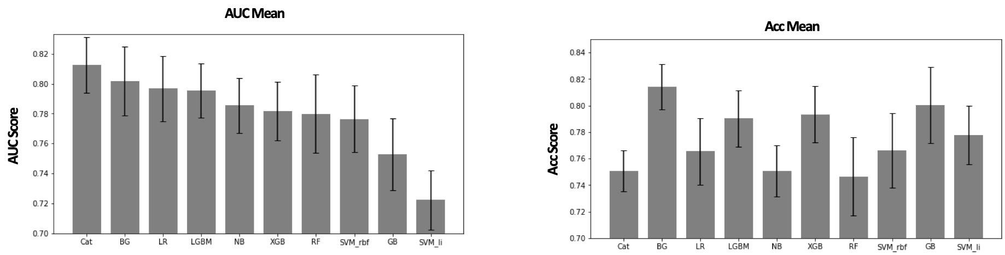
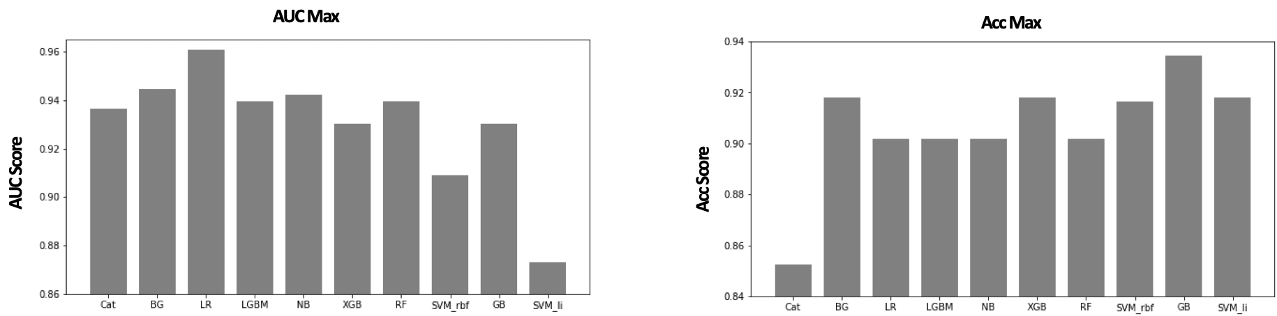
Figure S1. AUC Mean and Max result for each model.
Figure S2. Accuracy Mean and Max result for each model.
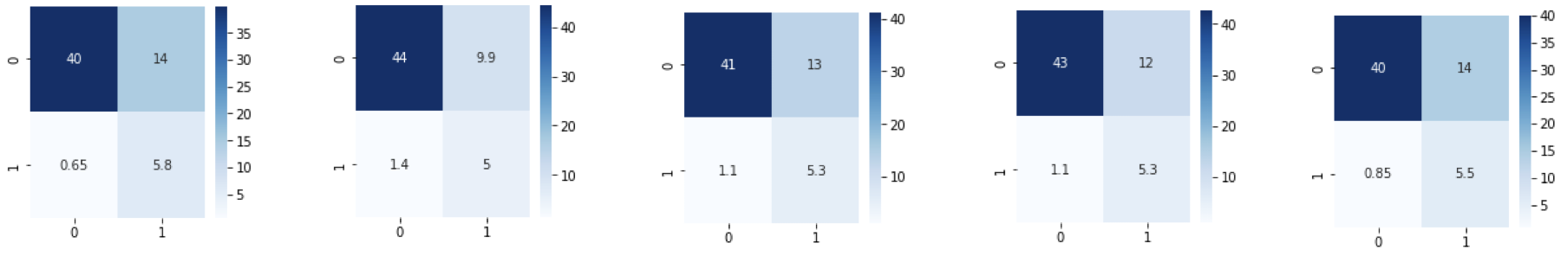
CatBoost Bagging
Logistic Regression LGBM

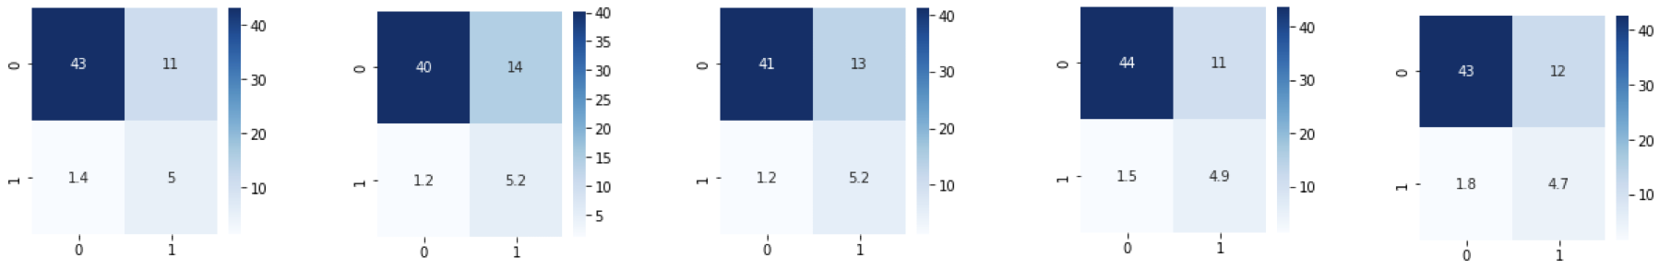
Naïve Bayes XGBoost
Random Forest SVM (RBF)

Gradient Boosting SVM (Linear)

Figure S3. Confusion matrix of AI models.
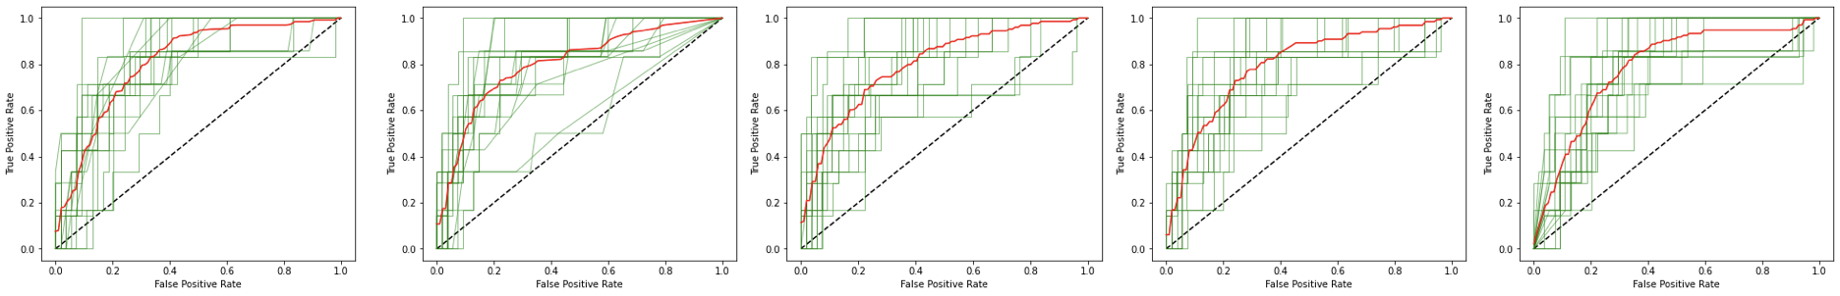
CatBoost Bagging
Logistic Regression LGBM

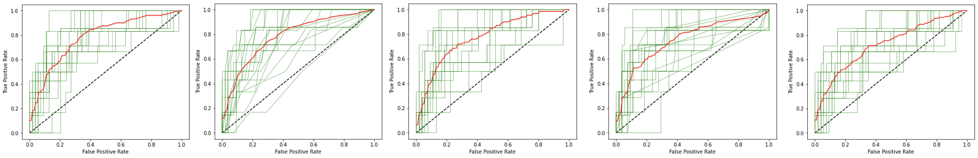
Naïve Bayes XGBoost
Random Forest SVM (RBF)
Gradient Boosting SVM (Linear)

Figure S4. ROC curve of AI models.
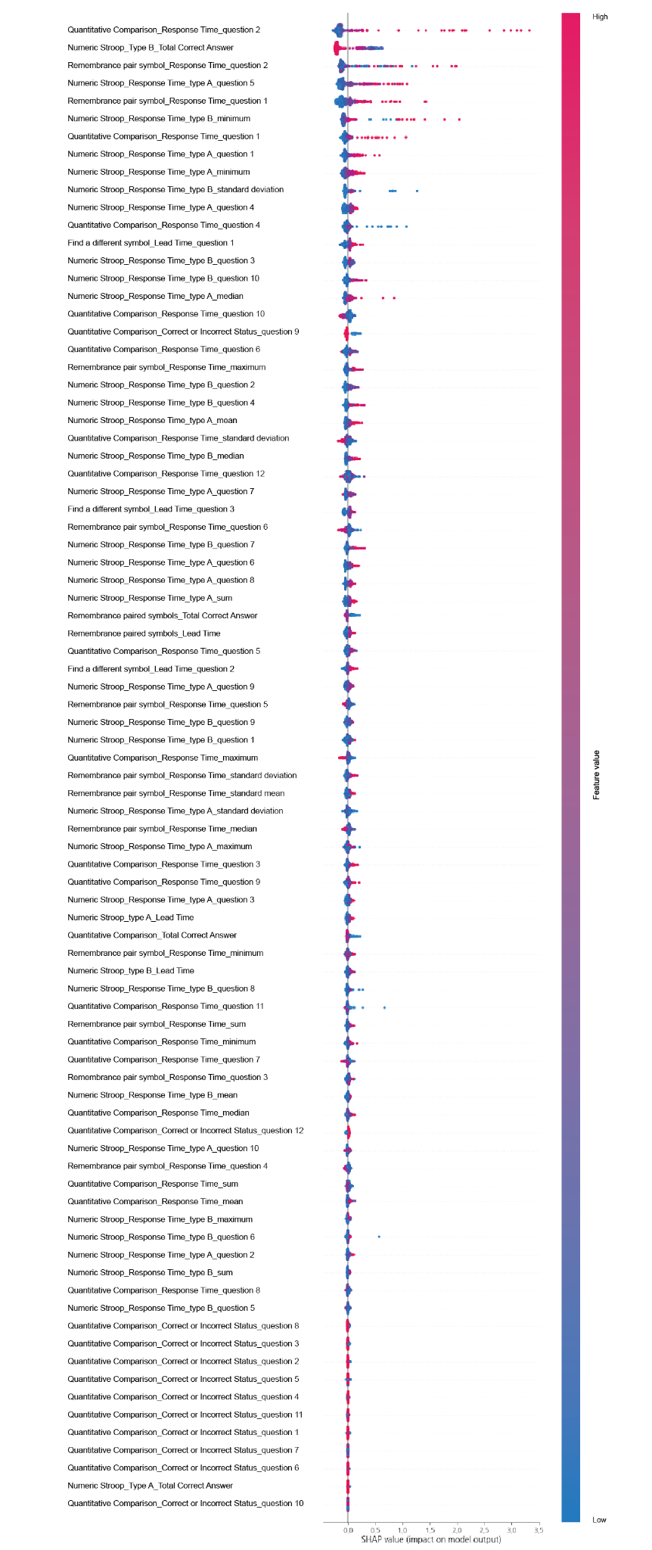
Figure S5. SHAP value.

Table S1. Performance of ten classifiers on the classification of HC and CI.
Model | AUC | Sensitivity | Specificity | Accuracy
CatBoost | 0.813 | 0.903 | 0.733 | 0.751
Bagging | 0.802 | 0.78 | 0.818 | 0.814
Logistic Regression | 0.8 | 0.83 | 0.758 | 0.765
LGBM | 0.8 | 0.833 | 0.786 | 0.79
Naïve Bayes | 0.785 | 0.737 | 0.872 | 0.751
XGBoost | 0.782 | 0.792 | 0.794 | 0.793
Random Forest | 0.78 | 0.814 | 0.739 | 0.747
SVM (RBF) | 0.776 | 0.82 | 0.761 | 0.766
Gradient Boosting | 0.753 | 0.768 | 0.804 | 0.8
SVM (Linear) | 0.722 | 0.723 | 0.784 | 0.778
The highest scores of AUC, sensitivity, specificity, and accuracy are in bold.

Table S2. Comparison of features between HC and CI groups and importance of each feature.
Task | Feature | Statistical significance  (p-value) | Feature  Importance
Numeric Stroop | Response Time_part A_question 5 | 2.88x10⁻⁰⁹ | 0.59
Numeric Stroop | Response Time_part A mean | 7.58x10⁻⁰⁸ | 0.16
Numeric Stroop | Response Time_part A sum | 7.58x10⁻⁰⁸ | 0.16
Numeric Stroop | Response Time_part A median | 1.24x10⁻⁰⁷ | 0.21
Numeric Stroop | Lead Time_part A | 2.40x10⁻⁰⁷ | 0.11
Numeric Stroop | Response Time_part B median | 4.91x10⁻⁰⁷ | 0.18
Numeric Stroop | Response Time_part B_question 4 | 1.87x10⁻⁰⁶ | 0.19
Numeric Stroop | Response Time_part A_question 4 | 5.72x10⁻⁰⁶ | 0.23
Numeric Stroop | Lead Time_part B | 1.49x10⁻⁰⁵ | 0.11
Numeric Stroop | Response Time_part B mean | 1.49x10⁻⁰⁵ | 0.07
Numeric Stroop | Response Time_part B sum | 1.49x10⁻⁰⁵ | 0.03
Numeric Stroop | Number of Correct Answers_part B | 8.09x10⁻⁰⁵ | 0.79
Numeric Stroop | Response Time_part B min | 1.82x10⁻⁰⁴ | 0.46
Numeric Stroop | Response Time_part A standard deviation | 4.05x10⁻⁰⁴ | 0.24
Numeric Stroop | Response Time_part A max | 4.56x10⁻⁰⁴ | 0.22
Numeric Stroop | Response Time_part A min | 7.17x10⁻⁰⁴ | 0.34
Numeric Stroop | Response Time_part A_question 3 | 1.21x10⁻⁰³ | 0.13
Numeric Stroop | Response Time_part A_question 8 | 1.21x10⁻⁰³ | 0.14
Numeric Stroop | Response Time_part A_question 1 | 1.73x10⁻⁰³ | 0.31
Numeric Stroop | Response Time_part B_question 10 | 6.69x10⁻⁰³ | 0.23
Numeric Stroop | Response Time_part A_question 2 | 9.33x10⁻⁰³ | 0.12
Numeric Stroop | Response Time_part B_question 6 | 1.07x10⁻⁰² | 0.08
Numeric Stroop | Response Time_part B max | 1.1x10⁻⁰² | 0.09
Numeric Stroop | Response Time_part B standard deviation | 1.79x10⁻⁰² | 0.25
Numeric Stroop | Response Time_part B_question 2 | 1.95x10⁻⁰² | 0.24
Numeric Stroop | Response Time_part B_question 5 | 2.22x10⁻⁰² | 0.09
Numeric Stroop | Response Time_part B_question 7 | 2.41x10⁻⁰² | 0.22
Numeric Stroop | Response Time_part B_question 9 | 4.12x10⁻⁰² | 0.14
Numeric Stroop | Response Time_part A_question 6 | 4.17x10⁻⁰² | 0.18
Remembrance paired symbols | Response Time_question 1 | 2.00x10⁻¹³ | 0.61
Remembrance paired symbols | Lead Time_total | 1.79x10⁻⁰⁷ | 0.17
Remembrance paired symbols | Response Time_question sum | 1.79x10⁻⁰⁷ | 0.1
Remembrance paired symbols | Response Time_question mean | 1.79x10⁻⁰⁷ | 0.13
Remembrance paired symbols | Response Time_question max | 3.63x10⁻⁰⁷ | 0.25
Remembrance paired symbols | Number of Correct Answers | 1.00x10⁻⁰⁶ | 0.13
Remembrance paired symbols | Response Time_question 2 | 1.74x10⁻⁰⁶ | 0.87
Remembrance paired symbols | Response Time_question standard deviation | 3.31x10⁻⁰⁶ | 0.16
Remembrance paired symbols | Response Time_question median | 3.70x10⁻⁰⁵ | 0.2
Remembrance paired symbols | Response Time_question min | 3.87x10⁻⁰⁵ | 0.25
Remembrance paired symbols | Response Time_question 3 | 2.12x10⁻⁰³ | 0.14
Quantitative Comparison | Response Time_question 2 | 5.68x10⁻⁰⁶ | 1.00
Quantitative Comparison | Response Time_question min | 1.01x10⁻⁰⁴ | 0.11
Quantitative Comparison | Response Time_question 4 | 1.25x10⁻⁰⁴ | 0.29
Quantitative Comparison | Response Time_question 3 | 1.97x10⁻⁰⁴ | 0.15
Quantitative Comparison | Response Time_question 1 | 3.84x10⁻⁰⁴ | 0.36
Quantitative Comparison | Number of Correct Answers | 9.91x10⁻⁰³ | 0.12
Quantitative Comparison | Correct answer_question 9 | 1.37x10⁻⁰² | 0.12
Quantitative Comparison | Response Time_question mean | 1.44x10⁻⁰² | 0.07
Quantitative Comparison | Response Time_question sum | 1.44x10⁻⁰² | 0.12
Quantitative Comparison | Response Time_question 7 | 2.38x10⁻⁰² | 0.15
Quantitative Comparison | Correct answer_question 3 | 3.06x10⁻⁰² | 0.03
Quantitative Comparison | Response Time_question 9 | 4.93x10⁻⁰² | 0.11
Find a different symbol | Lead Time_question 2 | 1.17x10⁻⁰³ | 0.15
Find a different symbol | Lead Time_question 1 | 6.57x10⁻⁰³ | 0.23
Find a different symbol | Lead Time_question 3 | 8.27x10⁻⁰³ | 0.16
We tested the correlation between the feature importance and p-value for all features, which showed that they are highly correlated, indicating that higher the p-value, the higher the feature importance is in the screening using the classifier. Features with a p-values of 0.05 or less were included in the table.

