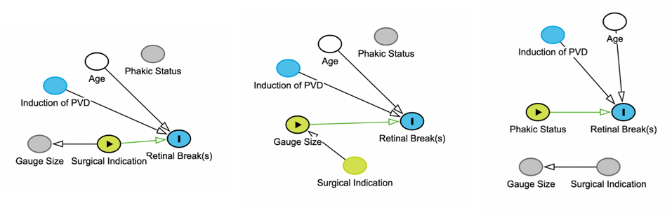

Figure 1. Directed Acyclic Graphs (DAGs) showing various relationships between factors influencing retinal breaks

