Extended Data
Structural and dMRI data for all subjects are featured on University of Oxford’s Digital Brain Zoo, and are available by request: https://open.win.ox.ac.uk/DigitalBrainBank/#/datasets/zoo
ROIs used in this study were uploaded for submission to Nature’s figshare service, and are available for reviewers.

Extended Data Table 1: Table of subjects
ID | Species | Age | Sex | Diagnoses | Death Date | Acquisition Date
CSL-11217 | CSL1 | Juvenile | M | abscess and malnutrition | 7/2/2014 | 8/14/2016
CSL-10814 | CSL2 | Adult | F | urogenital carcinoma | 3/14/2016 | 3/14/2016
CSL-10923 | CSL3 | Juvenile | M | malnutrition | 4/16/2014 | 7/14/2016
CSL-11141 | CSL4 | Adult | F | urogenital carcinoma | 5/30/2016 | 8/14/2016
HS-2514 | HS1 | Juvenile | F | verminous pneumonia and malnutrition | 9/19/2015 | 11/15/2016
HS-2420 | HS2 | Juvenile | M | malnutrition and maternal separation | 3/25/2015 | 6/15/2016
HS-2555 | HS3 | Juvenile | F | malnutrition and maternal separation | 3/21/2016 | 4/2016
HS-2571 | HS4 | Juvenile | M | malnutrition and maternal separation | 4/3/2016 | 4/26/2016
ES-3798 | ES2 | Juvenile | M | malnutrition and otostrongyliasis | 6/3/2015 | 9/15/2016
ES-3780 | ES1 | Juvenile | M | malnutrition and otostrongyliasis | 6/3/2015 | 9/15/2016
ES-3933 | ES3 | Juvenile | M | malnutrition | 4/1/2016 | 4/26/2016
08061 | COY1 | Adult | M | non-neurological disease | 2016 | 2016
08071 | COY2 | Adult | M | non-neurological disease | 2016 | 2016
08100 | COY3 | Adult | F | non-neurological disease | 2016 | 2016
08052 | COY4 | Adult | F | non-neurological disease | 2016 | 2016
ES-3788 | ES - histo | Juvenile | M | otostrongyliasis | 4/29/2015 | 2015
CSL-12320 | CSL - histo | Juvenile | F | malnutrition | 4/19/2015 | 2015
NIH archival | HS - histo | Juvenile | ? | ? | ? | 1980s

Extended Data Table 2: Analyzed regions and relevance to vocal learning
Region | Relevance
Nucleus ambiguus | Innervates laryngeal muscles for breathing, swallowing, and vocal control
Vocal motor cortex | Direct cortical control over volitional vocalization
Periaqueductal grey | Initiates species-typical vocalization and controls intensity
Pre vocal motor cortex | Includes Broca's Area in humans
Inferior colliculus | Auditory integration
Medial geniculate nucleus | Principal relay for auditory system
Auditory cortex | Auditory-motor feedback
Anterior cingulate | Volitional initiation and modulation of species typical vocalizations
Anterior Ventrolateral thalamus | Learned vocal motor control
Striatum | Reward-based motor learning
Rostral brainstem | Control tract
Caudal brainstem | Control tract
Brainstem pyramid | Brainstem corticospinal conduit
Internal capsule | Cortical corticospinal conduit

Extended Data Table 3: Regions of interest
Region | Abbreviation | Laterality | Localization | Validation Tracing
Nucleus ambiguus | N. Amb | L/R | Histology | PAG, contralateral N. Amb, lateral vagus root
Vocal motor cortex | VMC | L/R | Electrophysiology | Globus pallidus and putamen, anterior thalamus
Periaqueductal grey | PAG | Bilat | Anatomy | Anatomical
Pre vocal motor cortex | Pre-VMC | L/R | Tracing, electrophysiology | Anterior thalamus
Inferior colliculus | IC | L/R | Anatomy | Anatomical, MGN
Medial geniculate nucleus | MGN | L/R | Anatomy, tracing | Anatomical, IC
Auditory cortex | A1 | L/R | Tracing | MGN, medial temporal lobe
Anterior cingulate | AC | L/R | Anatomy, diffusion directionality | Anatomical
Anterior Ventrolateral thalamus | AVT | L/R | Anatomy | Post-cruciate motor cortex
Ventral striatum | Stri | L/R | Anatomy | Anatomical
Rostral brainstem | RBS | Bilat | Anatomy | Anatomical
Caudal brainstem | CBS | Bilat | Anatomy | Anatomical
Brainstem Pyramids | Pyr | L/R | Anatomy | Anatomical
Internal Capsule | In. Cap | L/R | Anatomy | Putamen
Regions of interest in the current study, abbreviations, laterality, method of localization and segmentation, method of validation

Extended Data Table 4: Tract results
Tract | Kruskal-Wallis  p-value (χ²) | Kruskal-Wallis  Effect Size (η²) | COY-CSL  p-value | COY-ES  p-value | COY-HS  p-value | CSL-ES  p-value | CSL-HS  p-value | ES-HS  p-value
VMC to N Amb | <0.001 (17.5, df=3) | 0.6037 | 0.0247 | 0.0073 | <0.001 | 1 | 1 | 1
AC to PAG | <0.001 (21, df=3) | 0.7243 | 1 | 0.1393 | <0.001 | 0.4601 | 0.0021 | 0.7378
AVT to Striatum | 0.5259 (2.2, df=3) | 0.0769 | 1 | 1 | 1 | 1 | 1 | 1
AVT to Pre-VMC | 0.0018 (15, df=3) | 0.5182 | 1 | 0.1785 | 0.0026 | 0.7378 | 0.0271 | 1
A1 to VMC | 0.0015 (15.5, df=3) | 0.5332 | 0.4993 | 0.222 | 1 | 0.0013 | 0.0271 | 1
AC to VMC | 0.0233 (9.5, df=3) | 0.3278 | 0.0586 | 0.1157 | 1 | 1 | 0.3895 | 0.5859
Brainstem | 0.1752 (5, df=3) | 0.3539 | 1 | 0.1584 | 1 | 1 | 1 | 1
Pyr to In. Cap | 0.0257 (9.2, df=3) | 0.3203 | 0.4149 | 1 | 1 | 0.0211 | 0.2136 | 1
Significance results for Kruskal-Wallis test of total streamline percentages by species, and post-hoc Tukey-Kramer pairwise comparisons

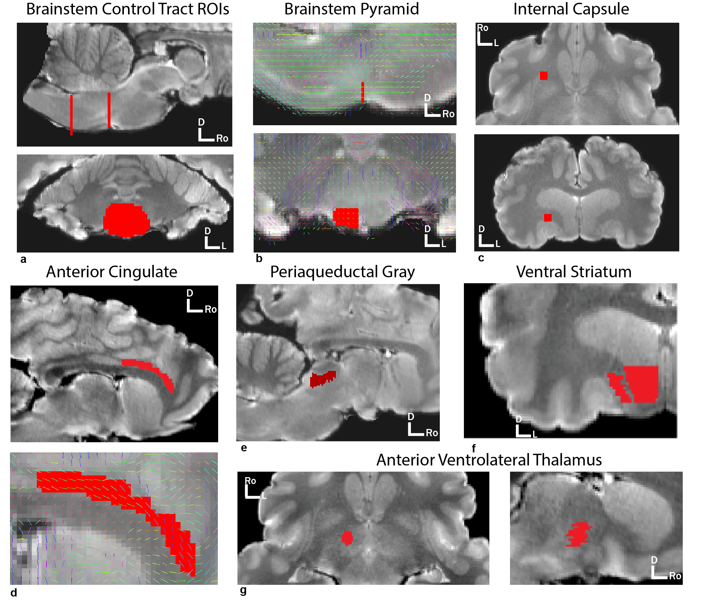
Extended Data Figure 1: Subcortical regions and segmentations used in tract tracing. All figures were traced separately in left and right hemisphere (right only shown here) except for brainstem cross-sections and PAG. A: whole axial brainstem caudal to rostral cross sections. B: Brainstem pyramids were segmented anatomically with overlaid DTIFit primary diffusion directions overlaid. All rostrocaudal voxels were taken in one axial cross-section just dorsal to the caudal portion of the putamen. C: Internal capsule was identified as an isotropic cube in a rostral lateral portion ventral to the lateral extension of the caudate head. D: Anterior cingulate was segmented anatomically in successive sagittal sections with overlaid DTIFit primary diffusion directions overlaid. E: PAG was segmented anatomically in successive axial sections. F: Ventral striatum (rostral putamen and rostroventral caudate head) was segmented anatomically in successive axial sections. G: Anterior ventrolateral thalamus was segmented anatomically in successive dorsal sections.
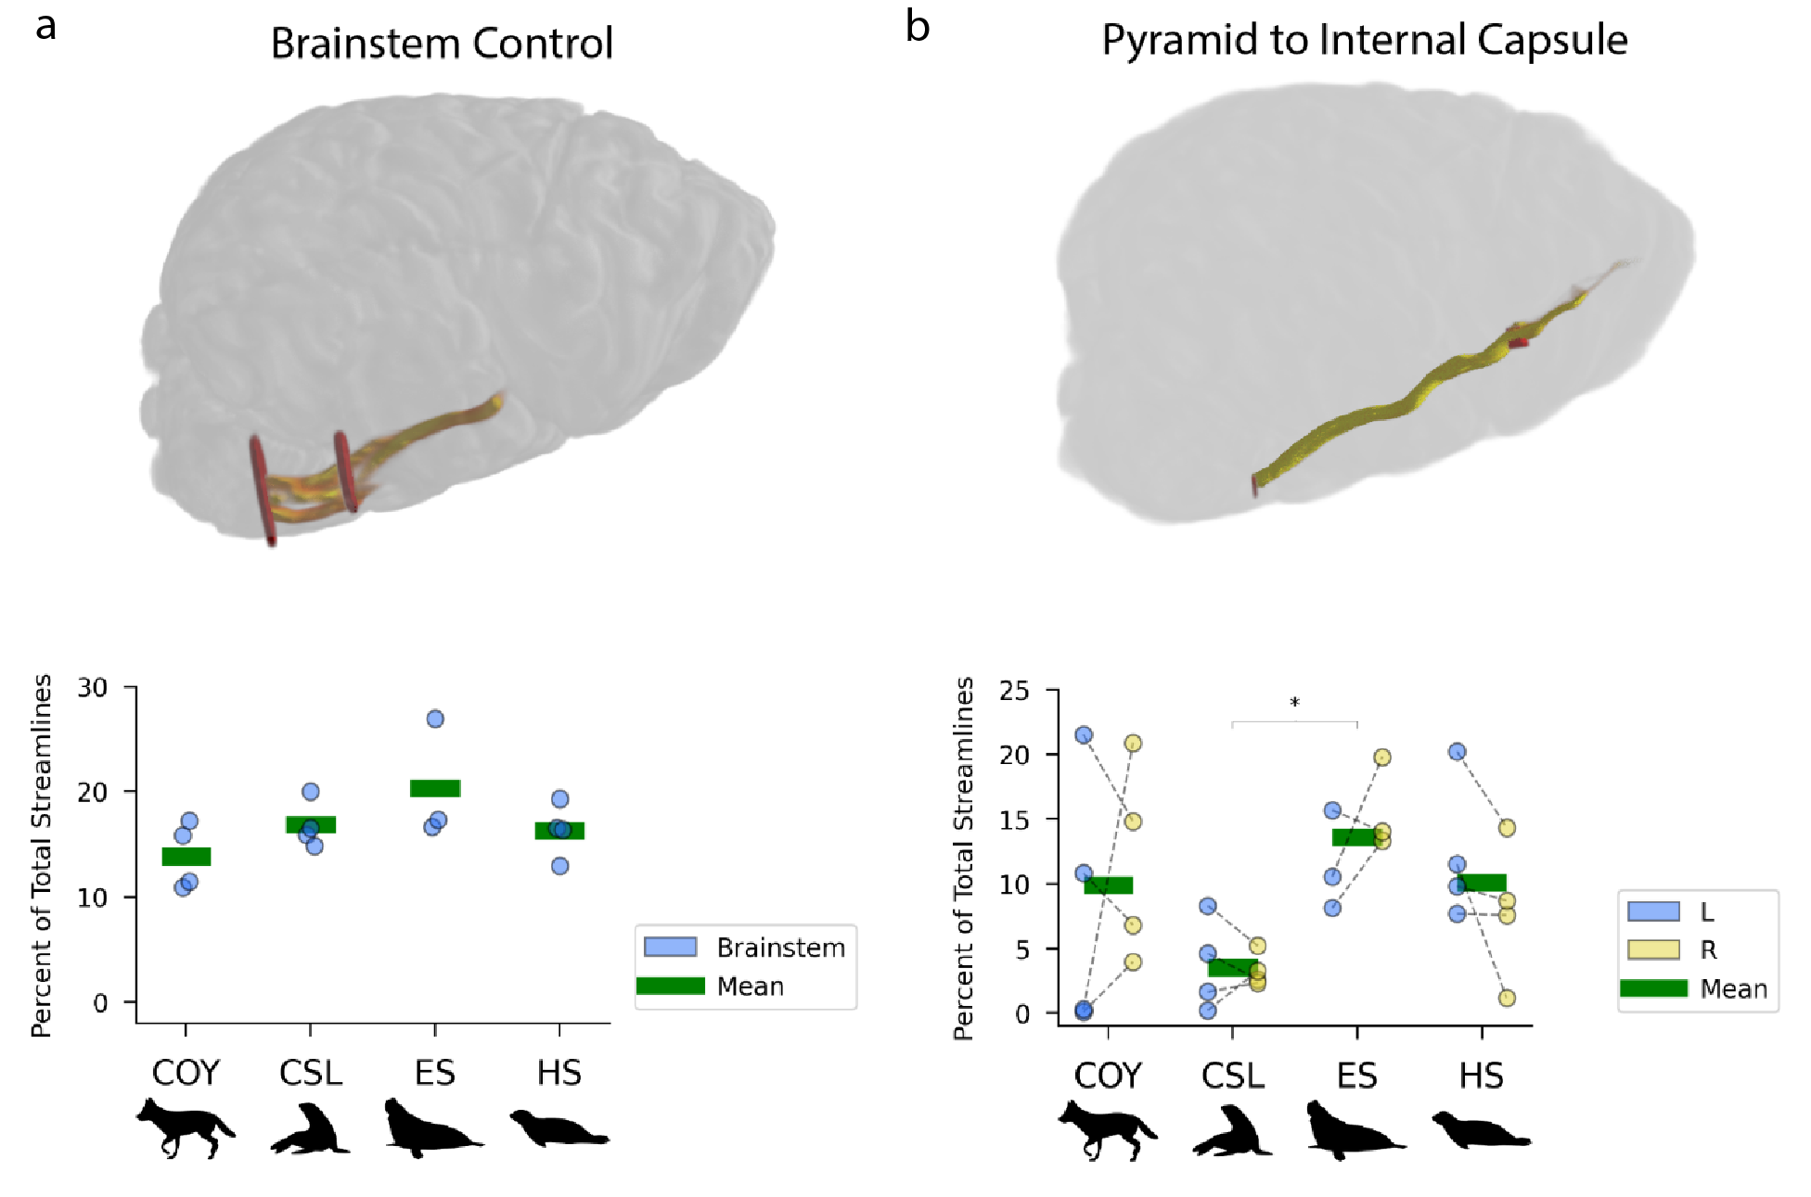
Extended Data Figure 2: Tract strength for brainstem and corticospinal control tracts. The two pathways are shown in the sagittal view with seeds and waypoint ROIs in red and paths in yellow. Each plot shows the percent of total streamlines for paths on the Y axis and the species in the X axis. 5000 probabilistic streamlines were generated from each voxel of the seed regions for each trace. Paths that make it from the seed region to the waypoint constitute the final probabilistic trace, and the number of such paths is the “waytotal.” Each subject’s corrected waytotal for each trace is shown for left hemisphere in blue and right hemisphere in yellow, with a dotted line connecting the values for each subject. Significant differences between species values are indicated by brackets and asterisks (Kruskal-Wallis test with Bonferroni-corrected pairwise comparisons, *p<0.05)

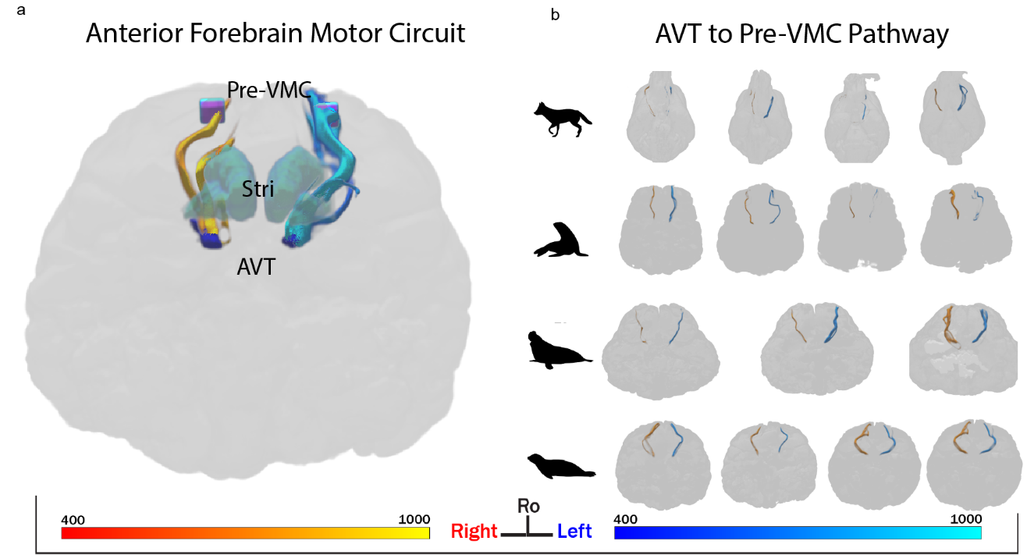
Extended Data Figure 3: Anterior forebrain motor learning circuit. A: Right (yellow) and left (blue) pathways between anterior ventrolateral thalamus (AVT) and Striatum (Stri), AVT and Pre-VMC, and Stri and PreVMC, viewed dorsally in a harbor seal brain. B: AVT to Thal pathways in all subject brains, viewed dorsally. Tracts are thresholded at 400 streamlines.
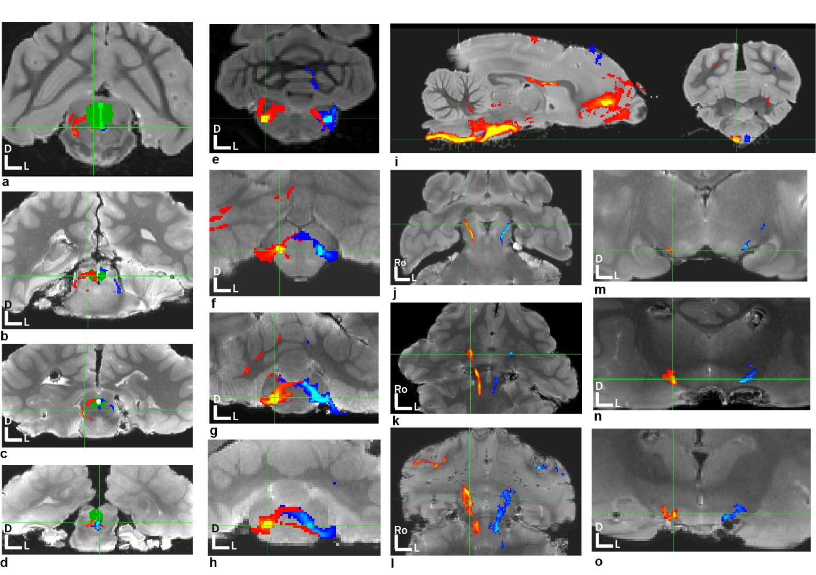
Extended Data Figure 4: Nucleus ambiguus validation in all species. A-d: coyote, sea lion, elephant seal, and harbor seal high resolution structural images in axial section through the midbrain. The PAG segmentation is in green. Left (blue) and right (red) thresholded N. Amb traces are shown where they intersect the PAG. E-h: coyote, sea lion, elephant seal, and harbor seal images in axial section through the brainstem near the obex. Left (blue) and right (red) pathways from the N. Amb are shown projecting to the contralateral N. Amb and, laterally, to the putative root of the vagus nerve. I. Sagittal and axial sections in coyote showing single-mask traces from the VMC. These passed through the brainstem pyramids and remained ventral in the brainstem at the level of the obex with no coherent pathways anywhere near putative N. Amb. J-l: sea lion, elephant seal, and harbor seal shown in dorsal section ventrally, and m-o axially. Left (blue) and right (red) N. Amb traces are shown projecting past the PAG and ventral to the thalamus in transit to motor cortex. Coyote N. Amb traces did not meaningfully project rostral to PAG.
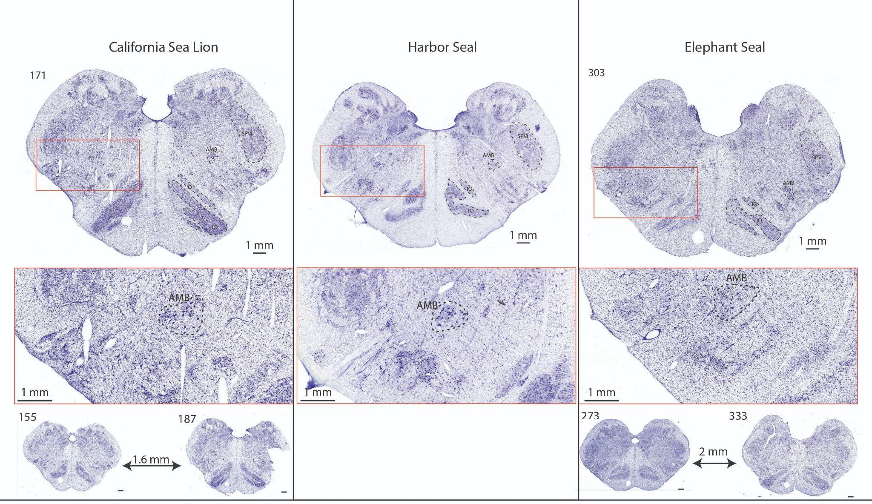
Extended Data Figure 5: Representative histological brainstem sections used to identify nucleus ambiguus in sea lions, harbor seals, and elephant seals. Brains were stained with cresyl violet, sectioned, and examined under a microscope. N. Amb was identified based on the criteria in Berman, 1968, as a group of “large, well-stained multipolar neurons with a loose and irregular arrangement.” The N. Amb is close to the obex in carnivore brains, and identifiable bilaterally directly between the inferior olive (IO) and spinal trigeminal nucleus (SPVi).
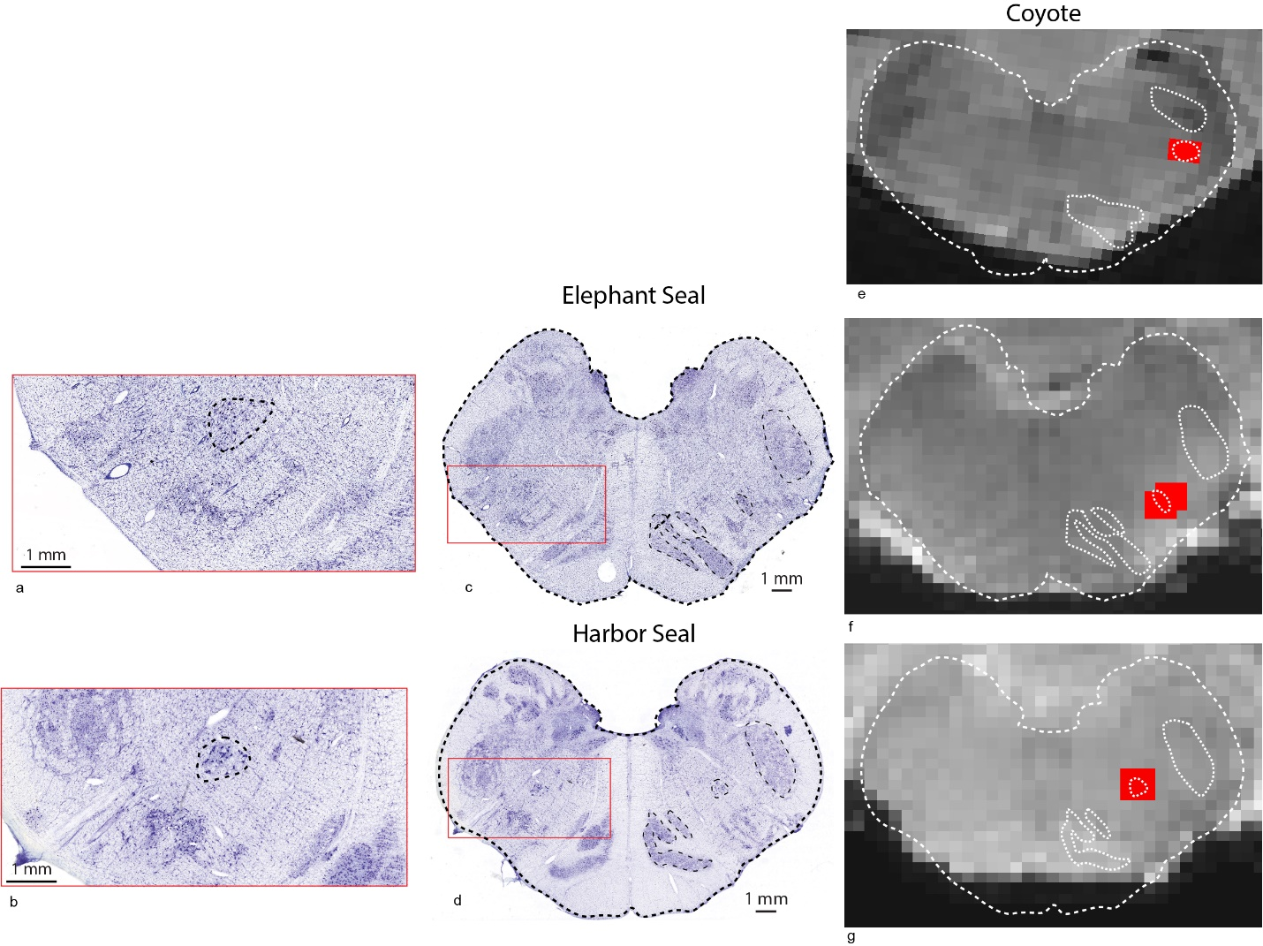Extended Data Figure 6: Histology to MRI overlay of nucleus ambiguus histology in coyotes, elephant seals, and harbor seals. A-b: zoomed in sections showing N. Amb in harbor seal and elephant seal. C-d: central stained brainstem sections from harbor seal and northern elephant seal showing location of Nucleus ambiguus, inferior olive, and spinal trigeminal nucleus. Canine brainstem histology used to create overlay for coyotes was drawn from: https://vanat.ahc.umn.edu/brainsect/showAtlasFrames.html. E-g: Coyote, elephant seal, and harbor seal brainstems, taken from the center of the N. Amb, with histological outlines overlaid on the brainstem. Voxels that overlapped the N. Amb in the MR data are in red. Because brains sometimes become vertically compressed when extracted, fixed, and placed ventrally for imaging, the top of the brainstem outline taken from histology sections was prioritized in matching to MR data. Further, left and right Nucleus ambiguus were matched and segmented separately—because the brainstem was not always symmetrical on a left-right axis, the overlay was best fit to the side of the brainstem that was being segmented. This is visible in the elephant seal segmentation here – on the right side of the brainstem the dorsomedial portion is more medially restricted than on the left.

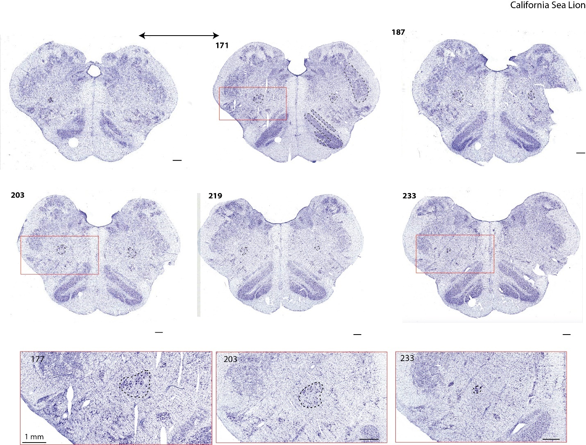
Extended Data Figure 7: Representative series of brainstem slices showing nucleus ambiguus in a California sea lion. Slices are shown from most rostral (top left) to most caudal (bottom right), with cutouts showing high resolution detail of the N. Amb at three representative locations.

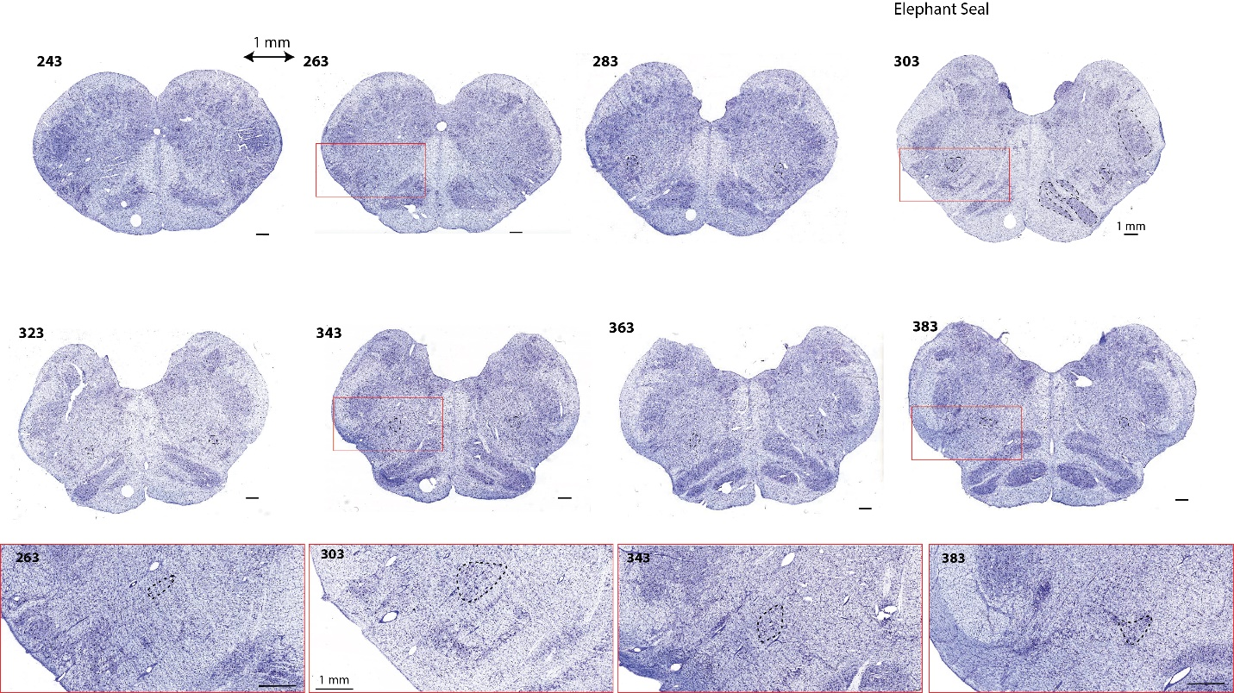
Extended Data Figure 8: Representative series of brainstem slices showing nucleus ambiguus in a Northern elephant seal. Slices are shown from most rostral (top left) to most caudal (bottom right), with cutouts showing high resolution detail of the N. Amb at four representative locations.

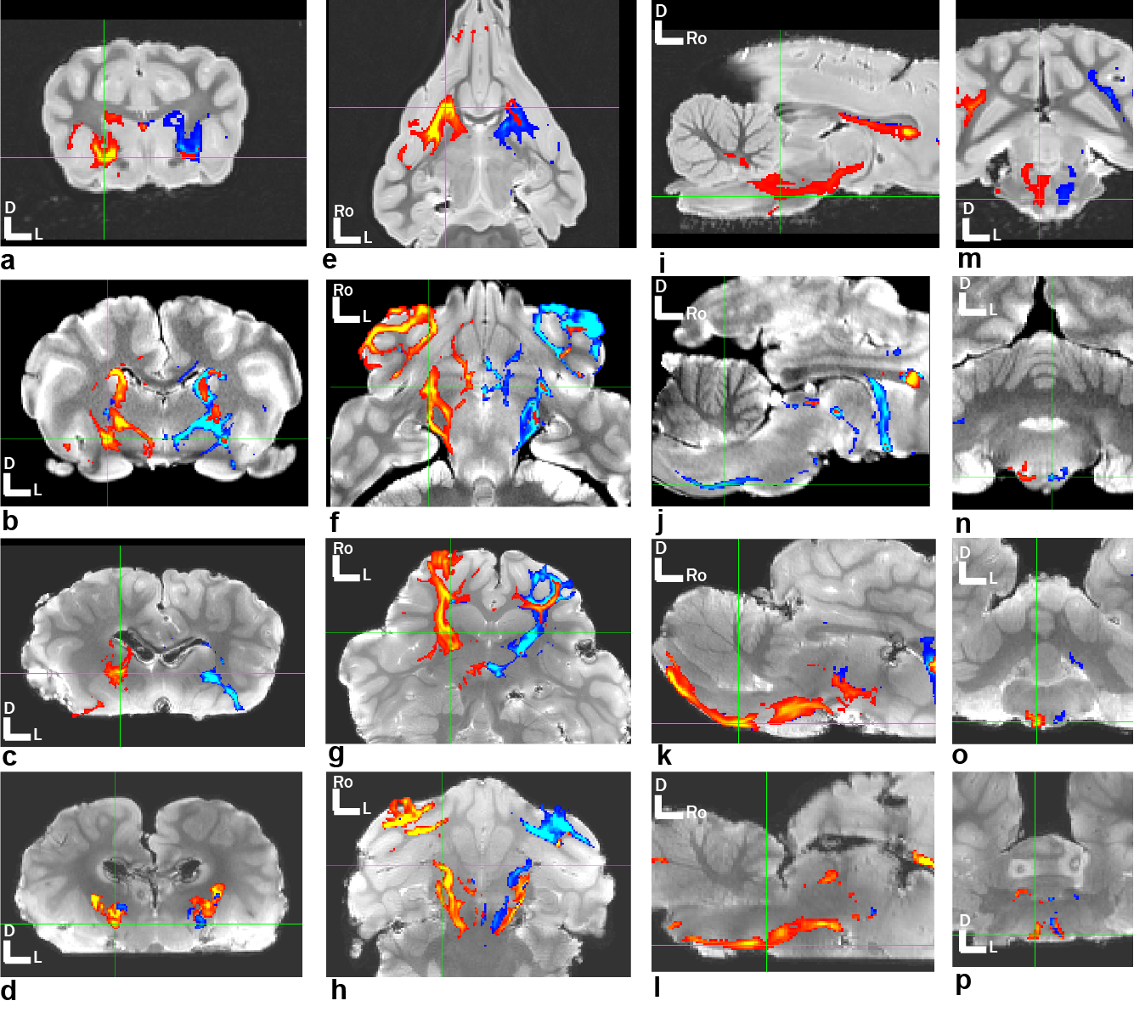
Extended Data Figure 9: Corticospinal control tract in all species. Coyote, sea lion, elephant seal, and harbor seal brains showing corticospinal traces (left in blue, right in red) from brainstem pyramids to internal capsule in an axial section at the level of the striatum (a-d), dorsal section at the level of the ventral striatum (e-h), sagittal section (i-l) and axial section at the level of the brainstem (m-p). All animals showed robust pathways bilaterally.

Supplementary Table 1: Individual tract strengths
 |  | VMC to  N. Amb (-PAG) |  | VMC to  N. Amb | AC to  PAG | AVT to  Stri | AVT to  Pre-VMC | Stri to  Pre-VMC | A1 to  Pre-VMC  (-MGN) | AC to  VMC | Brainstem | Pyr to In. Cap
 |  | ROI: N. Amb |  | ROI: N. Amb | ROI: AC | ROI: AVT | ROI: AVT | ROI: Stri | ROI: A1 | ROI: N. Amb
Laterality |  | Ipsi | Contra | Ipsi | Ipsi | Ipsi | Ipsi | Ipsi | Ipsi | Ipsi | Bilateral | Ipsi
Subject | Side | % of Streamlines | % of Streamlines | % of Streamlines | % of Streamlines | % of Streamlines | % of Streamlines | % of Streamlines | % of Streamlines | % of Streamlines | % of Streamlines | % of Streamlines
COY1 | L | 0.003 | 0.008 | 0.537 | 0.007 | 3.480 | 1.542 | 0.997 | 0.004 | 0.059 | 10.945 | 0.074
COY1 | R | 0.000 | 0.004 | 0.423 | 0.006 | 6.851 | 0.005 | 0.208 | 0.000 | 0.019 | 10.945 | 3.971
COY2 | L | 0.001 | 0.004 | 1.413 | 0.017 | 4.583 | 0.013 | 0.060 | 0.005 | 0.275 | 11.500 | 10.843
COY2 | R | 0.000 | 0.014 | 3.197 | 0.014 | 5.608 | 0.002 | 0.017 | 0.027 | 0.044 | 11.500 | 6.816
COY3 | L | 0.001 | 0.003 | 0.412 | 0.012 | 1.960 | 0.009 | 0.077 | 0.004 | 0.000 | 15.882 | 21.547
COY3 | R | 0.014 | 0.011 | 0.258 | 0.006 | 1.277 | 0.007 | 0.061 | 0.020 | 0.003 | 15.882 | 14.796
COY4 | L | 0.004 | 0.113 | 0.676 | 0.062 | 4.200 | 2.701 | 0.094 | 0.001 | 0.606 | 17.249 | 0.274
COY4 | R | 0.009 | 0.002 | 0.180 | 0.080 | 2.767 | 2.369 | 0.073 | 0.007 | 0.025 | 17.249 | 20.890
CSL1 | L | 0.402 | 0.005 | 0.706 | 0.103 | 2.705 | 1.278 | 0.698 | 0.000 | 0.505 | 15.909 | 4.617
CSL1 | R | 0.126 | 0.016 | 1.853 | 0.080 | 8.064 | 0.627 | 0.866 | 0.002 | 0.119 | 15.909 | 2.612
CSL2 | L | 0.160 | 0.007 | 0.132 | 0.078 | 6.928 | 1.623 | 0.121 | 0.000 | 2.020 | 16.583 | 1.661
CSL2 | R | 0.470 | 0.020 | 0.159 | 0.026 | 6.249 | 0.627 | 0.547 | 0.007 | 0.172 | 16.583 | 2.348
CSL3 | L | 0.115 | 0.015 | 0.373 | 0.005 | 0.232 | 0.191 | 0.392 | 0.001 | 1.342 | 14.883 | 8.312
CSL3 | R | 0.043 | 0.009 | 0.391 | 0.003 | 1.576 | 0.005 | 1.536 | 0.000 | 0.426 | 14.883 | 5.213
CSL4 | L | 0.013 | 0.042 | 0.290 | 0.021 | 2.243 | 0.097 | 0.128 | 0.000 | 0.069 | 20.013 | 0.202
CSL4 | R | 0.040 | 0.074 | 2.355 | 0.014 | 2.802 | 6.068 | 4.193 | 0.001 | 0.999 | 20.013 | 3.276
ES1 | L | 0.107 | 0.039 | 0.874 | 0.068 | 1.241 | 1.675 | 0.378 | 0.054 | 0.518 | 26.893 | 10.571
ES1 | R | 0.411 | 0.414 | 0.927 | 0.039 | 0.494 | 0.274 | 0.585 | 0.012 | 0.203 | 26.893 | 19.803
ES2 | L | 0.132 | 0.017 | 0.604 | 0.109 | 3.534 | 3.330 | 0.362 | 0.005 | 1.388 | 16.645 | 8.133
ES2 | R | 0.329 | 0.019 | 0.625 | 0.116 | 1.393 | 2.158 | 0.428 | 0.025 | 0.181 | 16.645 | 13.319
ES3 | L | 0.227 | 0.066 | 0.247 | 0.192 | 15.717 | 3.564 | 0.581 | 0.052 | 0.412 | 17.339 | 15.680
ES3 | R | 0.053 | 0.022 | 3.033 | 0.256 | 9.298 | 4.412 | 0.675 | 0.056 | 0.146 | 17.339 | 14.032
HS1 | L | 0.125 | 0.000 | 0.230 | 0.591 | 2.856 | 1.654 | 0.446 | 0.004 | 0.342 | 19.313 | 7.688
HS1 | R | 0.719 | 0.000 | 0.297 | 0.630 | 4.133 | 3.327 | 0.270 | 0.003 | 0.010 | 19.313 | 7.559
HS2 | L | 0.822 | 0.000 | 1.874 | 0.838 | 6.935 | 2.803 | 0.460 | 0.014 | 3.286 | 16.563 | 11.527
HS2 | R | 0.102 | 0.000 | 1.070 | 0.503 | 8.342 | 4.385 | 0.870 | 0.029 | 0.136 | 16.563 | 1.181
HS3 | L | 0.127 | 0.000 | 0.051 | 0.171 | 3.442 | 3.580 | 0.245 | 0.005 | 0.112 | 12.961 | 20.238
HS3 | R | 0.014 | 0.000 | 0.016 | 0.161 | 10.310 | 6.269 | 0.754 | 0.013 | 0.014 | 12.961 | 14.340
HS4 | L | 0.258 | 0.000 | 3.518 | 0.460 | 3.062 | 6.939 | 0.312 | 0.015 | 0.097 | 16.403 | 9.836
HS4 | R | 0.500 | 0.000 | 2.564 | 1.184 | 3.761 | 22.880 | 0.069 | 0.024 | 0.031 | 16.403 | 8.721

