Supplementary Information

Efficient single-photon emission via quantum-confined charge funneling to quantum dots

Sanghyeok Park, K. Azizur Rahman, Darryl Shima, Ganesh Balakrishnan, Jaeyeon Yu, Hyunseung Jung, Jasmine J. Mah, Samuel Prescott, Pingping Chen, Sadhvikas Addamane, Douglas Pete, Andrew Mounce, Ting Shan Luk, Prasad P Iyer, Igal Brener, Oleg Mitrofanov

Contents:
S1. Photoluminescence signature of energy landscape modified quantum dots
S2. Photoluminescence spectrum of ordinary quantum dots
S3. Photoluminescence saturation
S4. Overall efficiency of optically pumped single photon emitters
S5. Second order correlation function measurements
S6. Remote excitation of energy landscape-modified quantum dots

S1. Photoluminescence signature of energy landscape modified quantum dots
The charge carrier funnels modify the energy landscape around the QDs, attracting charge carriers and increasing the excitation (and the overall) efficiency of the QDs. As a result, light emission from these energy landscape modified quantum dots (ELM-QDs) is visibly stronger (over one order of magnitude), as discussed in the Article (Fig. 1d, Fig. 4b). In addition, the photoluminescence (PL) spectrum from the region around these QDs carries a signature of the energy landscape, with significant PL emission from the area immediately surrounding the QDs, i.e. from the funnel itself. Using spectrally-filtered PL imaging, we can selectively suppress the emission from either the funnel or the ELM-QDs to visualize them.
Figure S1 shows PL images of a 40 x 40 μm² area near one of the ELM-QDs using three different optical filters placed before an imaging camera. Without any filter, a PL image (not shown) displays one strongly emitting QD surrounded by ordinary QDs. When a short-wavelength band pass filter is introduced, the PL from the QD itself is suppressed, and a 5-7 μm diameter halo becomes visible around the QD (Fig. S1a, top row). The halo is caused by emission of photons with energies higher than the QD-emitted photon, and it comes from interband recombination of charge carriers within the funnel. If the bandpass filter is replaced with a longpass filter suppressing the funnel emission, we expect to observe only the QDs. However, the strong emission from the QD saturates the image making it difficult to differentiate between the funnel and the QD (Fig. S1a, middle row). When the transmission edge of the bandpass filter is shifted further to the longer wavelengths, and we can finally observe localized PL from only the ELM-QD itself (bottom row).
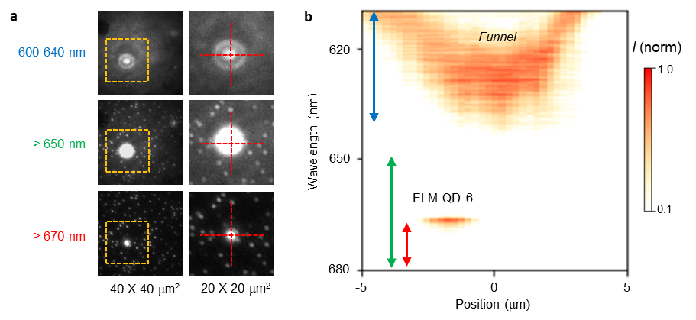
Figure S1. (a) PL images of ELM-QD and ordinary QDs obtained with different spectral filters: bandpass filter: 600-640 nm (top row); longpass filter: 650 nm (middle row); and longpass filter: 670 nm (bottom row), with the transmission bands indicated in the PL map. The right column images show magnified images of the area in the dashed box in the left column. (b) Spatial distribution of PL along a line scan across the ELM-QD in (a). The colored arrows indicate the spectral transmission windows for the filters used in (a).
These PL images are consistent with the confocal PL map displayed in Figure S1b. They are also consistent with the charge carrier funnel structure determined by TEM (see Article, Fig. 2) and with the bandgap energy calculations shown in Fig. 2e of the Article. The PL halo feature can be used to locate ELM-QDs within the wafer.
We note that the energy landscape in the funnels vary, and it can be characterized using the confocal PL maps in Fig. S1b. (see also Fig. 3 in the Article). In Fig. S2 we show PL maps for three additional ELM-QDs (ELM-QD 6, 7 and 8). All the maps show the common inverted bell-shaped signature.
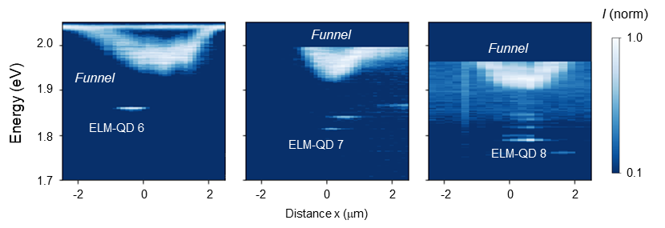
Figure S2. Spatial distribution of PL along a line scan across ELM-QD 6, 7 and 8.

S2. Photoluminescence spectrum of ordinary quantum dots
PL spectra of ordinary LDE GaAs QDs (o-QDs) were compared with the spectra of ELM-QDs (presented in the main manuscript in Figs. 3 and 4). Figure S3 shows an example of the o-QD spectrum; it was obtained with a micro-PL setup using a 50X microscope objective lens and the pump power of 5.6 nW.
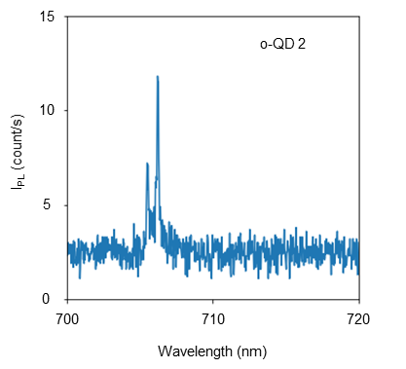
Figure S3. (a) PL spectrum of an ordinary GaAs QD (o-QD 2) pumped by a laser (λ = 515 nm) with the incident power of 5.6 nW.

S3. Photoluminescence saturation
The increase in excitation efficiency for the ELM-QDs was observed in the PL saturation curves measured for the ELM-QDs and o-QDs. We compare the PL intensity as a function of the QD excitation power for ELM-QD12 and o-QD2 (ordinary QD, Section S2) in Fig. S4. ELM-QD 12 shows a linear increase in PL intensity for the pump power below ~50 nW exhibiting saturation at ~100 nW. In contrast, the PL intensity for the ordinary QD (o-QD2) continues increasing with the pump power, albeit slightly sub-linearly. Most importantly, the efficiency of ELM-QDs is noticeably higher: at pump powers below 100 nW, the PL intensity for the ELM-QD 12 is ~8-10 times higher compared to o-QDs.
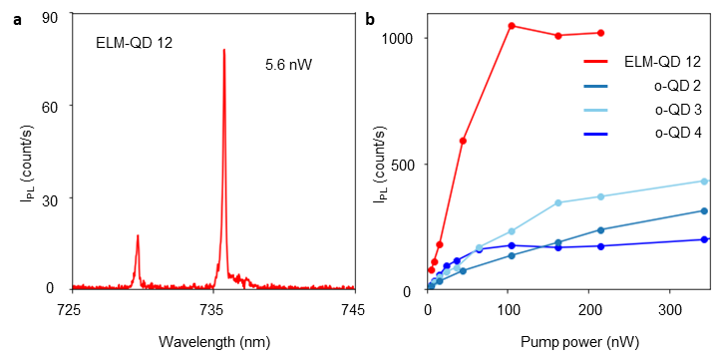
Figure S4. (a) PL spectrum of ELM-QD 12 excited with an optical pump power of 5.6 nW. (b) PL peak intensity dependence on the pump power for ELM-QD 12 (red line) and for ordinary QDs (o-QD 2, blue lines).
Below the saturation level (~100 nW), the main exciton peak dominates the spectra of ELM-QDs. At ~100 nW, ELM-QD 1 starts showing several emission lines corresponding to exciton complexes. Figure S5 displays the spectrum of ELM-QD1 for the excitation power of 100, 270 and 430 nW. As the pump power increases, the main exciton peak diminishes, and the emission from exciton complexes becomes more pronounced. This occurs because a higher charge carrier density facilitates the transition of excitons into exciton complex states. [1-4]
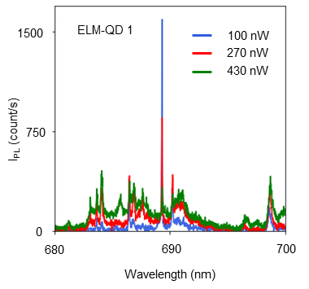
Figure S5. (a) PL spectra of ELM-QD1 for the optical pump power of 100 nW, 270 nW, and 430 nW.
S4. Overall efficiency of optically pumped single photon emitters
To compare the efficiency of ELM-QD emitters with other reported SPEs, we evaluated their overall quantum efficiency. For clarity, we define the overall quantum efficiency η as the number of single photons that can be generated per one pump photon. The overall efficiency is a product of the internal quantum efficiency η_{int}, the excitation efficiency η_{x} and the out-coupling efficiency η_{oc}: η = η_{int}η_{x}η_{oc}.
We estimated the overall efficiency for ELM-QDs to be 4.5×10⁻⁶. We note that this efficiency is comparable to the overall efficiency for reported QDs with enhanced out-coupling efficiency (Fig. S6a) [5-12]. The excitation efficiency η_{x} for ELM-QDs therefore must exceed the excitation efficiency for the reported QDs by approximately one order of magnitude. This increase in the excitation efficiency can be seen in a lower saturation power for ELM-QDs in comparison to that observed in other QDs and SPEs (Figure S6a). The out-coupling efficiency for ELM-QDs embedded in the high index substrate however is low (~0.02) and can be potentially improved by modifying the photonic environment.
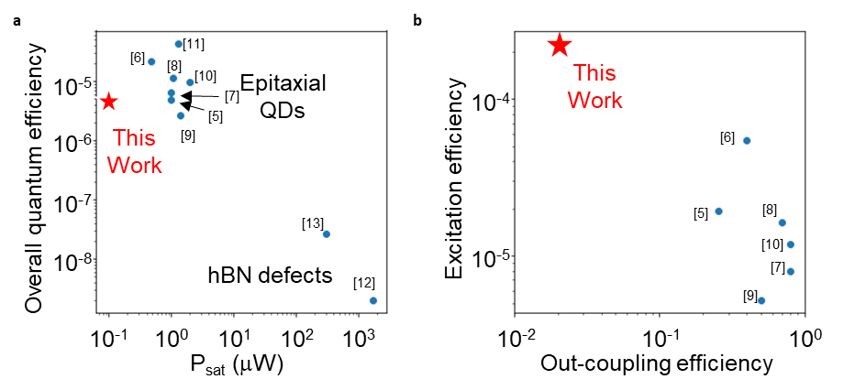
Figure S6. (a) Comparision of our ELM-QDs with other reported quantum emitters in terms of the saturation pump power and overall quantum efficiency. (b) Comparision of our ELM-QDs with other reported epitaxially grown QDs in terms of out-coupling efficiency and excitation efficiency.

Below, we provide details for our estimations of the overall single-photon emission quantum efficiency: the measured photon count was approximately 10 kHz for the pump power of 100 nW. Light emitted from the sample experienced a loss of 50% in the optical system (objective lens, beam splitters, mirrors, etc.) before reaching the single-mode fiber connected to the detector. The fiber coupling efficiency was ~15%, and the detection efficiency of the SNSPD (superconducting nanowire single-photon detector) was 85% at 700 nm. The optical setup for isolating a single QD emission peak included a long-pass and a short-pass filter, and it incurred a 75% loss. We assumed that the internal quantum efficiency η_{int} = 1 for QDs and the out-coupling efficiency η_{x} ~ 2% for QDs embedded in a high index substrate. The excitation efficiency of ELM-QDs can be estimated to be 2.27×10⁻⁴. Figure S6b compares the excitation and out-coupling efficiencies for our ELM-QDs with that in other studies reported in the literature. The excitation efficiency of ELM-QDs is approximately 4 to 40 times higher than other III-V quantum dots reported in the literature, despite the lower out-coupling efficiency.

S5. Second-order correlation function measurements
The ELM-QDs show the behavior of single photon emitter in the second order correlation measurements. To isolate the main QD emission peak spectrally, we used a pair of filters (FEL0700, Thorlabs and BrightLine® single-band bandpass filter (692/40 nm) from IDEX health & Science). By adjusting the angle of incidence for the filters, we obtained a 2.1 nm wide passband at ~689 nm for ELM-QD 1 (as shown in Fig S7a). However, the passband was still too wide for the QD peak, and it could not fully block emission at other wavelengths, creating a background signal in our second-order correlation measurements.
To eliminate the background signal, we used the random coincidence correlation correction [14]. We fitted the main peak in the PL spectrum with a Lorentzian function (red dashed line in Fig S7b) with the center energy of 1.7991 eV and the linewidth of 0.042 meV (4.2 $×$ 10⁻⁵ eV). It allowed us to estimate that within the filtered spectral range (orange shaded regions in Fig S7) the PL contribution from the main exciton peak was 0.78 of the total photon count. We eliminated the remaining background in the g⁽²⁾ measurements by using the random coincidence correlation correction [14], and the corrected result was presented in Fig. 4c in the Article. For completeness, in Fig. S7c we also show the second order correlation measurement result without applying the correction [14]. Even without the correction, the ELM-QD meets the standard for the single photon source with g⁽²⁾(0) = 0.33.
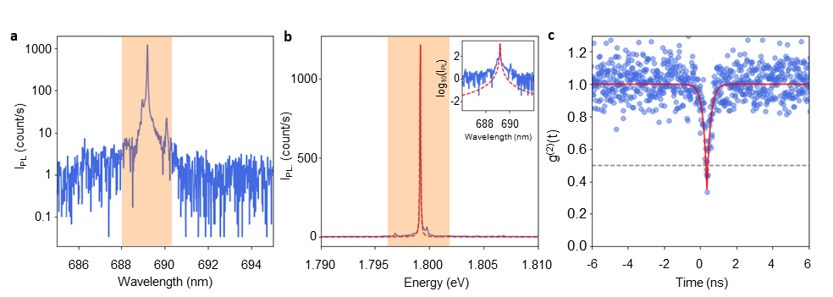
Figure S7. (a) Spectrally filtered PL of ELM-QD 1 for the pump power of 50 nW (logarithemic scale). The shaded region shows the 2.1 nm spectral window used for PL emission filtering. (b) Spectrally filtered PL of ELM-QD 1 (linear scale) with Lorentzian fitting (red dashed lines) (c) Second order correlation function for ELM-QD 1 without the random coincidence correlation correction.

S6. Remote excitation of energy landscape-modified quantum dots
ELM-QDs can be excited remotely by optically pumping them at a distance of several micrometers. Figure S8 illustrates the remote excitation configuration and summarizes our measurements for three ELM-QDs and for two ordinary QDs for comparison. The ELM-QDs continue emitting photons when the pump beam is shifted several micrometers away from the QD location, whereas PL of ordinary QDs drops quickly with the distance between the QD and the point of excitation. The QD PL intensity is plotted in Fig. S8 as a function of the distance between the QD and the pump beam position. These results are consistent with the results presented in Fig. 4 in the main Article.
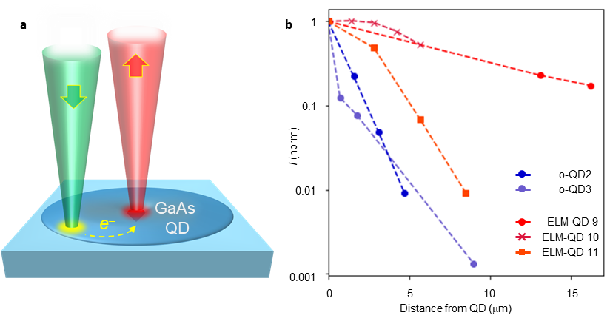
Figure S8. Remote optical excitation of ELM-QDs: (a) Schematic diagram of the experiment; and (b) normalized PL intensity as a function of the distance between the QD and the point of excitation for three ELM-QDs (red) and two o-QDs (blue) for reference.

References
1. Juska, G., et al. Towards quantum-dot arrays of entangled photon emitters. Nature Photon 7, 527–531 (2013).
2. Zieliński, M.et al. Excitonic complexes in natural InAs/GaAs quantum dots. Phys. Rev. B. 91,085303 (2015)
3. Abbarchi, M. et al. Energy renormalization of exciton complexes in GaAs quantum dots. Phys. Rev. B, 82, 201301 (2010)
4. Yu, Y. et al. Fundamental limits of exciton-exciton annihilation for light emission in transition metal dichalcogenide monolayers. Phys. Rev. B. 93, 201111 (2016)
5. Li, X., Liu, S., Wei, Y. et al. Bright semiconductor single-photon sources pumped by heterogeneously integrated micropillar lasers with electrical injections. Light Sci Appl 12, 65 (2023).
6. Larocque, H., Buyukkaya, M.A., Errando-Herranz, C. et al. Tunable quantum emitters on large-scale foundry silicon photonics. Nat Commun 15, 5781 (2024).
7. Reimer, M., Bulgarini, G., Akopian, N. et al. Bright single-photon sources in bottom-up tailored nanowires. Nat Commun 3, 737 (2012).
8. Claudon, J., Bleuse, J., Malik, N. et al. A highly efficient single-photon source based on a quantum dot in a photonic nanowire. Nature Photon 4, 174–177 (2010).
9. Sapienza, L., Davanço, M., Badolato, A. et al. Nanoscale optical positioning of single quantum dots for bright and pure single-photon emission. Nat Commun 6, 7833 (2015).
10. Gazzano, O., Michaelis de Vasconcellos, S., Arnold, C. et al. Bright solid-state sources of indistinguishable single photons. Nat Commun 4, 1425 (2013)
11. Schlehahn, A, et al. Generating single photons at gigahertz modulation-speed using electrically controlled quantum dot microlenses. Appl. Phys. Lett. 108, 021104 (2016)
12. Gan, L, et al. Large-Scale, High-Yield Laser Fabrication of Bright and Pure Single-Photon Emitters at Room Temperature in Hexagonal Boron Nitride. ACS Nano 16, 9, 14254-14261 (2022)
13. Wang, X.-J., et al. Enhanced brightness of quantum emitters via in situ coupling to the dielectric microsphere. Appl. Phys. Lett. 123, 133106 (2023)
14. Brouri. R. et al., Photon antibunching in the fluorescence of individual color centers in diamond. Opt. Lett. 25, 1294 (2000)

