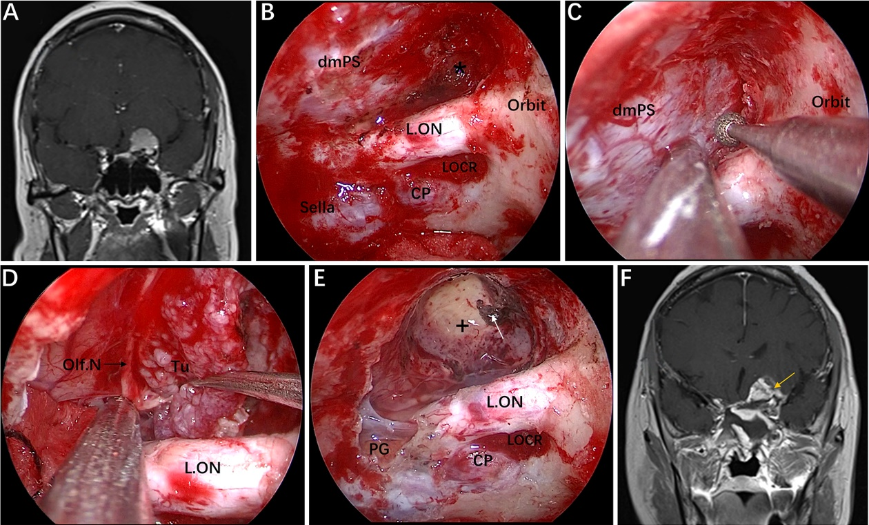
FIG. S2. Case 1, a 56-year-old woman, presented with a 1-year history of dizziness and progressive left visual loss for more than 1 month. A: Preoperative coronal Gd-enhanced MRI showing a left ACP meningioma. B-E: Intraoperative images. B: Exposure of the lateral dura of the planum sphenoidale and supraoptic recess (black asterisk). C: Drilling the roof wall of the optic canal and supraoptic recess in a medial-to-lateral direction toward the body of the lesser sphenoid wing. D: Separation of the tumor from the olfactory nerve through the supraoptic approach. E: Final endoscopic view after complete tumor removal. The white arrow represents the severed posterior ethmoidal artery. F: Postoperative coronal MRI showing total tumor removal. The yellow arrow represents the autologous fat used during the operation. + = tumor cavity. The figure is available in color only online.

