Supplementary material to “Evaluation and optimization of wheat and maize national evaluation systems in Europe”

Jip J.C. Ramakers, Waqas A. Malik, Claude Welcker, Boris Parent, Daniela Bustos-Korts, Nadir Abu-Samra Spencer, Harimurti Buntaran, Xinxin Chen, Damien Eylenbosch, Clemens Flamm, Christophe Grizeau, Juan M. Herrera, Jürg Hiltbrunner, Vladimíra Horáková, Lilia Levy Häner, Fabien Masson, Joke Pannecoucque, Márton Pécs, Marek Povolný, Philipp Starnberger, Margot Visse-Mansiaux, Tiziana Vonlanthen, Cécile Collonnier, François Laurens, Pierre Martre, Hans-Peter Piepho, Fred A. van Eeuwijk

Supplementary tables referred to in the main text (pp. 2–5):

Table S1: Estimated fixed effects and variance components of wheat grain yield
Table S2: Estimated fixed effects and variance components of maize grain yield
Table S3: Estimated genetic trends by maturity groups for French maize trials
Table S4: Data underlying Fig. 5C: Genetic trends vs. single-trial precision in other crops

Supplementary figures referred to in the main text (pp. 6–13):

Fig. S1: Rate of nitrogen fertilizer application across years in the historical wheat VCU networks
Fig. S2: Rate of nitrogen fertilizer application across years in the historical maize VCU networks
Fig. S3: Sowing date across years in the historical wheat VCU networks
Fig. S4: Sowing date across years in the historical maize VCU networks
Fig. S5: Harvest date across years in the historical wheat VCU networks
Fig. S6: Harvest date across years in the historical maize VCU networks
Fig. S7. Connectivity in wheat cultivars between years
Fig. S8. Connectivity in maize cultivars between years

Supplementary background referred to in main text (pp. 14–16):

Supplementary Section S1: Genetic trends in wheat in France from previous studies.

References (p. 17)

Table S1 Estimated fixed effects (± SE) and variance components of wheat grain yield, including genetic and non-genetic trends for the historical VCU networks of the seven countries analysed in this study.
 | Austria  East | Austria  West | Belgium | Czech  Republic | France  South | France  North | Germany | Hungary | Switzer  land
Fixed effects
Intercept ($μ$; t ha⁻¹) † | 6.344 ±  0.536 | 7.503 ±  0.471 | 8.663 ±  0.744 | 8.468 ±  0.429 | 7.498 ±  0.311 | 8.049 ±  0.423 | 8.395 ±  0.260 | 5.775 ±  0.355 | 6.379 ±  0.321
Genetic trend  (β; t ha⁻¹yr⁻¹) | 0.062 ±  0.053^{ns} | 0.038 ±  0.014* | 0.157 ±  0.022* | 0.071±  0.009* | 0.034 ±  0.008* | 0.043 ±  0.007* | 0.062 ±  0.008* | 0.057 ±  0.009* | 0.046 ±  0.008*
Change per year (%)‡ | 0.98 | 0.50 | 1.81 | 0.83 | 0.45 | 0.54 | 0.74 | 1.00 | 0.72
Non-genetic trend  (γ; t ha⁻¹yr⁻¹) | 0.069 ± 0.078^{ns} | 0.071 ± 0.041^{ns} | -0.163 ± 0.154^{ns} | -0.022 ± 0.045^{ns} | -0.045 ± 0.031^{ns} | -0.038 ± 0.044^{ns} | -0.023 ± 0.028^{ns} | 0.013 ± 0.037^{ns} | -0.070 ± 0.035*
Variance components (t² ha⁻²)
Genetic terms
G | 0.059 | 0.094 | 0.047 | 0.089 | 0.072 | 0.079 | 0.123 | 0.047 | 0.192
GL | <0.001 | 0.016 | 0.015 | 0.028 | 0.038 | 0.053 | 0.015 | 0.026 | 0.036
GY | 0.072 | 0.027 | 0.058 | 0.050 | 0.017 | 0.032 | 0.021 | 0.058 | 0.042
GLY'§ | 0.121 | 0.167 | 0.146 | 0.208 | 0.122 | 0.135 | 0.147 | 0.164 | 0.166
Non-genetic terms
S(LY) ‖ |  |  |  | 0.156 | 0.026 | 0.034 | 0.079 | 0.098
L | 0.089 | 0.834 | 0.317 | 0.359 | 0.291 | 0.541 | 0.552 | 0.215 | 0.062
Y | 0.791 | 0.347 | 1.320 | 0.550 | 0.194 | 0.692 | 0.228 | 0.291 | 0.327
LY | 1.387 | 0.776 | 0.650 | 1.366 | 0.892 | 0.767 | 0.599 | 0.966 | 0.691
Significance level: p < 0.05 (*) and not-significant (ns), based on conditional F-tests. Variance components: G = genotype; Y = year; L = year; S = series.
† The intercept was set to the first trial year
‡ Genetic change whilst ignoring the non-genetic trend (which is mostly non-significant).
§ Sum of the three-way interaction $(GLY)$ and the residual.
‖ Nested (sub)trial effect as per model (3).

Table S2 Estimated fixed effects (± SE) and variance components of maize grain yield, including genetic and non-genetic trends for the historical VCU networks of the seven countries analysed in this study.
 | Austria | Belgium | Czech Republic | France | Germany | Hungary | Switzerland
Fixed effects
Intercept ($μ$; t ha⁻¹) † | 11.044 ± 0.398 | 10.431 ± 0.186 | 9.027 ± 0.654 | 10.817 ± 0.118 | 10.824 ± 0.229 | 9.197 ± 0.606 | 11.205 ± 0.23
Genetic trend  (β; t ha⁻¹yr⁻¹) | 0.100 ± 0.008* | 0.131 ± 0.017* | 0.125 ± 0.014* | 0.098 ± 0.004* | 0.097 ± 0.008* | 0.089 ± 0.009* | 0.133 ± 0.008*
Change per year (%)‡ | 0.91 | 1.36 | 1.39 | 0.91 | 0.90 | 1.03 | 1.19
Non-genetic trend  (γ; t ha⁻¹yr⁻¹) | -0.021 ± 0.047^{ns} | -0.047 ± 0.036^{ns} | -0.106 ± 0.101^{ns} | -0.106 ± 0.021* | -0.034 ± 0.047^{ns} | -0.018 ± 0.112^{ns} | 0.022 ± 0.041^{ns}
Variance components (t² ha⁻²)
Genetic terms
G | 0.065 | 0.192 | 0.091 | 0.085 | 0.060 | 0.292 | 0.268
GL | 0.035 | 0.028 | 0.016 | 0.043 | 0.036 | 0.030 | 0.080
GY | 0.035 | 0.042 | 0.070 | 0.030 | 0.037 | 0.045 | 0.043
ML | <0.001 |  |  | 0.061 | 0.005 | <0.001 | 0.064
MY | 0.021 |  |  | 0.004 | 0.000 | 0.017 | 0.095
MLY | 0.103 |  |  | 0.073 | 0.089 | 0.204 | 0.206
GLY'§ | 0.225 | 0.227 | 0.347 | 0.156 | 0.262 | 0.281 | 0.344
Non-genetic terms
S(LY) ‖ |  | 0.045 |  | 0.049 | 0.062
L | 0.870 | 0.042 | 1.034 | 0.209 | 0.575 | 1.098 | 0.224
Y | 0.447 | 0.205 | 2.895 | 0.156 | 0.702 | 3.564 | 0.372
LY | 1.247 | 0.915 | 2.358 | 0.674 | 1.096 | 2.294 | 1.501
Significance level: P < 0.05 (*) and not-significant (ns), based on conditional F-tests. Variance components: G = genotype; Y = year; L = year; M = maturity group; S = series.
† The intercept was set to the first trial year, averaged over maturity groups (not shown).
‡ Genetic change whilst ignoring the non-genetic trend (which is mostly non-significant).
§ Sum of the three-way interaction $(GLY)$ and the plot-level residual.
‖ Nested (sub)trial effect as per model (3) or (5).

Table S3 Estimated genetic trends by maturity groups for French maize trials (see Extended Data Fig. 3 for a visualisation of the trends).
Model term | No. of varieties | Estimate |  | % per year  (β/$μ$* 100) | SE
Genetic Trend (β; t ha⁻¹yr⁻¹)
Maturity Group A: Very early | 105 | 0.0591 |  | 0.61 | 0.0080
Maturity Group B : Early | 216 | 0.0827 |  | 0.84 | 0.0061
Maturity Group C1: Middle | 138 | 0.0939 |  | 0.89 | 0.0062
Maturity Group C2: Middle | 81 | 0.1103 |  | 1.00 | 0.0069
Maturity Group D: Late | 126 | 0.1076 |  | 0.94 | 0.0071
Maturity Group E, E1+E2: Very late | 99 | 0.1420 |  | 1.22 | 0.0082
Non-Genetic Trend (γ; t ha⁻¹yr⁻¹) |  | -0.1064 |  |  | 0.0213
Maturity Group × Genetic Trend |  |  | Significant (P < 0.0001)
Intercept ($μ$; t ha⁻¹)
Maturity Group A: Very early |  | 9.624 |  |  | 0.183
Maturity Group B : Early |  | 9.876 |  |  | 0.154
Maturity Group C1: Middle |  | 10.539 |  |  | 0.156
Maturity Group C2: Middle |  | 11.069 |  |  | 0.153
Maturity Group D: Late |  | 11.401 |  |  | 0.156
Maturity Group E, E1+E2: Very late |  | 11.675 |  |  | 0.173
Variance components (t² ha⁻²)†
G |  | 0.0853 |  |  | 0.0069
GY |  | 0.0310 |  |  | 0.0021
GL |  | 0.0416 |  |  | 0.0020
GLY' |  | 0.1561 |  |  | 0.0019
ML |  | 0.0684 |  |  | 0.0309
MY |  | 0.0033 |  |  | 0.0086
MLY |  | 0.0695 |  |  | 0.0152
S(LY) |  | 0.0498 |  |  | 0.0029
Y |  | 0.1599 |  |  | 0.0655
L |  | 0.2033 |  |  | 0.0637
YL |  | 0.6802 |  |  | 0.0456
Note. See Tables S1 and S2 for an explanation of the components in this table.
† Variance components differ slightly from those reported in Table S2 for France as the very late maturity groups (E vs. E1 + E2) were merged in the current table.
Table S4 Data underlying Fig. 4c (main text).
Reference | Ref. code | Crop | Crop code | Country | Genetic trend  (% yr⁻¹)* | LSD%  (1 yr, 1 loc)
Laidig_et al.¹ | a | Winter rye, hybrid | Rye | DE | 0.8154 | 9.1799
Laidig_et al.¹ | a | Winter rye, population | Rye | DE | 0.4229 | 9.0407
Laidig_et al.¹ | a | Winter triticale | Tri | DE | 0.6382 | 14.1473
Laidig_et al.¹ | a | Winter barley, 2r | Bar | DE | 0.9686 | 9.7308
Laidig_et al.¹ | a | Winter barley, 6r | Bar | DE | 0.8474 | 10.0892
Laidig_et al.¹ | a | Spring barley | Bar | DE | 0.8439 | 9.7851
Cormier et al.² | b | WinterWheat | Whe | FR | 0.4500 | 17.8198
Chapman & de la Vega³ | c | sunflower, central | Sun | AR | 0.5575 | 21.0391
INVITE-AGES | e | sunflower, Austria | Sun | AT | 0.6597 | 17.0193
INVITE-CREA | f | sunflower, Italy | Sun | IT | 1.5014 | 24.2757
INVITE-GEVES | g | sunflower, France | Sun | FR | 0.7652 | 14.9800
INVITE-NEBIH | h | sunflower, Hungary | Sun | HU | 0.6424 | 17.2763
INVITE-AGES | e | soybean, Austria | Soy | AT | 1.8200 | 16.2367
Malik et al.⁴ | d | Maize, Poland | Mai | PL | 1.6172 | 10.9127
INVITE-GEVES | g | Soybean, France | Soy | FR | 1.0540 | 16.6859
*In Fig. 4c in main text, the genetic trend was multiplied by 10.

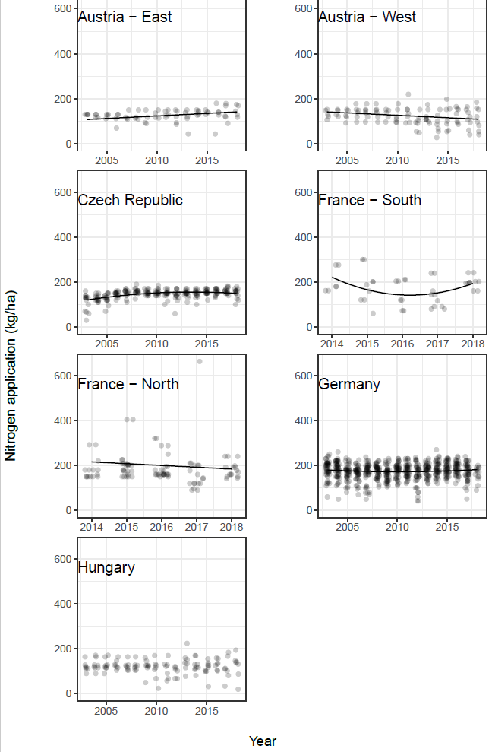
Figure S1 Rate of nitrogen fertilizer application across years in the historical wheat VCU networks for the five of seven countries analysed in this study (excluding Belgium and Switzerland). Points are locations within a year (random horizontal spacing added for clarity); lines are estimates from a model with year (and year²) as a fixed and site as a random term. Although significant trends occurred in four countries (AT, CZ, FR and DE), none of them appeared to relate to a positive or negative agronomic trend (Table S1) in a consistent way.

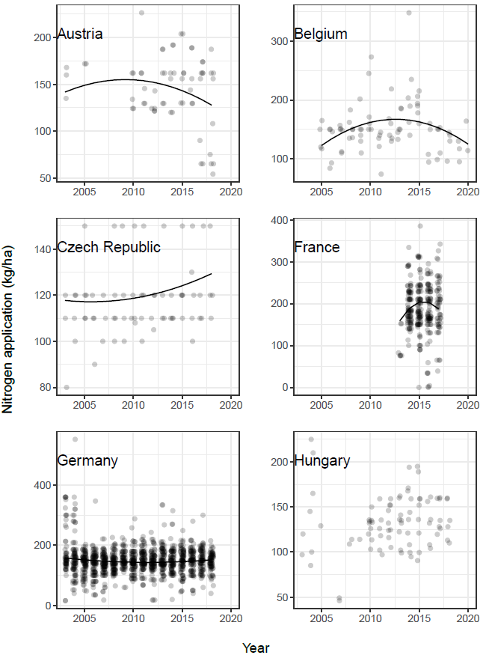
Figure S2 Rate of nitrogen fertilizer application across years in the historical maize VCU networks for the six of seven countries analysed in this study (excluding Switzerland). Points are locations within a year (random horizontal spacing added for clarity); lines are estimates from a model with year (and year²) as a fixed and site as a random term. In five countries (all except HU) a significant trend in nitrogen application was found, albeit quadratic in nature. None of these quadratic trends, which peaked approximately halfway through the studied period, appeared to align with the linear agronomic trends found in Table S2.

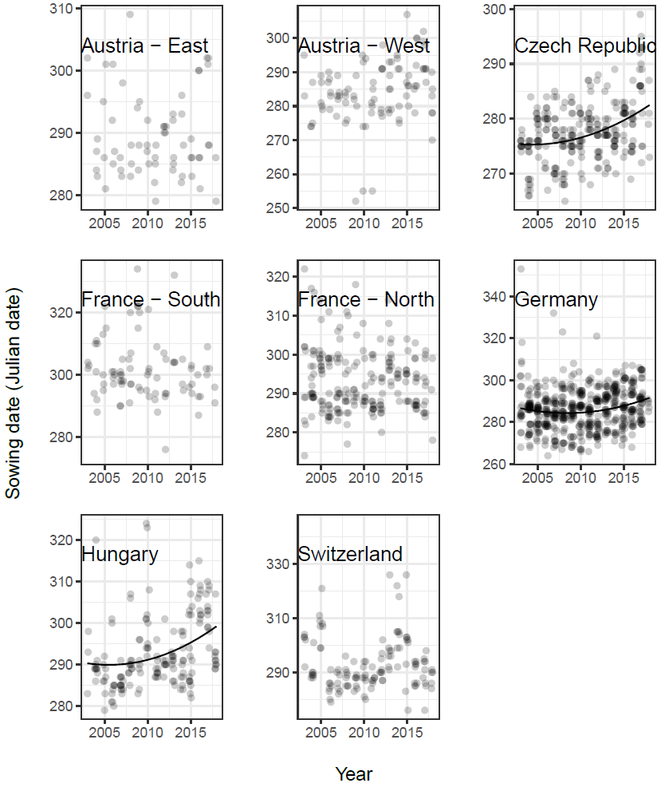
Figure S3 Sowing date (Julian date) across years in the historical wheat VCU networks for six of the seven countries analysed in this study (excluding Belgium). Points are locations within a year (random horizontal spacing added for clarity); lines are estimates from a model with year (and year²) as a fixed and site as a random term. Significant delays in sowing date were observed over time in CZ, DE and HU, but since these countries were the ones with smallest effect size in the agronomic trend (Table S1) there is no reason to assume that these delays in sowing date contributed to agronomic trends.

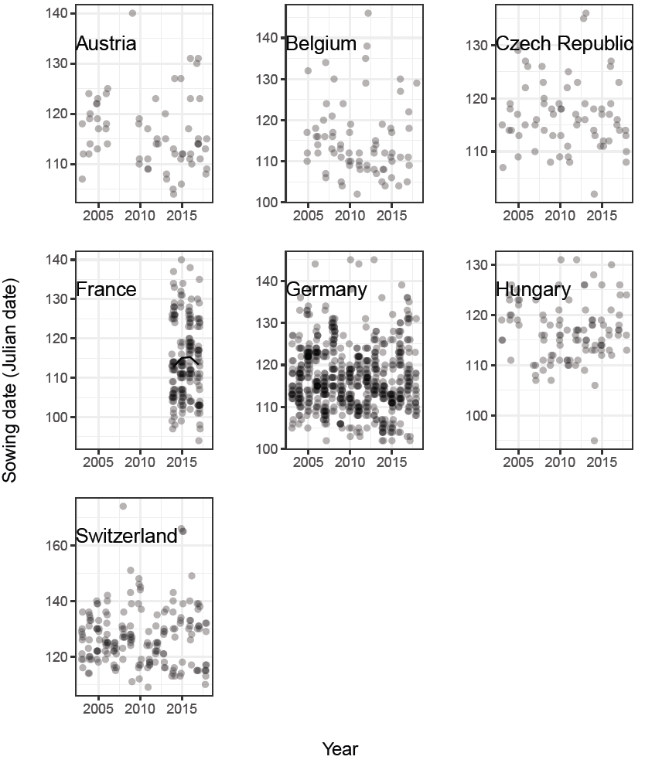
Figure S4 Sowing date (Julian date) across years in the historical maize VCU networks for the seven countries analysed in this study. Points are locations within a year (random horizontal spacing added for clarity); lines are estimates from a model with year (and year²) as a fixed and site as a random term. None of the countries exhibited a significant delay or advance in sowing date over time. Hence, sowing date is not likely to explain any agronomic trends in Table S2.

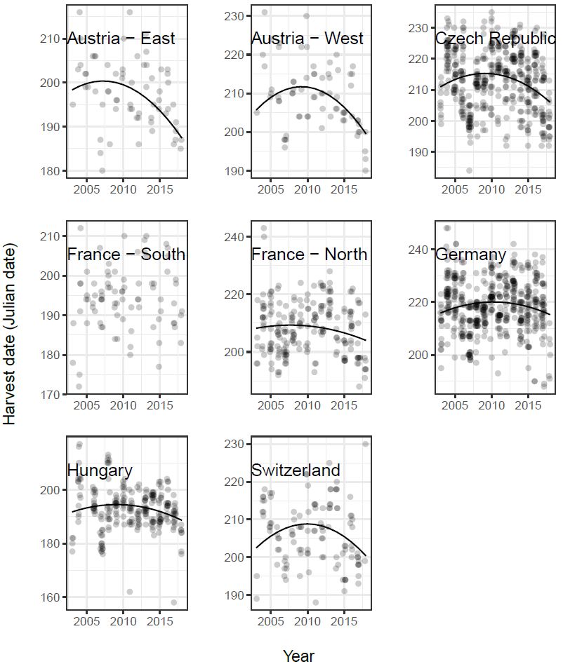
Figure S5 Harvest date (Julian date) across years in the historical wheat VCU networks for six of the seven countries analysed in this study. Points are locations within a year (random horizontal spacing added for clarity); lines are estimates from a model with year (and year²) as a fixed and site as a random term. All countries (except the FR-South network) showed a significant quadratic effect of year on harvest date; with harvest date peaking halfway through the study period and declining afterwards. The patterns displayed here suggest little consistency with the non-genetic trends in Table S1.

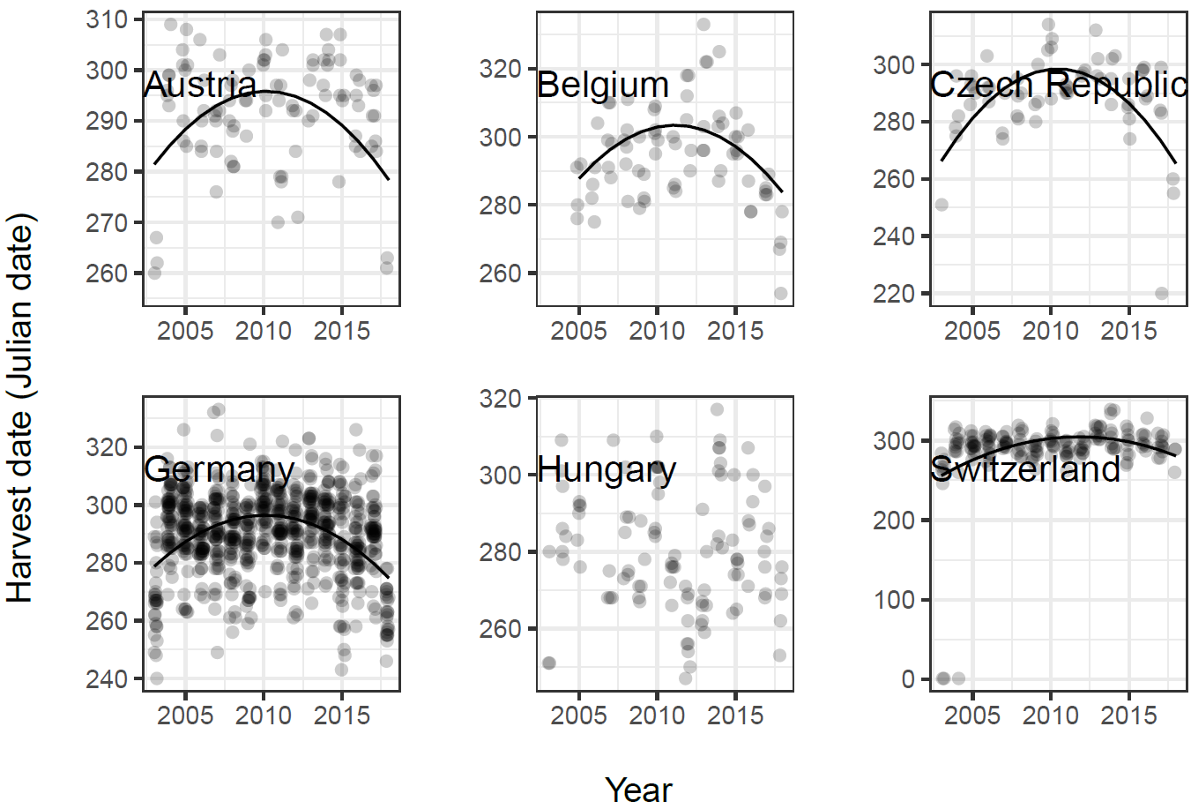
Figure S6 Harvest date (Julian date) across years in the historical maize VCU networks for six of the seven countries analysed in this study. Points are locations within a year (random horizontal spacing added for clarity); lines are estimates from a model with year (and year²) as a fixed and site as a random term. All countries except HU showed a significant quadratic effect of year on harvest date; with harvest date peaking halfway through the study period and declining afterwards. The patterns displayed here suggest little consistency with the non-genetic trends in Table S2.

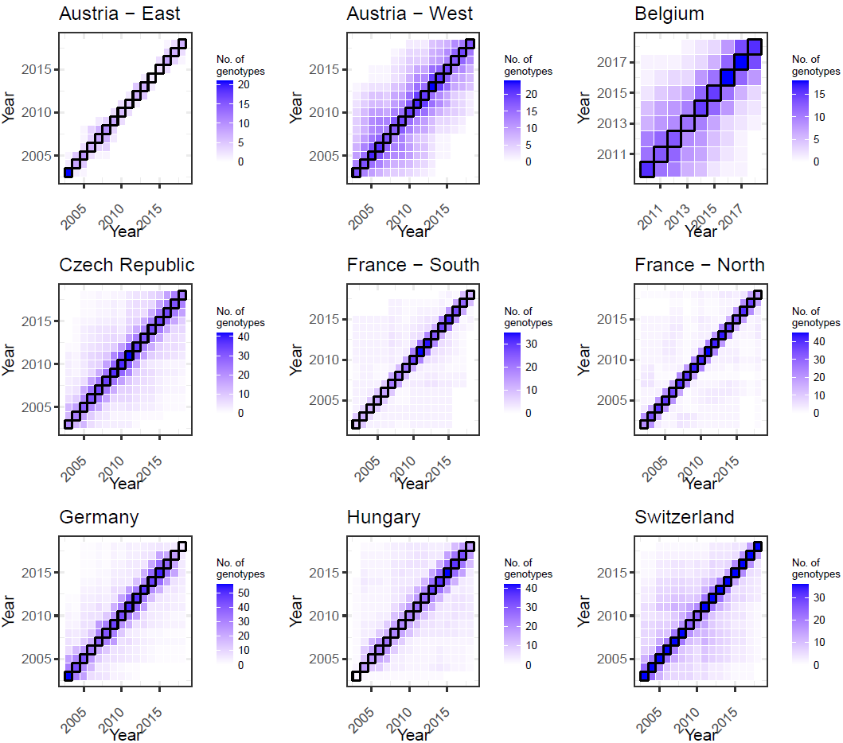
Figure S7 Connectivity of wheat varieties across years. Cells on the diagonal (with black outlines) indicate the number of unique cultivars in a given year. The off-diagonals indicate the number of overlapping cultivars between years. Note the different scaling between the panels.

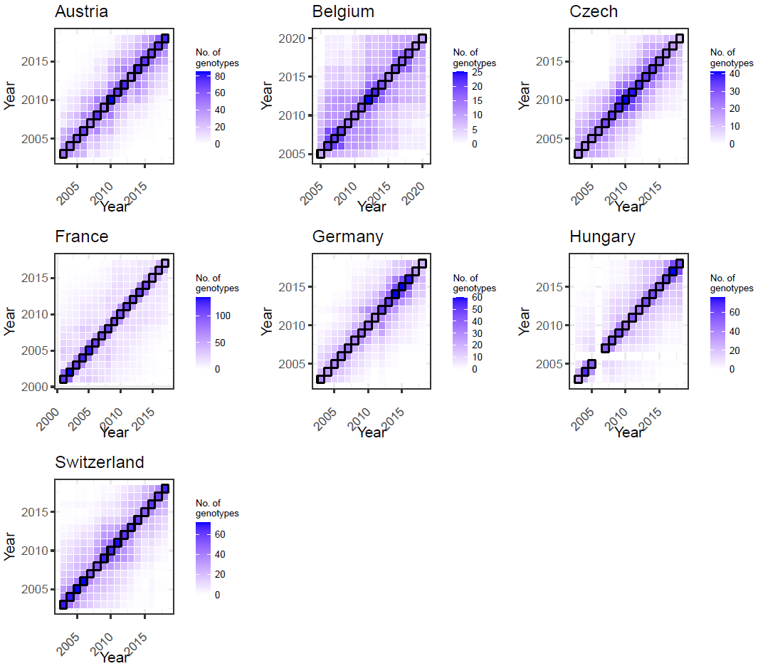
Figure S8 Connectivity of maize varieties across years. Cells on the diagonal (with black outlines) indicate the number of unique cultivars in a given year. The off-diagonals indicate the number of overlapping cultivars between years. Note the different scaling between the panels.

Supplementary section S1 – Previous studies on genetic gain in French wheat

Background
Genetic trends in wheat grain yield have been studied extensively in France^{2,5-7}, but each with their own methods and in different time periods, resulting in reported trends that may differ from the ones reported in our study. In this section we aim to give some context behind these differences.

Summary French wheat data INVITE
Genetic gain in France in the current study was estimated based on data from 2002 to 2018, by courtesy of GEVES. Across trials in both the northern and southern network, the average proportion of varieties in the data that were VCU candidates was 0.72–0.74; the remainder consisted of varieties that we denote here as reference varieties. This proportion is lower than the actual proportion of candidate varieties tested, which is a about 0.85. Therefore, like VCU networks from other countries, we have a non-random subset of the candidate varieties that were actually tested at our disposal. Like other countries for which both low- and high-input fungicide trials were available, we restricted our analysis of the French wheat network to high-input trials.

Comparison with previous studies
Previous studies have estimated genetic trends within French networks in different ways, i.e., from historical (long-term) data within a different range of years to our study^{5,6} and by testing varieties of different ages alongside one another in a limited number of trials ². In the latter case, sometimes called ‘era trials’ (because varieties from different eras are assembled), the genetic trend is estimated by extracting genotypic means from the mixed model and regressing them on the year of release in a separate linear model that accounted for covariates quality class, plant height and precocity. In the former two studies, genetic gain was calculated by correcting the yield of each variety in a given year for the year effect only, subsequently taking the average of these corrected yields and regressing these averages against the release year. Our study takes yet another approach: varieties’ mean yield was regressed directly on the release year in a mixed model that accounted for background genotypic, environmental (location and year) and G×E variation as well as a non-genetic trend. A more recent analysis conducted by Arvalis⁷ studied the genetic trend in wheat grain yield by fitting mixed models to model genotypic, environmental and G×E variation, extracting the genotypic main effect from this model and regressing them on the release year; further details are not known. A summary of all methods and the resulting estimated genetic trend are displayed in Supplementary Section Table S.S1.

Table S.S1 Overview of some studies conducting genetic-trend analysis for wheat grain yield in France. The different methods of trend calculation are marked in different colours.
Reference | Year range | Type of trials | Remarks  about data | Method | Gen. trend  (t ha⁻¹yr⁻¹)
Brisson et al.⁵ | 1982–2008 | Elite lines†‡ |  | Regress varieties’ year-corrected average yield on release year | 0.094
 | 1994–2008 | VCU† |  |  | 0.115
Cormier et al.² | 1969–2010* | Post-registration |  | Extract mean yield from mixed model and regress on release year in ANOVA (with covariates quality class, plant height and precocity) | 0.033
Oury et al.⁶ | 1986–2010 | VCU (north)† | Only candidates tested for 2 yrs | Regress varieties’ year-corrected average yield on release year | 0.137
 |  | VCU (south)† | Only candidates tested for 2 yrs |  | 0.065
 | 1982–2010 | Elite lines†‡ |  |  | 0.091
Gravé et al.⁷ | 1987–2023 | Post-registration |  | Extract mean yield from mixed model and regress on release year | 0.054
This study | 2002–2018 | VCU (north)† | Only registered varieties; ~50% of candidates provided | Regress mean yield on release year within mixed model (that includes a non-genetic trend) | 0.043
 |  | VCU (south)† | Only registered varieties; ~50% of candidates provided |  | 0.034
 |  | VCU (north)† |  | Regress varieties’ year-corrected average yield on release year | 0.237
 |  | VCU (south)† |  |  | 0.041
* Release years of tested varieties; the actual test years were 2007–2009.
† Fungicide-treated trials (note: the treatment status for the post-registration trials is unknown)
‡ Only advanced varieties were tested (at least F8 generation).

The genetic trends reported from various sources ranges from 0.033 to 0.137 t ha⁻¹yr⁻¹. It is important to note that, to our knowledge, all studies quoted here concern the trials with fungicide treatment; as a general rule, genetic trends tend to be higher in untreated trials. (Oury et al.⁶ attributed this feature to a possible additive effect of breeding efforts for increased resistance and increased grain yield.) Striking is the more than threefold difference in the genetic trend in the northern VCU network found by Oury et al.⁶ versus our study, and the two- to threefold difference between Brisson et al’s⁵ and our work. There are three important differences: the range of years under study (the genetic trend might have attenuated in more recent years); the method of analysis (our models corrected for genetic, environment and G×E effects, as well as a genetic trend); and the varieties in the dataset (our data contain a mere subset of the registered varieties). Of these, the second reason is likely the main contributor to the stark difference: applying Brisson/Oury et al.’s method to the northern network in France, we obtained a more than fivefold increase in the genetic trend (0.237 vs 0.043 t ha⁻¹ yr⁻¹; Table S.S1). This may be an overestimation compared to the other two studies (Table S.S1), but it gives us confidence that our mixed-model estimates appear to be more robust than simply trying to correct for year effects. Our estimates resemble those from post-registration trials. Gravé et al.⁷ used mixed model analysis, potentially similar to ours, to compute the genetic trend; although they do not provide details, their trend is quite close to what we observed for the VCU networks.

Concluding remarks
Our mixed model-based estimates of the genetic trend in wheat grain yield in France resembles those reported earlier for post-registration trials. The stark difference we observed for the northern VCU network with earlier work is most likely due to differences in methods, where we consider our method more robust. Taken together, we believe it is reasonable to assume that the genetic trend in the French VCU networks in the past decades has hovered around 0.3–0.5 t ha⁻¹yr⁻¹.

References
1 Laidig, F. et al. Long-term breeding progress of yield, yield-related, and disease resistance traits in five cereal crops of German variety trials. Theoretical and Applied Genetics, 1-23 (2021).
2 Cormier, F. et al. A multi-environmental study of recent breeding progress on nitrogen use efficiency in wheat (Triticum aestivum L.). Theoretical and Applied Genetics 126, 3035-3048 (2013). https://doi.org:10.1007/s00122-013-2191-9
3 Chapman, S. C. & de la Vega, A. J. Spatial and seasonal effects confounding interpretation of sunflower yields in Argentina. Field Crops Research 73, 107-120 (2002). https://doi.org:https://doi.org/10.1016/S0378-4290(01)00185-X
4 Malik, W. A., Buntaran, H., Przystalski, M., Lenartowicz, T. & Piepho, H.-P. Assessing the between-country genetic correlation in maize yield using German and Polish official variety trials. Theoretical and Applied Genetics 135, 3025-3038 (2022).
5 Brisson, N. et al. Why are wheat yields stagnating in Europe? A comprehensive data analysis for France. Field Crops Research 119, 201-212 (2010). https://doi.org:https://doi.org/10.1016/j.fcr.2010.07.012
6 Oury, F.-X. et al. A study of genetic progress due to selection reveals a negative effect of climate change on bread wheat yield in France. European Journal of Agronomy 40, 28-38 (2012). https://doi.org:https://doi.org/10.1016/j.eja.2012.02.007
7 Gravé, J. et al. Céréales à paille : retour sur 40 ans de progrès génétique. Perspectives Agricoles 518, 46-58 (2024).

