Phospholipid membrane permeabilization and leakage of cell content by surfactin-C₁₅ from novel B. Subtilis B-11 strain: a computational and experimental analysis
Asma Sani ^{a, c, *}, Jia-Yi Li ^{a, c}, Chaudhry Haider Ali ^{d}, Hong-Ze Gang ^{a, c}, Yi-Fan Liu ^{a, b, c}, Shi-Zhong Yang ^{a, b, c}, Bo-Zhong Mu ^{a, b, c, *}

ª State Key Laboratory of Bioreactor Engineering and School of Chemistry and Molecular Engineering, East China University of Science and Technology, Shanghai 200237, China
^{b} Shanghai Collaborative Innovation Center for Biomanufacturing Technology, East China University of Science and Technology, Shanghai, 200237, China.
^{c} Engineering Research Center for Microbial Enhanced Oil Recovery, Ministry of Education, East China University of Science and Technology, Shanghai 200237, China.
^{d} Department of Chemical, Polymer and Composite Materials Engineering, University of Engineering & Technology, New Campus, KSK, Lahore 54890, Pakistan.
*Corresponding Authors: y10200205@mail.ecust.edu.cn

Supporting Information

Table of Contents

Table ST1. Biosurfactants produced from microbial strains that are extracted from raw material.
Table ST2 Leakage of contents for 10 µM DPPC LUV measured by the release of CF (increase in fluorescence intensity).
Table ST3. Root mean-square deviation (RMSD) of surfactin-C₁₅ with respect to the initial structure for the simulations with the DPPC bilayer membrane

Figure S1 Electrospray ionization quadruple-time-of-flight mass spectrometry (TOF MS ES) of biosurfactant produced by Bacillus Subtillis strain B-11.
Figure S2 High-performance liquid chromatography (HPLC) and liquid chromatography/mass spectrometry (LC/MS) of lipopeptides produced by Bacillus Subtillis B-11.

Table ST1. Biosurfactants produced from microbial strains that are extracted from raw material.

Sr. no. | Stains |  | Biosurfactant
 | Fictibacillus nanhaiensis 10Sa-46 |  | surfactin
 | Geobacillus thermodenitrificans 10Sa-63 |  | surfactin
 | Exiguobacterium aurantiacum 50Sa-80 |  | surfactin
 | Sporosarcina luteola 10Sa-44 |  | surfactin
 | Thauera propionica 1BS-5 |  | surfactin
 | Niallia circulans 10Sa-77 |  | surfactin
 | Siminovitchia thermophile 10Sa-49 |  | surfactin
 | Bacillus subtilis 50Sa-74 |  | surfactin
 | Lacrimispora sphenoides B-5 |  | surfactin
 | Bacillus subtilis B-11 |  | surfactin
 | Bacillus subtilis | 237-E7 | surfactin
 | Bacillus subtilis | 237-E8 | surfactin
 | Bacillus subtilis | 237-E10 | surfactin
 | Pseudomonas aeruginosa | 238-E6 | rhamnolipid
 | Pseudomonas aeruginosa | 238-F1 | rhamnolipid
 | Pseudomonas aeruginosa | 238-H7 | rhamnolipid
 | Pseudomonas aeruginosa | 239-BE6 | rhamnolipid
 | Pseudomonas aeruginosa | 239-F1 | rhamnolipid

Fermentation medium
Reagents | Concentration | Reagents | Concentration
Sucrose | 70 g/L | MgSO₄ | 0.07326 g/L
NaNO₃ | 25 g/L | CaCl₂ | 7.5 mg/L
Yeast Extract | 1 g/L | MnSO₄∙H₂O | 6 mg/L
KH₂PO₄ | 0.333 g/L | FeSO4∙7H₂O | 6 mg/L
Na₂HPO₄ | 0.3964 g/L | - | -

S1. Luria-Bertani (LB) medium: 10.0 g peptone, 5.0 g yeast extract, and 10.0 g NaCl per liter. Adjust all media from their original pH to 7.2 using 1.0 M NaOH or 1.0 M HCl. Make solid medium by adding 2% (w/v) agar powder to the above medium. The medium was sterilized at 115 °C for 30 min, and then, the culture medium was incubated with an inoculum size of 1% (v/v). One hundred milliliters of the resultant medium in a 250 mL Erlenmeyer flask were aerobically cultured at 37 °C for 72 h on a rotary shaker (180 r/min).

Biosurfactant extraction
The cell-free broth was obtained by the centrifugation of the culture at 5,000×g, for 25 min. The supernatant was adjusted to final pH of 2.0 by adding 6 M HCl and then kept overnight at room temperature followed by centrifuging at 5,000×g for 20 min to obtain the precipitate. The precipitate was extracted three times with ethyl acetate, and the organic phase was combined and washed two times with deionized water. Finally, the organic phase was dried by air blowing to obtain the crude biosurfactant.

Determination of Molecular Masses: The biosurfactant was dissolved in methanol and analyzed by ESI-MS. The electrospray source was operated at ionization source temperature of 80 °C, electrolyte voltage of 100 V, and spray inlet temperature of 120 °C. The spectrum was acquired in the negative and positive ion mode.

Reversed-phase high performance liquid chromatography: The purified biosurfactant mixture was separated into individual biosurfactant by preparative reverse-phase HPLC using a HPLC system (LC 100) equipped with a HiQ sil C18 W column (KYA TECH, Japan; 5 μm, 250 × 21.2 mm). mixture. The system was run at 30 °C with an 80% to 100% linear gradient of 0.5% (v/v) formic acid in acetonitrile and 0.5% (v/v) formic acid in water as mobile phases. Peaks were eluted at a flow rate of 1 ml/min and detected by a UV monitor at 205 nm.

Purification of surfactin-C₁₅
Purification of surfactin C₁₅ from a mixture containing C12, C13, C14, and C15 homologues along with other compounds typically involves a multi-step process. Initially, acid precipitation is performed by adjusting the pH of the fermentation supernatant to 2.0 using concentrated HCl, followed by centrifugation to collect the precipitate. The precipitate is then dissolved in an alkaline solution to neutralize the pH. Further purification steps may include solvent extraction using organic solvents like chloroform-methanol or ethyl acetate to remove impurities. Chromatographic separation, particularly preparative HPLC using a C18 column with a gradient mobile phase of acetonitrile and water (acidified with 0.1% formic acid), is employed to separate the surfactin homologues based on their hydrophobicity. Fractions corresponding to pure C15 surfactin are collected using UV detection, typically at 210 nm. Finally, the purified fractions are evaporated, and the residue is freeze-dried to obtain surfactin C15 as a white powder with high purity. This process allows for the separation and isolation of the C15 homologue from the mixture, which contains predominantly C15 (60%) and C14 (40%) chains.
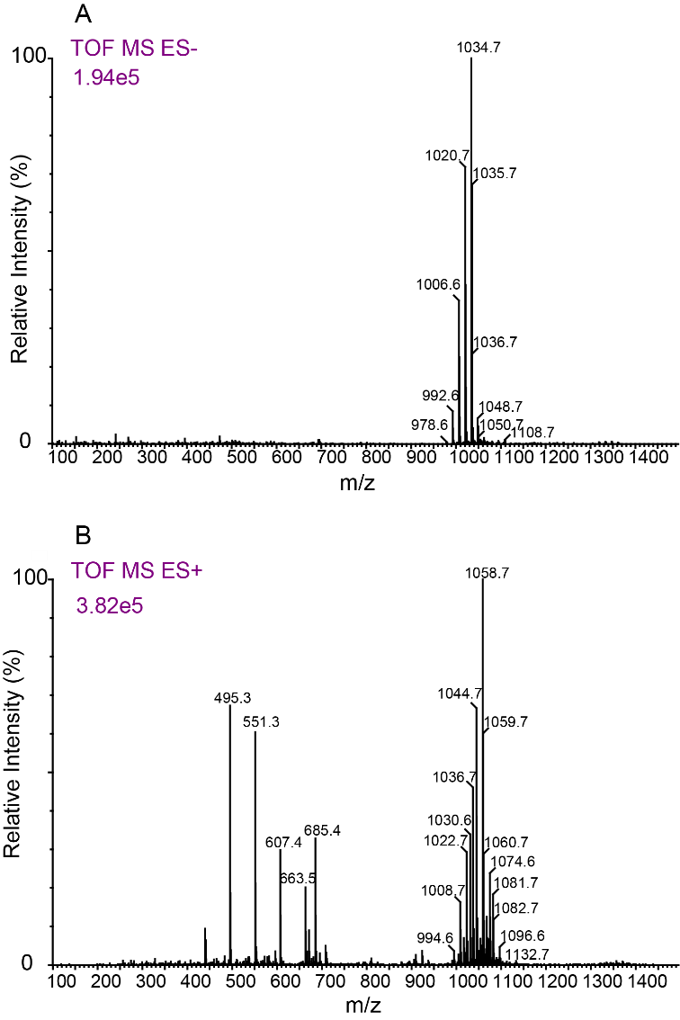
Figure S1 Electrospray ionization quadruple-time-of-flight mass spectrometry (TOF MS ES) of biosurfactant produced by Bacillus Subtillis strain B-11.
Figure S2 High-performance liquid chromatography (HPLC) and liquid chromatography/mass spectrometry (LC/MS) of lipopeptides produced by Bacillus Subtillis B-11.

S2. Computational Studies
- Optimization of structure: The Gaussian 03 program was utilized to optimize the structure of surfactin molecules and DPPC lipid bilayer membrane. Density functional theory (DFT) was applied, utilizing the hybrid functional B3LYP and the basis set 6-311++G(2d,2p) level. Using the polarizable continuum model (PCM) and the integral equation formalism variant (IEFPCM), the Gaussian default SCRF method was utilized to simulate water solvation, with a dielectric constant of ε = 78.3553. From previously published cartesian coordinates, the optimized structures of both Surfactin-C₁₅ and DPPC bilayers were obtained.

Figure S3 (a) surfactin produced from Bacillus Subtillis B-11 are of different carbon number chains with iso or anteiso orientation. (b) Optimized structures of Surfactin at B3LYP/6-311++ G (d, p) level of density functional theory (DFT). (c) Optimized structures of DPPC lipid bilayer at B3LYP/6-311++ G (d, p) level of density functional theory (DFT).

- Molecular Dynamics Simulation Analysis: The normal Antechamber process was used to set up the parameters for Molecular Dynamics simulations of surfactant molecules, methane, ethyl diazoacetate, and tetrahydrofuran. In summary, from the solvated DFT B3LYP optimized structures, charges were computed using Gaussian at the Hartree-Fock level (HF/6-31G* Pop=MK iop(6/33=2) iop(6/42=6)). After that, the general AMBER force field (GAFF) atom types were assigned and the data was structured and produced for Ambertools15 and AMBER16 using the Restrained Electrostatic Potential (RESP) approach implemented in Antechamber. Using the Seminario approach and the Python-based metal center parameter builder MCPB.py, the final force constant parameters of the catalytic intermediates were produced. [49] Density functional theory approaches were applied in the computations utilizing the Gaussian 03 program package (DFT). With the matching electron core potentials for Ag, LANL2DZ, and C, N, O, H, Br, and F, the chosen basis set was 6-31G(d), and the chosen functional was B3LYP. Using the VDW values from the universal force field, the charge calculation treated the VDW radius of Ag+ as 1.5 Å. (UFF).
Table ST2 Leakage of contents for 10 µM DPPC LUV measured by the release of CF (increase in fluorescence intensity).
Time (min) | Carboxy Fluorescence Leakage (%)  Concentrations of Surfactin-C₁₅
Time (min) | 0 mol% | 5 mol% | 10 mol% | 15 mol% | 25 mol% | 50 mol%
0 | 0 | 0 | 0 | 0 | 0 | 0
0.2 | 0.1112 | 0.59 | 1.34 | 3.1 | 10 | 15
0.3 | 0.11 | 1 | 4 | 6.2 | 16 | 25
0.4 | 0.12 | 1.73 | 5.87 | 9.3 | 21 | 35
0.5 | 0.23 | 2 | 6 | 12.4 | 29 | 40
0.6 | 0.23 | 2.44 | 7.22 | 15.5 | 36 | 48
0.7 | 0.24 | 3 | 8 | 18.6 | 44 | 57
0.8 | 0.44 | 3.95 | 9.54 | 21.7 | 50 | 67
0.9 | 0.56 | 4 | 10 | 24.8 | 56 | 73
1 | 0.67 | 4.19 | 11.32 | 27.9 | 63 | 78
1.1 | 0.78 | 5 | 12 | 31 | 69 | 82
1.2 | 0.85 | 5.21 | 13.34 | 34.1 | 72 | 85
1.3 | 0.92 | 6 | 14 | 37.2 | 74 | 89
1.4 | 1.1 | 6.93 | 15.32 | 40.3 | 77 | 92
1.5 | 1.12 | 7 | 16 | 43.4 | 79 | 95
1.6 | 1.43 | 7.54 | 17.43 | 46.5 | 79.5 | 96
1.7 | 1.56 | 8 | 18 | 49.6 | 80.32 | 98
1.8 | 1.89 | 8.12 | 20 | 52.7 | 81.34 | 99
1.9 | 2.12 | 8.96 | 21.86 | 55.8 | 81.97 | 99.56
2 | 2.34 | 9.56 | 22 | 59 | 82 | 100

Table ST3. Root mean-square deviation (RMSD) of surfactin-C₁₅ with respect to the initial structure for the simulations with the DPPC bilayer membrane
Mode | Affinity  (kcal/mol) | Distance of surfactin-C₁₅ from DPPC bilayer membrane
Mode | Affinity  (kcal/mol) | RMSD  (lower bound)  (Å) | RMSD  (upper bound)  (Å)
0 | -7.0 | 0.000 | 0.000
1 | -6.3 | 2.149 | 6.665
2 | -6.3 | 2.004 | 3.736
3 | -6.1 | 42.506 | 47.129
4 | -6.1 | 56.711 | 60.171
5 | -6.1 | 56.606 | 60.178
6 | -6.1 | 30.361 | 35.521
7 | -6.0 | 56.611 | 60.079
8 | -5.9 | 30.614 | 35.676

