Table 1. Search procedure criteria
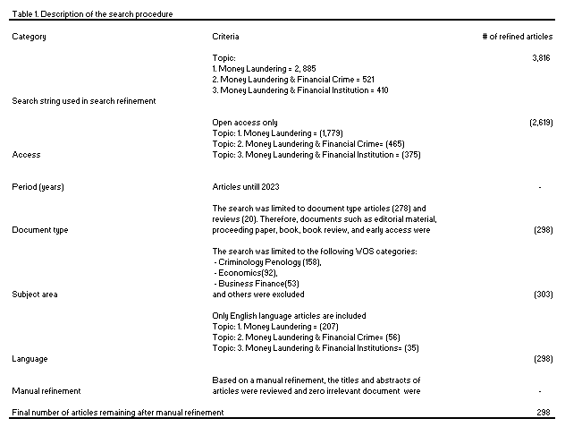
Source: created by the author

Table 2. The top-15 most active institutions contributed to publications related to Anti-Money Laundering / Financial Crime.

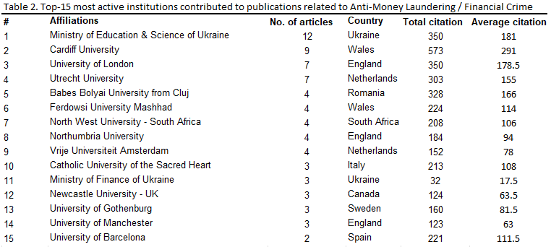
Source: created by the author

Table 3. Top-15 Anti-Money Laundering / Financial Crime, most active source titles for published.

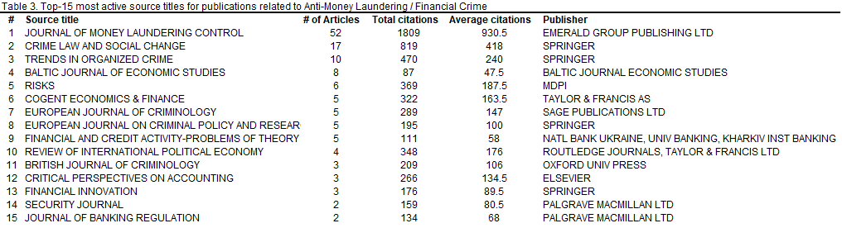
Source: created by the author.

Table 4. Top-15 Countries that contributed to Anti-Money Laundering / Financial Crime publications.

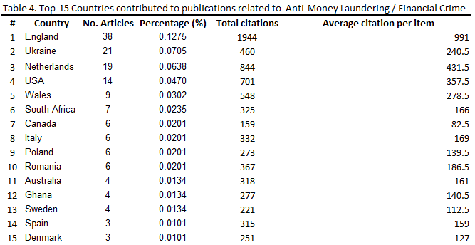
Source: created by the author.

Table 5. Top-15 Anti-Money Laundering / Financial Crime highly cited publications
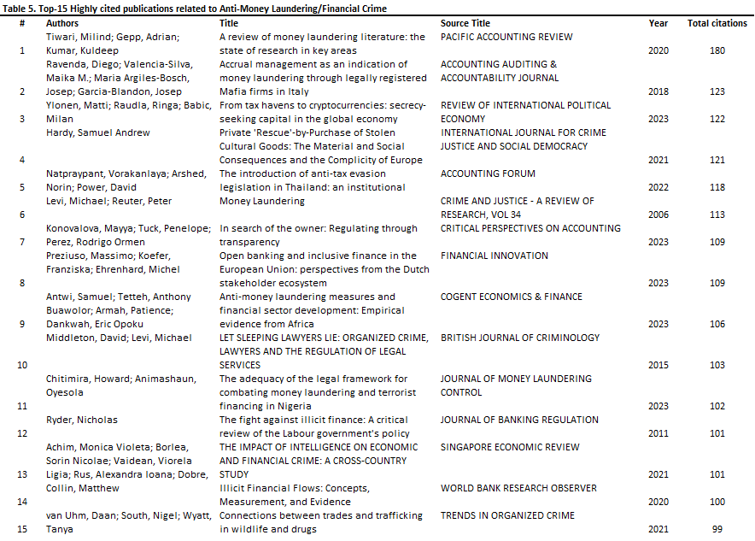
Source: created by the author.

Table 6. Top 10 cited references in the selected sample.
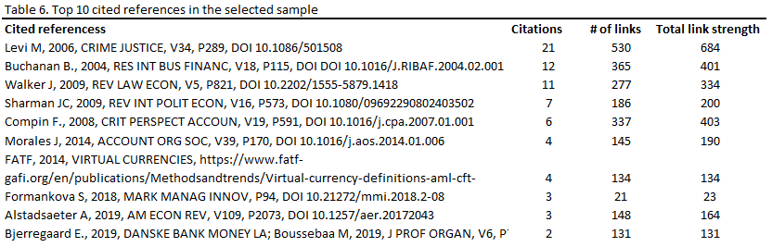
Source: created by the author based on the VOS viewer analysis.

Note: Strength of a link signifies the number of references cited together, and the total link strength signifies the total strength of the each link in the network files.

Table 7. Top 10 authors in the field of Anti-Money Laundering / Financial Crime that most collaborated
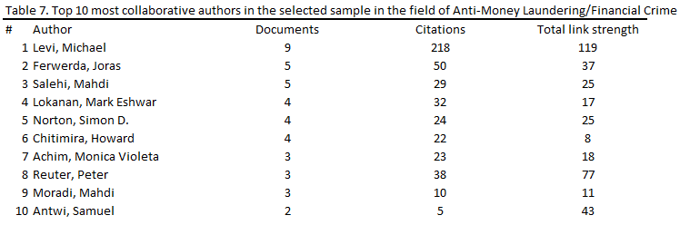
Source: created by the author based on the VOS viewer analysis.
Note: Total link strength signifies the total strength of the co-authorship. Also the link between the author and other authors, accordingly.

Table 8. Top 10 journals per bibliographic coupling link strength
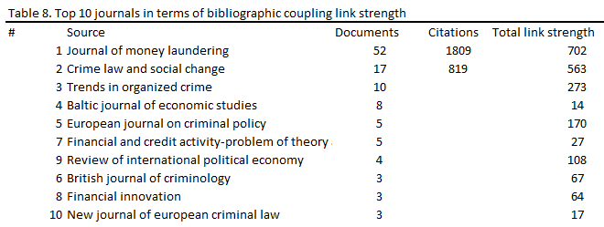
Source: created by the author based on the VOS viewer analysis.
Note: Total link strength depict the total strength of the bibliographic coupling links between a given journal and other journals.

Table 9. Top 10 authors per bibliographic coupling link strength
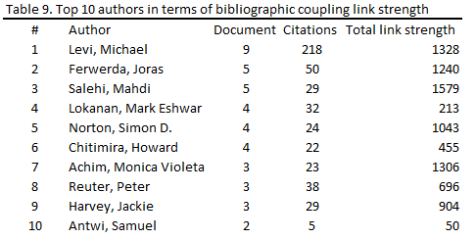
Source: created by the author based on the VOS viewer analysis.
Note: The total link strength shows the absolute strength of the bibliographic coupling links between a given author and other authors

Table 10. Bibliographic coupling link strength top ten papers per
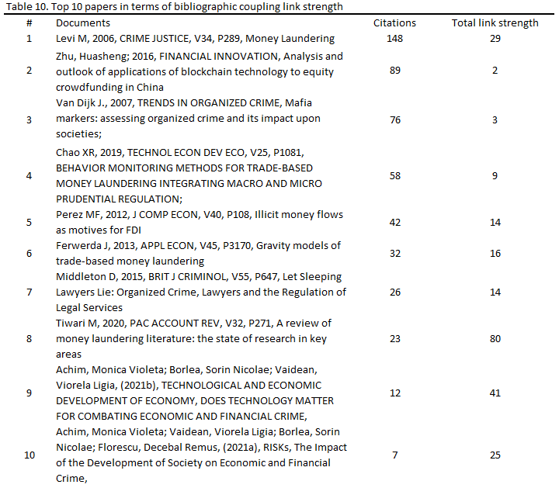
Source: created by the author based on the VOS viewer analysis
Note: Total link strength displays the total strength of the bibliographic coupling links between a given paper and other papers

Table 12. Future research directions
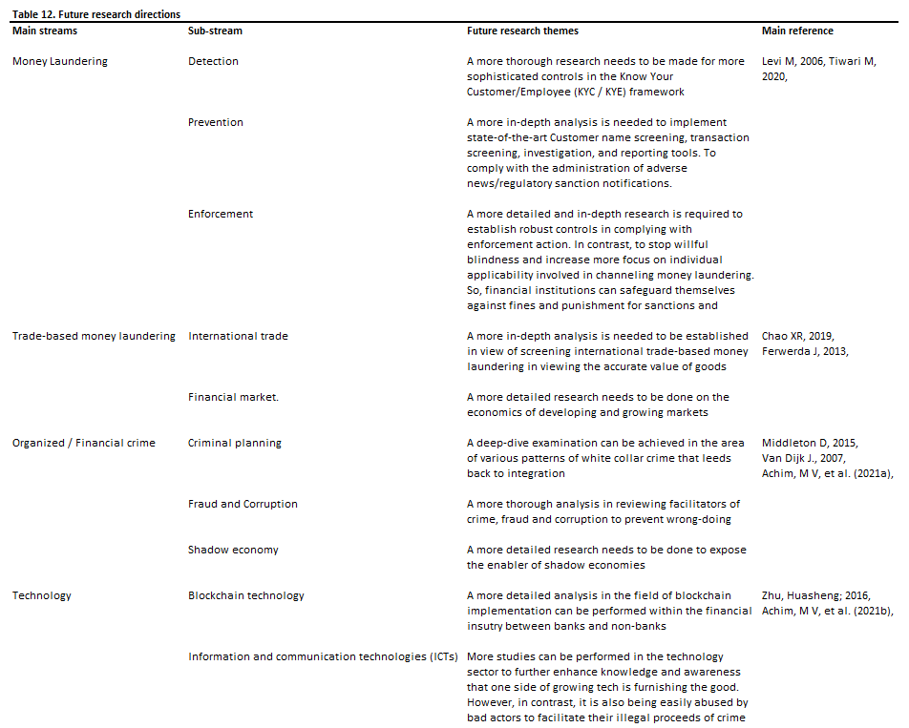
Source: created by the author

