Supplementals materials
Supplemental Table 1: Frequency of interventions reported by included studies by type of interventions.
Type of intervention | Studies | Frequency
Education materials | Ma et al ¹⁶, Paskett et al¹⁷, Winer et al¹⁸, Tiro et al¹⁹ | 4
Reminder magnets | Coley et al²⁰ | 1
Parent health messages | Rickert et al²¹ | 1
Narrative intervention videos | Lee et al²² | 1
Fact sheet library | Dempsey et al²³ | 1
Decision Aid | Bennett et al²⁴ | 1

Supplemental Table 2: Meta-regression of factors associated with HPV vaccine uptake.

Variables | Coefficients | Std errors | Z-test | P-value | Lower 95%CI | Upper 95%CI
Age | -0.042 | 0.125 | -0.34 | 0.736 | -0.286 | 0.202
HPV dose timing | -0.818 | 0.335 | -2.44 | 0.015 | -1.475 | -0.162
High school or above | 0.231 | 0.073 | 3.16 | 0.002 | 0.086 | 0.374
Health insurance | -0.069 | 0.037 | -1.89 | 0.059 | -.141 | .003

Risk of Bias in Included Studies
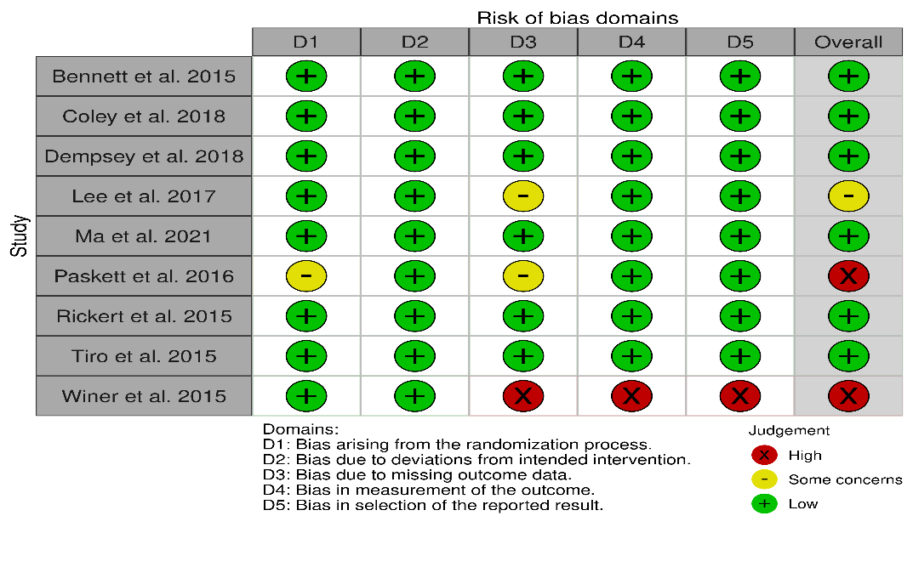
Supplementals Figure 1: Risk of Bias in Included Studies
The risk of bias in the included studies is summarized in Supplemental Figure 1. Briefly the risk related to randomization were found in 1 study¹². The risk of bias related to protocol deviations was not found, risk of bias due to missing outcome data was found in 3 studies^{12,13,17,} and risk of bias due to measurement of outcome and selective reporting of outcomes was found in one study. ^{13,}

Effectiveness of parent and adolescent dyadic interventions on the initiation of second dose by time and gender with study by Ma et al included.

Considering the gender-specific impact of interventions on the initiation of the second dose of the HPV vaccine, the data suggests a variation in effect sizes over time (Figure 3). At 6 months, females showed a greater, though not statistically significant, inclination towards vaccine uptake with an odds ratio (OR) of 1.16 (95% CI: 0.56, 2.38) as compared to males. By the 12-month benchmark, there was a slight but statistically significant increase in vaccine uptake among females (OR: 1.10, 95% CI: 1.02 to 1.19) as compared to males. When considering the overall pooled effect size, the combined OR was 1.03 (95% CI: 0.83, 1.27), reflecting a negligible overall effect with no significant difference in the initiation of the second dose across both genders and all time points. This suggests that while there were initial indications of effectiveness, particularly at the 12-month milestone, these did not translate into a statistically significant increase in uptake when considering the overall timeframe and gender combined.

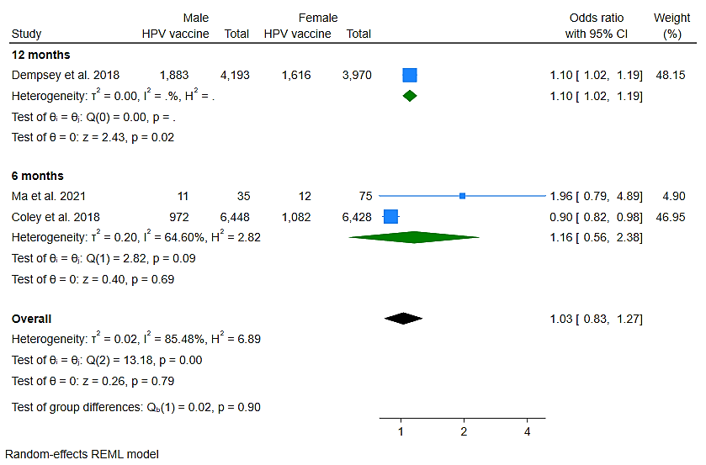
Supplementals Figure 2: Effectiveness of parent-centered or parent-adolescent dyad interventions in improving dose 2 of HPV vaccination over time and by gender.
Effectiveness of parent and adolescent dyadic interventions on HPV vaccination uptake with Ma et al. included.
Supplemental Figure 2 presents a forest plot that examines the differential impact of interventions on the uptake of various doses of the HPV vaccine. For the first dose, the estimated effect of the interventions is not statistically significant, with an odds ratio (OR) of 1.85 (95% CI: 0.91, 3.79). Regarding the second dose, while the OR increases to 2.32 (95% CI: 0.65, 8.28), indicating a potentially higher effect size, the wide confidence interval suggests a lack of statistical significance and considerable uncertainty. For the uptake of at least three doses, the interventions demonstrate a statistically significant effect, with an OR of 1.13 (95% CI: 1.07, 1.20), indicating a meaningful increase in vaccine completion rates. Aggregating the effect across all doses, the interventions show a consistent and statistically significant positive influence, with an overall OR of 1.14 (95% CI: 1.10, 1.18), reinforcing the efficacy of the interventions across the full course of the HPV vaccination schedule.

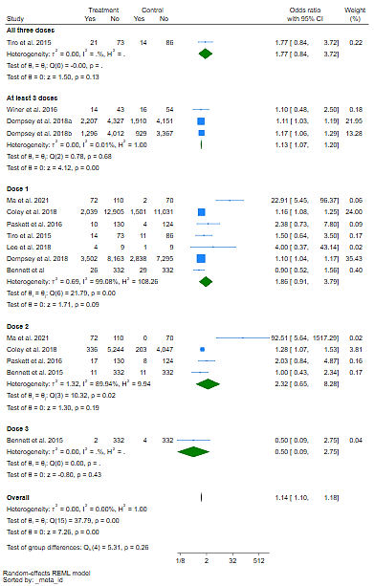
Supplemental Figure 3: Effectiveness of parent-centered or parent-adolescent dyad interventions in improving all dose of HPV vaccination

Publication bias with inclusion of Ma et al. study

The Galbraith and L'Abbé plots, illustrated in Supplemental figures 4 and 5, have been instrumental in evaluating heterogeneity and potential biases and thus exclusion of some studies for sensitivity analysis. The Galbraith plot for (Supplemental figure 4) reveals that studies with higher precision tend to report larger effect sizes, suggesting heterogeneity and potential small-study effects that could indicate publication bias or systematic methodological variances. Complementing this, the L'Abbé plot for the first dose and all doses combined (Supplemental figure 5) displays variability in study outcomes, with a general positive consensus on the intervention's effect, yet individual study results vary. This variability may be attributed to differences in study design, population, and intervention strategies, highlighting the significance of individual study contexts in the synthesis of meta-analytic findings. Together, these plots underscore the complexity of drawing conclusions from pooled data and the importance of a nuanced interpretation that considers both the collective trends and the individual study characteristics.

Supplemental figures

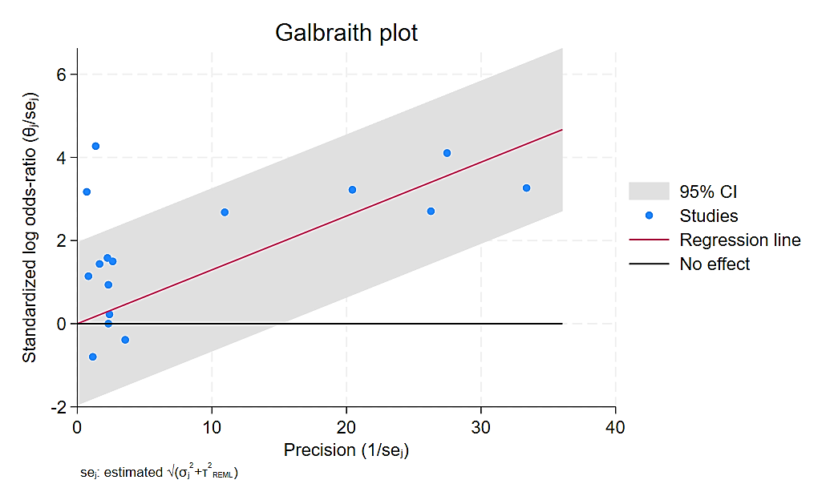
Supplemental Figure 4: Galbraith plot of HPV vaccination of all the doses

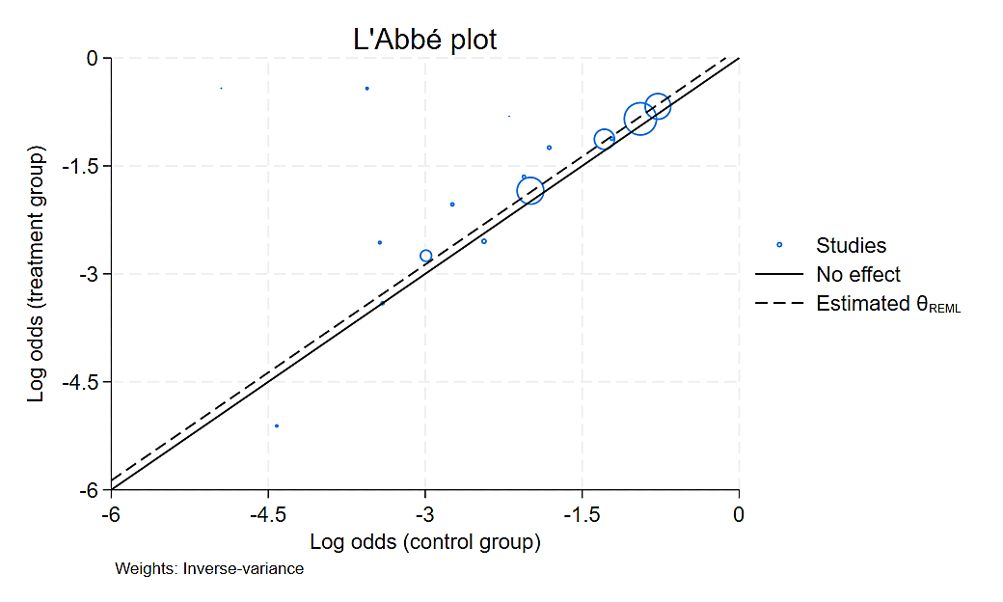
Supplemental Figure 5: Abbe plot of HPV vaccination of all the doses

