Supplementary information

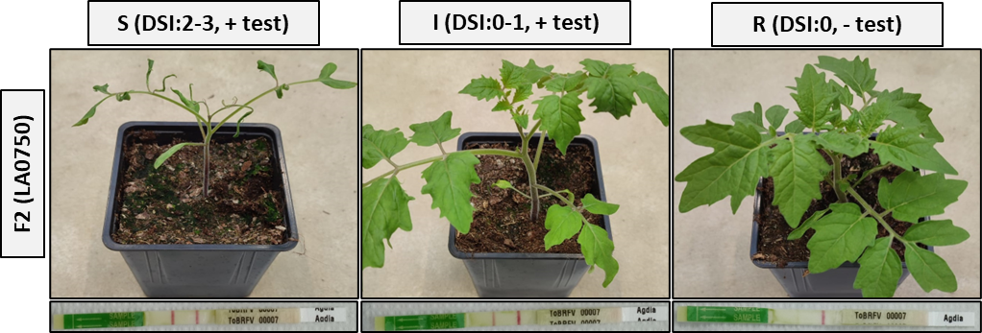
Figure S1 Phenotypes observed in the F2 (LA 0750) four weeks post ToBRFV inoculation. One representative F2 plant of each phenotype [47 plants Susceptible (S), 47 plants Intermediate (I) and 6 plants Resistant (R)] after ToBRFV inoculation evaluated with disease severity index (DSI). Below each plant, the ToBRFV immunostick test result is shown, with two red lines indicating presence of ToBRFV coat protein while one red line indicates absence of coat protein.

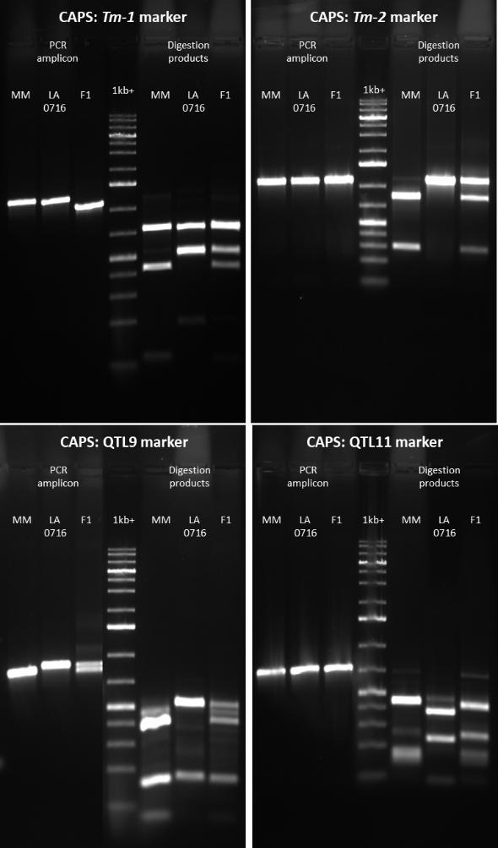
Figure S2 Gel image of the CAPS markers. The three bands to the right of the DNA ladder (GeneRuler 1 kb Plus DNA Ladder, ThermoFisher Scientific) represent PCR products amplified using specific primers for each locus. To the left of the 1kb+ ladder are the corresponding PCR products digested with specific restriction enzymes. Primers and restriction enzymes are provided in Table 1.

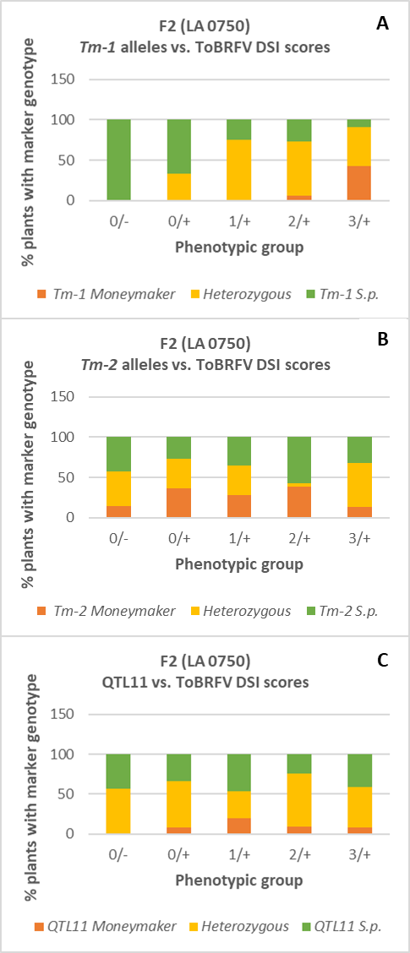
Figure S3 Distribution of F2 (LA 0716) individuals with CAPS marker in homozygous state for the MM or the S.p. allele or heterozygous in five different phenotypic groups, DSI (Disease Severity Index) 0/no Coat Protein (CP) ( 0/-), DSI 0/ detected CP (0/+), DSI 1/ detected CP (1/+), DSI 2/ detected CP (2/+), and DSI 3/detected CP (3/+). A CAPS marker Tm-1, B CAPS marker Tm-2, C CAPS marker QTL.

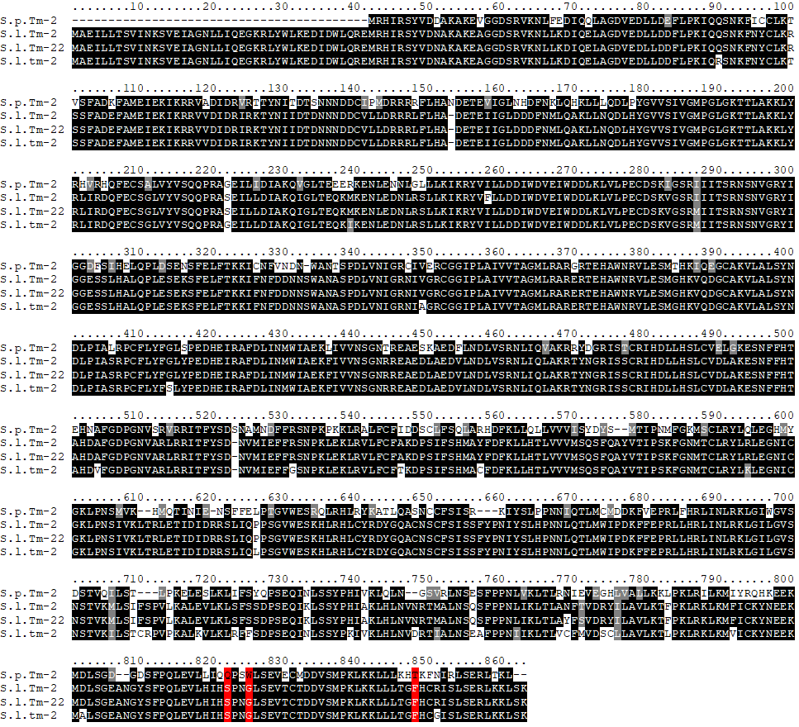
Figure S4 Protein sequence alignment of S. pennellii LA 0716 Tm-2 (S.p. Tm-2, Sopen09g035210), the ToMV resistance Tm-2 (S.l. Tm-2, NCBI: AF536200), allelic variant Tm-2² (S.l. Tm-22, NCBI: AF536201), and the ToMV susceptible tm-2 (S.l. tm-2, NCBI: AF536199). Amino acids highlighted in red (S822, G825 and F848) indicate the positions of the engineered substitutions in Tm-2², which can confer resistance to ToBRFV (Lindbo 2022).

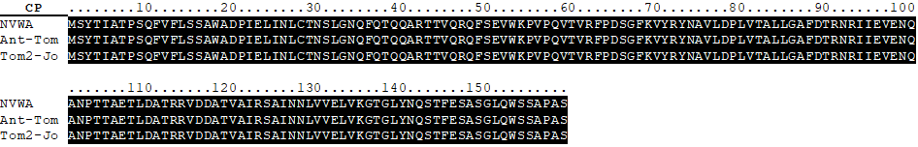
Figure S5 Coat protein sequence alignment of ToBRFV isolates NVWA (NCBI: MN882011.1), CA18( NCBI: MT002973.1) and Ant-TOM (NCBI: MT107885.1).

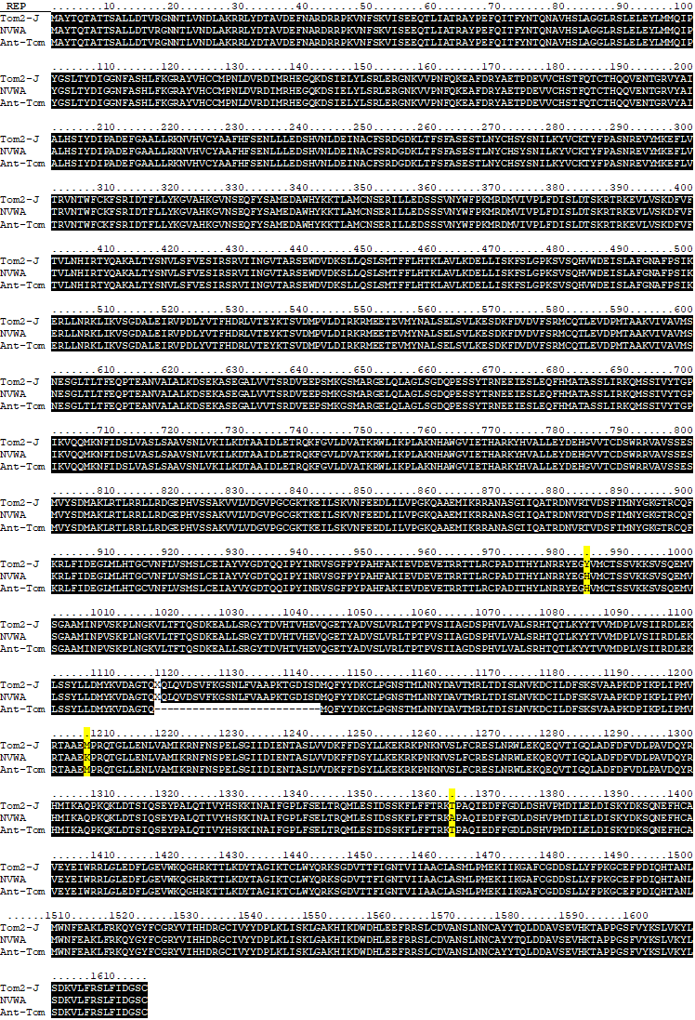
Figure S6 Replication protein sequence alignment of ToBRFV isolates NVWA (NCBI: MN882011.1), CA18( NCBI: MT002973.1) and Ant-TOM (NCBI: MT107885.1). The aa differences are highlighted with yellow colour.
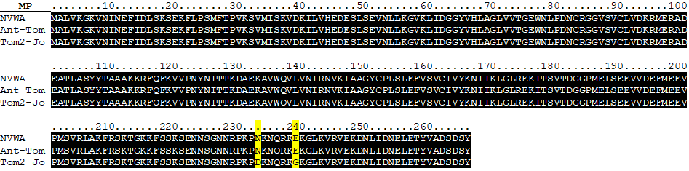
Figure S7 Movement protein sequence alignment of ToBRFV isolates NVWA (NCBI: MN882011.1), CA18( NCBI: MT002973.1) and Ant-TOM (NCBI: MT107885.1). The aa differences are highlighted with yellow colour.

