Table 1: List of genes upregulated in Acomys but not Mus, or upregulated in both species at D1 after treatment, with references linking them to relevant functions.
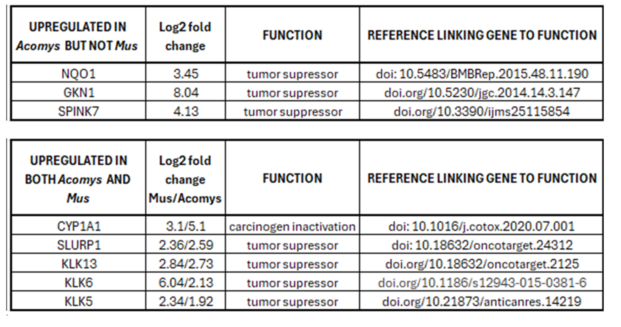

Table 2: List of genes exclusively upregulated in Acomys but not Mus related to tumor suppressor functions; List of genes exclusively upregulated in Mus but not Acomys, related to tumor suppressor functions.
