Supplementary Information for
Quantifying the Urban Parks' Cooling Effects on Land Surface Temperature in Istanbul Using Random Forest

Supporting methods S1
In this study, land use classification was done with the random forest (RF) method because it is a powerful method and gives more accurate results in complex and large data structures (Abdi, 2020). Random Forest became popular in the early 2000s, and due to its high accuracy, it is widely used in remote sensing image classification. It gives very robust results, especially in environmental sciences, remote sensing, and terrain classification studies. Random Forest is based on an ensemble approach that operates by generating a large number of decision trees. Each decision tree is trained on a specific subset of data with a selected subset of features. Each tree is trained with training data. At the end of each tree, the class to which the data belongs is determined. When a classification is needed, the data is run through each tree, with each tree predicting the class it belongs to. The predictions from all trees are then collected and the class with the most votes becomes the final prediction of Random Forest (Breiman, 2001; Morell-Monzó et al., 2021). This process creates the overall prediction of the model. RF reduces the risk of overfitting and provides data diversity thanks to randomness and ensemble learning. In addition, feature importance ranking provides insight into which variables are effective in the model. At this stage, the foundation for the Random Forest model to be used in the study was prepared. The land use classification scheme was developed based on Google Earth observations of the study area, combined with ground verifications within the buffer zone.
The dataset was divided into two subsets according to 70% training and 30% testing ratio. For training this model, validation data was taken from Google Earth and accurate predictions were made by the method stated in the study of Tariq et al.( 2022). The training set was used for the learning process of the model, while the test set was kept to evaluate the model's performance. Random Forest model was created using training data. To distinguish each land use class in the model, decision trees were created and each tree was built using randomly selected subsets from different samples and variables. After the model's training process was completed, land classification was performed using 100x100 pixel grid data. Each pixel was associated with the land use class predicted by the model. Confusion matrix was created to evaluate the classification success of the Random Forest model (Table S2). The confusion matrix shows the correct and incorrect predictions of the classification and how accurately each class was classified. In this study, the model achieved an overall accuracy rate of 89%, and the precision, recall and F1-scores calculated for each class are summarized in Table S2.

Abdi, A.M., 2020. Land cover and land use classification performance of machine learning algorithms in a boreal landscape using Sentinel-2 data. GIScience Remote Sens. 57 (1), 1–20. https://doi.org/10.1080/15481603.2019.1650447.
Breiman, L., 2001. Random Forests. Machine Learning, 45, 5–32. https://doi.org/10.1023/A:1010933404324
Morell-Monzó, S., Sebastiá-Frasquet, M.-T., Estornell, J., 2021. Land Use Classification of VHR Images for Mapping Small-Sized Abandoned Citrus Plots by Using Spectral and Textural Information. Remote Sens. 13, 681. https:// doi.org/10.3390/rs13040681.
Tariq, S., Siddiqui, A., Sharifi, S., Hassan, I., 2022. Impact of spatio- temporal land surface temperature on cropping pattern and land use and land cover changes using satellite imagery, Hafizabad district, Punjab, province of Pakistan. Arab. J. Geosci. 15 (11), 1–16. doi: 10.1007/s12517-022-10238-8.

Table S1. Description of land cover classes used in this study
LULC Features | Description
Vegetation | Sparse and dense vegetation, small and large trees, pasture, and vegetation within house boundaries
Urban | Housing, high-rise buildings, industrial zones, asphalt roads
Bareland | Bareland and ongoing construction sites, vacant uncultivated agricultural lands
Water | Open or temporary water bodies, including natural or artificial ponds

Table S2. The overall accuracy rate, precision, recall and F1-scores of the model for each land use class and Accuracy assessment for LULC
Land use | Precision | Recall | F1-Score | Area (ha)
Bareland | 0.83 | 0.75 | 0.79 | 3590.4574
Vegatation | 0.88 | 1.00 | 0.93 | 3614.0378
Urban | 0.87 | 0.87 | 0.87 | 3296.1163
Water | 1.00 | 1.00 | 1.00 | 19.9744
Overall Accuracy |  |  | 0.89 | ---
Macro Average | 0.90 | 0.90 | 0.90
Weighted Average | 0.87 | 0.89 | 0.88

Land Use | Producer | User | Accuracy
Bareland | 20 | 15 | 0.75
Vegatation | 24 | 24 | 1.00
Urban | 23 | 20 | 0.87
Water | 5 | 5 | 1.00
Accuracy | 72 | 64 | 0.89

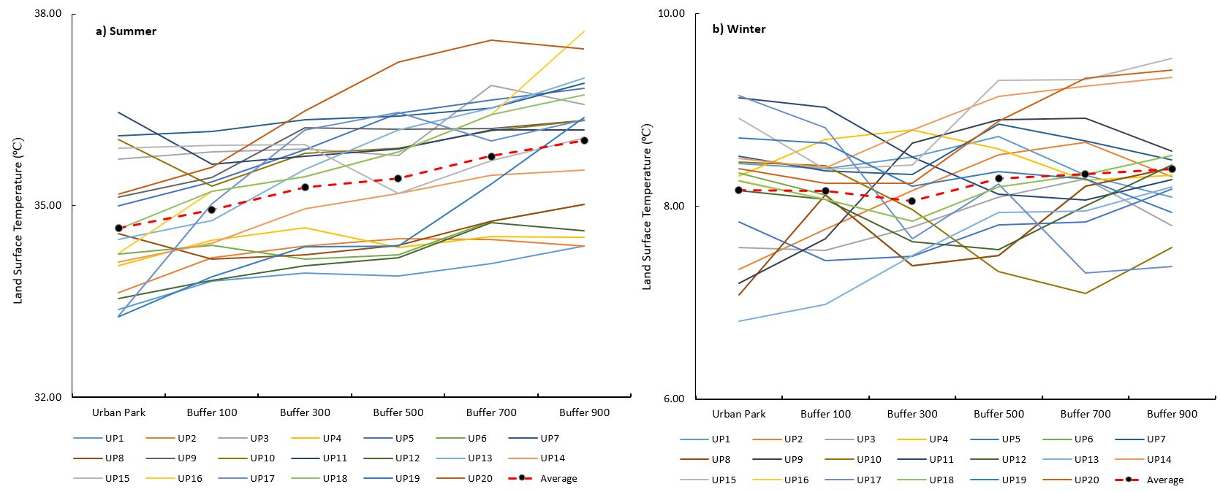
Supporting figure S1:Average land surface temperature (LSTs) of urban parks and Buffer 100 m-300 m-500 m-700 m-900 m (line) during summer (a) and winter (b) periods for the study area.

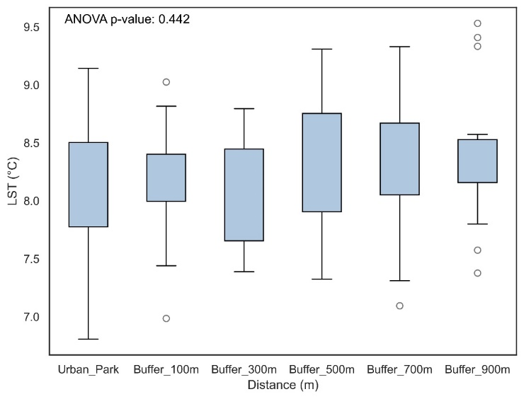
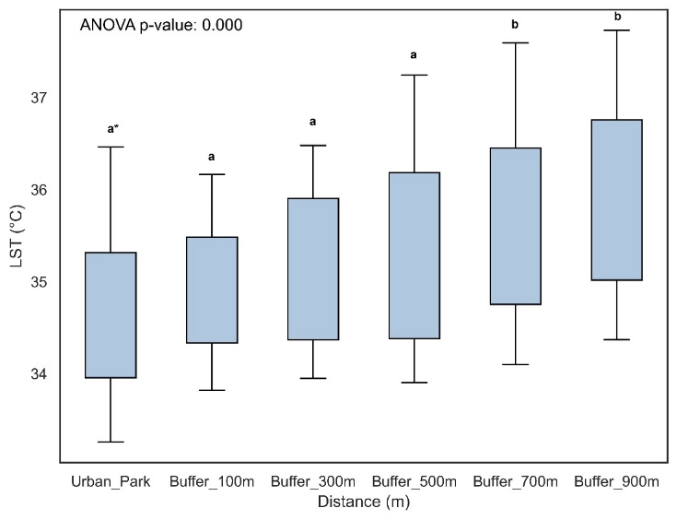
(a) (b)
Supporting figure S2: Mean values ​​of LST values ​​of urban parks and buffer zones for summer (a) and winter (b) (mean ± SD).

