Table S1. Phenotypes of the original commercial F₁ tomato hybrids in the bulk selection program.
F₁ hybrid | Source | Phenotype^{z}
65010 | Syngenta | Determinate and resistant to TYLCV (Ty-1/Ty-3a and Ty-4/ty-4), fusarium (I-1 and I-2) and verticillium wilt.
Nairouz (TH99806) | Syngenta | Determinate; highly tolerant to TMV, verticillium and fusarium wilts; and TYLCV-moderately tolerant (Ty-1/Ty-3, Ty-2/Ty-2, and Ty-4/ty-4).
SVTD8320 | Seminis | Indeterminate and tolerant to fusarium wilt, verticillium wilt, powdery mildew, and TYLCV (Ty-1/Ty-3a, Ty-2/Ty-2, Ty-4/ty-4, and Ty-5/ty-5).
Tyrmes | Syngenta | Indeterminate; and highly tolerant to verticillium and fusarium wilts (I-1 and I-2), and TMV (Tm-2); and TYLCV-moderately resistance/tolerance (Ty-1/Ty-3a, Ty-2/ty-2, Ty-4/ty-4, and Ty-5/ty-5).
^{z}Phenotypes are based on pamphlets of producing companies. TYLCV resistance genes were identified by Mahmoud et al. (2023).
Table S2. Phenotype of TYLCD-symptomless selected plants of F₅ families.
The original F₁ hybrid | Code^{z} | TSS | Average fruit weight  (g) | Early Yield  (g plant⁻¹) | Total yield  (g plant⁻¹) | Flesh thickness  (mm) | Fruit shape index | Fruit firmness (kg/cm²) | No. of fruit locules
‘Nairouz’ | F_{5:} 7-R2-8 | 3.5 | 80 | 2800 | 3500 | 0.7 | 0.88 | 3.60 | 3
‘Nairouz’ | F_{5:} 7-R2-9 | 3.6 | 90 | 2200 | 4000 | 0.6 | 0.88 | 5.85 | 3
‘Nairouz’ | F_{5:} 7-R3-1 | 3.5 | 75 | 3000 | 4000 | 0.6 | 0.88 | 5.85 | 5
‘Nairouz’ | F_{5:} 7-R3-2 | 4.0 | 79 | 2600 | 3500 | 0.5 | 0.96 | 4.50 | 4
‘Nairouz’ | F_{5:} 7-R3-3 | 4.0 | 80 | 2600 | 3450 | 0.5 | 0.96 | 4.41 | 3
‘Nairouz’ | F_{5:} 7-R3-8 | 3.9 | 97 | 1605 | 3505 | 0.5 | 0.93 | 4.05 | 4
‘Nairouz’ | F_{5:} 7-R3-9 | 4.0 | 95 | 2000 | 3500 | 0.6 | 0.97 | 5.54 | 4
‘Nairouz’ | F_{5:} 7-R3-10 | 4.5 | 76 | 2200 | 3000 | 5.6 | 0.91 | 5.04 | 4
‘65010’ | F_{5:} 8-R2-2 | 6.1 | 100 | 500 | 3500 | 0.6 | 0.71 | 5.85 | 5
‘65010’ | F_{5:} 8-R2-3 | 3.4 | 115 | 2900 | 4000 | 0.6 | 0.83 | 5.45 | 3
‘65010’ | F_{5:} 8-R2-4 | 3.9 | 117 | 1100 | 3800 | 0.5 | 0.71 | 4.14 | 5
‘65010’ | F_{5:} 8-R3-3 | 3.5 | 70 | 1500 | 3500 | 0.5 | 0.86 | 6.03 | 4
‘65010’ | F_{5:} 9-R2-2 | 4.2 | 97 | 1800 | 3250 | 0.8 | 0.84 | 6.84 | 4
‘65010’ | F_{5:} 9-R2-5 | 4.6 | 105 | 900 | 3000 | 0.4 | 0.83 | 4.14 | 4
‘65010’ | F_{5:} 10-R1-3 | 3.9 | 86 | 1600 | 3000 | 0.4 | 0.81 | 5.31 | 4
‘65010’ | F_{5:} 10-R1-4 | 4.0 | 90 | 1000 | 3200 | 0.4 | 0.88 | 5.31 | 4
‘65010’ | F_{5:} 10-R3-1 | 3.1 | 105 | 1900 | 3500 | 0.4 | 0.72 | 6.08 | 5
‘65010’ | F_{5:} 11-R2-1 | 5.3 | 100 | 1700 | 3500 | 0.7 | 0.73 | 4.95 | 5
‘65010’ | F_{5:} 11-R2-2 | 3.5 | 110 | 2050 | 3000 | 0.6 | 0.72 | 3.60 | 6
‘65010’ | F_{5:} 11-R2-3 | 4.0 | 110 | 1000 | 3150 | 0.7 | 0.70 | 4.50 | 4
‘65010’ | F_{5:} 11-R2-4 | 3.5 | 105 | 1600 | 3200 | 0.6 | 0.73 | 4.73 | 5
‘65010’ | F_{5:} 11-R2-5 | 3.0 | 100 | 1700 | 3300 | 0.6 | 0.70 | 4.64 | 5
‘65010’ | F_{5:} 11-R2-6 | 3.6 | 113 | 1500 | 3050 | 0.5 | 0.72 | 4.77 | 4
‘65010’ | F_{5:} 11-R2-7 | 3.5 | 110 | 1450 | 3000 | 0.7 | 0.70 | 4.50 | 4
‘65010’ | F_{5:} 11-R2-9 | 3.7 | 106 | 2100 | 3500 | 0.6 | 0.73 | 4.82 | 4
‘65010’ | F_{5:} 11-R2-10 | 3.5 | 110 | 1800 | 3600 | 0.6 | 0.69 | 4.95 | 5
‘65010’ | F_{5:} 11-R2-11 | 3.1 | 115 | 1600 | 3400 | 0.5 | 0.70 | 4.73 | 4
‘65010’ | F_{5:} 11-R3-1 | 2.8 | 85 | 600 | 3200 | 0.4 | 0.84 | 4.55 | 6
‘SV8320’ | F_{5:} 12-R1-3 | 3.0 | 90 | 2700 | 3400 | 0.5 | 0.70 | 4.95 | 4
 | F_{5:} 12-R1-4 | 3.6 | 90 | 800 | 3000 | 0.5 | 0.68 | 4.05 | 4
 | F_{5:} 12-R1-5 | 3.4 | 85 | 1900 | 3000 | 0.4 | 0.78 | 4.50 | 5
 | F_{5:} 12-R3-1 | 4.0 | 115 | 2300 | 3800 | 0.7 | 0.72 | 5.04 | 5
 | F_{5:} 12-R3-4 | 3.5 | 105 | 1505 | 3505 | 0.6 | 0.89 | 5.22 | 4
 | F_{5:} 14-R1-1 | 4.1 | 120 | 1000 | 3500 | 0.7 | 0.73 | 6.89 | 4
 | F_{5:} 14-R1-2 | 4.0 | 115 | 900 | 3400 | 0.7 | 0.74 | 6.30 | 4
 | F_{5:} 14-R1-3 | 3.9 | 125 | 1100 | 3500 | 0.7 | 0.72 | 6.08 | 4
 | F_{5:} 14-R1-4 | 4.0 | 120 | 1300 | 3300 | 0.7 | 0.75 | 5.85 | 4
 | F_{5:} 14-R1-5 | 4.2 | 120 | 1100 | 3200 | 0.7 | 0.70 | 6.35 | 4
 | F_{5:} 14-R1-6 | 4.1 | 115 | 1300 | 3400 | 0.7 | 0.71 | 6.39 | 4
 | F_{5:} 14-R1-7 | 3.9 | 120 | 1500 | 3500 | 0.7 | 0.73 | 6.26 | 4
 | F_{5:} 14-R1-8 | 4.0 | 125 | 1250 | 3250 | 0.7 | 0.73 | 6.08 | 4
 | F_{5:} 14-R1-9 | 4.2 | 120 | 1000 | 3350 | 0.7 | 0.73 | 6.53 | 4
 | F_{5:} 14-R1-10 | 4.5 | 115 | 1600 | 3400 | 0.7 | 0.71 | 6.44 | 4
 | F_{5:} 14-R1-11 | 4.0 | 115 | 1250 | 3450 | 0.7 | 0.71 | 6.12 | 4
 | F_{5:} 14-R1-12 | 3.9 | 115 | 1000 | 3000 | 0.7 | 0.71 | 6.71 | 4
‘Tyrmes’ | F_{5:} 17-R1-1 | 3.4 | 95 | 1200 | 3000 | 0.5 | 0.83 | 5.40 | 3
‘Tyrmes’ | F_{5:} 18-R1-1 | 4.0 | 150 | 1500 | 3000 | 0.5 | 0.68 | 5.94 | 5
^{z}Code: Gerneration – plant number in replicate.
The selected F₅ symptomless plants are shaded in green.

Table S3. Scheme of ANOVA and ANCOVA for pooled data from two years of RCBD.
Source of variance | df | MS (or MP) | Expected MS | Expected mean cross products
Year (Y) | y-1 | - | - | -
Replicate (R) | r-1 | - | - | -
R (Y) | y (r-1) | - | - | -
Genotype (G) | l-1 | MS_{g} | δ²_{e} + rδ²_{gy} + yrδ²_{g} | COV_{e} + rCOV_{gy} + yrCOV_{g}
G × Y | (y-1) (g-1) | MS_{gy} | δ²_{e} + rδ²_{gy} | COV_{e} + rCOV_{gy}
Pooled error | y (r-1) (g-1) | MS_{e} | δ²_{e} | COV_{e}
y: number of years, r: number of replicates, and g: number of germplasm (tomato lines).
δ²_{g}: genotypic variance, δ²_{gy}: interaction variance between germplasm and years; δ²_{e}: error variance; and similarly, for covariances.

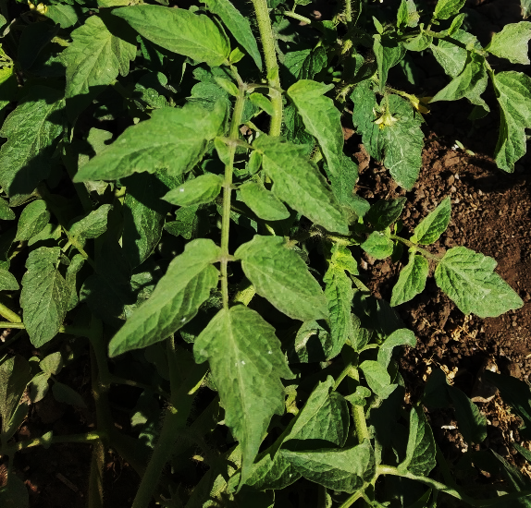  Score 1 | 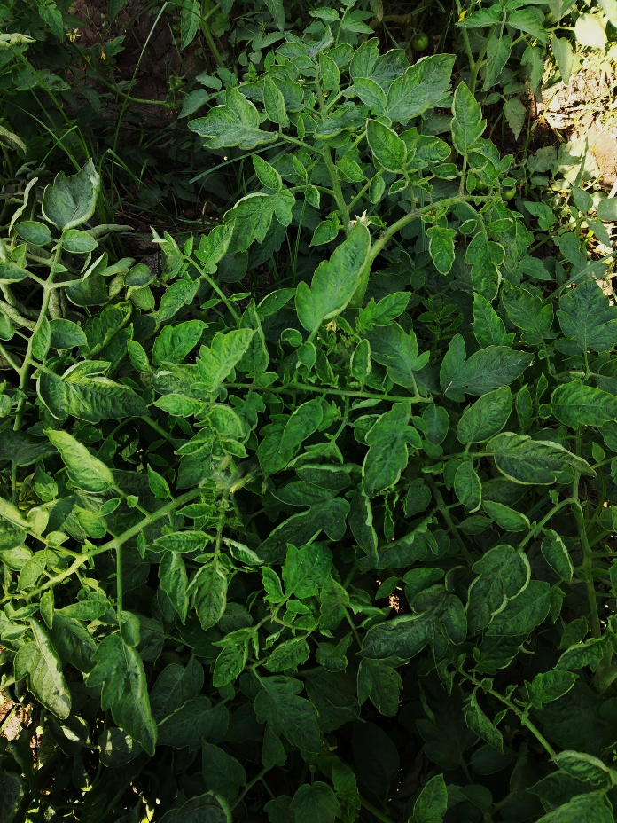  Score 2
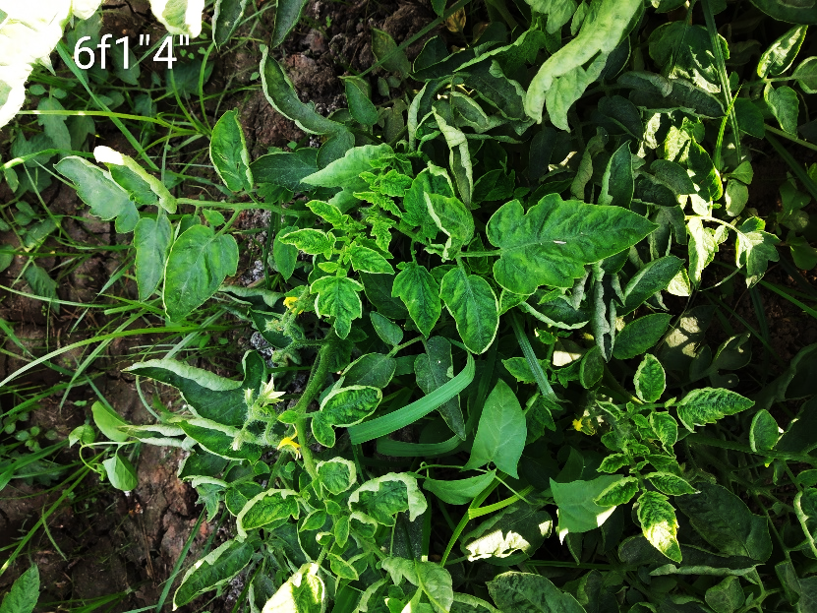  Score 3 | 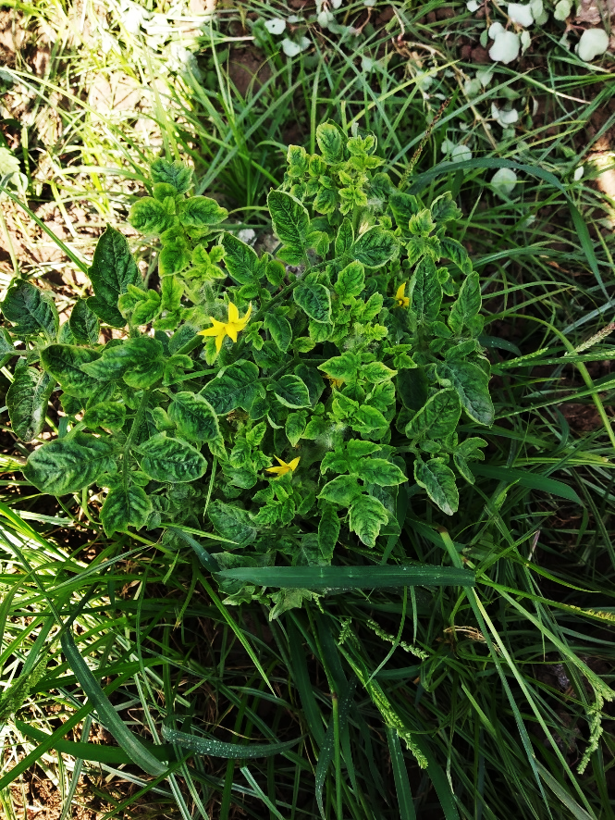  Score 4
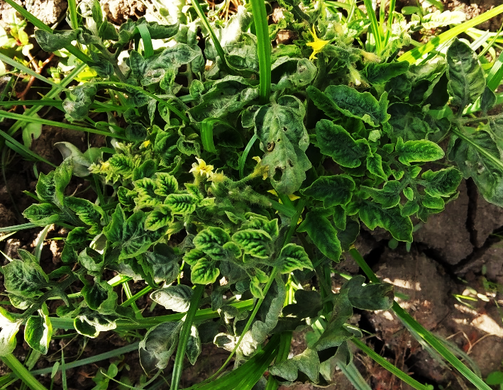
Score 5
Fig. S1. TYLCD symptoms severity score.
The score is 1: symptomless plant, 2: slight symptoms on plant top, 3: moderate symptoms, 4: severe symptoms on the entire plant, and 5: severe symptoms and plant stunting.
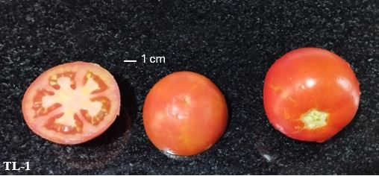 | 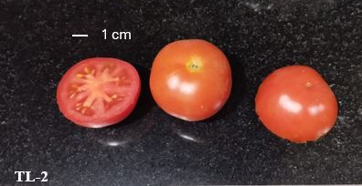 | 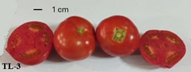 |  | 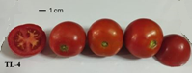
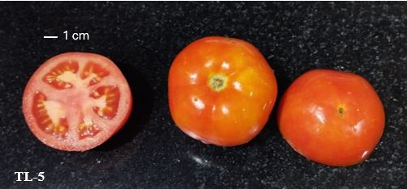 | 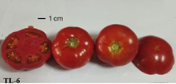 | 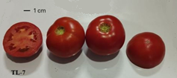 |  | 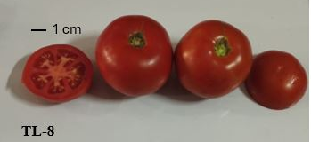
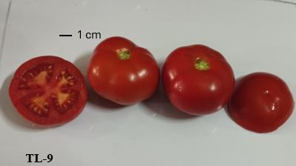 | 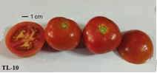 | 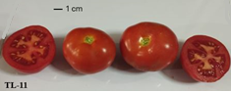 |  | 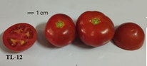
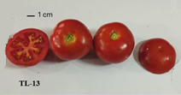 | 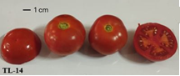 | 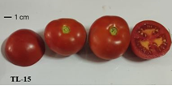 |  | 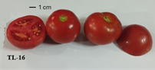
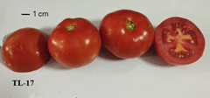 |  |  | 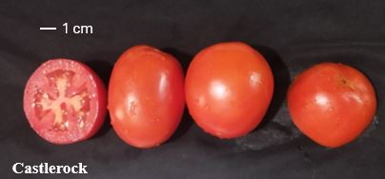
Fig. S2. Fruits of tomato lines.
F₇ tomato lines selected from tomato commercial F₁ hybrids ‘Nairouz’ for TL-1&TL-2, ‘65010 F₁’ for TL-3&TL-6, ‘SVTD8320 F₁’ for TL-7-TL16, and ‘Tyrmes F₁’ for TL-17.
A photo’s aspect ratios are preserved when zoomed in, highlighting the 1cm mark in each one.

