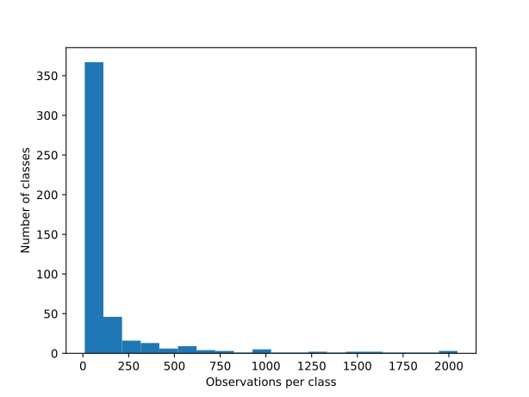
Supplementary Figure 1: Number of positive instances per ChemOnt classes (N=485) in the MIBiG 3.1 dataset (N=2,068 BGCs) used to train CHAMOIS.

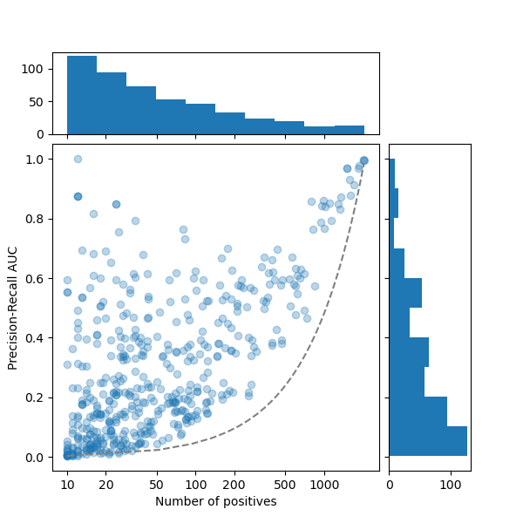
Supplementary Figure 2: Distribution of CHAMOIS’s performance per ChemOnt class in function of class members, assessed by cross-validation (see Cross-validation section of the Online Methods, and the actual metric for each ChemOnt class in Supplementary Table 1).

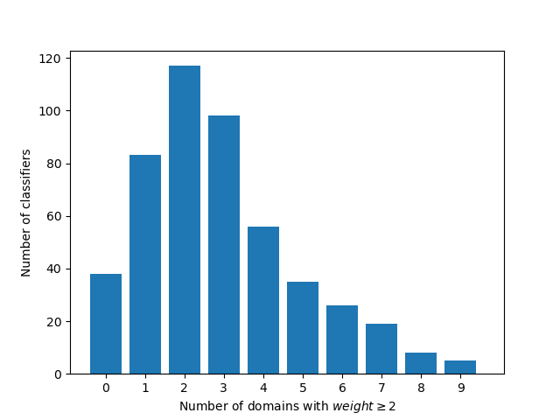
Supplementary Figure 3: Number of domains with weight (coefficient) >=2.0 in CHAMOIS’s classifiers (see Supplementary Table 2 for the complete matrix of weights).

