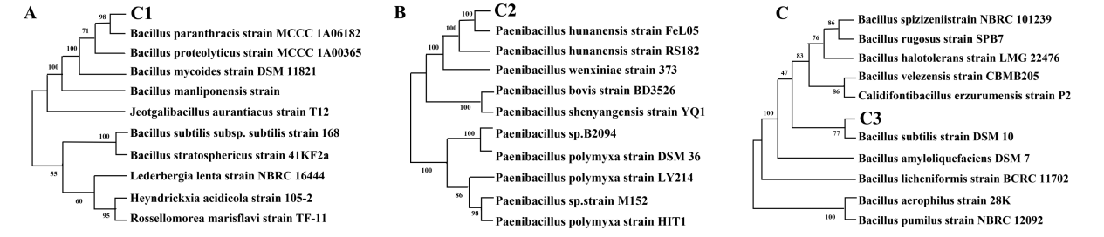

Figure S1 Phylogenetic tree based on 16S rDNA sequences. (A) C1, (B) C2, (C) C2.

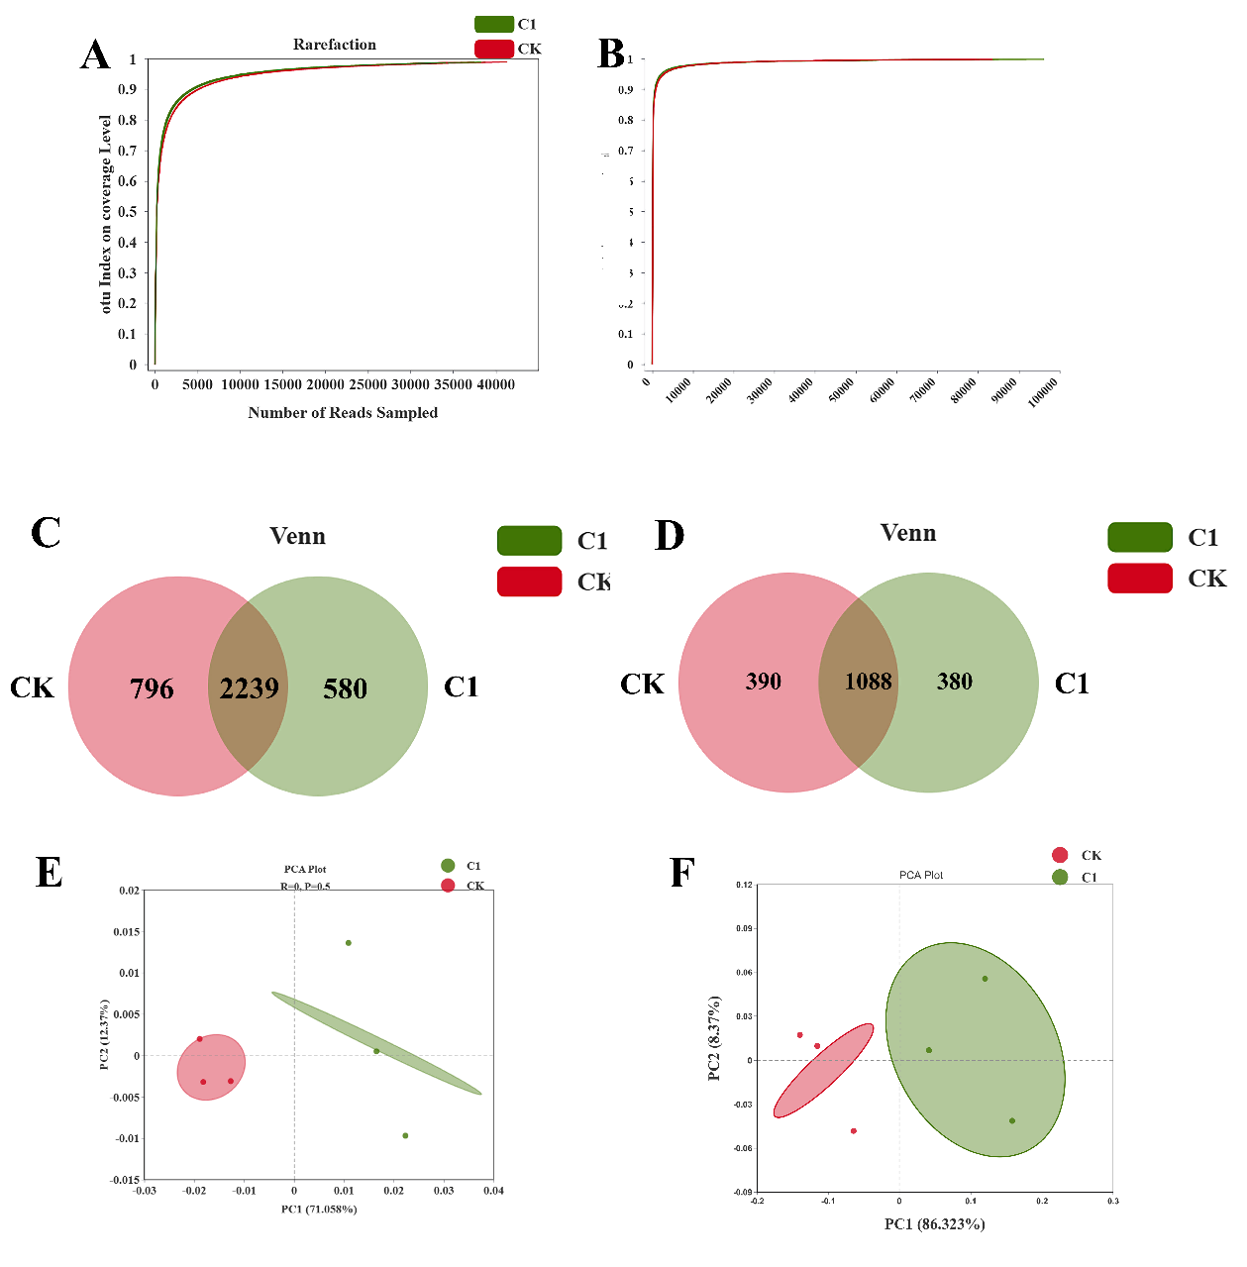
Figure S2 Dilution curves of different treatments based on OTU level coverage index (a) bacterial , (b)fungal. Venn diagrams of rhizosphere (c) bacteria, (d) fungi. PCA analysis of (e) bacterial, (f) fungal

