Supplementary Figure 1: Histopathology and Immunohistochemistry of small cell carcinoma esophagus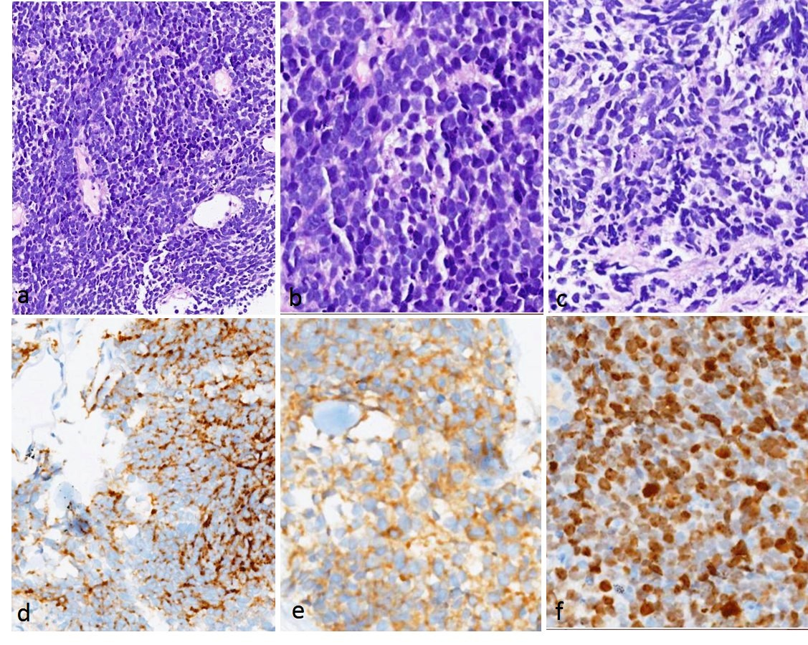Figure 1:(a-c) H&E images showing sheets of small round blue cells with hyperchromatic nuclei showing nuclear molding, inconspicuous nucleoli and scanty/absent cytoplasm. Apoptosis is noted. Immunohistochemistry showed positivity for chromogranin (d) and synaptophysin (e). The proliferation index (Ki-67) was very high (>85%)

