Polarization-Encoded Neuromorphic Vision in Infrared via Gate-Programmable 2D Anisotropic Semiconductors
Shi Zhang^{1,2}†, Shuguang Zhu¹†, Shijian Tian¹†, Libo Zhang^{1, 2}*, Kening Xiao^{1,2}, Wenqi Mo¹, Cheng Chen³, Shicong Hou^{1, 4}, Yunduo Zhang¹, Yuanfeng Wen¹, Yiran Tan¹, Kaixuan Zhang¹, Jiayue Han⁵, Changlong Liu¹, Jiale He¹*, Weiwei Tang¹, Jun Wang⁵, Lin Wang²*, Guanhai Li^{1,2}, Kai Zhang³, and Xiaoshuang Chen^{1,2}*

¹College of Physics and Optoelectronic Engineering, Hangzhou Institute for Advanced Study, University of Chinese Academy of Sciences, No. 1, Sub-Lane Xiangshan, Xihu District, Hangzhou 310024, China.
²State Key Laboratory of Infrared Physics, Shanghai Institute of Technical Physics, Chinese Academy of Sciences, 500 Yu-Tian Road, Shanghai 200083, China.
³CAS Key Laboratory of Nanophotonic Materials and Devices & Key Laboratory of Nanodevices and Applications, i-Lab, Suzhou Institute of Nano-Tech and Nano-Bionics (SINANO), Chinese Academy of Sciences, Suzhou 215123, China.
⁴Shanghai Key Lab of Modern Optical System, University of Shanghai for Science and Technology, 516 Jungong Road, Shanghai 200093, China.
⁵School of Optoelectronic Science and Engineering, University of Electronic Science and Technology of China, Chengdu 610054, China.
S.Z., S.G.Z., and S.J.T. contributed equally to this work.

Table of contents
Section S1. Anisotropic Characterization of High-quality b-As_{0.2}P_{0.8} Crystals
Note S1. Synthesis instructions of b-As_{x}P_{1-x} crystals.........................................................................4
Fig. S1. Growth of b-As_{x}P_{1-x} crystal...................................................................................................5
Fig. S2. First principles calculation....................................................................................................6
Note S2. First principles calculation method......................................................................................7
Note S3. Characterization data details of b-As_{0.2}P_{0.8} crystal...............................................................8
Fig. S3. Characterization of b-As_{0.2}P_{0.8} crystal nanosheets.................................................................9
Section S2. Phototransistor Configuration and Polarization-Dependent Performance
Fig. S4. AFM image of the device....................................................................................................10
Fig. S5. Device element analysis and morphology characterization.................................................11
Note S4. Detection mechanism description......................................................................................12
Fig. S6. The energy band diagrams under different conditions……………………………………14
Fig. S7. Photoelectric anisotropy behavior of b-As_{0.2}P_{0.8} phototransistors.......................................15
Table S1. Performance Comparison with State-of-the-Art Polarization-Sensitive Neuromorphic Devices………………………………………………………………..………………………16
Section S3. Neuromorphic Computing Simulation and Polarization Imaging Application
Fig. S8. LTP/LTD curves of the b-As_{0.2}P_{0.8} device at different electrical gate voltages.....................17
Note S5. Derivation of the relationship between LTP/LTD and time under periodic pulses..............18
Fig. S9. The fitting results of the LTP/LTD process..........................................................................19
Fig. S10. The training flowchart.......................................................................................................20
Table S2. Extracting LTP/LTD parameters under different polarization attitudes from experimental data...................................................................................................................................................21
Note S6. Weight Update method.......................................................................................................22
Fig. S11. Weight map diagram..........................................................................................................23
Fig. S12. Schematic diagram of a three-layer encoder-decoder network architecture.......................24
Note S7. Reconstruction accuracy calculation method.....................................................................25
Section S4. Multifunctional Stokes polarization imaging
Fig. S13. Infrared transmittance of high-resistance silicon wafer.....................................................26
Note S8. Single-device imaging mechanism………………………………………………………27
Note S9. Polarization state calculation...........................................................................................28
Fig. S14. Linear polarization imaging of “hang” ..............................................................................29
Fig. S15. Linear polarization imaging of “AsP” ...............................................................................30
Reference…………………………………………………………………………………………..31

Section S1. Anisotropic Characterization of High-quality b-As_{0.2}P_{0.8} Crystals
Note S1. Synthesis instructions of b-As_{x}P_{1-x} crystals
The bulk b-As_{x}P_{1-x} crystals, with x varying from 0 to 0.5, were synthesized via chemical vapor transport (CVT) using high-purity gray arsenic (99.9999%) and red phosphorus (99.999%) as precursors, with SnI₄ (99.999%) and Sn (99.999%) as mineralizers (see Methods). Supplementary Fig. S1a details the synthesis workflow, including the preparation of starting materials, mixture configurations, and the overall synthesis sequence. In terms of light-absorbing materials, the grown b-As_{x}P_{1-x} in this work possess better crystal quality to favor the performance of the design photodetectors. All chemicals were hermetically sealed within an evacuated silica glass quartz tube, measuring 100 mm in length with an internal diameter of 85 mm. The gray arsenic and red phosphorus with molar ratios of 0:1, 1:4, 3:7, 2:3, and 1:1 was marked as bP, b-As_{0.2}P_{0.8}, b-As_{0.3}P_{0.7}, b-As_{0.4}P_{0.6}, and b-As_{0.5}P_{0.5}, respectively. The thermal treatment protocol involved ramping the temperature up to 750°C over a span of 8 hours, maintaining this peak temperature for 20 hours, subsequently reducing it to 550°C within 2 hours, and then holding it for an additional hour. The cooling process to ambient temperature was naturally conducted over 5 hours. Crystallization of b-As_{x}P_{1-x} occurred at the colder end of the silica glass tubes. In the context of light-absorbing materials, the b-As_{x}P_{1-x} crystals produced in this study exhibit enhanced crystal quality, which is advantageous for optimizing photodetector performance. A key innovation in this work is the application of a seed-induced growth strategy coupled with precise feed control, enabling the formation of centimeter-scale, highly oriented b-As_{x}P_{1-x} flakes. Unlike the irregular, clustered morphologies typically produced by conventional methods (Figs. S1b and 1c), our synthesized b-As_{x}P_{1-x} crystals exhibit well-defined shapes and smooth surfaces (Figs. S1d and 1e), indicating a reduced defect density.

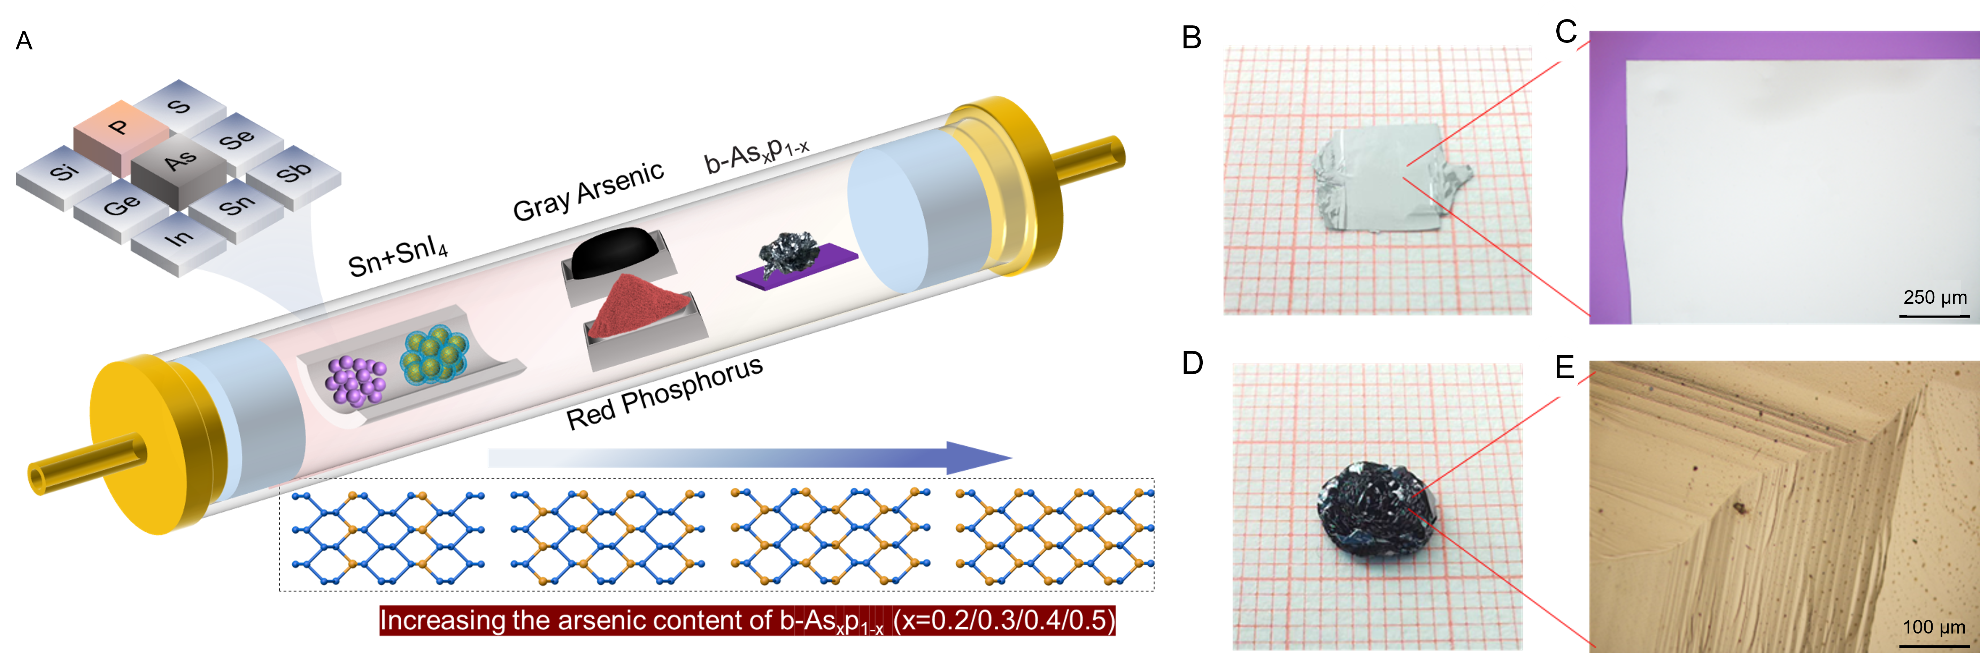
Fig. S1. Growth of b-As_{x}P_{1-x} crystal. a Schematic of a typical CVD system for the synthesis of b-As_{x}P_{1-x} crystal nanoplates. All chemicals were enclosed in an evacuated silica glass quartz tube (length: 100 mm; internal diameter: 85 mm). b, c Typical photograph and magnified optical microscope of b-As_{x}P_{1-x} crystal grown by conventional method, respectively. d, e Typical photograph and magnified optical microscope of b-As_{x}P_{1-x} crystal grown by the improved method, respectively.

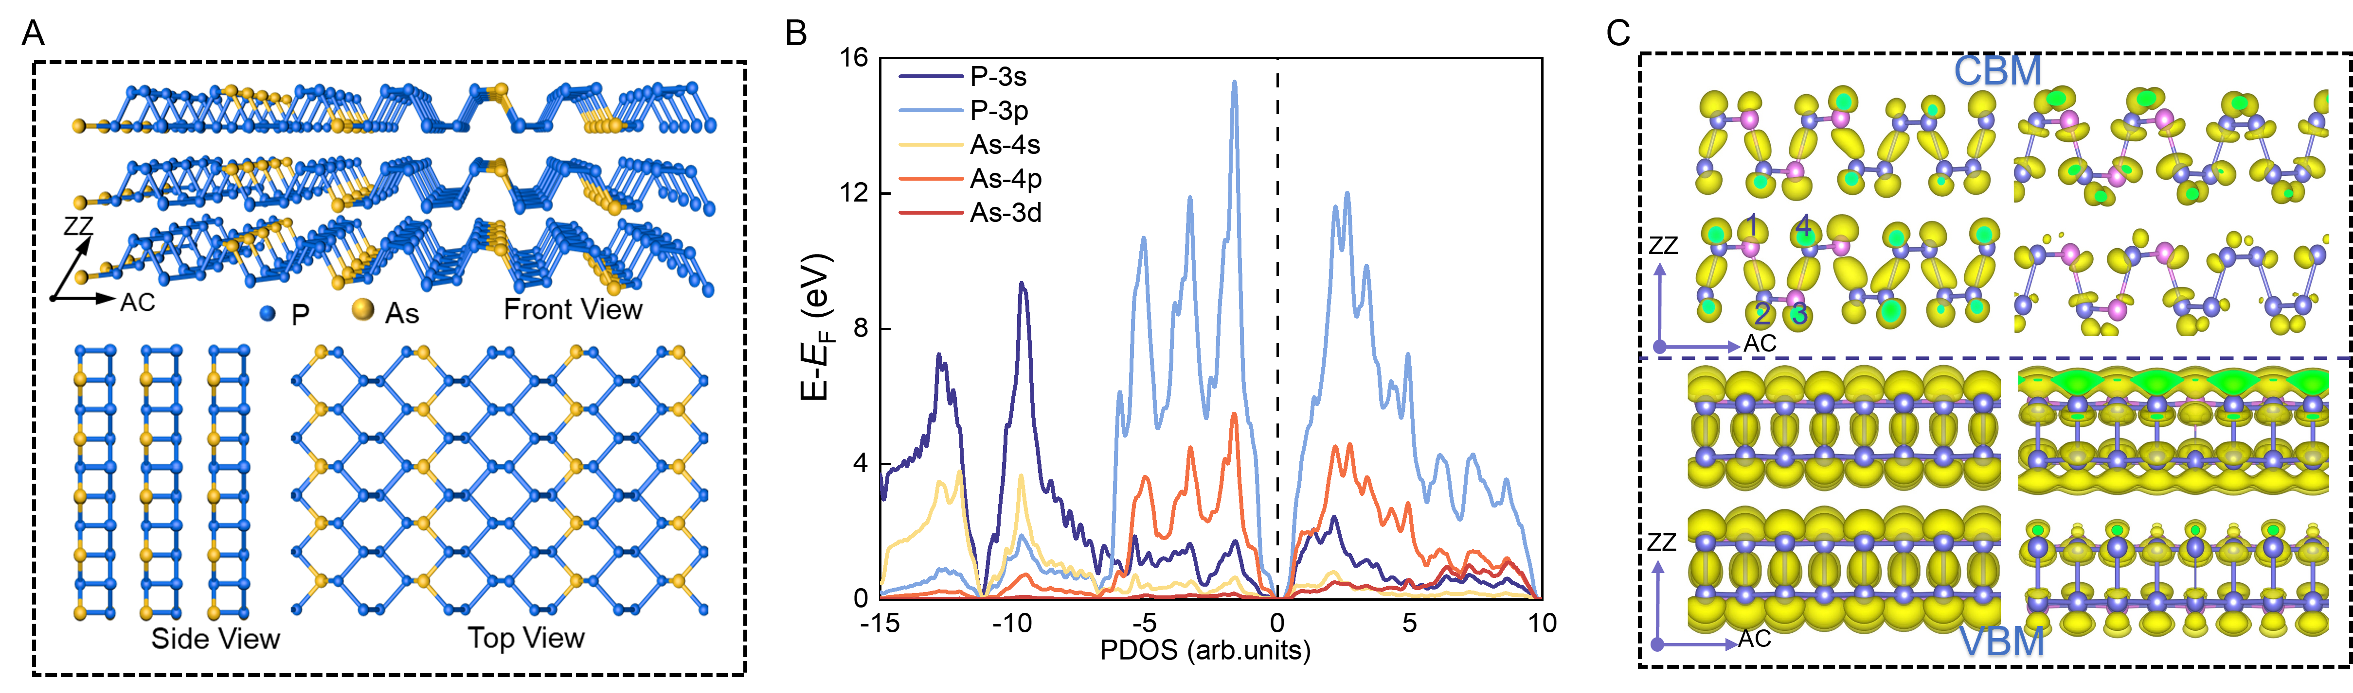
Fig. S2. First principles calculation. a Crystallographic structure of b-As_{0.2}P_{0.8}, in both front (upper panel), side, and top (bottom panel) views. b The PDOS, and c The partial charge density distribution of CBM and VB computed by the DFT method for As_{0.2}P_{0.8} crystal.

Note S2. First principles calculation method.
Further exploration into the electronic properties of gradually substituting As atoms for P atoms in b-As_{0.2}P_{0.8} was conducted through density functional theory (DFT) with the corresponding calculation process. The calculations are computed by using the projector augmented plane-wave method based on the DFT framework in the Vienna ab initio simulation package (VSAP). The generalized gradient approximation of the Perdew-Burke-Ernzerhof function is adopted for electron exchange and correlation (PBE-GGA). A vacuum larger than 20 Å is used to eliminate the interaction between adjacent structures. The cutoff energy for the plane-wave basis set is set to 500 eV, all the structures are fully relaxed with energy and force tolerance of 10⁻⁵ eV/atom and 10⁻³ eV/Å, respectively. The first Brillouin zone is sampled using a 5×5×1 Monkhorst-Pack grid for relaxation and a 15×15×1 grid for computing the density of states. A supercell structure of 2×3×1 was utilized to facilitate observation of the effects of varying doping concentrations. Additionally, the calculation results of the partial density of states (PDOS) analyses, displayed in Fig. S2b, indicate that the 3p orbital electrons in the b-As_{x}P_{1-x} structure exhibit strong contributions near the Fermi level, while the influence of 3s orbital electrons is relatively weak. As atom concentration, the contribution of P-3p orbital electrons decreases, while the effect of As-4p orbital electrons near the Fermi level begins to increase. Fig. S2c illustrate the local charge density distribution at the CBM and VBM, where in the VBM, the charge mainly concentrates between 1 and 2, 3 and 4, while in the VBM, the charge predominantly gathers between 1 and 4, 2 and 3, displaying typical covalent bond formations. These results underscore the potential applicability of layered b-As_{0.2}P_{0.8} materials in various fields, including electronics and optoelectronics, specifically targeting applications like infrared photodetection, optoelectronic synapses, and optical communications.

Note S3. Characterization data details of b-As_{0.2}P_{0.8} crystal
Raman spectroscopy was employed to characterize the lattice vibrational modes of b-As_{x}P_{1-x} crystal nanosheets as a function of composition with the three characteristic peaks (A_{g}¹, B _{2g}, and A _{g}²). With increasing arsenic content, the intensity of phosphorus-phosphorus (P-P) bond peaks decreases, while the arsenic-arsenic (As-As) bond peaks intensify, consistent with prior studies. Furthermore, a progressive redshift in the Raman peaks correlates with higher arsenic concentrations, providing an efficient and precise means of estimating the crystal composition within b-As_{0.2}P_{0.8}.
The electronic structure and bonding characteristics of the synthesized samples were probed through X-ray photoelectron spectroscopy (XPS). As shown in Figs. S3a and 3b), the XPS spectra enabled a quantitative compositional analysis of phosphorus and arsenic by integrating the P 3p and As 3d core-level peaks.
X-ray diffraction (XRD) patterns, compared in Supplementary Fig. S3c, reveal lattice disorder effects due to the distinct lattice parameters of orthorhombic arsenic and phosphorus in b-As_{x}P_{1-x}. The substitution of phosphorus atoms with larger arsenic atoms within the crystal lattice results in peak broadening and a shift toward lower angles, with the magnitude of this shift increasing alongside arsenic content.

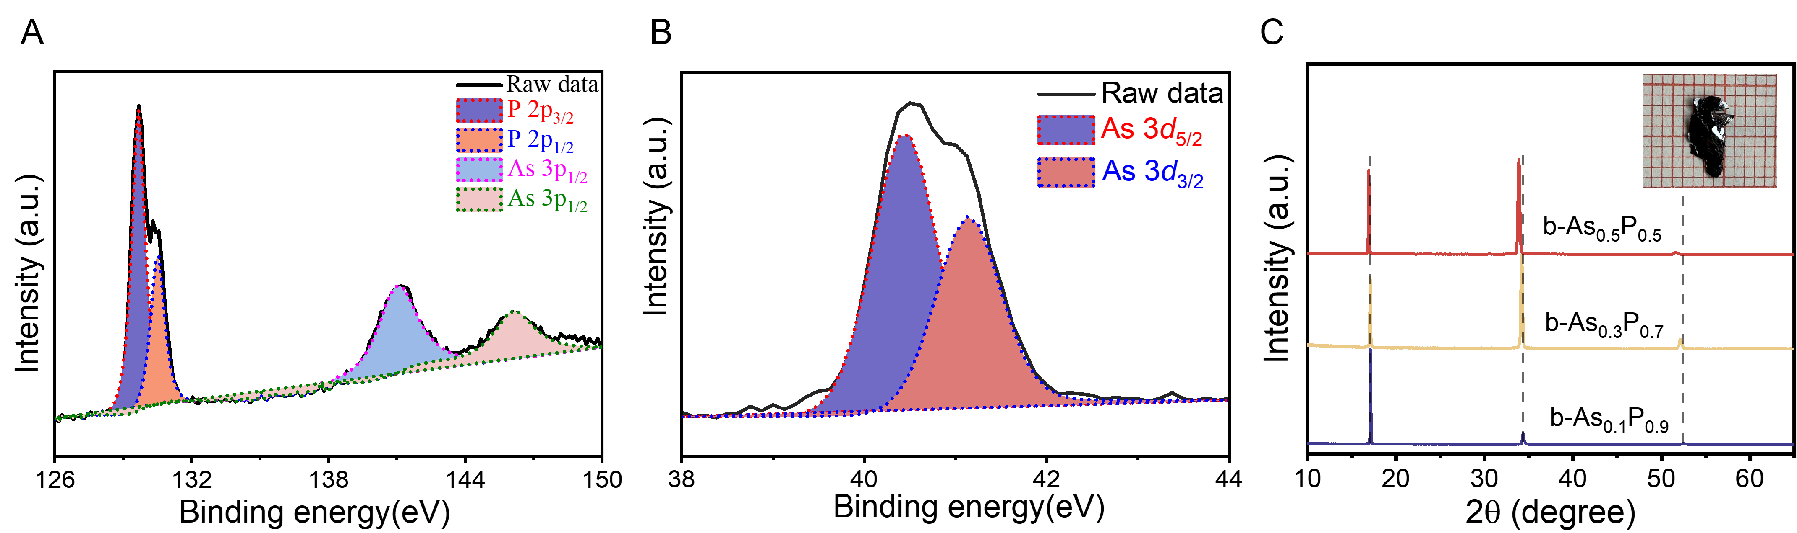
Fig. S3. Characterization of b-As_{0.2}P_{0.8} crystal nanosheets. a, b XPS spectra of P 2p, As 3p, and As 3d core levels on the monolayer b-As_{0.2}P_{0.8} crystal nanoplates. c XRD spectrum of b-As_{0.2}P_{0.8} with different components. The inset shows the optical microscope (OM) image of b-As_{0.2}P_{0.8} crystal nanosheets.

Section S2. Phototransistor Configuration and Polarization-Dependent Performance

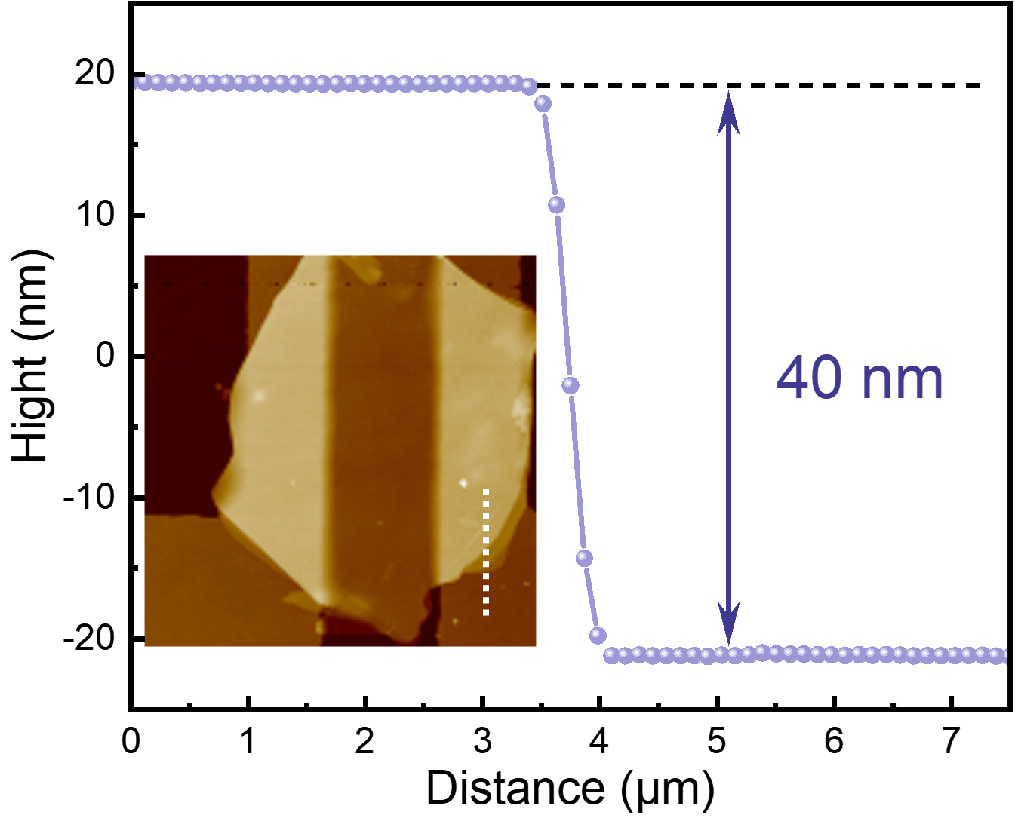
Fig. S4. AFM image of the device. The inset shows the corresponding thickness map, which is about 40 nm. The exfoliated material displays a uniform thickness, with a corresponding contour plot taken along the electrode-material interface (indicated by the white dashed line) showing a thickness centered around 40 nm.

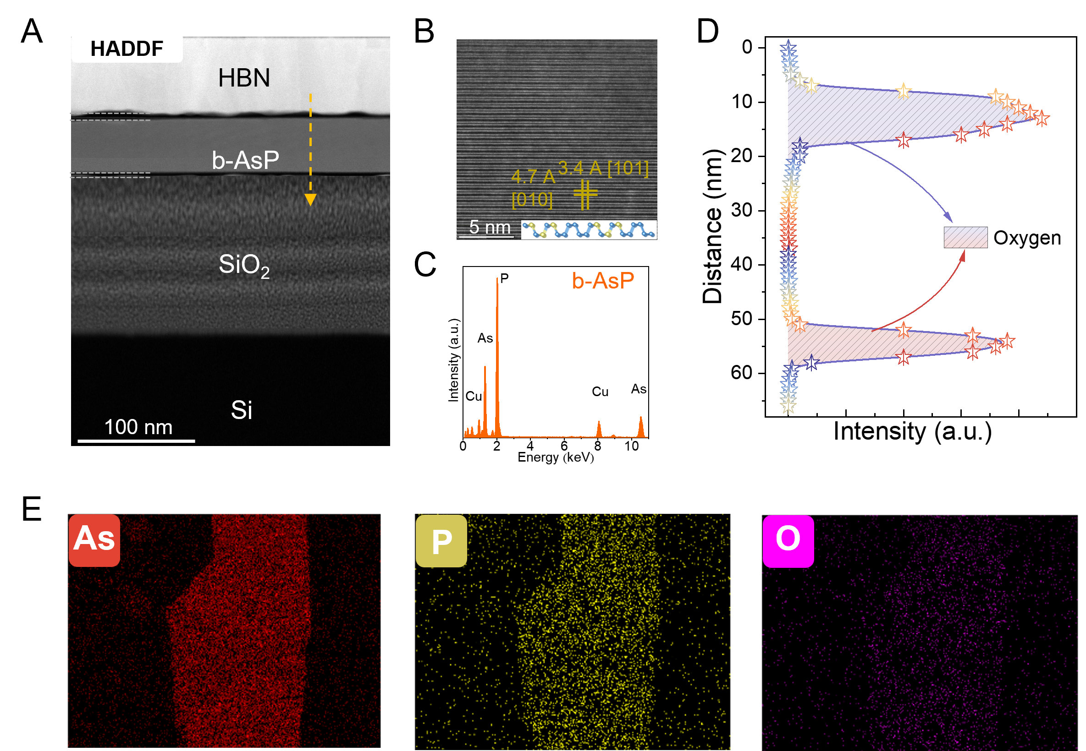
Fig. S5. Device element analysis and morphology characterization. a Cross-sectional TEM image of the device fabricated on a SiO₂/Si substrate. b The HRTEM images along the interfaces at high magnification. c The element intensity distributions. d Electron energy loss spectroscopy line scan collected along the vertical dashed line in (a). e Corresponding element diagrams of As, P, and O in the SEM image.
Note S4. Detection mechanism description
Figure 2c in the main text shows the output characteristic curves (I_{ds}-V_{ds}) of the b-As_{0.2}P_{0.8} phototransistor under different gate voltages (V_{g}). During the test, it was found that when a large voltage was applied, the b-As_{0.2}P_{0.8} would partially or completely turn black or even ablate and melt. In order to prevent the current passing through the b-As_{0.2}P_{0.8} from being too large and causing damage to the material and device, the V_{ds} at both ends of the source and drain was controlled between -0.1 V to 0.1 V, and the test range of the V_{g} was -60 V to 60 V. It can be seen from the figure that the b-As_{0.2}P_{0.8} phototransistor exhibits p-type channel field effect characteristics. When the applied V_{g} is small, the holes in the device channel accumulate less and no conductive channel is formed, and the current between the drain and source is small. When a certain V_{g} is applied, I_{ds} is proportional to V_{g} and maintains a good linear relationship, indicating that the contact formed between the channel material b-As_{0.2}P_{0.8} and the metal electrode is an ohmic contact. As V_{g} increases, the saturation of I_{ds} deteriorates, which is mainly due to the low dielectric constant of silicon dioxide. It can also be seen that the slope of the output characteristic curve is different under different V_{g}, that is, the gate voltage can effectively coordinate the output characteristics of the b-As_{0.2}P_{0.8} b-As_{0.2}P_{0.8} phototransistor.
When our p-type b-As_{0.2}P_{0.8} device is illuminated with 1550 nm light, photons with energy (0.80 eV) greater than the bandgap (0.28 eV) generate electron-hole pairs. The band structure undergoes several key changes: 1)The photogenerated holes enhance the existing majority carrier concentration in the valence band, increasing channel conductivity. 2) Photogenerated electrons (minority carriers) populate the conduction band and, critically, can be captured by trap states located near the conduction band edge. These trap states originate primarily from surface oxidation at the semiconductor-dielectric interface. 3) Under 1550 nm illumination, photogenerated electron-hole pairs form, with holes enhancing channel conduction while electrons can be captured by oxide-related traps. At negative gate voltages, downward band bending accumulates holes in the channel and simultaneously reduces the energy barrier for photogenerated electrons to become trapped at surface defects. These trapped electrons screen hole carriers, causing the observed current depression. At positive gate voltages, upward band bending depletes holes from the channel but also raises the energy level of trap states relative to the conduction band, reducing the barrier for electron release.
The band structure evolution under four key conditions are in Supplementary Fig. S6:
Dark state with VG < 0: Downward band bending at the semiconductor-dielectric interface creates a hole accumulation layer, with the Fermi level positioned close to the valence band edge.
Dark state with VG > 0: Upward band bending depletes holes from the interface region, creating a depletion layer with the Fermi level shifting toward mid-gap.
Light on, VG < 0: Photogeneration creates electron-hole pairs. Holes enhance channel conductivity while electrons populate trap states. The negative gate field stabilizes trapped electrons by increasing the energetic barrier for de-trapping.
Light on, VG > 0: Photogeneration still occurs, but the positive gate field reduces the barrier for electron de-trapping, accelerating their release from trap states.
The channel current of the b-As_{0.2}P_{0.8} phototransistor is closely related to the channel length. The shorter the channel length, the smaller the channel resistance and the larger the channel current. According to the transfer and output characteristic curves of the b-As_{0.2}P_{0.8} phototransistor, the basic electrical performance parameters of the device are extracted and analyzed. In the phototransistor, the relationship between I_{ds} and V_{ds} is: I_{ds} =SσV_{ds}/L, where L is the length of the conductive channel, S is the cross-sectional area, and σ is the conductivity of b-As_{0.2}P_{0.8}. When V_{g} is zero, the resistance of the device is calculated to be 0.95×l0⁴ Ω. The low resistance value indicates that the quality of the b-As_{0.2}P_{0.8} sheet is good and the contact between the metal electrodes at both ends is stable.
The inset in Fig. 2c is the transfer characteristic curve of the back-gate b-As_{0.2}P_{0.8} phototransistor. At this time, the V_{ds} loaded on the source and drain is 0.1 V, the test range of the V_{g} is -60V-60V, and the test temperature is T=300 K. It can be seen from the transfer characteristic curve that when V_{ds} is constant, I_{ds} decreases with the increase of V_{g}, and the slope is also gradually decreasing. In the b-As_{0.2}P_{0.8} phototransistor, we can use the maximum slope in the I_{ds}-V_{g} curve to obtain the carrier mobility inside the b-As_{0.2}P_{0.8} according to the formula. The field effect mobility μ can be expressed by the following formula: μ=$\frac{dI_{ds}}{dV_{g}}\frac{L}{W}\frac{1}{CV_{ds}}$, In the formula, dI_{ds}/dV_{g} is the maximum slope in the transfer curve, that is, the transconductance. I_{ds} is the source-drain current; V_{g} is the gate voltage; V_{ds} is the voltage between the source and the drain, and V_{ds}=0. 1 V; C is the gate capacitance per unit area, C =ε₀×ε_{r}/d, where ε₀ is the vacuum dielectric constant, ε_{r} is the relative dielectric constant of SiO₂; L and W are the length and width of the channel, which are 6 μm and 2 μm, respectively. According to calculations, the hole mobility of the device at room temperature is 381.5 cm²V⁻¹s⁻¹, and the electron mobility is 8.2 cm²V⁻¹s⁻¹.

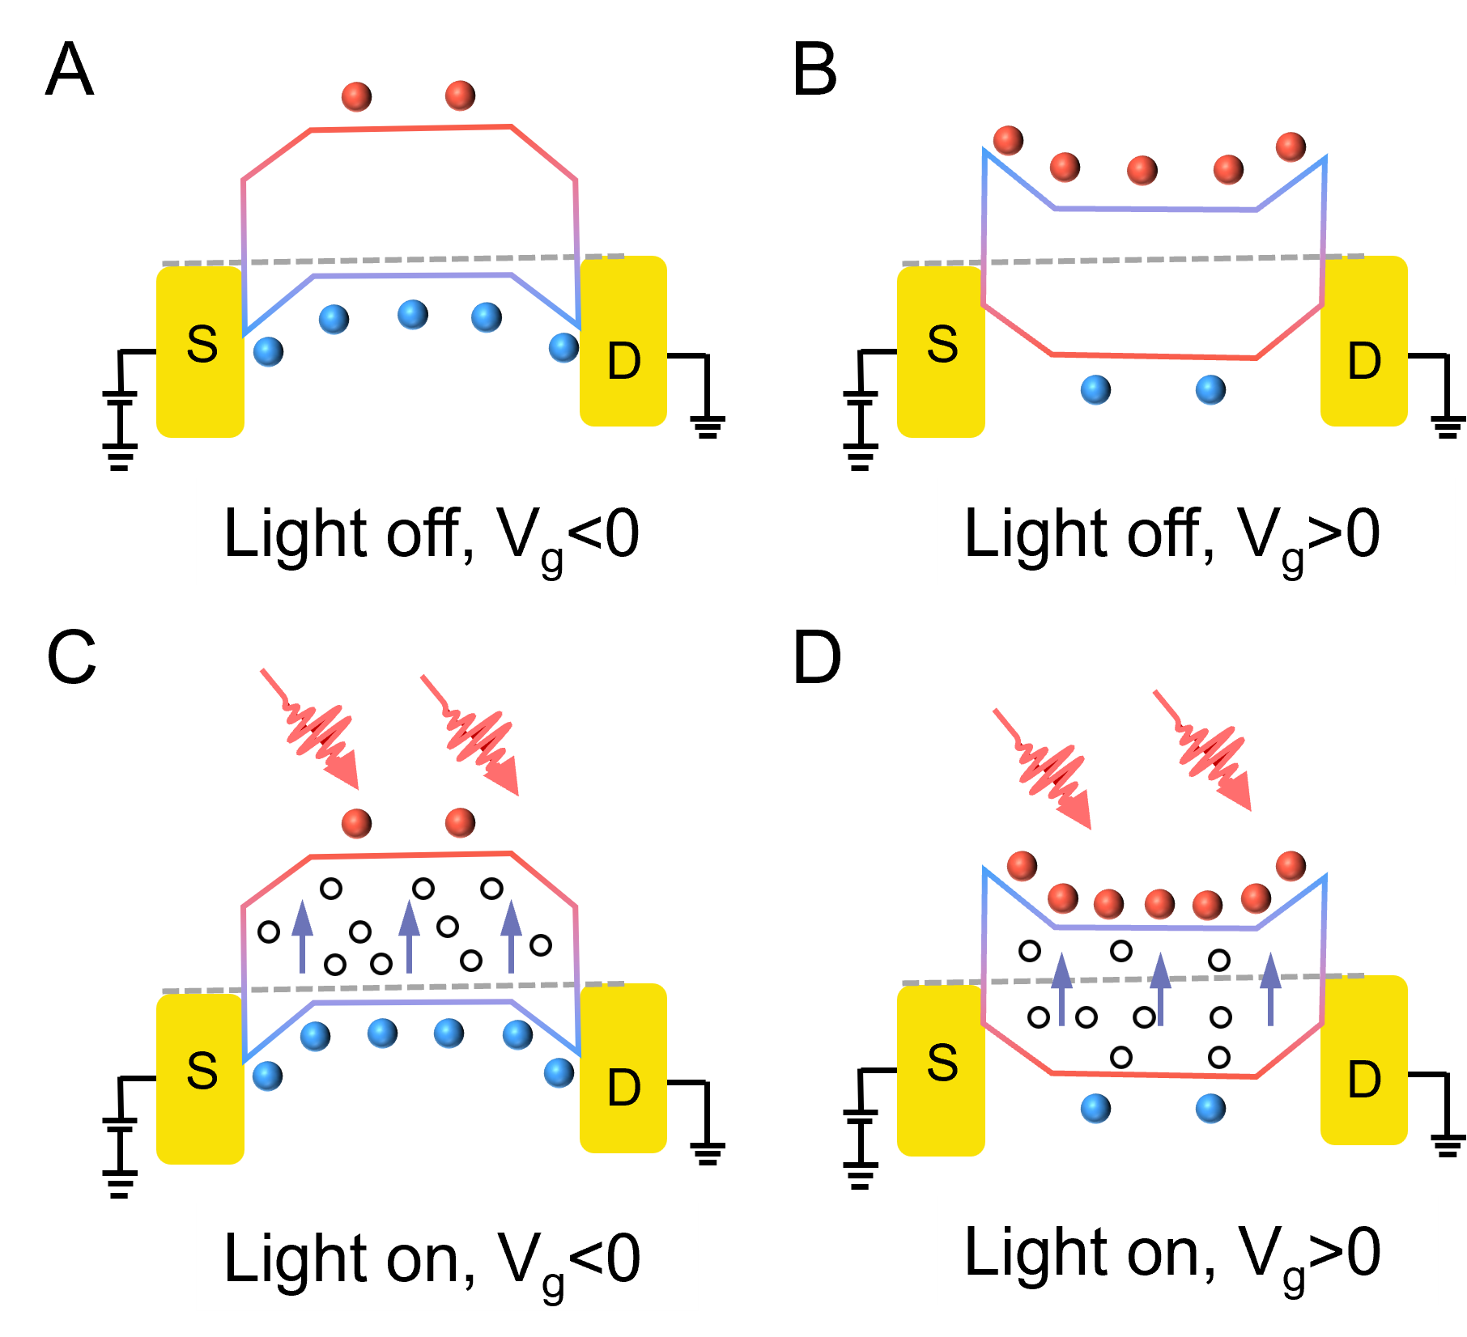
Fig. S6. The energy band diagrams under different conditions, such as a Light off, V_{g}<0. b Light off, V_{g}>0. c Light on, V_{g}<0. d Light on, V_{g}>0.

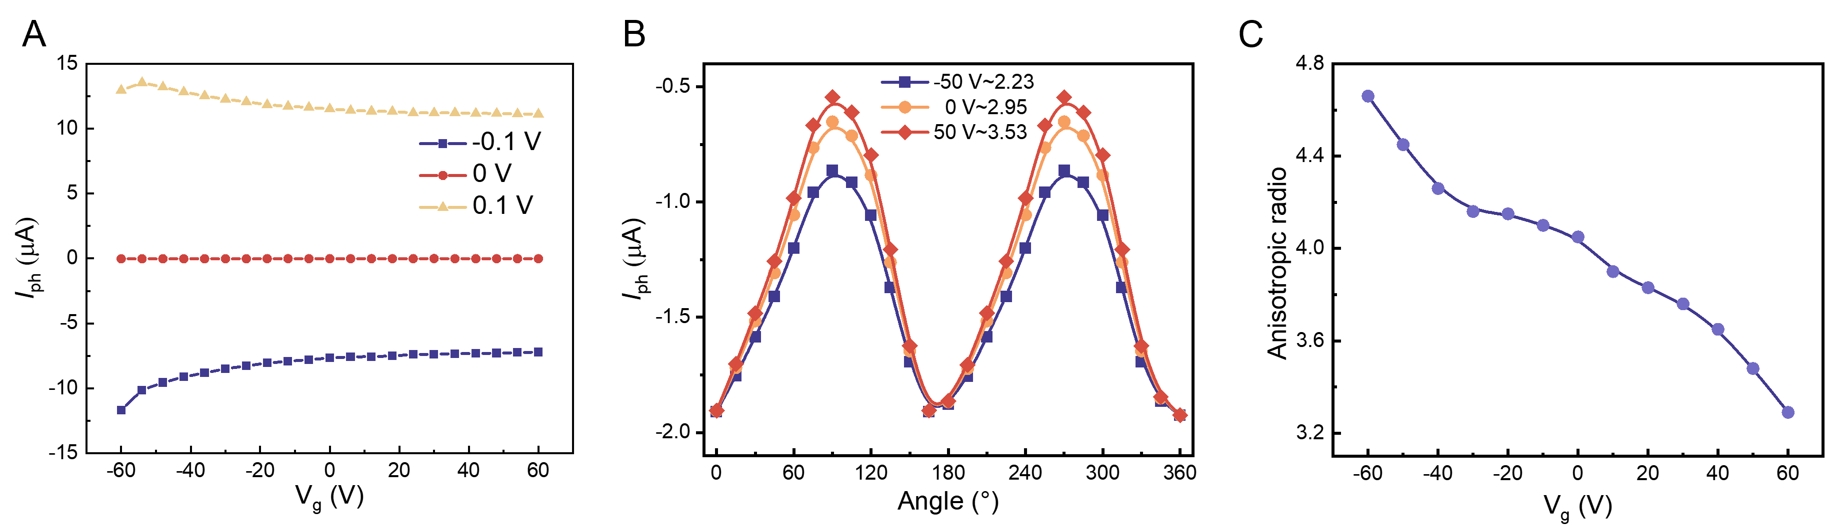
Fig. S7. Photoelectric anisotropy behavior of b-As_{0.2}P_{0.8} phototransistors. a Transfer characteristic curves of the device under different V_{ds} (-0.1 V, 0 V, and 0.1 V). b Polarization behavior of the device under different V_{g} (-50 V, 0 V, and 50 V). c Anisotropy ratio of the device at different V_{g} (-60 V to 60 V).

Table S1. Performance Comparison with State-of-the-Art Polarization-Sensitive Neuromorphic Devices.
Material | Polarization Ratio | R_{I} (A/W) | Energy/Spike (pJ) | PPF | Multimodal Capability | Ref
PbS QDs/Graphene | - | 0.0071 | - | 178% | Polarization +Intensity | [1]
Twisted b-AsP homojunctions | 1.1 | 0.15 | - | - | Polarization +Intensity+ Wavelength | [2]
Ph-BTBT-10 | 3.85 (365 nm) | 1.47 × 10⁴ | 0.9 × 10⁻³ | - | Polarization | [3]
Graphene/MoS₂ Heterostructure | 1.76 (635 nm) | 105 | - | 115% | Polarization | [5]
MoS₂ | - | - | - | 107.5% | STP+LTP/LTD | [5]
h-BN/WSe₂ heterostructure | - | - | 0.066 | - | LTP/LTD +STDP | [6]
MoS₂/PTCDA | - | - | 10 | 147% | STP+LTP | [7]
ZnO/P3HT | - | - | - | 149% | STP+LTP | [8]
b-AsP | 4.7 (1550 nm) | 2.88 | 25 | 201% | Polarization +Intensity+ Wavelength +STP+LTP/LTD | This Work

Section S3. Neuromorphic Computing Simulation and Polarization Imaging Application

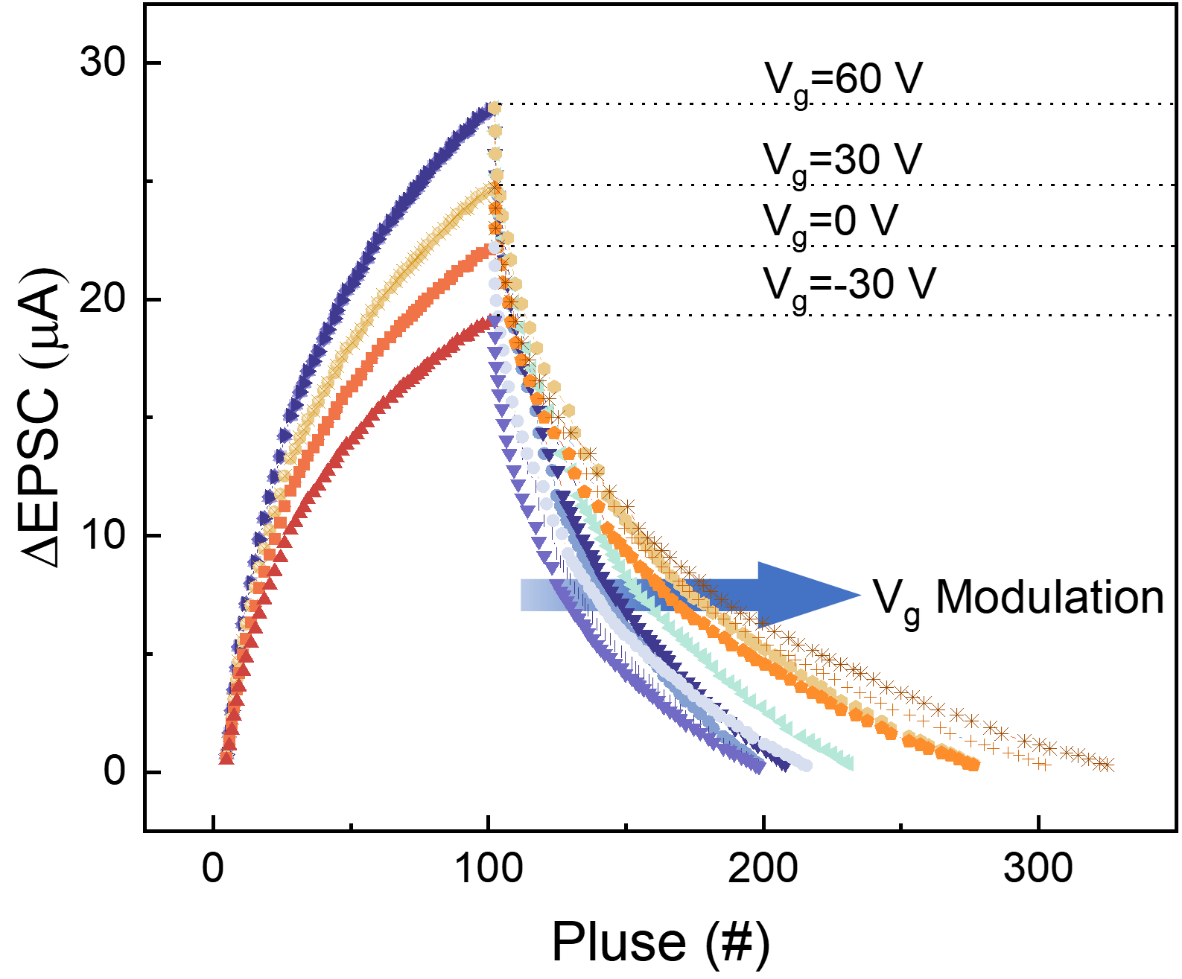
Fig. S8. LTP/LTD curves of the b-As_{0.2}P_{0.8} device at different electrical gate voltages.

Note S5. Derivation of the relationship between LTP/LTD and time under periodic pulses
In our b-As_{0.2}P_{0.8} optoelectronic memories device, synaptic plasticity, exemplified by long-term potentiation (LTP) and short-term depression (LTD), is modulated via irradiation with near-infrared laser light (1550 nm) at variable polarization states and controlled gate voltages. The weight changes in artificial neural network synapses rely on the LTP/LTD dynamics, tested by adjusting linear polarization angles from 0° to 90°. For defining the weight update rule in our HOENN simulations, the nonlinearity (NL) of the experimentally obtained LTP/LTD curves is calculated across different light pulse widths. The NL values for synaptic potentiation and depression are determined by fitting the LTP/LTD responses as follows:
where, G_{i} and G_{i+1} are the conductance of i^{th} and (n+1)^{th} pulses, G_{min} and G_{max} are the minimum and maximum conductance, α_{p} and α_{d} are the differences in the conductance between two points on the potentiation and depression curves, β_{p} and β_{d} are the curvatures of the potentiation and depression curves (i.e., NL), respectively.
For (1-1), by the continuity condition, combined with Taylor expansion, we have:
Comparing (1-1) with (1-3), we have:
Separate the variables and integrate both sides.
We have：
For the LTD process, we also have:
In which, the undetermined coefficients are α_{p} and α_{d}. While C_{d} is a constant related to the starting point of timing and does not affect the trend of the curve.

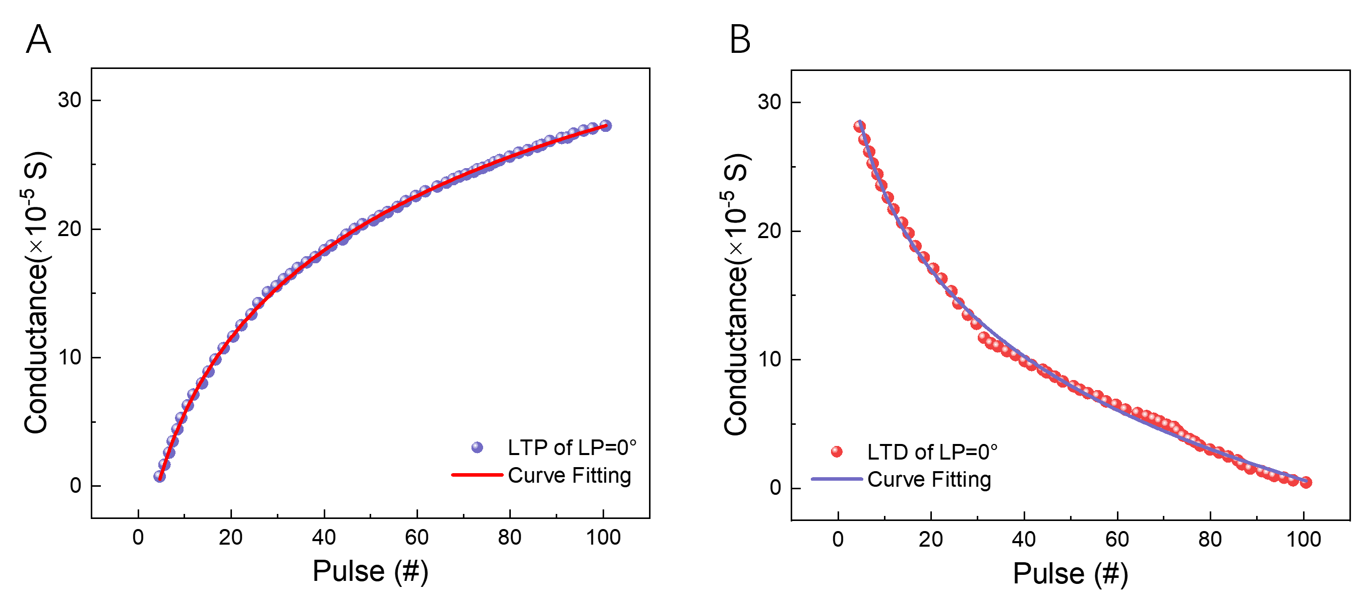
Fig. S9. a, b The fitting results of the LTP/LTD process under the LP=0° polarization state.

Specifically, the conductance value, serving as the photoresponse metric in optoelectronic devices, functions equivalently to weight parameters in neural networks. In the simulation architecture, each neural node comprises two complementary devices (G⁺_{n,m} and G⁻_{n,m}), with bidirectional regulation enabling weight updates. For instance, when backpropagation calculations require weight enhancement (Δw>0), the G⁺_{n,m} device demonstrates long-term potentiation (LTP) through conductance amplification, while the G⁻_{n,m} device exhibits long-term depression (LTD) via conductance attenuation. The equivalent weight of each node is subsequently characterized by the differential value (G⁺_{n,m} and G⁻_{n,m}).
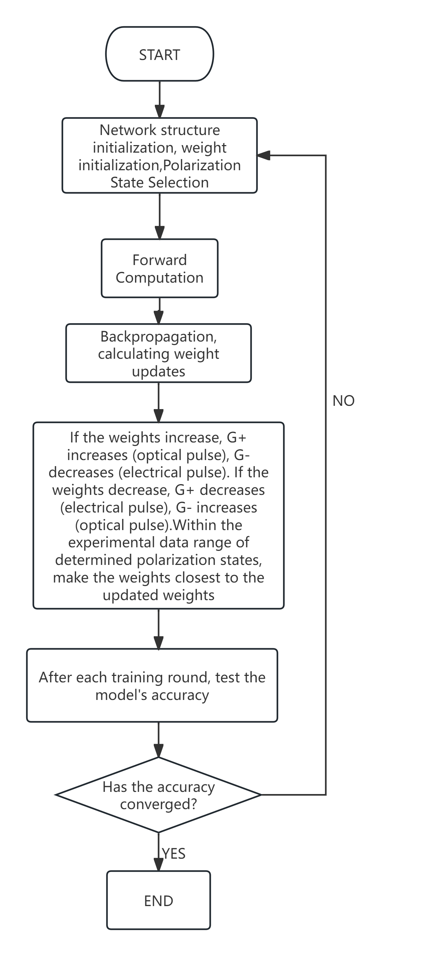
Fig. S10. The training flowchart.

Table S2. Extracting LTP/LTD parameters under different polarization attitudes from experimental data.
Linear polarization Angle | G_{min}  (×10⁻⁵ S) | G_{min}  (×10⁻⁵ S) | Fitting parameters LTP |  | Fitting  parameters LTD
Linear polarization Angle | G_{min}  (×10⁻⁵ S) | G_{min}  (×10⁻⁵ S) | α_{p} | β_{p} | α_{d} | β_{d}
0 | 28.00515 | 0.34934 | -3.12E-5 | 11.2 | 8.90E-5 | 13.99
15 | 27.44783 | 0.34239 | -3.06E-5 | 10.37 | 8.715E-5 | 13.67
30 | 24.66125 | 0.30763 | -2.73E-5 | 10.15 | 7.83E-5 | 13.14
45 | 13.93291 | 0.1738 | -1.56E-5 | 9.21 | 4.97E-5 | 12.43
60 | 13.51492 | 0.16859 | -1.51E-5 | 8.87 | 4.28E-5 | 11.13
75 | 10.72834 | 0.13383 | -1.19E-5 | 8.46 | 3.37E-5 | 10.79
90 | 8.49908 | 0.10602 | -1.04E-5 | 8.23 | 2.51E-5 | 10.53

Note S6. Weight Update method
Simulating Optoelectronic Hybrid Neural Networks Using PyTorch: In this approach, the synaptic weights are represented by the difference in conductance between two devices, that is, W=k (G⁺-G⁻), where k denotes the amplification coefficient for the current. The changes in the required weights ΔW for each iteration are calculated using the backpropagation algorithm. When ΔW >0, G⁺_{n,m} increases and G⁻_{n,m} decreases, corresponding to the photocurrent pulse, W ultimately increases; conversely, when ΔW <0, G⁺_{n,m}, decreases and G⁻_{n,m} increases, corresponding to the electric current pulse, W ultimately decreases.

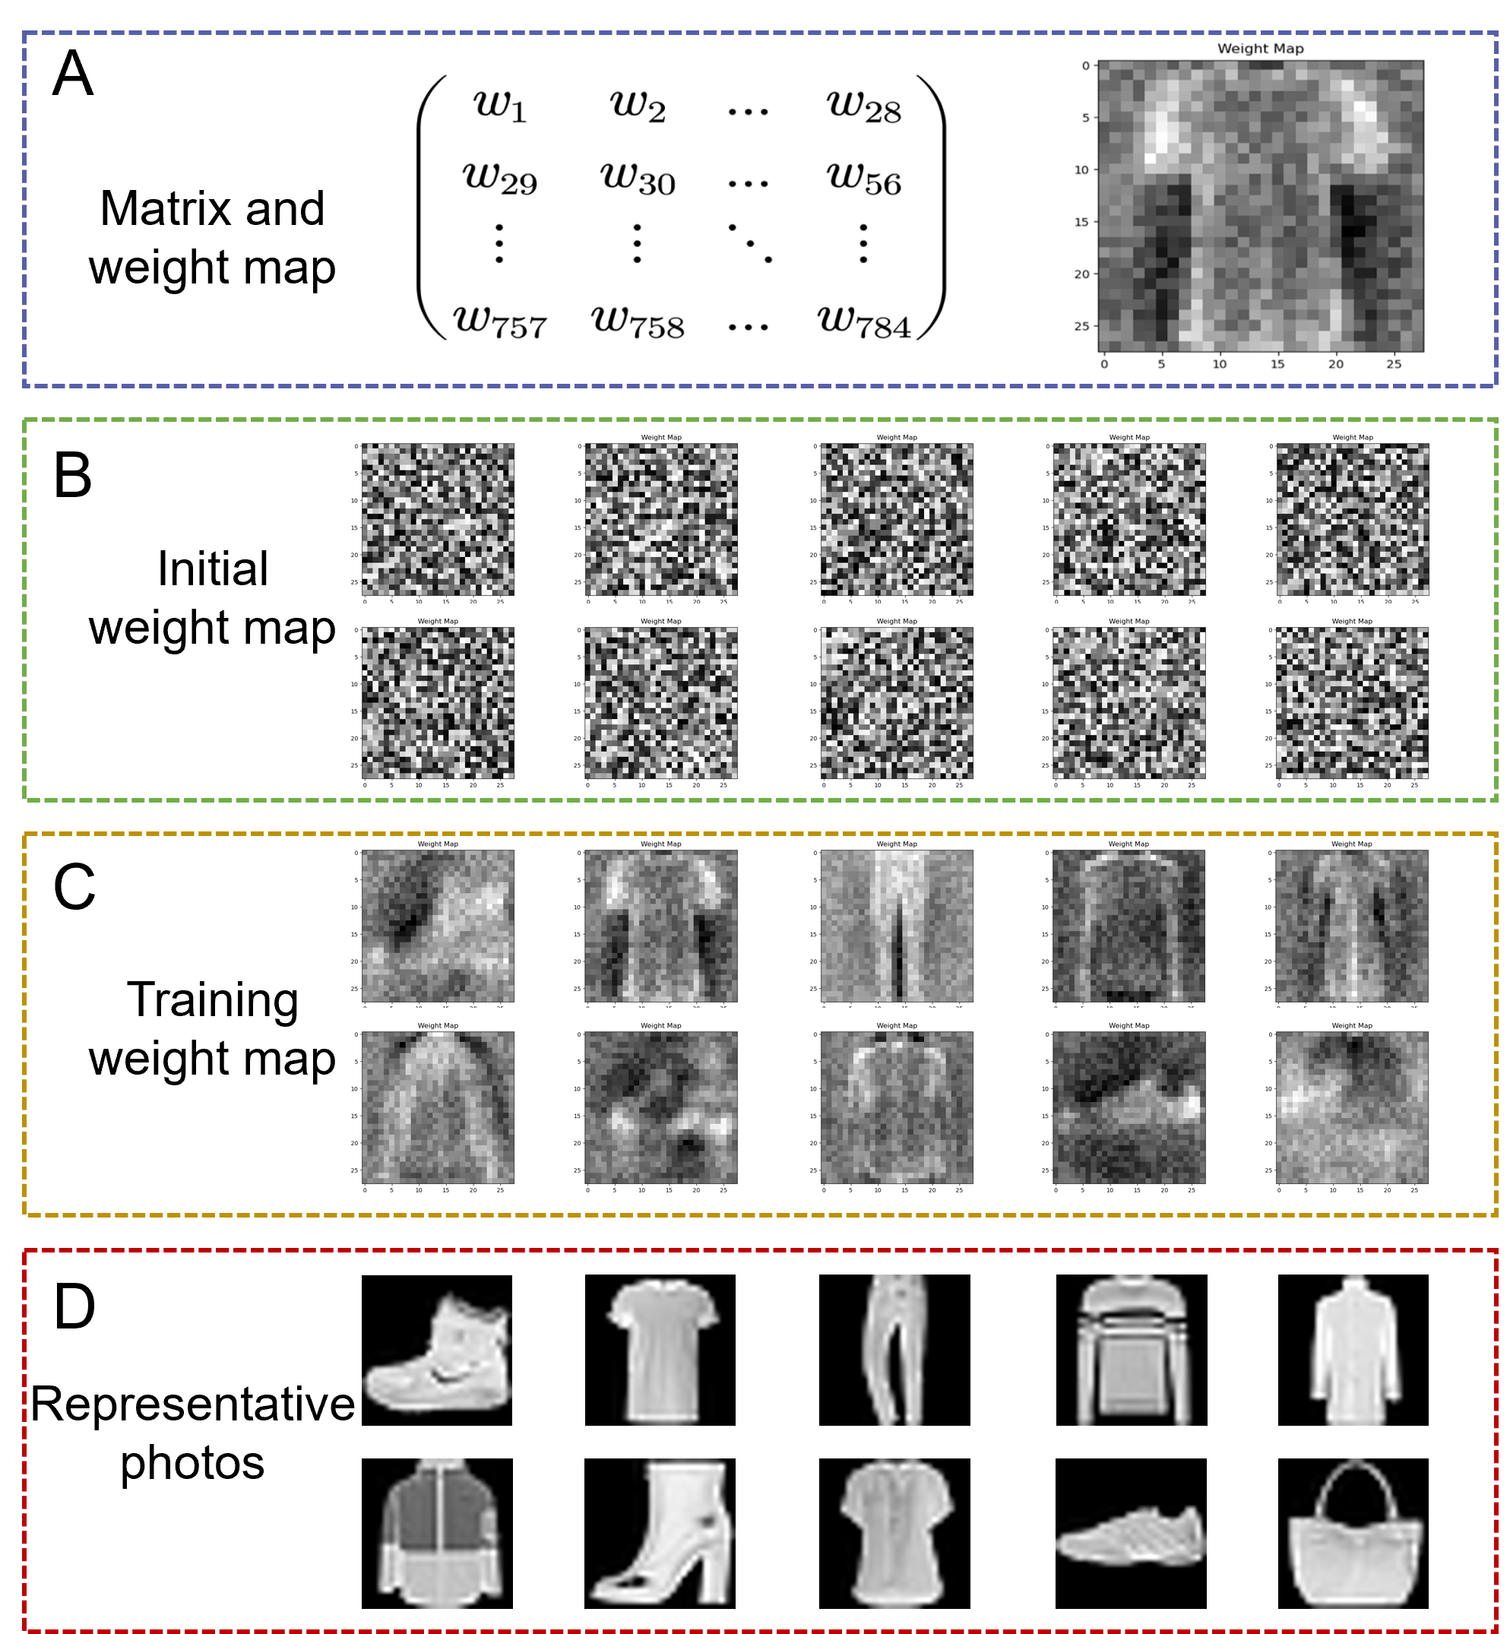
Fig. S11. Weight map diagram. a The 784 weights connected to a representative node in the output layer are rearranged into a 28×28 matrix in the classification task, and then the matrix is mapped into the weight map shown in the right panel. b The weight mapping connected to the ten nodes in the output layer in the initial state. c The weight mapping after training. d The typical representatives of each type of image.

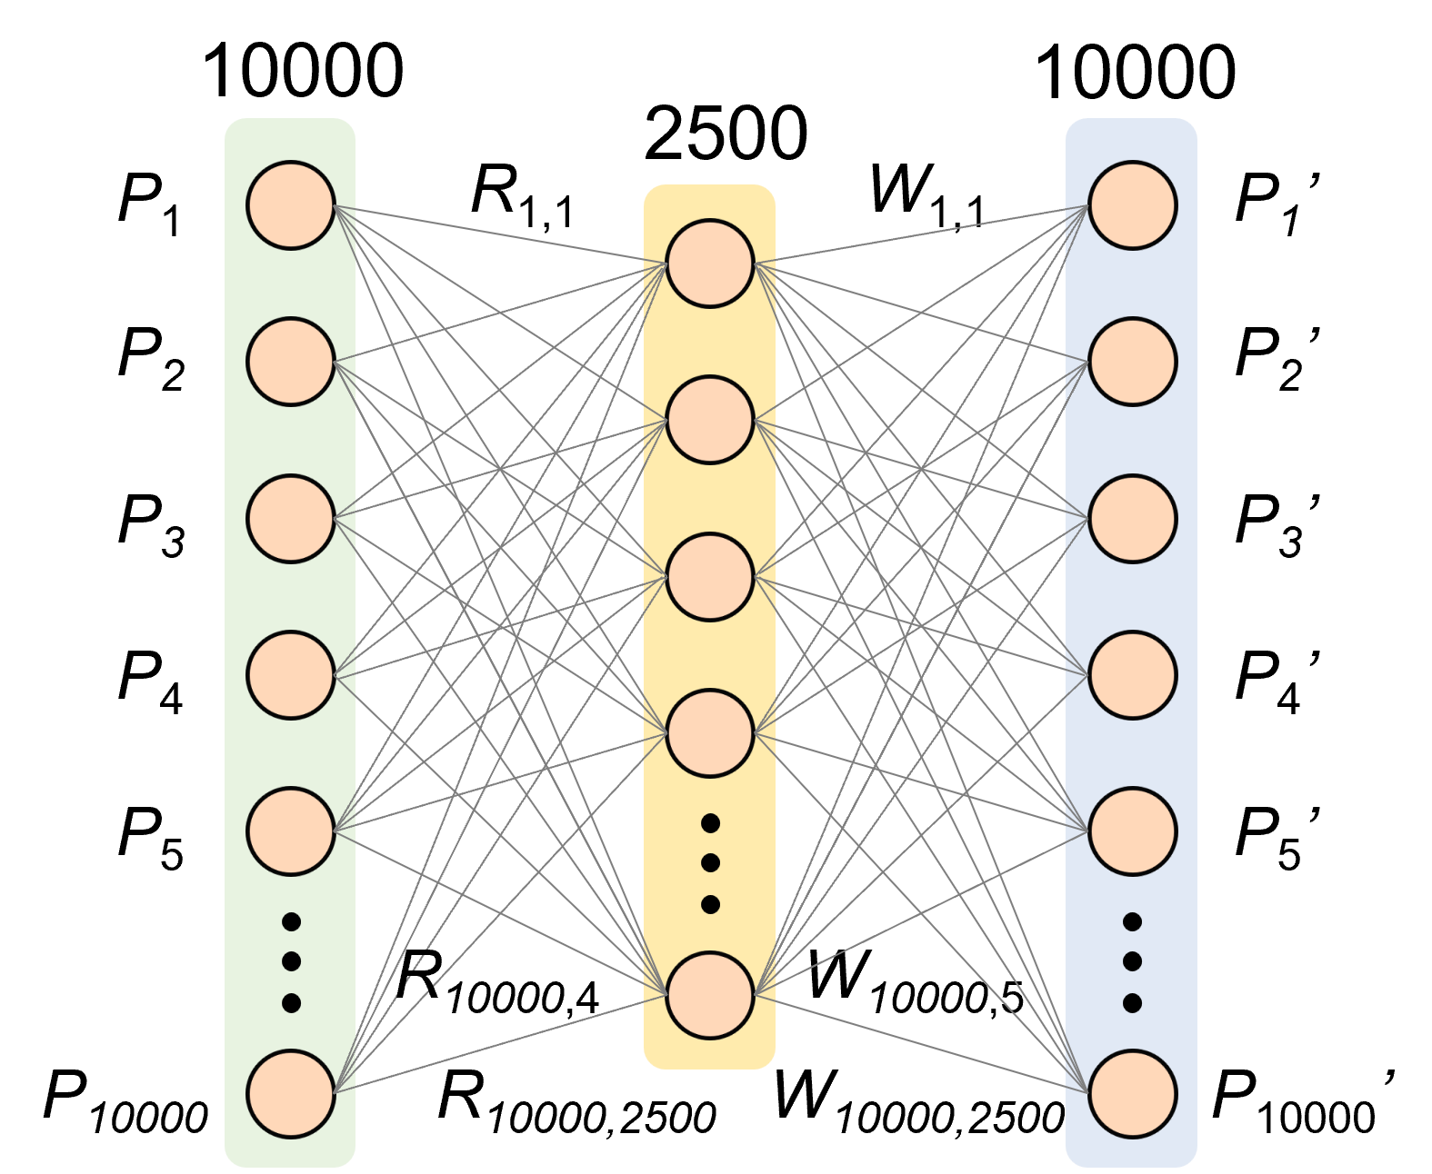
Fig. S12. Schematic diagram of a three-layer encoder-decoder network architecture of size 10000-2500-10000, aimed at reconstructing images from the Yale Face Database.

Note S7. Reconstruction accuracy calculation method
The structural similarity is used to calculate the similarity between the reconstructed image and the original image.
The structural similarity is defined as：
Where μ_{x}, μ_{y} is the average value, σ_{x}, σ_{y} is the standard deviation, Z is the covariance of x and y, is a constant used to maintain stability, and L is the dynamic range of the pixel. Usually, k₁=0.01, k₂=0.03.
In actual calculation, scikit-image in Python is used to calculate the structural similarity. The example code is as follows:
from skimage.metrics import structural_similarity as ssim
img1 = io.imread (‘img1.png’)
img2 = io.imread (‘img2.png’)
ssim_value = ssim (img1, img2, multichannel=True)
In the reconstruction task, the reconstruction effect of an image is tested after each epoch, and then the structural similarity is calculated.

Section S4. Multifunctional Stokes polarization imaging

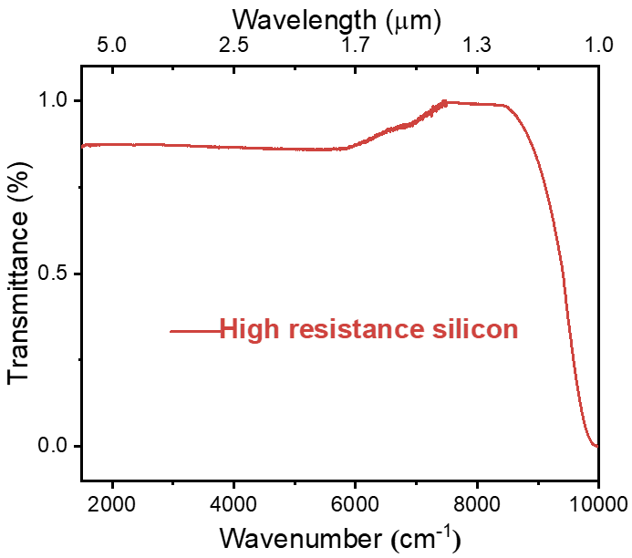
Fig. S13. Infrared transmittance (1 μm to 5 μm) of high-resistance silicon wafer measured by Fourier-transform infrared (FTIR) spectrometer.
Note S8. Single-device imaging mechanism
a. Scanning-Based Imaging:
The polarization-resolved images in Figure 5 were acquired using a single-device scanning setup (not a pixelated array). A focused 1550 nm laser spot (diameter≈100 µm) was raster-scanned across a stationary metal mask, while the photocurrents of the b-AsP phototransistor were recorded at each position.
b. Spatial Resolution:
The effective resolution is determined by the laser spot size and step size (10 µm). This method is analogous to confocal microscopy and avoids the need for large-scale device arrays. It suggests that the b-AsP based device needs fewer pixels to realize the same resolution for DoLP, making it easier to further promote the imaging resolution.

Note S9. Polarization state calculation
The incident polarization information in a polarimeter can be characterized using a set of Stokes vectors. Each component of the Stokes vector is defined as follows:
Where S₀, S₁, S₂, and S₃ represent the four Stokes parameters. I_{LP-0°}, I_{LP-45}, I_{LP-90°}, and I_{LP-135} denote the linear polarized intensities measured at angles of 0°, 45°, 90°, and 135°, respectively I_{R}(x,y) and I_{L}(x,y) correspond to the right and left circularly polarized intensities, respectively.
Specifically:
$$S_{0}=I_{LP-0°}\left(x,y\right)+I_{LP-90°}\left(x,y\right)$$
$$S_{1}=I_{LP-0°}\left(x,y\right)-I_{LP-90°}\left(x,y\right)$$
$$S_{2}=I_{LP-45°}\left(x,y\right)-I_{LP-135°}\left(x,y\right)$$
Therefore, the image via raster-scanned, the photocurrent response size at each location is obtained. After all the data at polarization angles of 0°, 45°, 90° and 135° are obtained, the image can be reconstructed.
Stokes Parameter Extraction Workflow:
Step 1: Measure I_{LP-0°}, I_{LP-45°}, I_{LP-90°}, and I_{LP-135°}at each scan position.
Step 2: Compute S₀, S₁, and S₂ using the equations above.
Step 3: Normalize parameters to reconstruct polarization-resolved images.
From these parameters, the degree of linear polarization (DoLP) and the angle of linear polarization (AoLP) can be calculated using the following equations:
,
In this work, the circular polarization Stokes parameter (S₃) is set to zero as the device is completely linearly polarized and the S₃ component can be considered to be 0 and not taken into account. Specifically, our device focuses on linear polarization imaging (S₀, S₁, S₂) due to the intrinsic in-plane anisotropy of b-AsP, which inherently responds to linear polarization angles, in this case the S₃ component is 0. Circular polarization (S₃) detection would require additional optical components (e.g., quarter-wave plates) to convert circularly polarized light into linear polarization, which falls outside the scope of this work and it will be our follow-up research work.

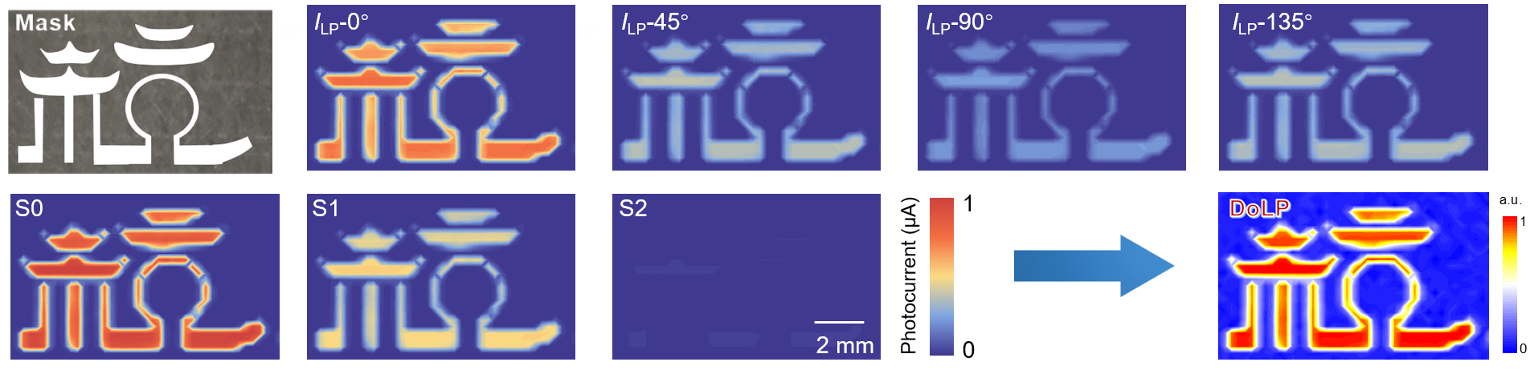Fig. S14. Linear polarization imaging of “hang” with four different polarization angles 0°, 45°, 90°, and 135° and the DoLP imaging results of the device.

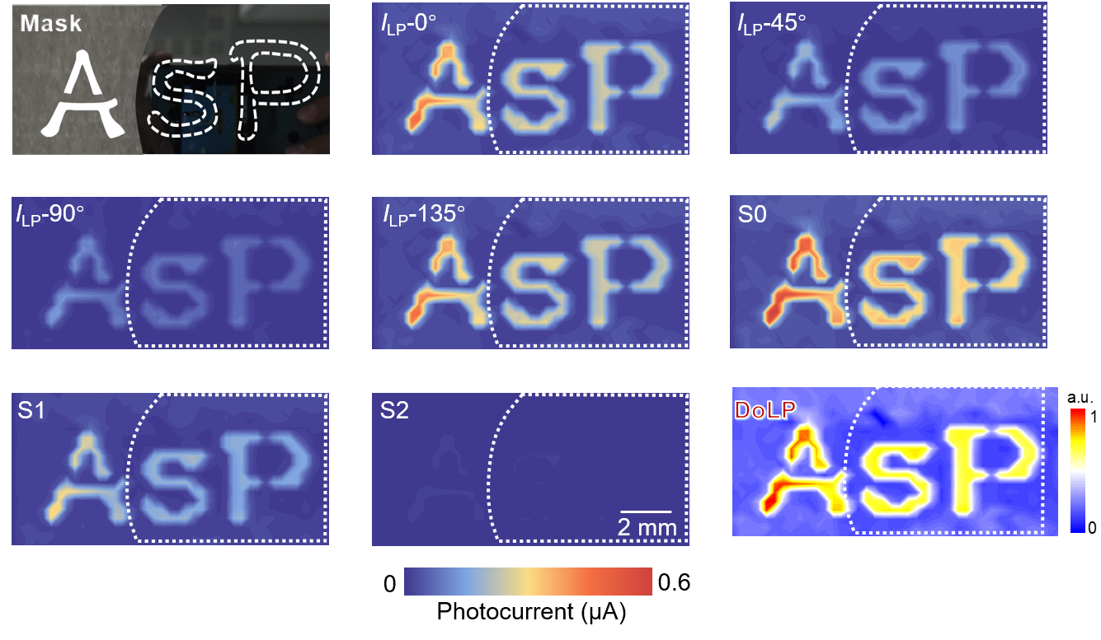
Fig. S15. Linear polarization imaging of “AsP” with four different polarization angles 0°, 45°, 90°, and 135° and the DoLP imaging results of the device.

Reference
[1] Lee K J, Kim J H, Jeon S, et al. Polarization-Dependent Memory and Erasure in Quantum Dots/Graphene Synaptic Devices[J]. Nano Letters, 2024, 24(7): 2421-2427.
[2] Wang F, Zhu S, Chen W, et al. Multidimensional detection enabled by twisted black arsenic–phosphorus homojunctions[J]. Nature Nanotechnology, 2024, 19(4): 455-462.
[3] Dong M, Zhang Y, Zhu J, et al. All‐in‐One 2D Molecular Crystal Optoelectronic Synapse for Polarization‐Sensitive Neuromorphic Visual System[J]. Advanced Materials, 2024, 36(40): 2409550.
[4] Li Y, Zhang Y, Wang Y, et al. Polarization‐sensitive optoelectronic synapse based on 3D graphene/MoS₂ heterostructure[J]. Advanced Functional Materials, 2024, 34(15): 2302288.
[5] Wang B, Wang X, Wang E, et al. Monolayer MoS₂ synaptic transistors for high-temperature neuromorphic applications[J]. Nano Letters, 2021, 21(24): 10400-10408.
[6] Seo S, Jo S H, Kim S, et al. Artificial optic-neural synapse for colored and color-mixed pattern recognition[J]. Nature Communications, 2018, 9(1): 5106.
[7] Wang S, Chen C, Yu Z, et al. A MoS₂/PTCDA hybrid heterojunction synapse with efficient photoelectric dual modulation and versatility[J]. Advanced Materials, 2019, 31(3): 1806227.
[8] Zhao P, Ji R, Lao J, et al. Multifunctional two-terminal optoelectronic synapse based on zinc oxide/poly (3-hexylthiophene) heterojunction for neuromorphic computing[J]. ACS Applied Polymer Materials, 2022, 4(8): 5688-5695.

