Table 1. Evaluation table of comfort level of living environment.
Level | Degree of sensation | temperature and humidity index | wind efficiency index (WEI) | Population Health Index
1 | cold (climate) | <14.0 | <14.0 | It's cold and uncomfortable.
2 | surname leng | 14.0-16.9 | -400—-300 | Cold, less comfortable
3 | comforts | 17.0-25.4 | -299—-100 | comforts
4 | heat up | 25.4-27.5 | -90—-10 | Hot and uncomfortable
5 | sultriness | >27.5 | >-10 | It's hot. It's uncomfortable.
Table 2. Table of the relationship between pedestrian comfort and wind speed frequency.
air velocity (m/s) | wind rating | human comfort
V<5m/s | 0-3 | comforts
5m/s<V<10m/s | 4-5 | Uncomfortable and impaired mobility
10m/s<V<15m/s | 6-7 | Very uncomfortable, impaired mobility
15m/s<V<20m/s | 8 | Unbearable. Dangerous.
20m/s<V | 9 | mortal danger
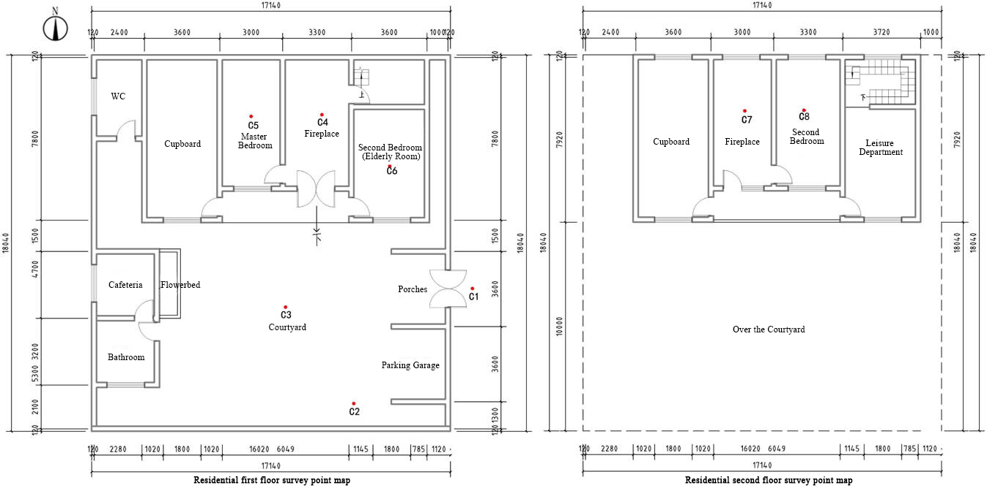
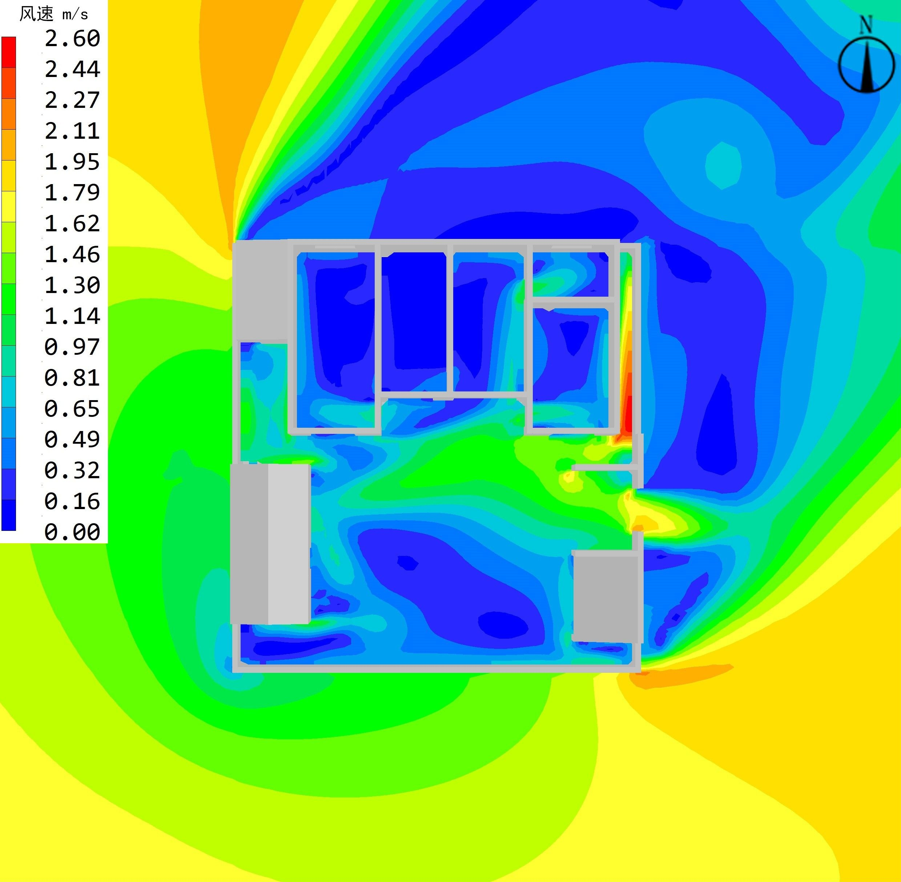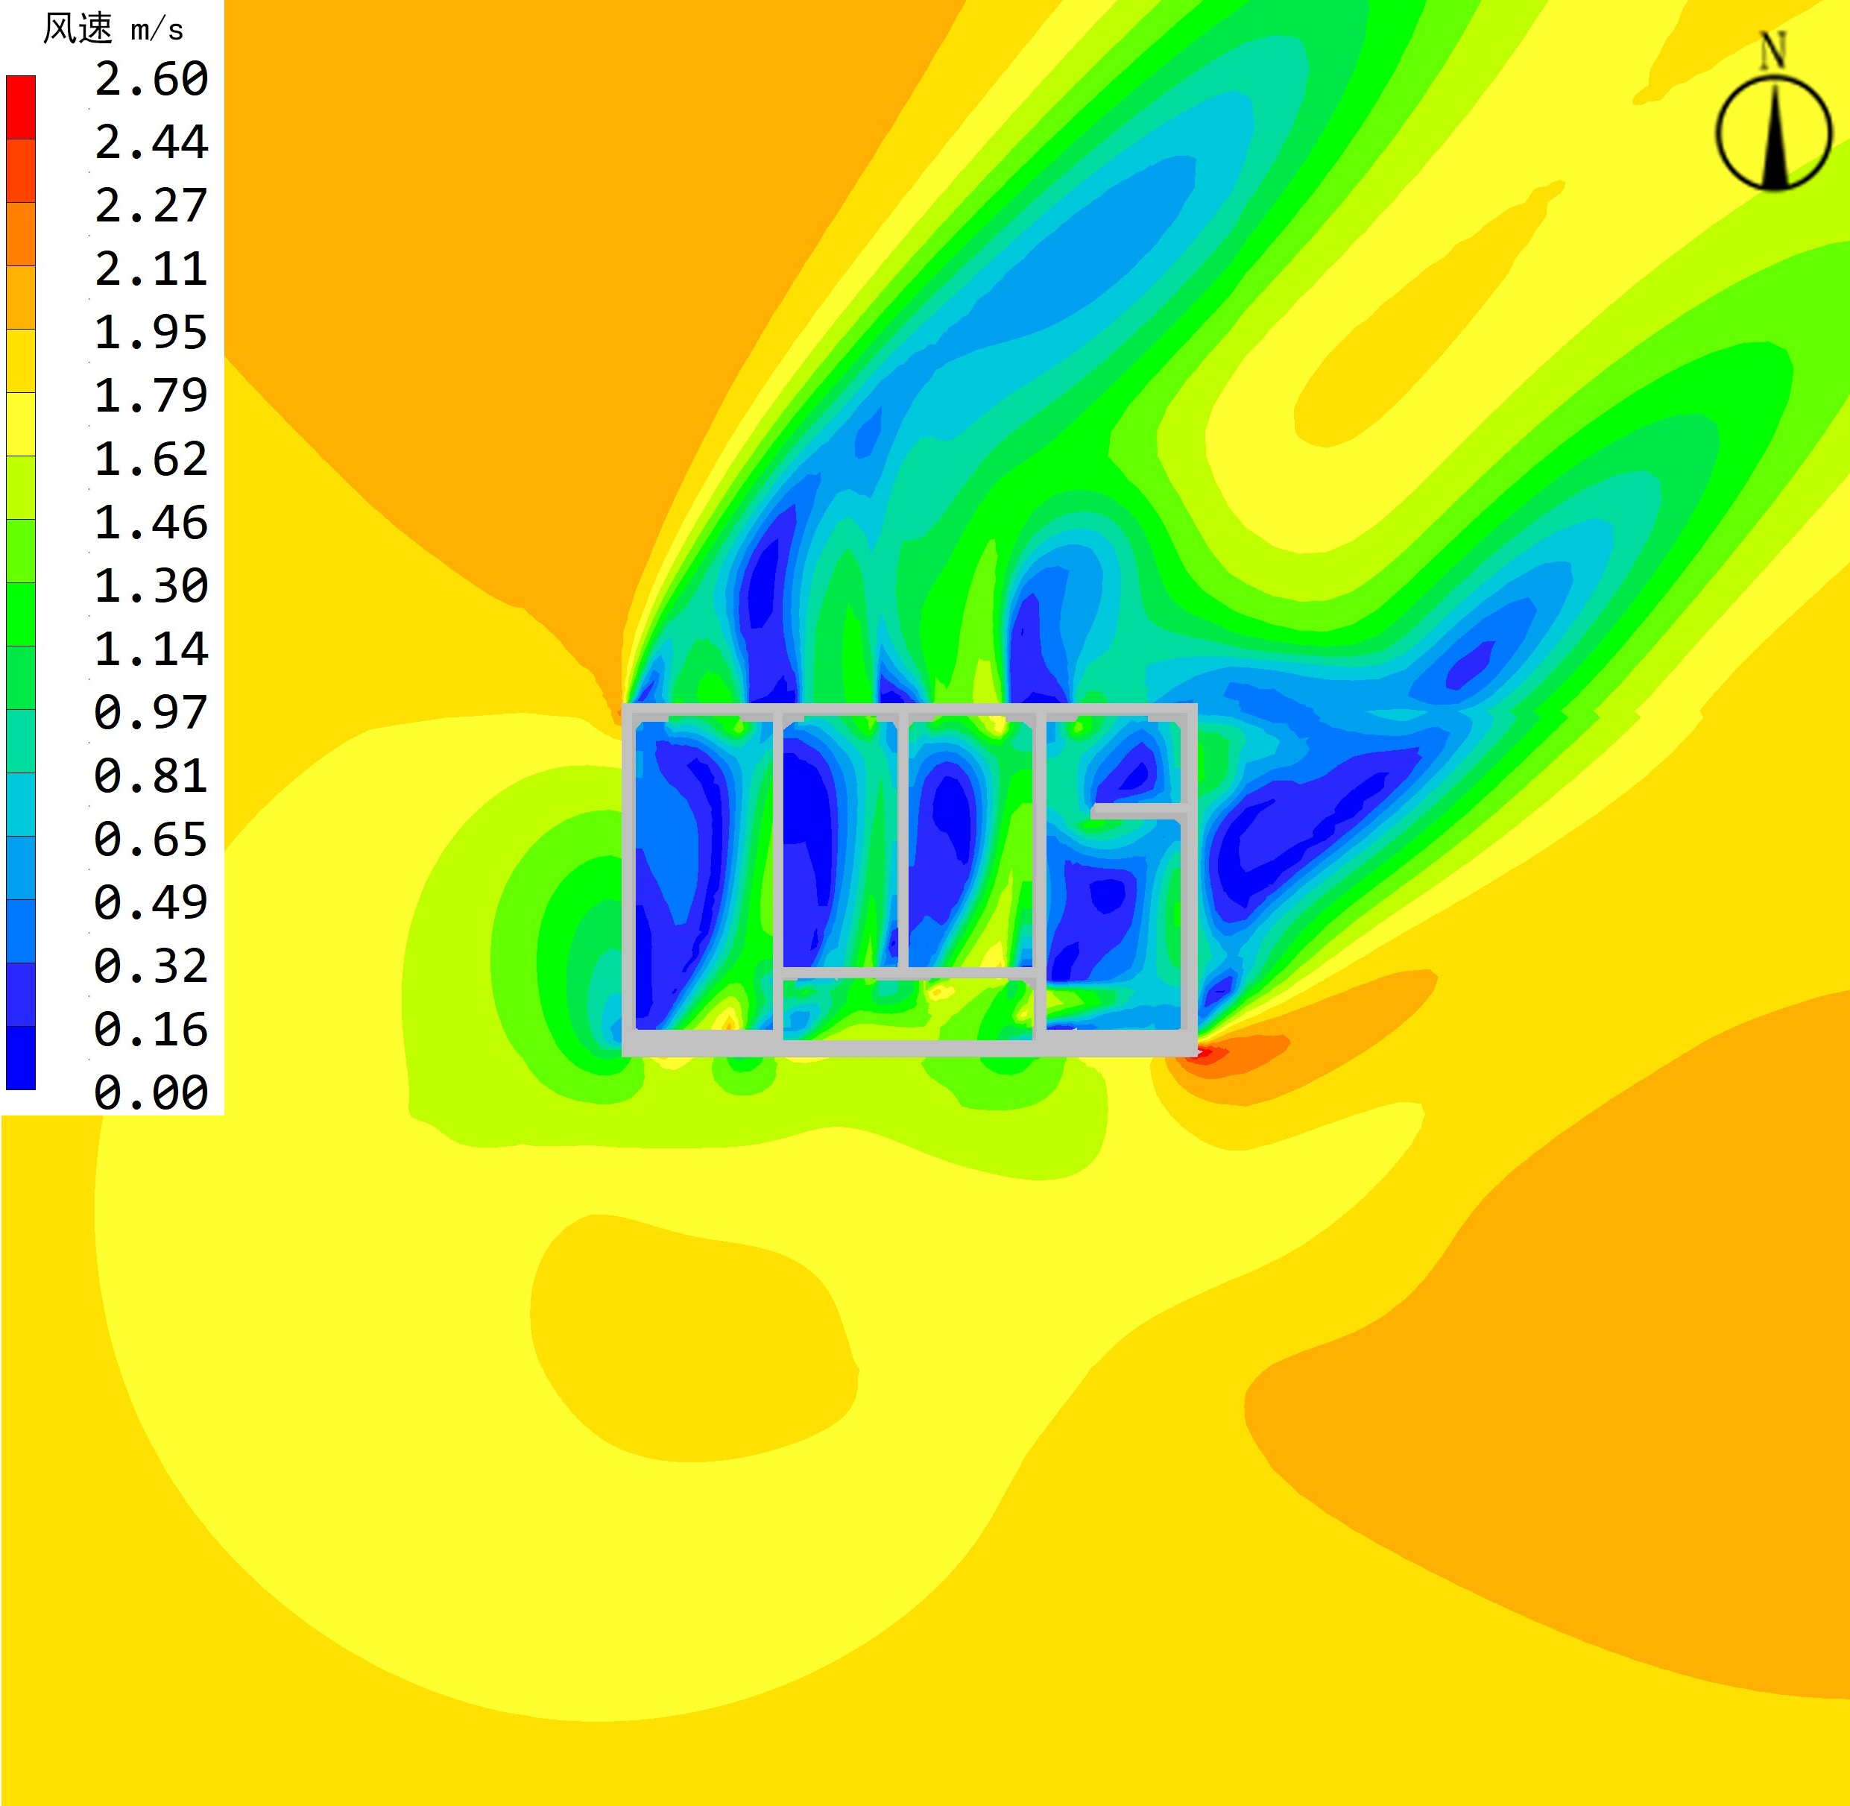
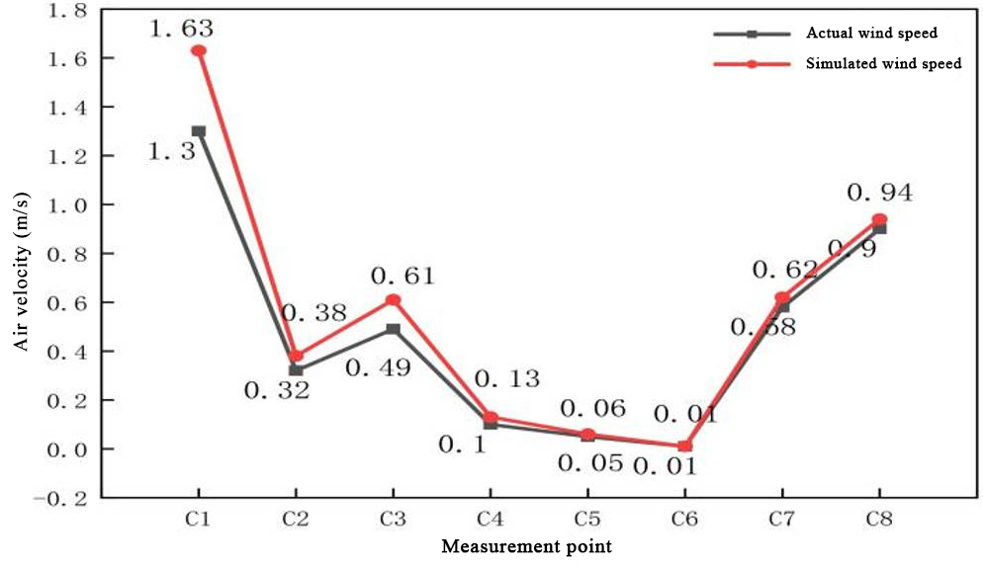
Figure 5. Comparison of measured and simulated wind environment results and fitting degree.
Table 3. Simulation results of wind environment in different courtyard forms under summer working conditions.
 | One Courtyard House | L-Shaped Duplex | Front and Rear Type Duplex | Triple Courtyard House
Outdoor 1.5m wind speed distribution cloud map | 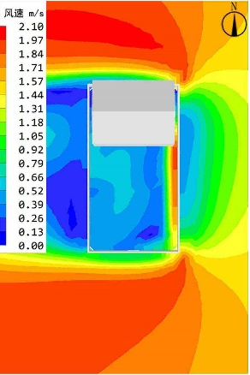 | 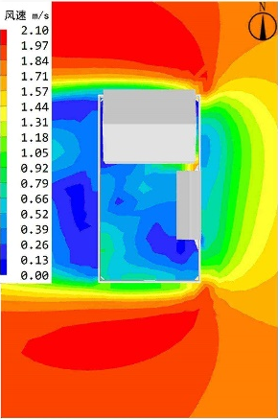 | 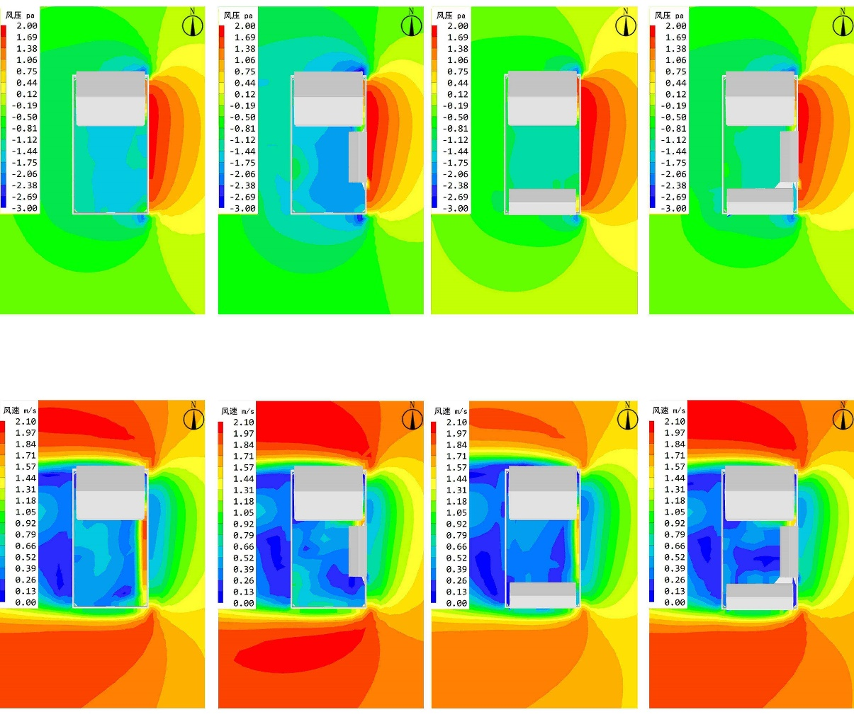
Outdoor 1.5m wind pressure distribution cloud map | 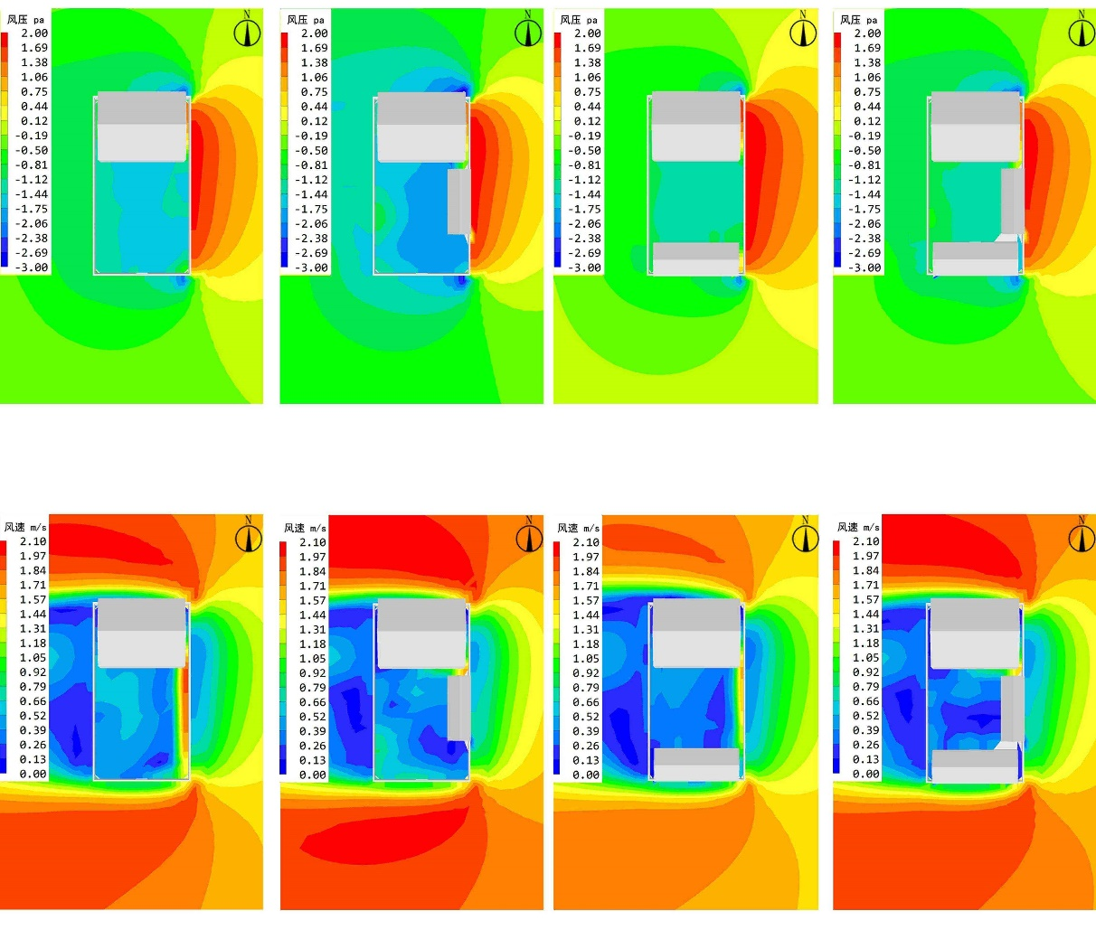 | 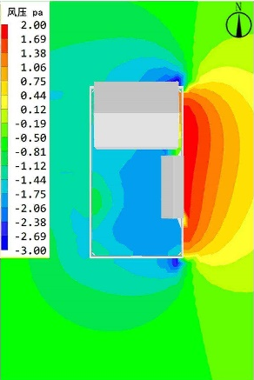
Wind speed range m/s | 0.16-1.64 | 0.04-1.56 | 0.20-1.70 | 0.1-1.56
Average wind speed m/s | 0.69 | 0.7 | 0.72 | 0.55
Comfortable wind speed zone ratio | 13.00% | 8.61% | 11.43% | 6.25%
Quiet Wind Zone Ratio | 85.00% | 86.12% | 88.00% | 92.36%
Range of pressure differences before and after construction (pa) | 0-0.36 | 0-0.28 | 0-0.32 | 0-0.26
Table 4. Simulation results of wind environment in different courtyard forms under winter working conditions.
 | One Courtyard House | L-Shaped Duplex | Front and Rear Type Duplex | Triple Courtyard House
Outdoor 1.5m wind speed distribution cloud map | 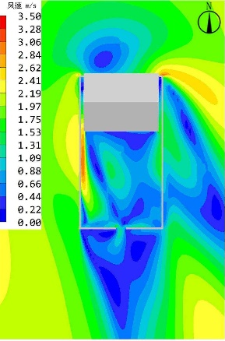 | 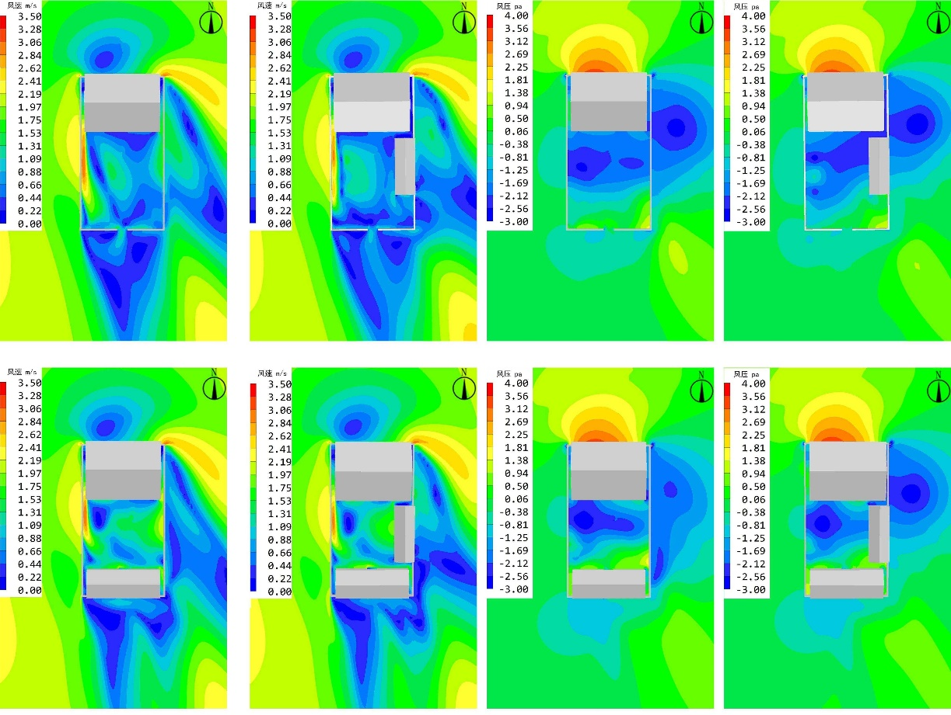 | 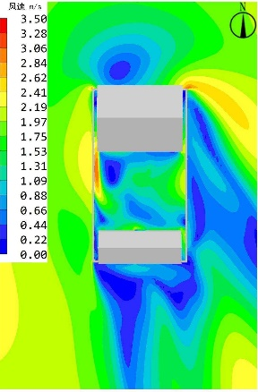 | 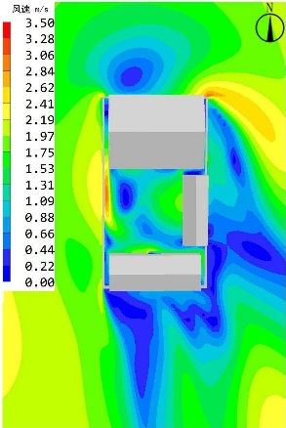
Outdoor 1.5m wind pressure distribution cloud map | 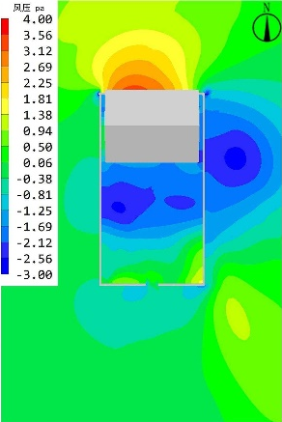 | 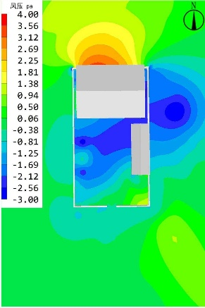 |  | 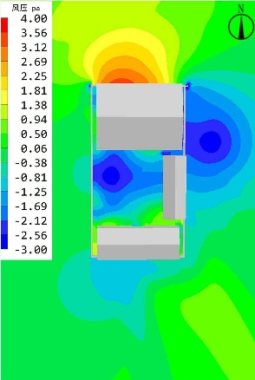
Wind speed range m/s | 0.23-2.82 | 0.03-2.93 | 0.02-2.95 | 0.10-2.93
Average wind speed m/s | 1.52 | 1.07 | 1.56 | 1.29
Comfortable wind speed zone ratio | 34.13% | 44.03% | 35.10% | 42.93%
Quiet Wind Zone Ratio | 15.92% | 5.16% | 13.21% | 5.58%
Range of pressure differences before and after construction (pa) | 0-4.24 | 0-3.93 | 0-4.16 | 0-3.97
Table 5. Simulation results of wind environment at different gate positions of a courtyard under summer working conditions.
 | The gate is on the south side. | The gate is on the southwest side. | The gate is on the southeast side.
Outdoor 1.5m wind speed distribution cloud map | 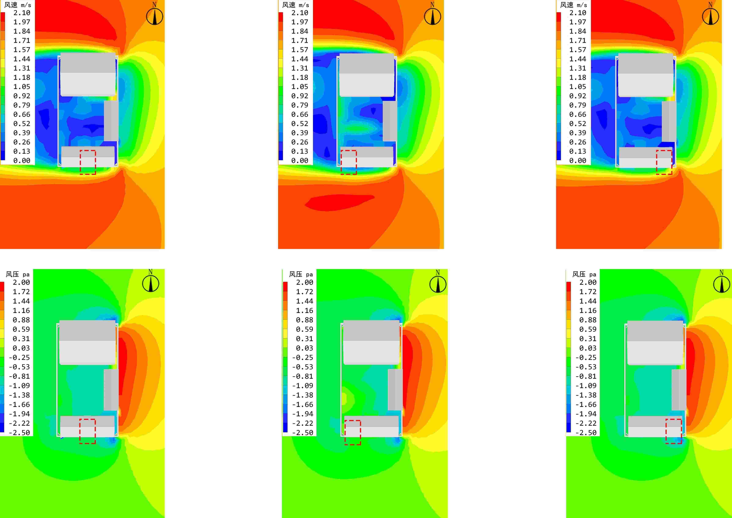 |  | 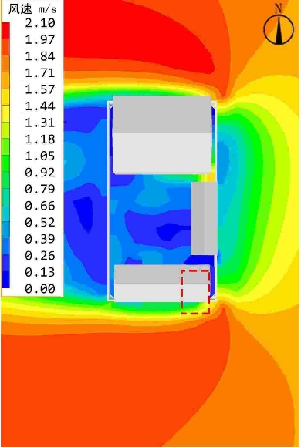
Outdoor 1.5m wind pressure distribution cloud map |  | 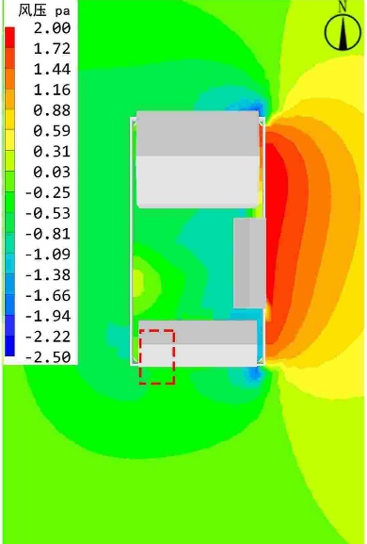
Wind speed range m/s | 0.1-1.56 | 0.06-1.56 | 0.06-1.56
Average wind speed m/s | 0.52 | 0.47 | 0.48
Comfortable wind speed zone ratio | 6.25% | 6.12% | 6.54%
Quiet Wind Zone Ratio | 91.36% | 92.36% | 86.81%
Range of pressure differences before and after construction (pa) | 0-0.23 | 0-0.21 | 0-0.24

Table 6. Simulation results of wind environment at different gate positions of a courtyard under winter working conditions.
 | The gate is on the south side. | The gate is on the southwest side. | The gate is on the southeast side.
Outdoor 1.5m wind speed distribution cloud map | 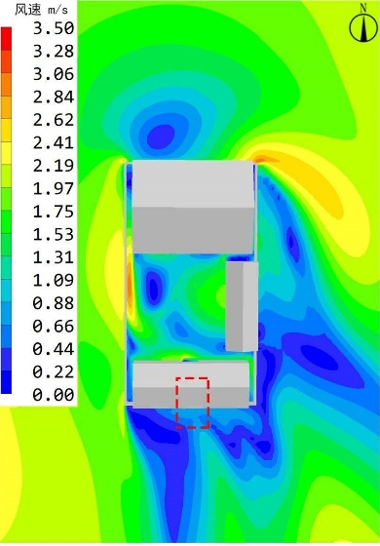 | 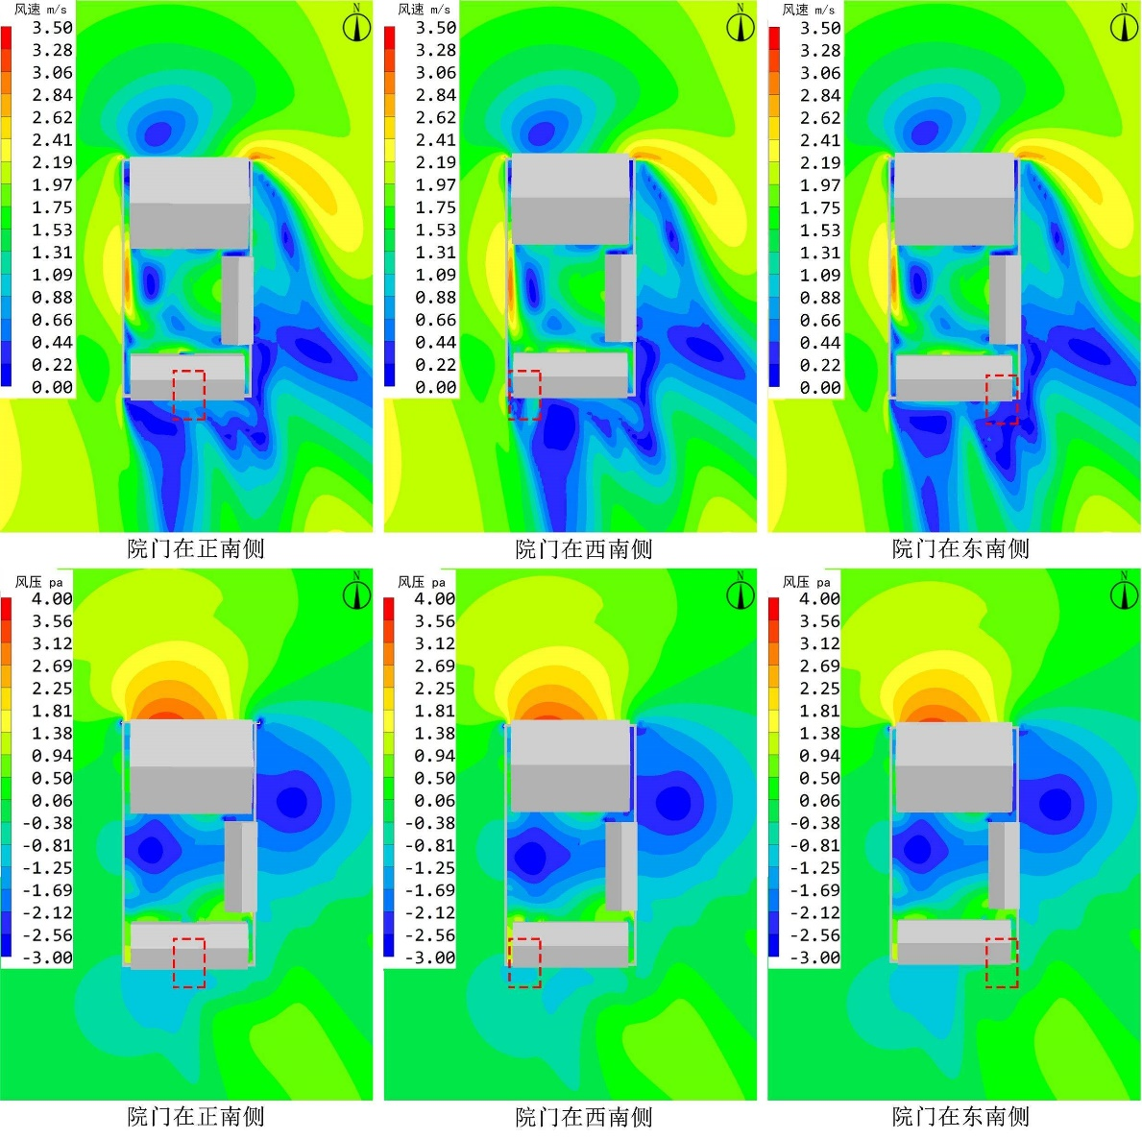 | 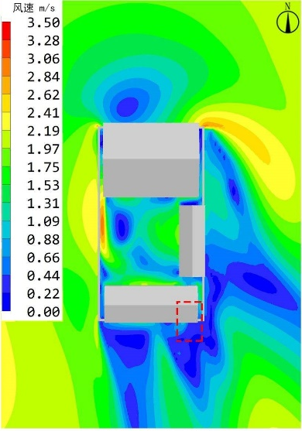
Outdoor 1.5m wind pressure distribution cloud map |  | 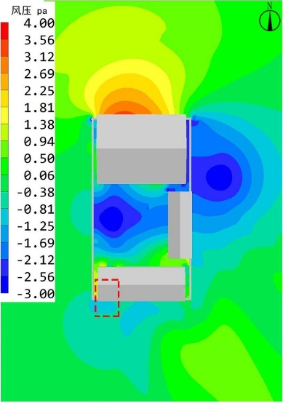 | 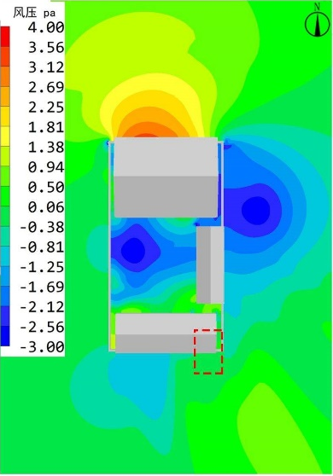
Wind speed range m/s | 0.10-2.93 | 0.23-2.86 | 0.23-2.82
Average wind speed m/s | 1.29 | 1.52 | 1.12
Comfortable wind speed zone ratio | 45.36% | 44.86% | 45.62%
Quiet Wind Zone Ratio | 5.58% | 5.81% | 5.16%
Range of pressure differences before and after construction (pa) | 0-3.97 | 0-4.24 | 0-3.86
Table 7. Simulation results of wind environment with different roof slopes in a courtyard under summer working conditions.
 | Roof slope of 0° | 15° roof slope | 30° roof slope
Outdoor 1.5m wind speed distribution cloud map | 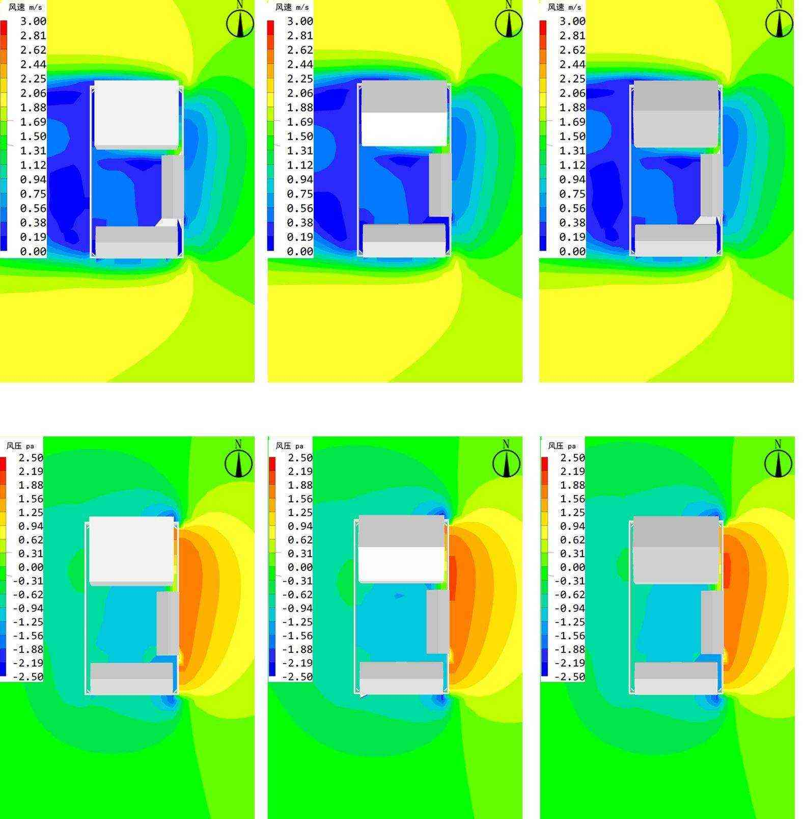
Outdoor 1.5m wind pressure distribution cloud map
Wind speed range m/s | 0.08-1.66 | 0.09-1.64 | 0.07-1.67
Average wind speed m/s | 0.58 | 0.6 | 0.53
Comfortable wind speed zone ratio | 7.64% | 6.94% | 5.56%
Quiet Wind Zone Ratio | 41.67% | 89.58% | 90.28%
Range of pressure differences before and after construction (pa) | 0-0.32 | 0-0.29 | 0-0.26
Table 8. Simulation results of wind environment on different roof slopes of a courtyard under winter working conditions.
 | Roof slope of 0° | 15° roof slope | 30° roof slope
Outdoor 1.5m wind speed distribution cloud map | 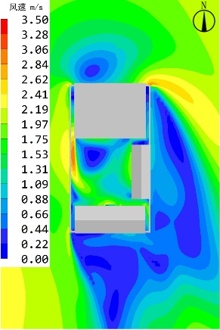 | 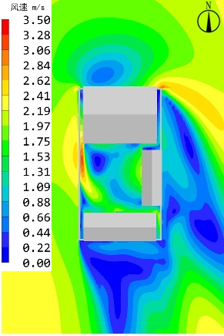 | 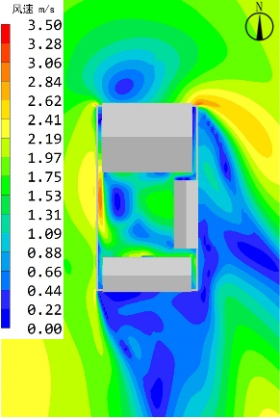
Outdoor 1.5m wind pressure distribution cloud map | 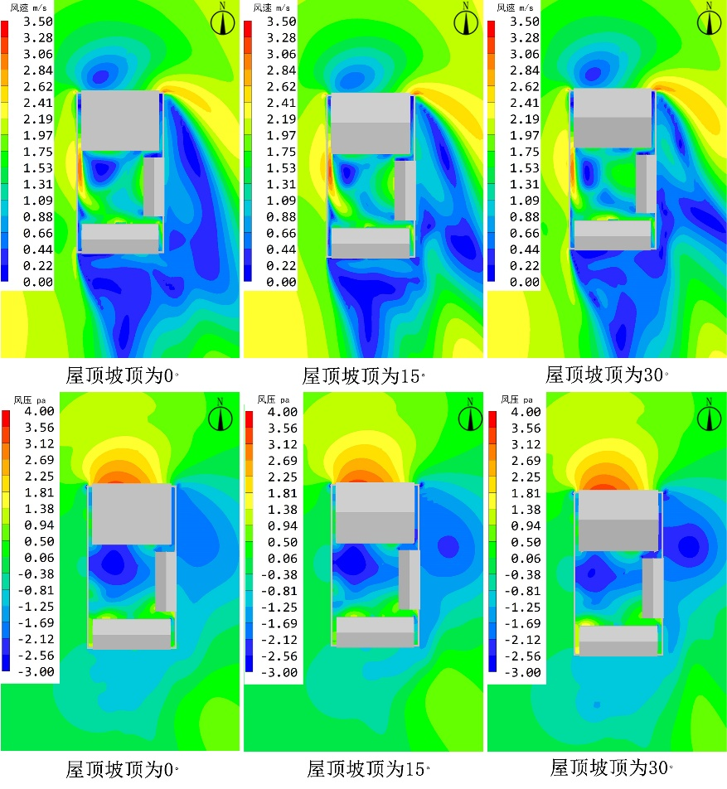
Wind speed range m/s | 0.12-2.81 | 0.12-2.79 | 0.12-2.91
Average wind speed m/s | 1.53 | 1.5 | 1.46
Comfortable wind speed zone ratio | 24.85% | 30.77% | 39.64%
Quiet Wind Zone Ratio | 8.28% | 5.92% | 5.33%
Range of pressure differences before and after construction (pa) | 0-4.12 | 0-4.08 | 0-3.93
Table 9. Simulation results of wind environment at different heights of the three courtyard walls under summer working conditions.
 | Wall height 2m | Wall height 2.25m | Wall height 2.5m
Outdoor 1.5m wind speed distribution cloud map | 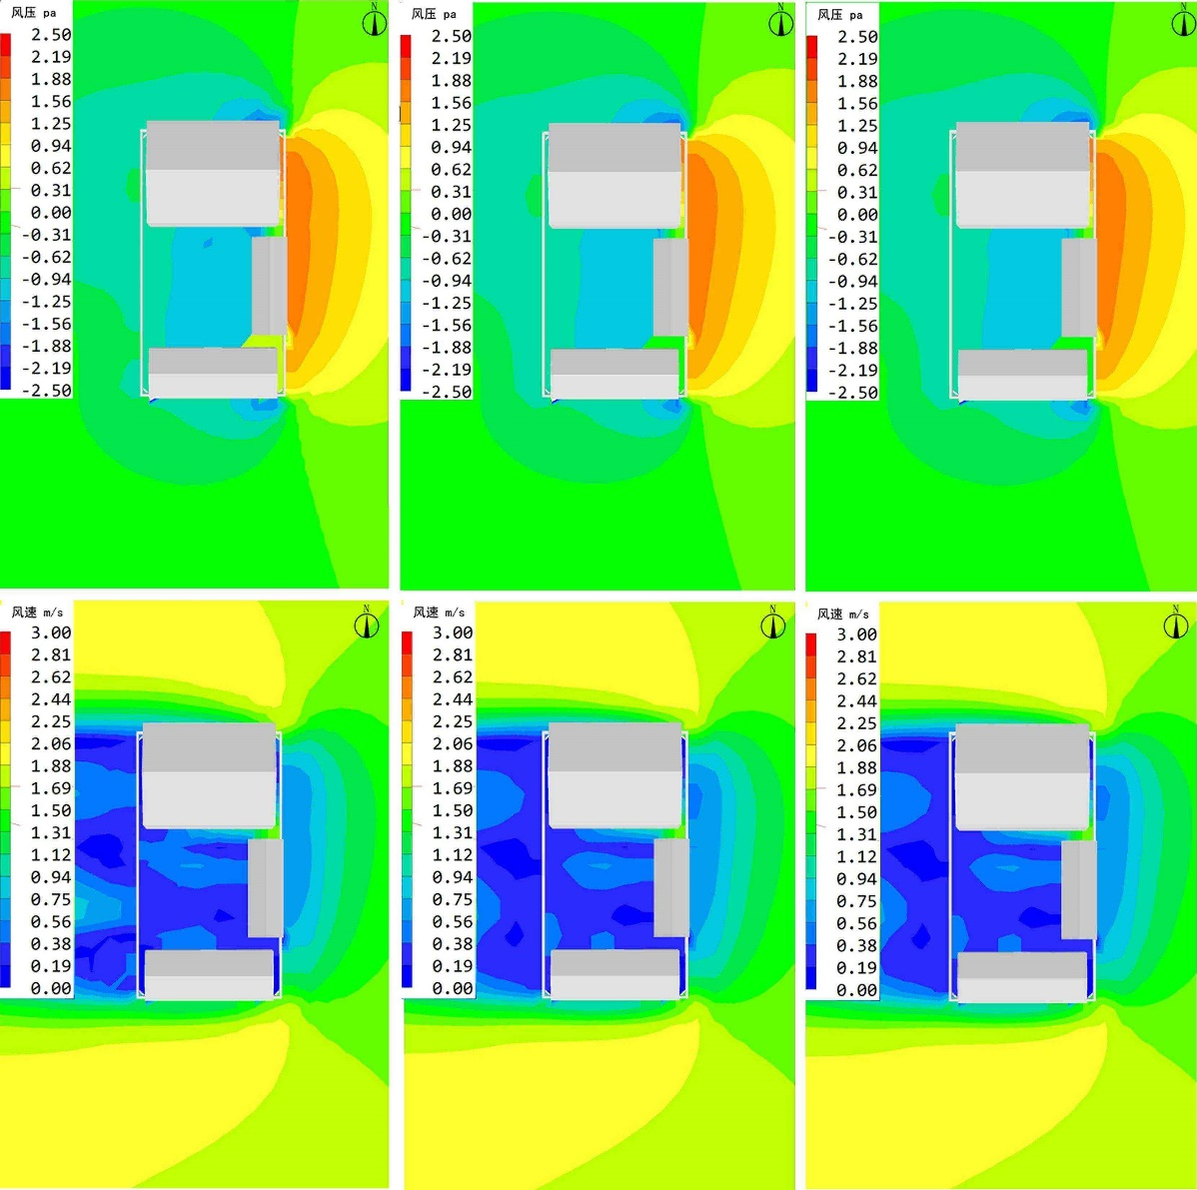 | 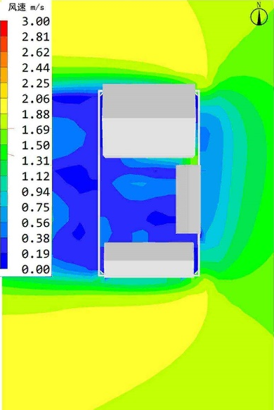 | 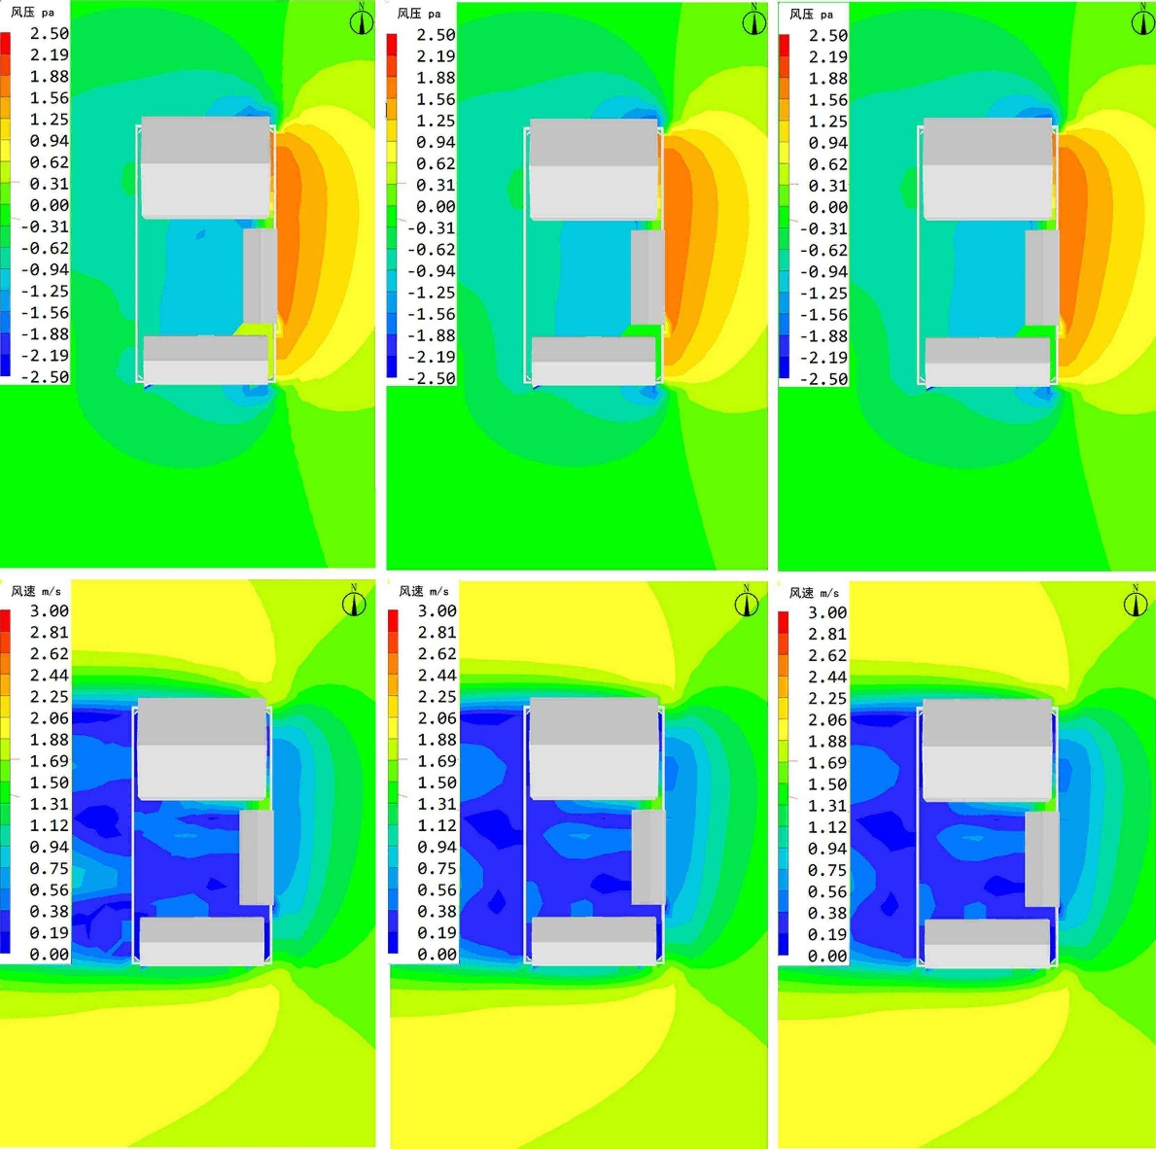
Outdoor 1.5m wind pressure distribution cloud map |  | 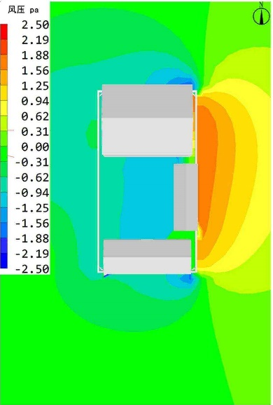
Wind speed range m/s | 0.04-1.67 | 0.09-1.64 | 0.07-1.64
Average wind speed m/s | 0.59 | 0.48 | 0.55
Comfortable wind speed zone ratio | 6.94% | 6.25% | 4.86%
Quiet Wind Zone Ratio | 88.19% | 89.19% | 89.58%
Range of pressure differences before and after construction (pa) | 0-0.31 | 0-0.25 | 0-0.21
Table 10. Simulation results of wind environment at different heights of the three courtyard walls under winter working conditions.
 | Wall height 2m | Wall height 2.25m | Wall height 2.5m
Outdoor 1.5m wind speed distribution cloud map | 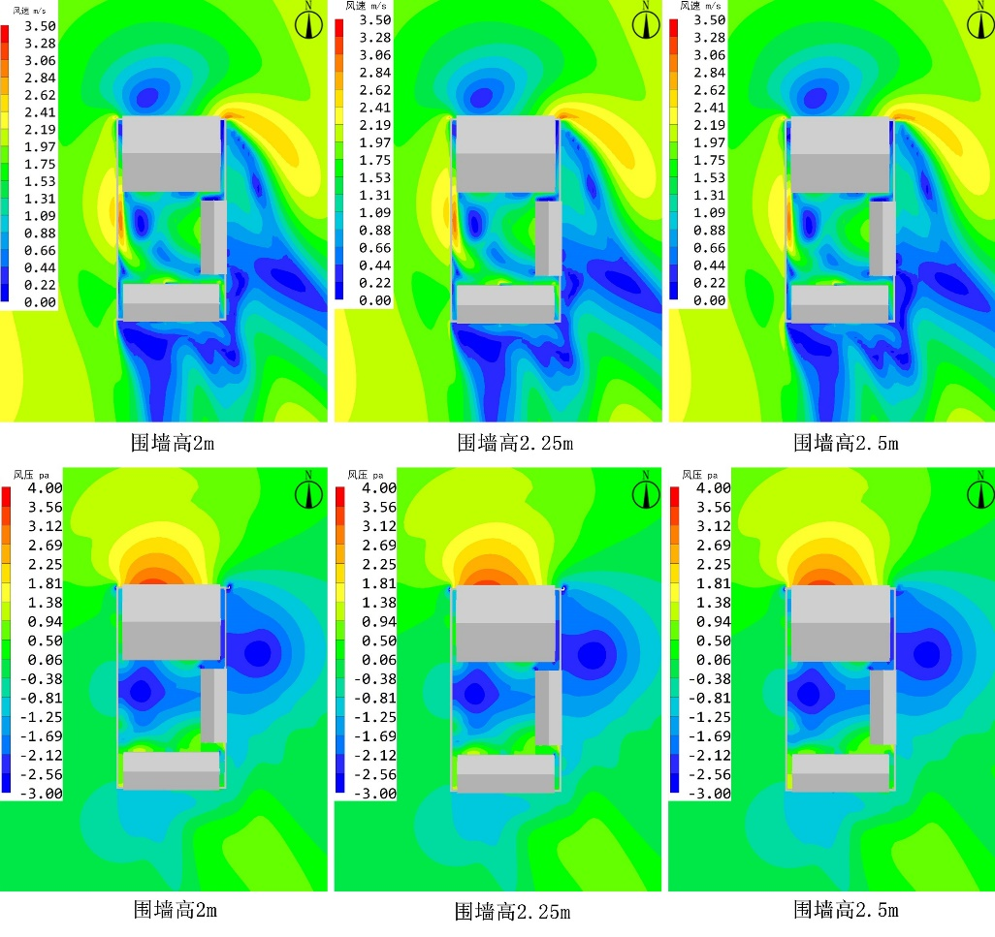
Outdoor 1.5m wind pressure distribution cloud map | 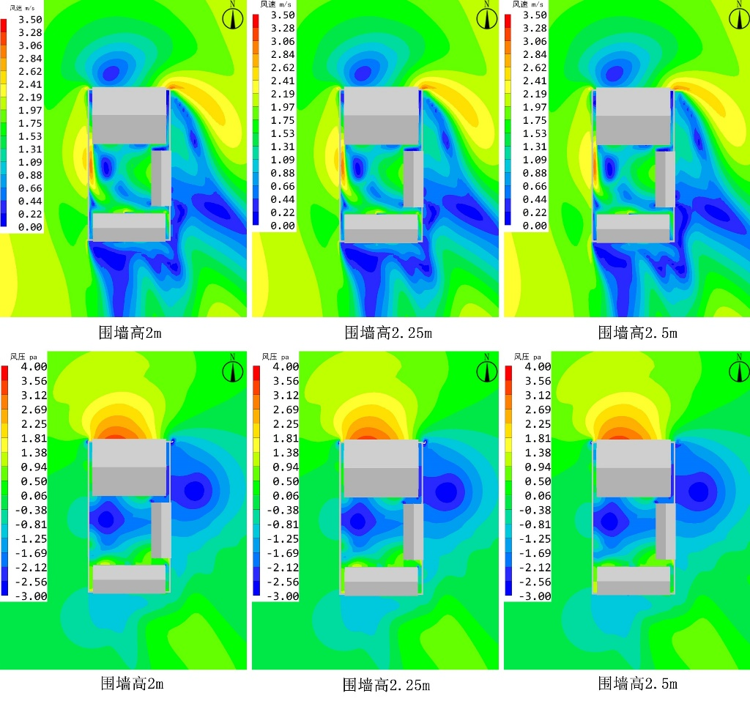
Wind speed range m/s | 0.17-2.95 | 0.17-2.95 | 0.17-2.95
Average wind speed m/s | 0.98 | 0.98 | 0.96
Comfortable wind speed zone ratio | 32.58% | 32.98% | 33.30%
Quiet Wind Zone Ratio | 4.97% | 4.82% | 3.74%
Range of pressure differences before and after construction (pa) | 0-4.18 | 0-4.16 | 0-4.13
Table 11. Simulation Results of Outdoor Wind Environment in Summer for Residential A Renovation.
 | pre-remodeling | after remodeling
Outdoor 1.5m wind speed distribution cloud map | 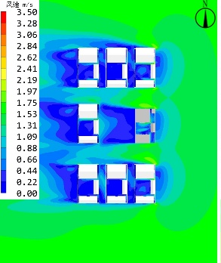 | 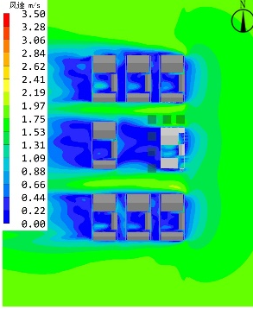
Outdoor 1.5m wind pressure distribution cloud map | 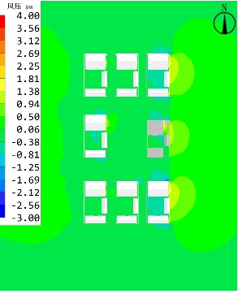 | 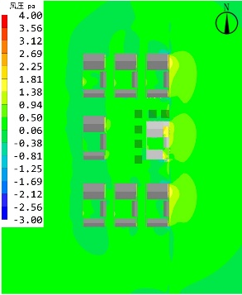
Wind speed range m/s | 0.19-1.54 | 0.16-1.99
Average wind speed m/s | 0.65 | 1.15
Comfortable wind speed zone ratio | 1.05 | 1.09
Quiet Wind Zone Ratio | 73.81% | 80.95%
Range of pressure differences before and after construction (pa) | 26.19% | 19.05%
Wind speed range m/s | 0-0.22 | 0-0.41
Table 12. Simulation Results of Indoor Wind Environment in Summer for Residential A Renovation.
 | First floor before remodeling | First floor after remodeling
Indoor 1.5m wind speed distribution | 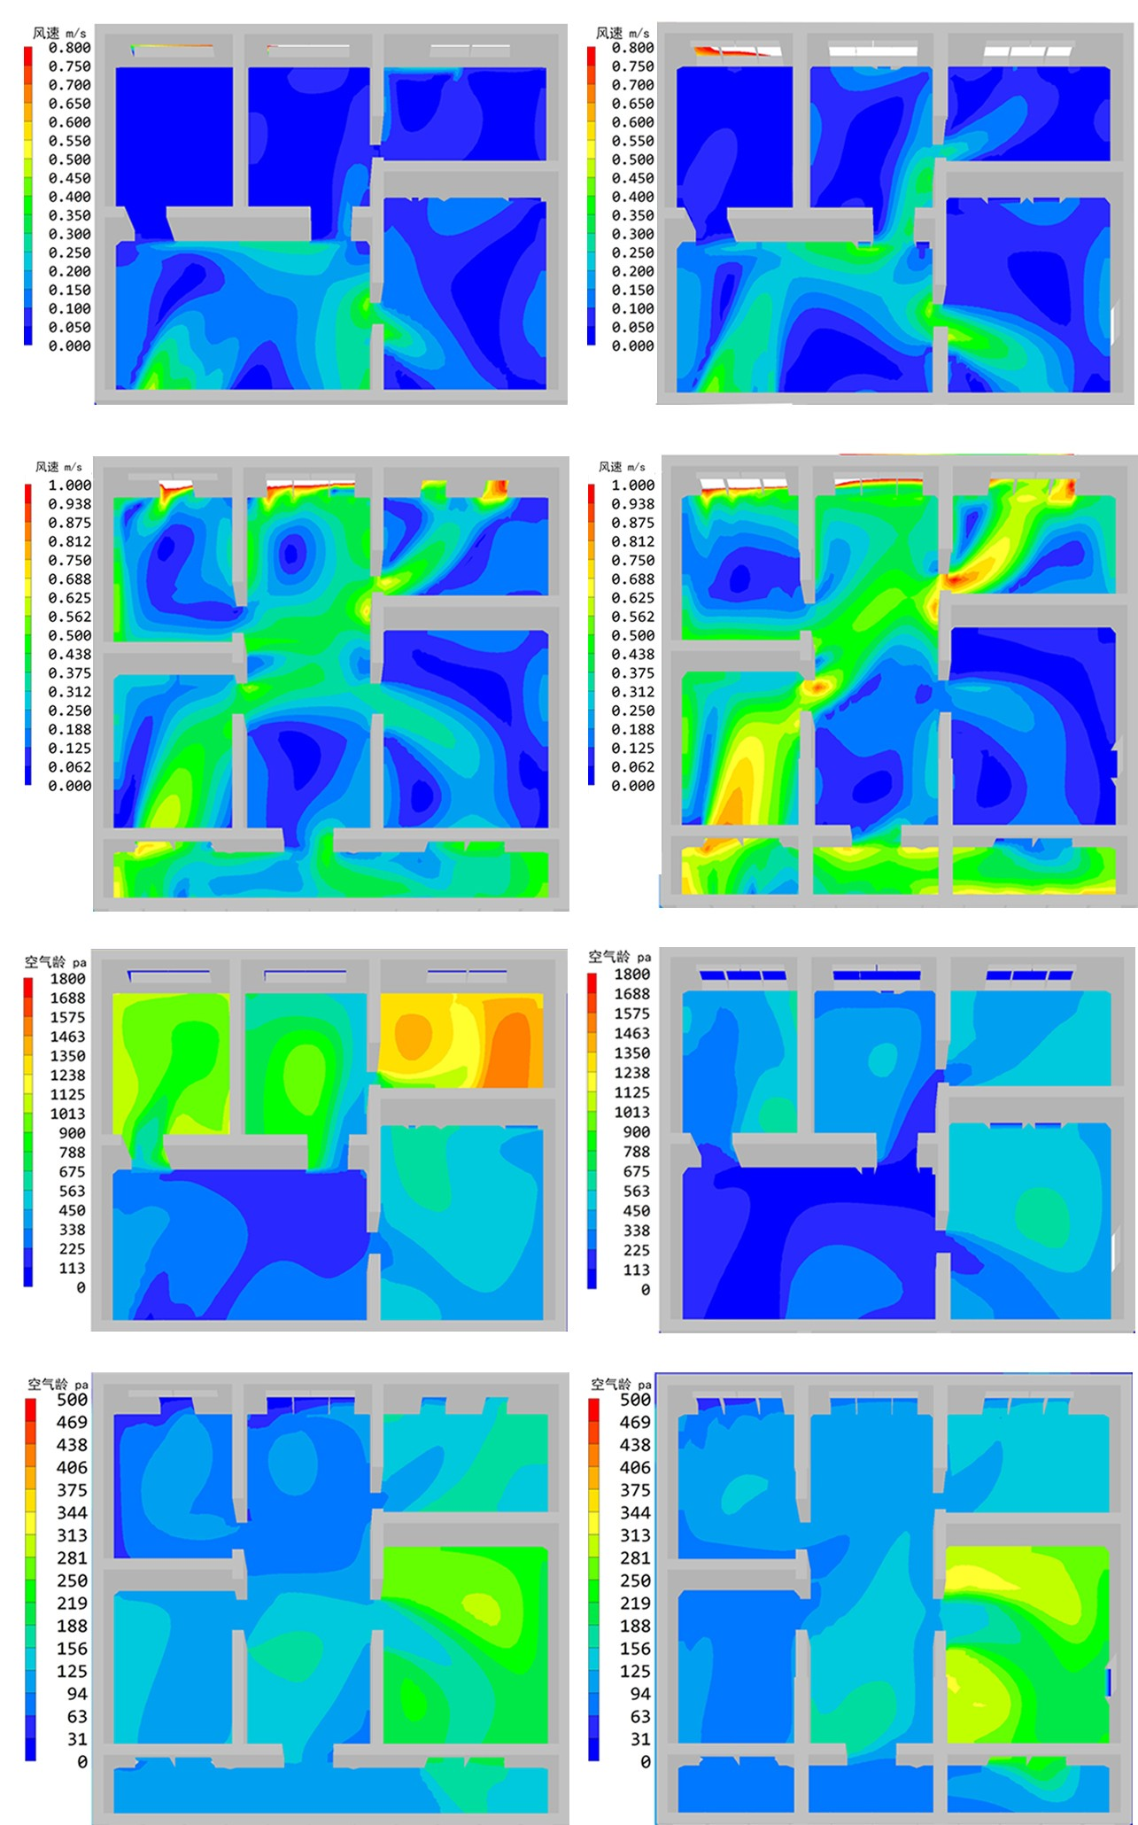
Indoor 1.5m air age distribution
Wind speed range m/s | 0.03-030 | 0.04-0.56
Average wind speed m/s | 0.16 | 0.33
Comfort Wind Speed Zone Ratio | 10.32% | 15.48%
Air age mean (s) | 749 | 336
 | Second floor before remodeling | Second floor after remodeling
Indoor 1.5m wind speed distribution
Indoor 1.5m air age distribution
Wind speed range m/s | 0.09-0.84 | 0.14-0.81
Average wind speed m/s | 0.38 | 0.47
Comfort Wind Speed Zone Ratio | 79.94% | 85.32%
Air age mean (s) | 164 | 152
Table 13. Simulation Results of Outdoor Wind Environment in Winter for Residential A Renovation.
 | pre-remodeling | after remodeling
Outdoor 1.5m wind speed distribution cloud map | 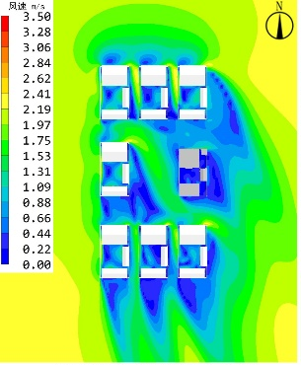 | 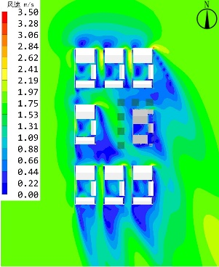
Outdoor 1.5m wind pressure distribution cloud map | 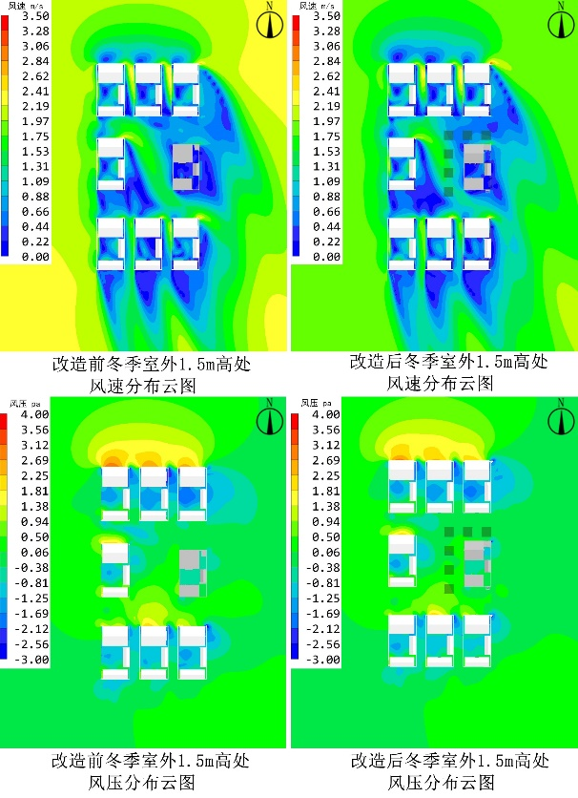
Wind speed range m/s | 0.12-2.25 | 0.11-1.78
Average wind speed m/s | 1.41 | 1.33
Comfortable wind speed zone ratio | 0.46 | 0.52
Quiet Wind Zone Ratio | 11.20% | 33.30%
Range of pressure differences before and after construction (pa) | 88.80% | 66.70%
Wind speed range m/s | 0-0.08 | 0-0.13
Table 14. Simulation Results of Indoor Wind Environment in Winter for Residential A Renovation.
 | First floor before remodeling | First floor after remodeling
Indoor 1.5m wind speed distribution | 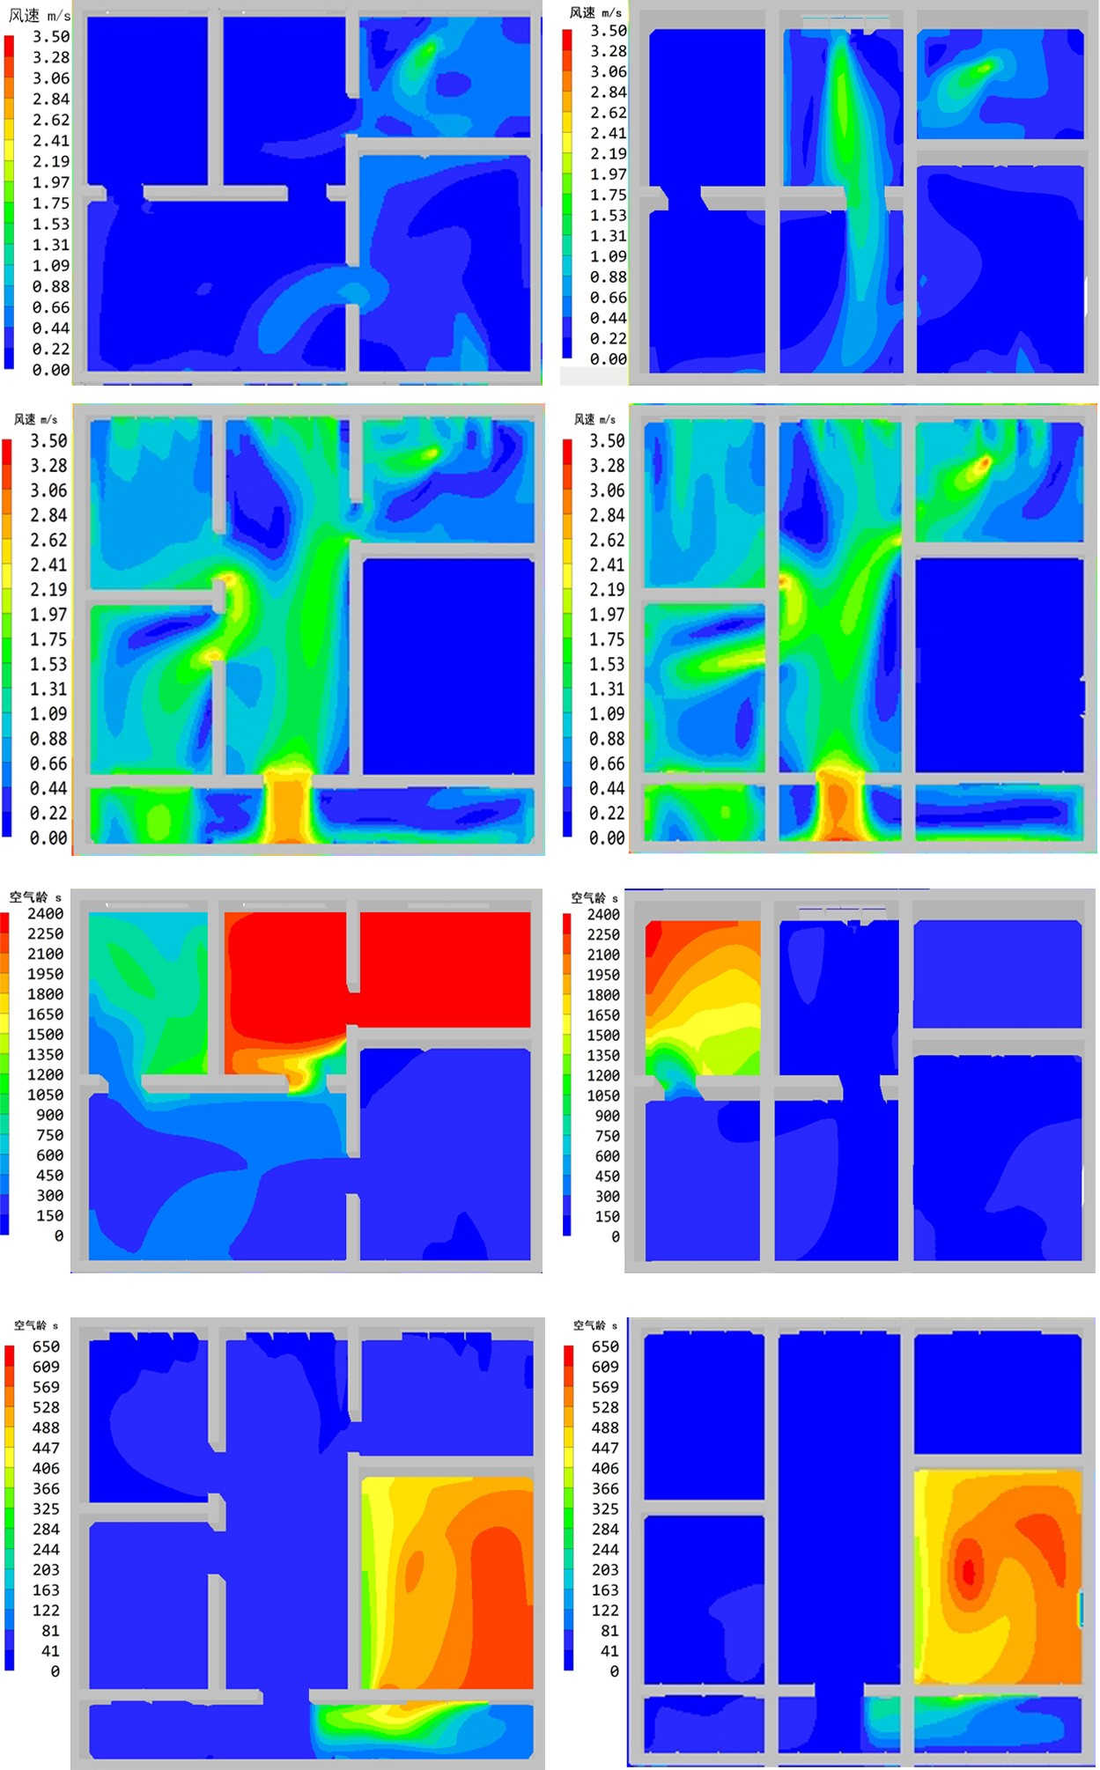
Indoor 1.5m air age distribution
Wind speed range m/s | 0.22-1.69 | 0.11-1.78
Average wind speed m/s | 0.56 | 0.74
Comfort Wind Speed Zone Ratio | 4.32% | 5.86%
Air age mean (s) | 894 | 795
 | Second floor before remodeling | Second floor after remodeling
Indoor 1.5m wind speed distribution
Indoor 1.5m air age distribution
Wind speed range m/s | 0.08-2.78 | 0.04-2.97
Average wind speed m/s | 1.23 | 1.42
Comfort Wind Speed Zone Ratio | 75.14% | 79.62%
Air age mean (s) | 474 | 262

