NPJVACCINES submission- Metavac®-RSV mucosal bivalent vaccine candidate protects cotton rats against RSV and HMPV and its production process in serum-free Vero cells is scalable in 2L bioreactor

List of supplementary figures
Figure S1. Mutations identified in Metavac®-RSV virus produced in up to 6 cell passages on Vero cells
Figure S2. Virus replication and pulmonary inflammation after IN infection
Figure S3. Pulmonary cytokines levels after viral challenge
Figure S4. Metavac®-RSV produced in 2L stirred-tank bioreactor conserve its morphologic property and its replicative capacity in 3D-human airway epithelium

Supplementary figure S1

⁽¹⁾ First position is at the beginning of Metavac®-RSV genome
⁽²⁾ First position is at the beginning of each protein sequence
⁽³⁾ Mean frequency of two independent lineages

Figure S1. Mutations identified in Metavac®-RSV virus produced in up to 6 cell passages on Vero cells.
Six serial passages of Metavac®-RSV (P+1 to P+6) were realized by infection of Vero cells monolayers in 24-well plates at low MOI (10⁻³-10⁻⁴) in fresh infection medium. Viral RNA sequencing was made from samples of supernatant of selected passages P+1, P+4 and P+6. Library preparation was performed from the RNA extracted from samples using the Illumina Stranded Total RNA Prep with Ribo-Zero Plus kit, following the manufacturer's recommendations. The prepared libraries were sequenced on an Illumina NovaSeq platform, using a 2x150 bp paired-end configuration.
Briefly, read trimming was conducted using fastp with the pipeline default parameters, followed by an iterative classification process using Kraken2 (https://genomebiology.biomedcentral.com/articles/10.1186/s13059-019-1891-0) to eliminate potential host and bacterial contamination. The pipeline retained only unclassified reads for further analysis. Trimmed reads were also mapped to the Metavac®-RSV sequence using Bowtie2 (https://www.nature.com/articles/nmeth.1923) to identify anchored reads. These anchored reads were then merged with the unclassified reads to generate a set of cleaned reads. De novo assembly was performed on the cleaned reads using SPAdes (https://currentprotocols.onlinelibrary.wiley.com/doi/abs/10.1002/cpbi.102) in "rnaviral" mode (https://academic.oup.com/gigascience/article/8/9/giz100/5559527?login=false). The resulting contigs were evaluated through reference proteome mapping using miniprot (PMID: 36648328), with the contig showing maximum similarity with the maximum number of proteins being selected for annotation and reorientation as necessary.
Variant analysis was conducted using the nexomis/viral-variant pipeline (version 1.1.1) with default parameters. Cleaned reads were mapped to the Metavac®-RSV sequence reference using BWA-MEM (arXiv:1303.3997v2), followed by duplicate marking using Picard tools (“Picard Toolkit.” 2019. Broad Institute, GitHub Repository. https://broadinstitute.github.io/picard/; Broad Institute). Alignment files underwent local realignment using ABRA2 (PMID: 30649250), and variants were subsequently called using sav_call (https://github.com/nexomis/sav_call). The final variant analysis incorporated sequence-specific annotation and filtering through the "call.py" script from the sav_call project. To ensure high-confidence variants, stringent filtering criteria were applied, with indels below 10% frequency and SNPs below 3% frequency being excluded from the final analysis.

All data sets of RNA sequencing of this study are available in European Nucleotide Archive (ENA - https://www.ebi.ac.uk/ena) under Study Accession number ERA31166782.

Supplementary figure S2

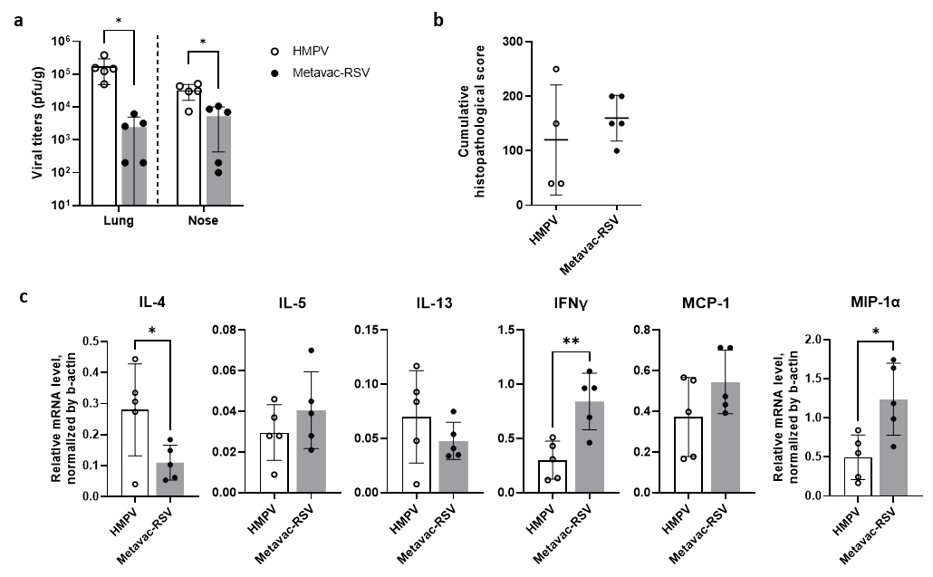

Figure S2. Virus replication and pulmonary inflammation after IN infection.
Nasal tissue and lungs of cotton rats were collected 5 days post infection with 5x10⁵ TCID₅₀ of Metavac®-RSV or 10⁵ PFU of HMPV WT.
(a) Nasal tissue and left section of lungs were collected for viral titration, as described in Materials and Methods. Visible plaques were counted and virus titers were expressed as plaque forming units per gram of tissue. Viral titers were calculated as geometric mean ± SD. *p<0.05 using t-test.
(b) Cumulative histopathology scores were measured in fixed lung tissue stained with H&E. Peribronchiolitis, perivasculitis, interstitial pneumonia, and alveolitis were blindly scored on a 0-4 severity scale. The scores were subsequently converted to a 0 -100% histopathology scale and cumulated for graphical representation.
(c) Cytokine quantification was performed by qPCR from flash frozen lung lingular lobes. Total RNA was extracted from lung homogenate using RNeasy purification kit (Qiagen). One μg of total RNA was used to prepare cDNA using Super Script II RT (Invitrogen) and oligo dT primer (1 μl, Invitrogen). For real-time PCR reactions the Bio-Rad iQTM SYBR Green Supermix were used in a final volume of 25 μl, with final primer concentrations of 0.5 μM. Reactions were set up in duplicates in 96-well trays. Amplifications were performed on a Bio-Rad iCycler for 1 cycle of 95°C for 3 min, followed by 40 cycles of 95°C for 10 seconds (s), 60°C for 10 s, and 72°C for 15 s. The baseline cycles and cycle threshold (Ct) were calculated by the iQ5 software in the PCR Base Line Subtracted Curve Fit mode. Relative quantitation of DNA was applied to all samples. The standard curves were developed using serially-diluted cDNA sample most enriched in the transcript of interest. The Ct values were plotted against log10 cDNA dilution factor. These curves were used to convert the Ct values obtained for different samples to relative expression units. These relative expression units were then normalized to the level of β-actin mRNA (“housekeeping gene”) expressed in the corresponding sample. Results are shown as mean ± SD. *p<0.05, **p<0.01 using t-test.

Supplementary figure S3

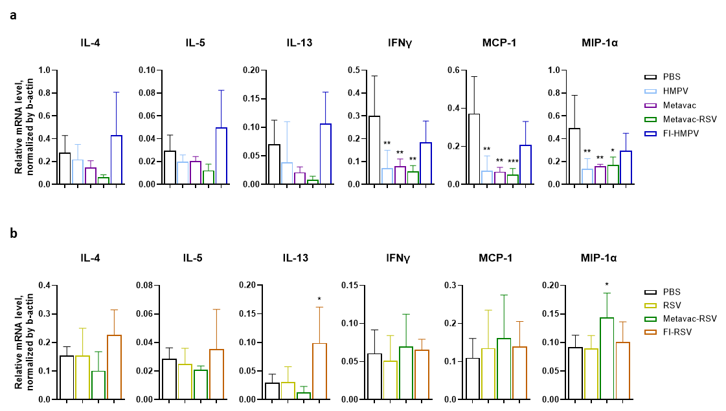

Figure S3. Pulmonary cytokines levels after viral challenge.
Lungs of vaccinated cotton rats were collected 5 days post challenge with HMPV (a) or RSV (b).
Cytokine quantification was performed by qPCR from flash frozen lung lingular lobes. Total RNA was extracted from lung homogenate using RNeasy purification kit (Qiagen). One μg of total RNA was used to prepare cDNA using Super Script II RT (Invitrogen) and oligo dT primer (1 μl, Invitrogen). For real-time PCR reactions the Bio-Rad iQTM SYBR Green Supermix were used in a final volume of 25 μl, with final primer concentrations of 0.5 μM. Reactions were set up in duplicates in 96-well trays. Amplifications were performed on a Bio-Rad iCycler for 1 cycle of 95°C for 3 min, followed by 40 cycles of 95°C for 10 seconds (s), 60°C for 10 s, and 72°C for 15 s. The baseline cycles and cycle threshold (Ct) were calculated by the iQ5 software in the PCR Base Line Subtracted Curve Fit mode. Relative quantitation of DNA was applied to all samples. The standard curves were developed using serially-diluted cDNA sample most enriched in the transcript of interest. The Ct values were plotted against log10 cDNA dilution factor. These curves were used to convert the Ct values obtained for different samples to relative expression units. These relative expression units were then normalized to the level of β-actin mRNA (“housekeeping gene”) expressed in the corresponding sample. Results are shown as mean ± SD. *p<0.05, **p<0.01, ***p<0.001 using 1-way ANOVA and Dunnett post-test.

Supplementary figure S4
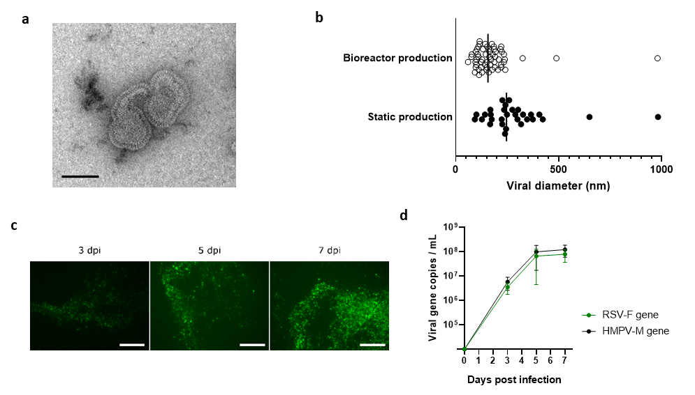
Figure S4. Metavac®-RSV produced in 2L stirred-tank bioreactor conserve its morphologic property and its replicative capacity in 3D-human airway epithelium.
a Transmission electron microscopy image of Metavac®-RSV particles produced in bioreactor, concentrated by ultracentrifugation, resuspended in NaCl (0.9%) and filtered at 0.45 μm. Viral suspensions were adsorbed on 200-mesh nickel grids coated with formvar-C for 10 min at room temperature. Then, grids with suspensions were colored with Uranyless (Delta Microscopies, Mauressac, France) for 1 min and observed on a transmission electron microscope (Jeol 1400 JEM, Tokyo, Japan) equiped with a Gatan camera (Orius 1000) and Digital Micrograph software. Scale bar=100 nm. b Diameter of Metavac®-RSV particles produced in bioreactor or in static 24-well plates was measured on transmission electron microscopy pictures (n=58 for bioreactor production and n=30 for static production).
c-d 3D-reconstituted human airway epithelium derived from primary nasal cells of healthy donors (MucilAir™ purchased from Epithelix, Plan-les-Ouates, Switzerland) were infected by instillation at the apical side of Metavac®-RSV produced in bioreactor at a MOI of 0.1. c Images of the GFP+ infected epithelium were captured using fluorescent microscopy at 3, 5 and 7 dpi (x10 magnification). Scale bar = 250 µm. d Viral RNA was extracted from apical washes harvested at 3, 5, and 7 dpi with the QIAamp® Viral RNA kit (Qiagen, Hilden, Germany). The RNA was reverse-transcribed at 42 °C using SuperScript™ II RT (Invitrogen) with random primers. Amplification of the viral genes was performed by RT-qPCR using Express one-step Supermix, premixed with ROX (ThermoFisher Scientific). HMPV-M gene with forward primer 5′CTGCATCACAAARTGGTC-3′ and reverse primer 5′-GGGAAGTACAGACATTGCT-3; RSV-F gene with forward primer 5′ATCAATCAACATGCAGTGC-3′ and reverse primer 5′CAATTTTACCTTAGCATCTGT-3′. The calibration of HMPV-M and RSV-F copies was assessed by amplification of a standard plasmid. Data are shown as means ± SD and represent experimental triplicates.

