Supplementary material
Biannual coral spawning provides a mechanism for ecosystem resilience in Western Australia
Natalie L. Rosser^{*,1,2}, Jessica A. Benthuysen¹, Carolina Castro-Sanguino¹, Camille M. Grimaldi¹,
1 Australian Institute of Marine Science, Crawley, Western Australia 6009, Australia
2 School of Biological Science, University of Western Australia, Crawley, Western Australia, Australia
*Corresponding author: N.Rosser@aims.gov.au

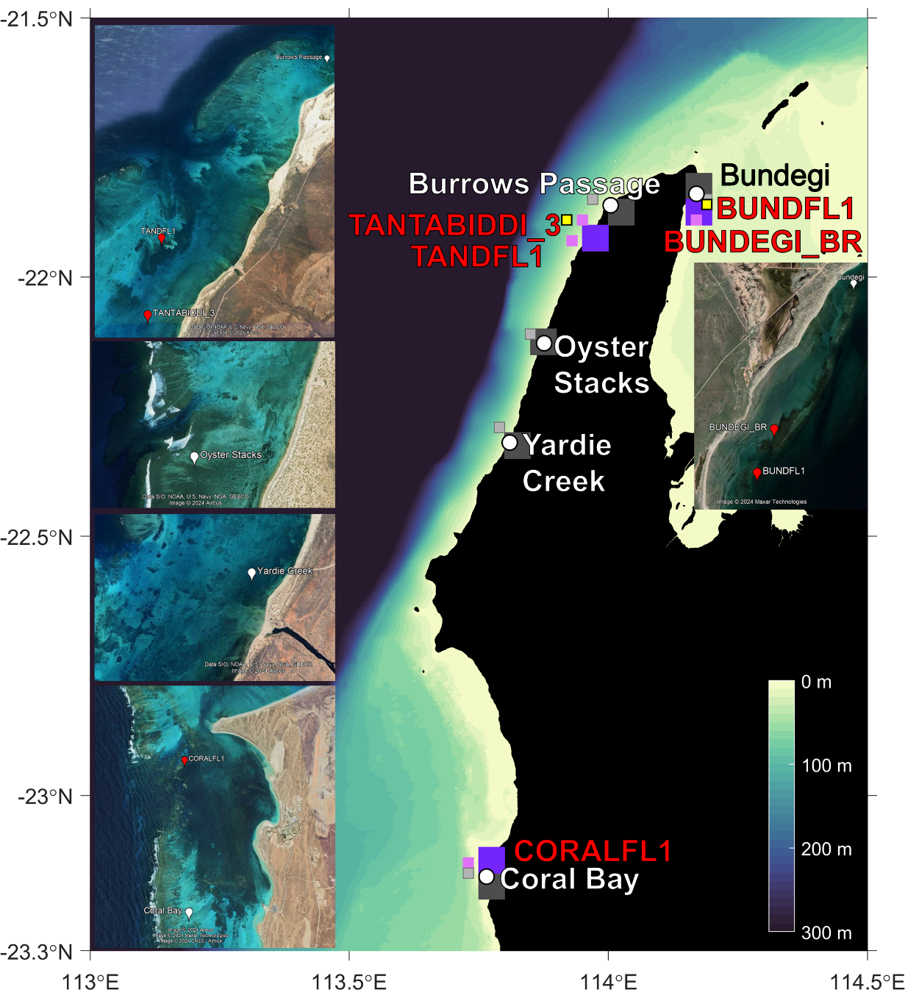
Fig. S1. Map of survey sites (white circle), in situ temperature locations (red circle) from the AIMS temperature database, and wave buoy locations (yellow square). The satellite pixels are shaded by spatial coverage from the ESA CCI SST v3 corresponding to the closest locations to the survey sites (dark grey square) and in situ temperature locations (dark purple square) and IMOS L3SM-1d (night-time) dataset corresponding to the closest locations to the survey (grey square) and in situ temperature locations (light purple square). The bathymetry is shaded with depths deeper than 300 m in dark blue. The inset images are from Google Earth displaying the survey sites and in situ temperature locations. In situ temperature data are collected from BUNDFL1 (3.7 m), BUNDEGI_BR (3 m), TANDFL1 (3.9 m), TANTABIDDI_3 (2 m), and CORALFL1 (4.7 m).

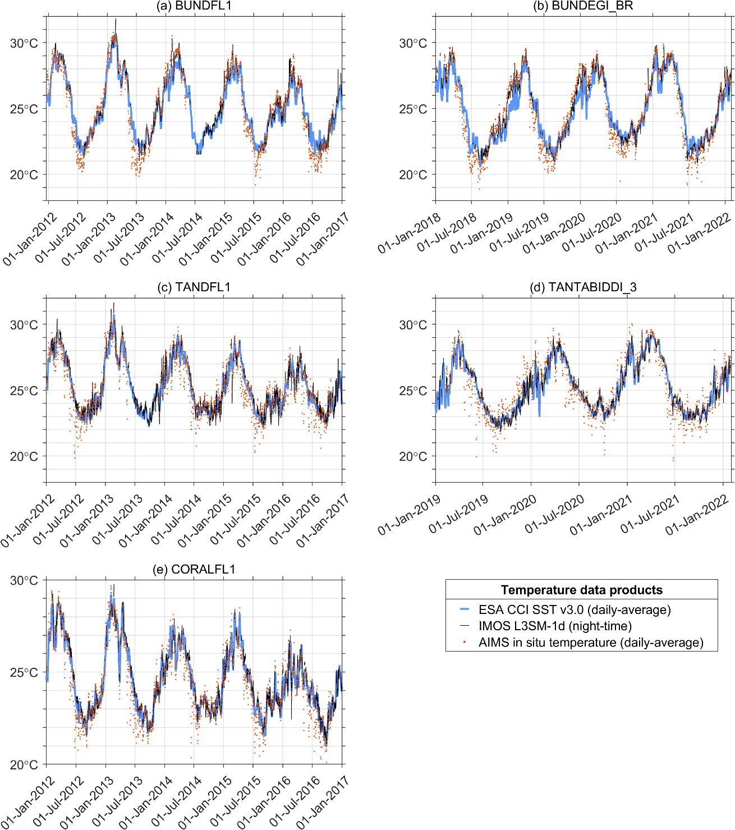
Fig. S2. Comparison of daily-mean in situ temperature (orange dots) with ESA CCI SST v3.0 (0.05° resolution, daily-mean; blue curves) and IMOS L3SM-1d (0.02° resolution, night-time; black curves).

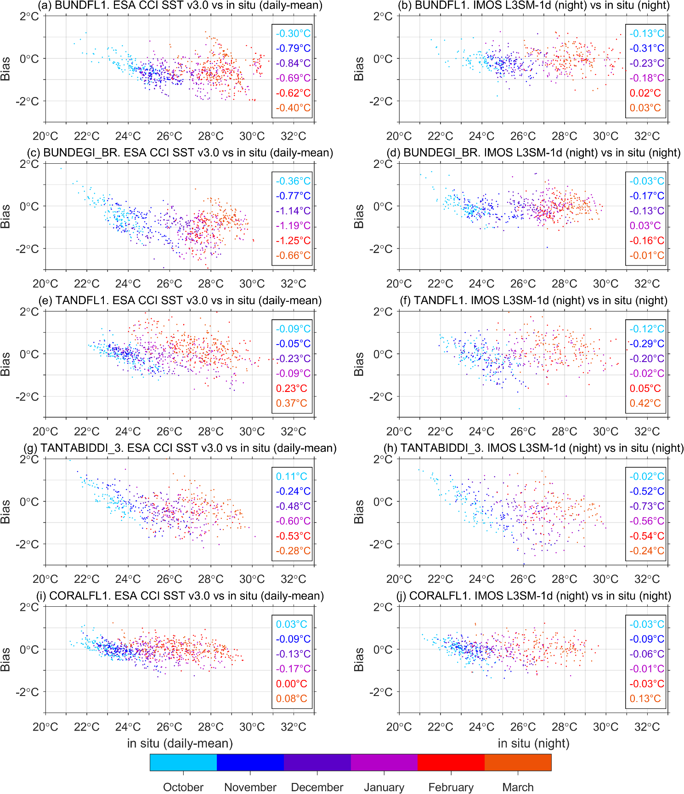
Fig. S3. Temperature bias between daily remotely sensed sea surface temperatures (SSTs) and in situ temperatures, with locations shown in Fig. S1. The bias comparisons are shown for (left column) ESA CCI SST v3.0 and (right column) IMOS L3SM-1d (night). In situ night-time temperatures were selected from the time nearest to the IMOS multi-sensor composite time. The daily values are colored based on the month, and the mean bias is based on all values for each month and shown on the right. A cold bias indicates that the remotely sensed SST at the nearest pixel underestimates the local night-time in situ temperature.

Table S1. Monthly sea surface temperature (SST) for each study site during the spawning period from November to March from remotely sensed observations, based on ESA CCI SST v3.0 (1991-2020) and the SST Atlas of Australian Regional Seas (SSTAARS) climatology (centred on 2005; based on daily night-time L3S SST). The corresponding pixels are shown in Fig. S1.
ESA CCI SST v3.0
Site name | November | December | January | February | March | April
Bundegi | 23.89°C | 24.85°C | 26.07°C | 26.99°C | 27.65°C | 27.53°C
Burrows Passage | 23.83°C | 24.72°C | 25.84°C | 26.85°C | 27.63°C | 27.70°C
Oyster Stacks | 23.63°C | 24.41°C | 25.44°C | 26.39°C | 27.30°C | 27.66°C
Yardie Creek | 23.52°C | 24.27°C | 25.26°C | 26.27°C | 27.11°C | 27.45°C
Coral Bay | 23.10°C | 23.94°C | 24.92°C | 25.83°C | 26.26°C | 26.55°C
SST Atlas of Australian Regional Seas (SSTAARS) climatology
Bundegi | 24.38°C | 25.46°C | 26.62°C | 27.55°C | 27.95°C | 27.36°C
Burrows Passage | 23.89°C | 24.65°C | 25.75°C | 26.92°C | 27.74°C | 27.87°C
Oyster Stacks | 23.76°C | 24.44°C | 25.47°C | 26.69°C | 27.53°C | 27.69°C
Yardie Creek | 23.53°C | 24.27°C | 25.40°C | 26.64°C | 27.38°C | 27.53°C
Coral Bay | 23.15°C | 24.00°C | 25.12°C | 26.09°C | 26.57°C | 26.66°C

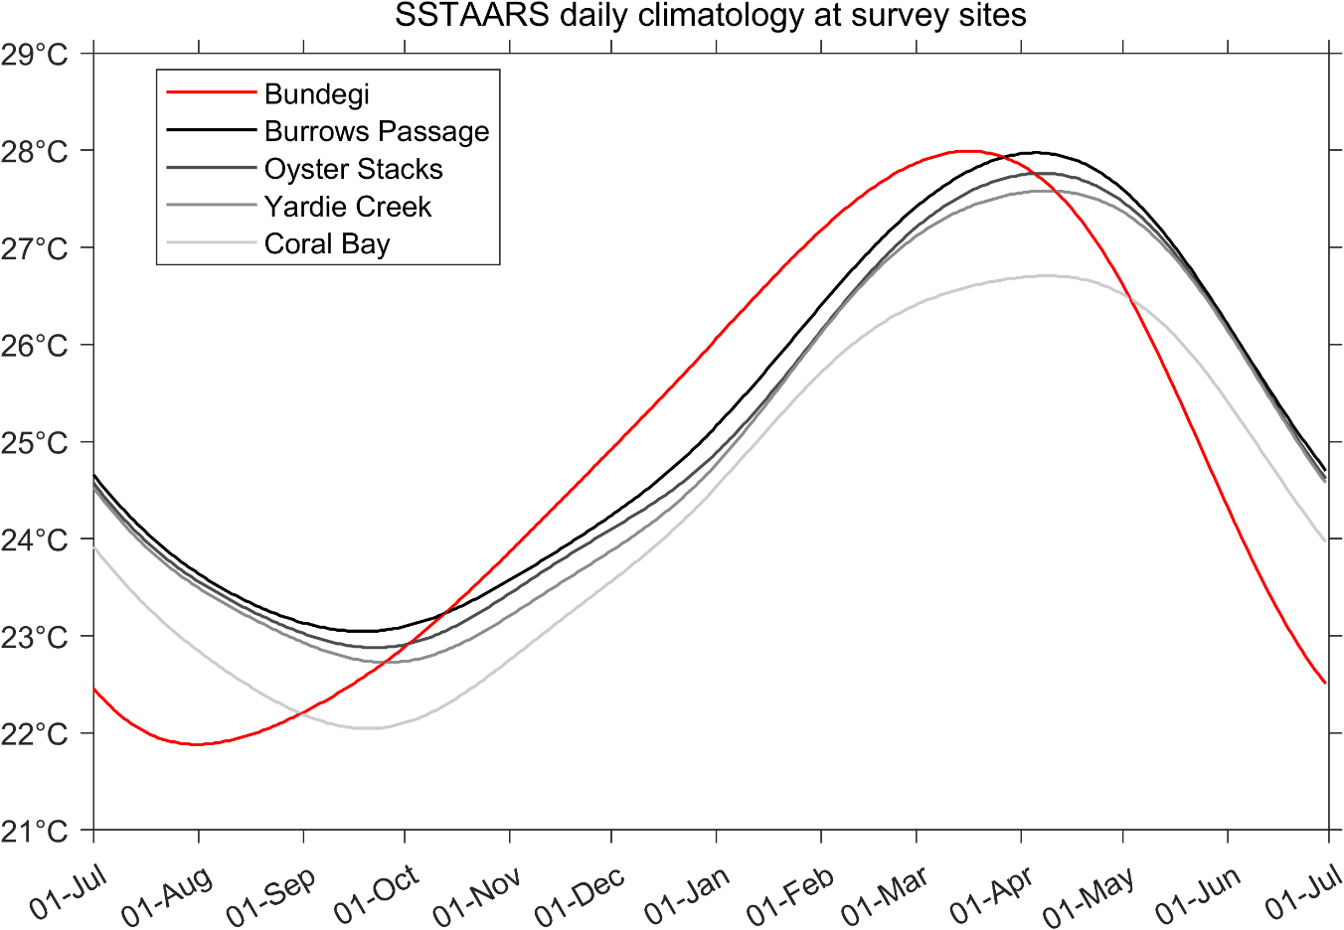
Fig. S4. Daily sea surface temperature from the SST Atlas of Australian Regional Seas (SSTAARS) climatology (centred on 2005; based on daily night-time L3S SST). The corresponding pixels are shown in Fig. S1.
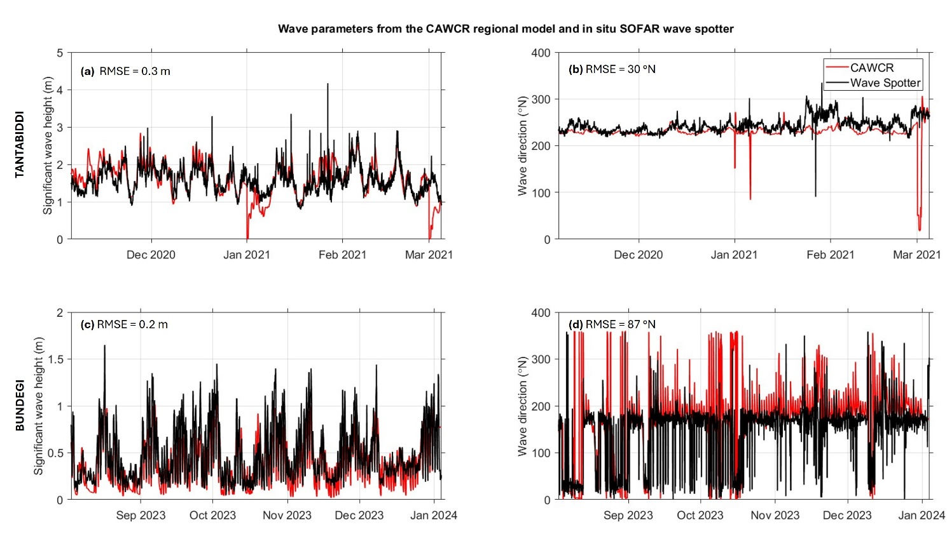Fig. S5. Comparison of hourly in situ wave measurements from wave spotter buoys and Centre for Australian Weather and Climate Research (CAWCR) wave hindcast for (a, c) significant wave height and (b and d) wave direction at (a,b) Tantabiddi (113.92°E, -21.89°N) and (c,d) Bundegi (114.19°E, -21.86°N). Root mean square error (RMSE) are shown for each site and parameters.
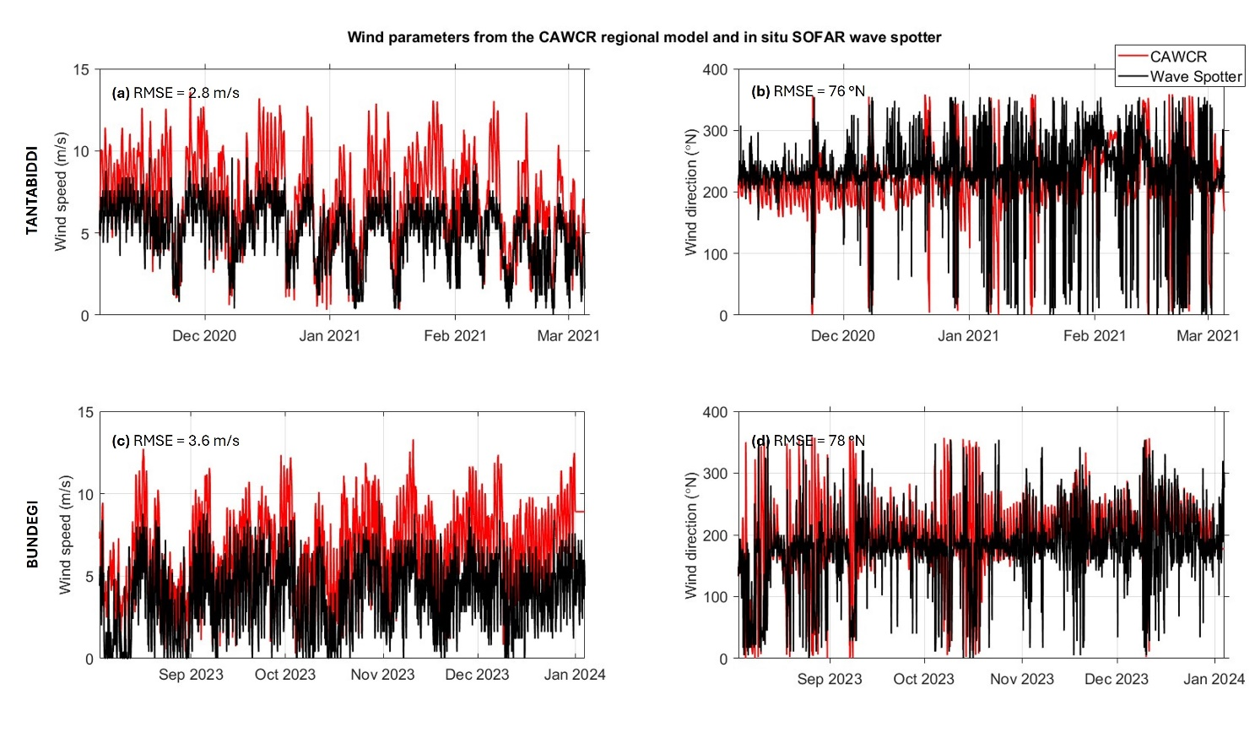Fig. S6. Comparison of hourly derived winds parameters from wave spotter buoys and Centre for Australian Weather and Climate Research (CAWCR) wave hindcast for (a and c) wind speed and (b and d) direction at (a,b) Tantabiddi (113.92°E, -21.89°N) and (c,d) Bundegi (114.19°E, -21.86°N). Root Mean Square Error (RMSE) are shown for each site and parameters.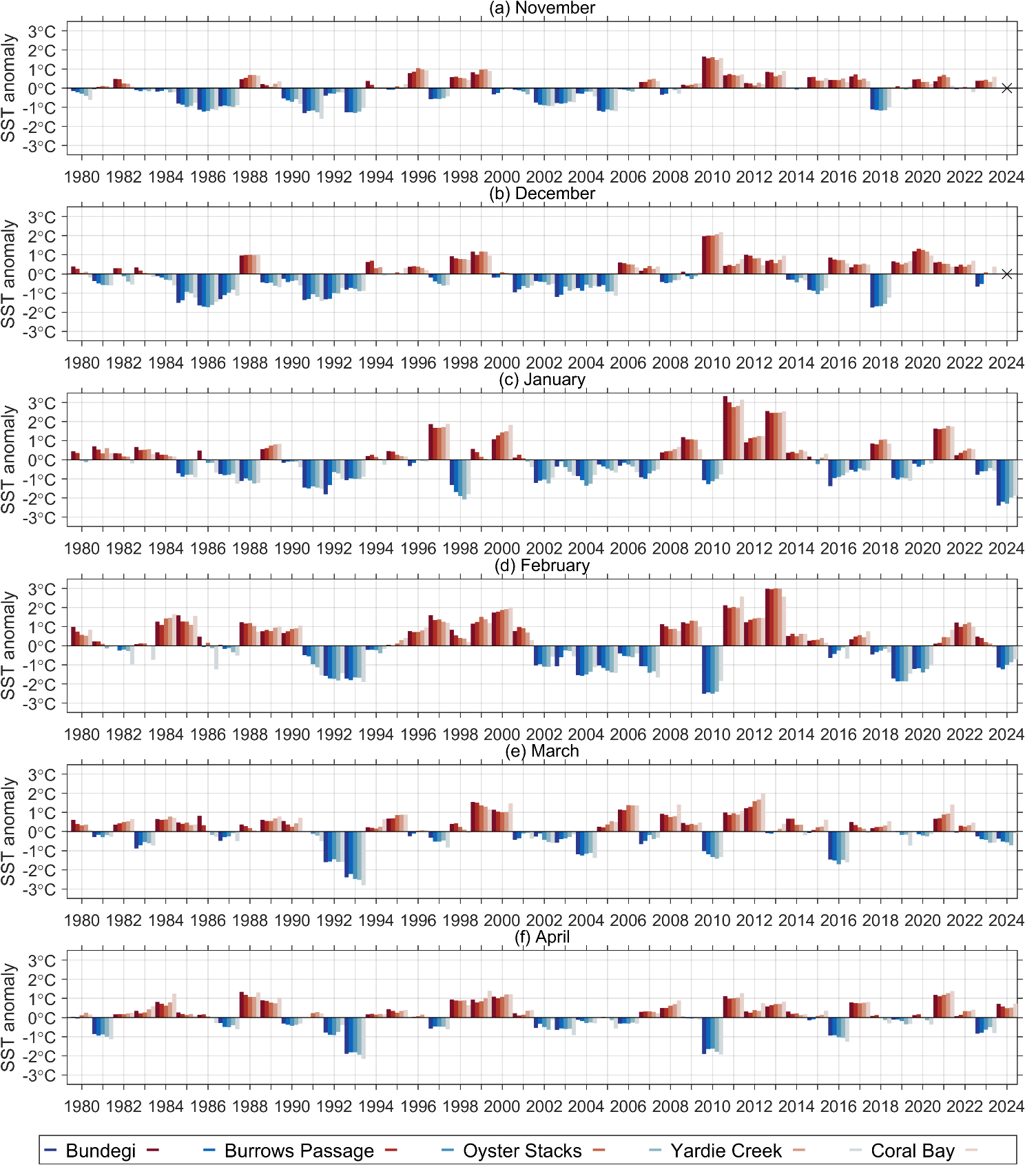Fig. S7. Monthly sea surface temperature (SST) anomalies for each of the study sites encompassing the spawning periods, from late-spring (November) to autumn (April). The SST anomalies are based on ESA CCI SST v3.0 with respect to a 1991-2020 reference period and shaded by each study site as indicated in the legend by blue (cool anomalies) and red (warm anomalies). The black crosses in (a,b) indicates no data available at the time of analysis.

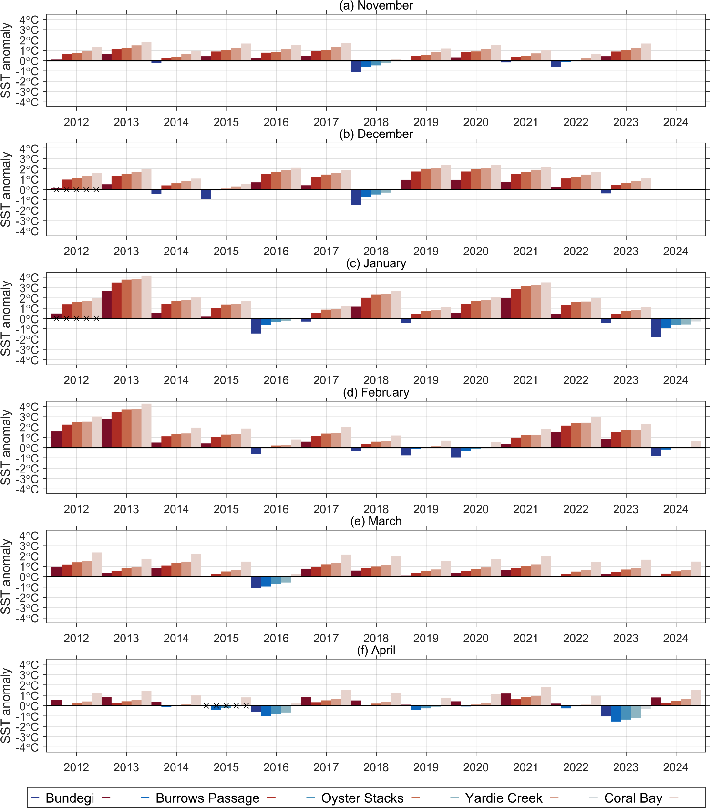
Fig. S8. Monthly sea surface temperature (SST) anomalies for each of the study sites encompassing the spawning periods, from late-spring (November) to autumn (April). The SST anomalies are based on IMOS L3SM-1d (night-time) with respect to the SST Atlas of Australian Regional Seas (SSTAARS) climatology (centred on 2005) and shaded by each study site as indicated in blue (cool anomalies) and red (warm anomalies). Monthly SST anomalies denoted by × are based on less than 10 days of observations.
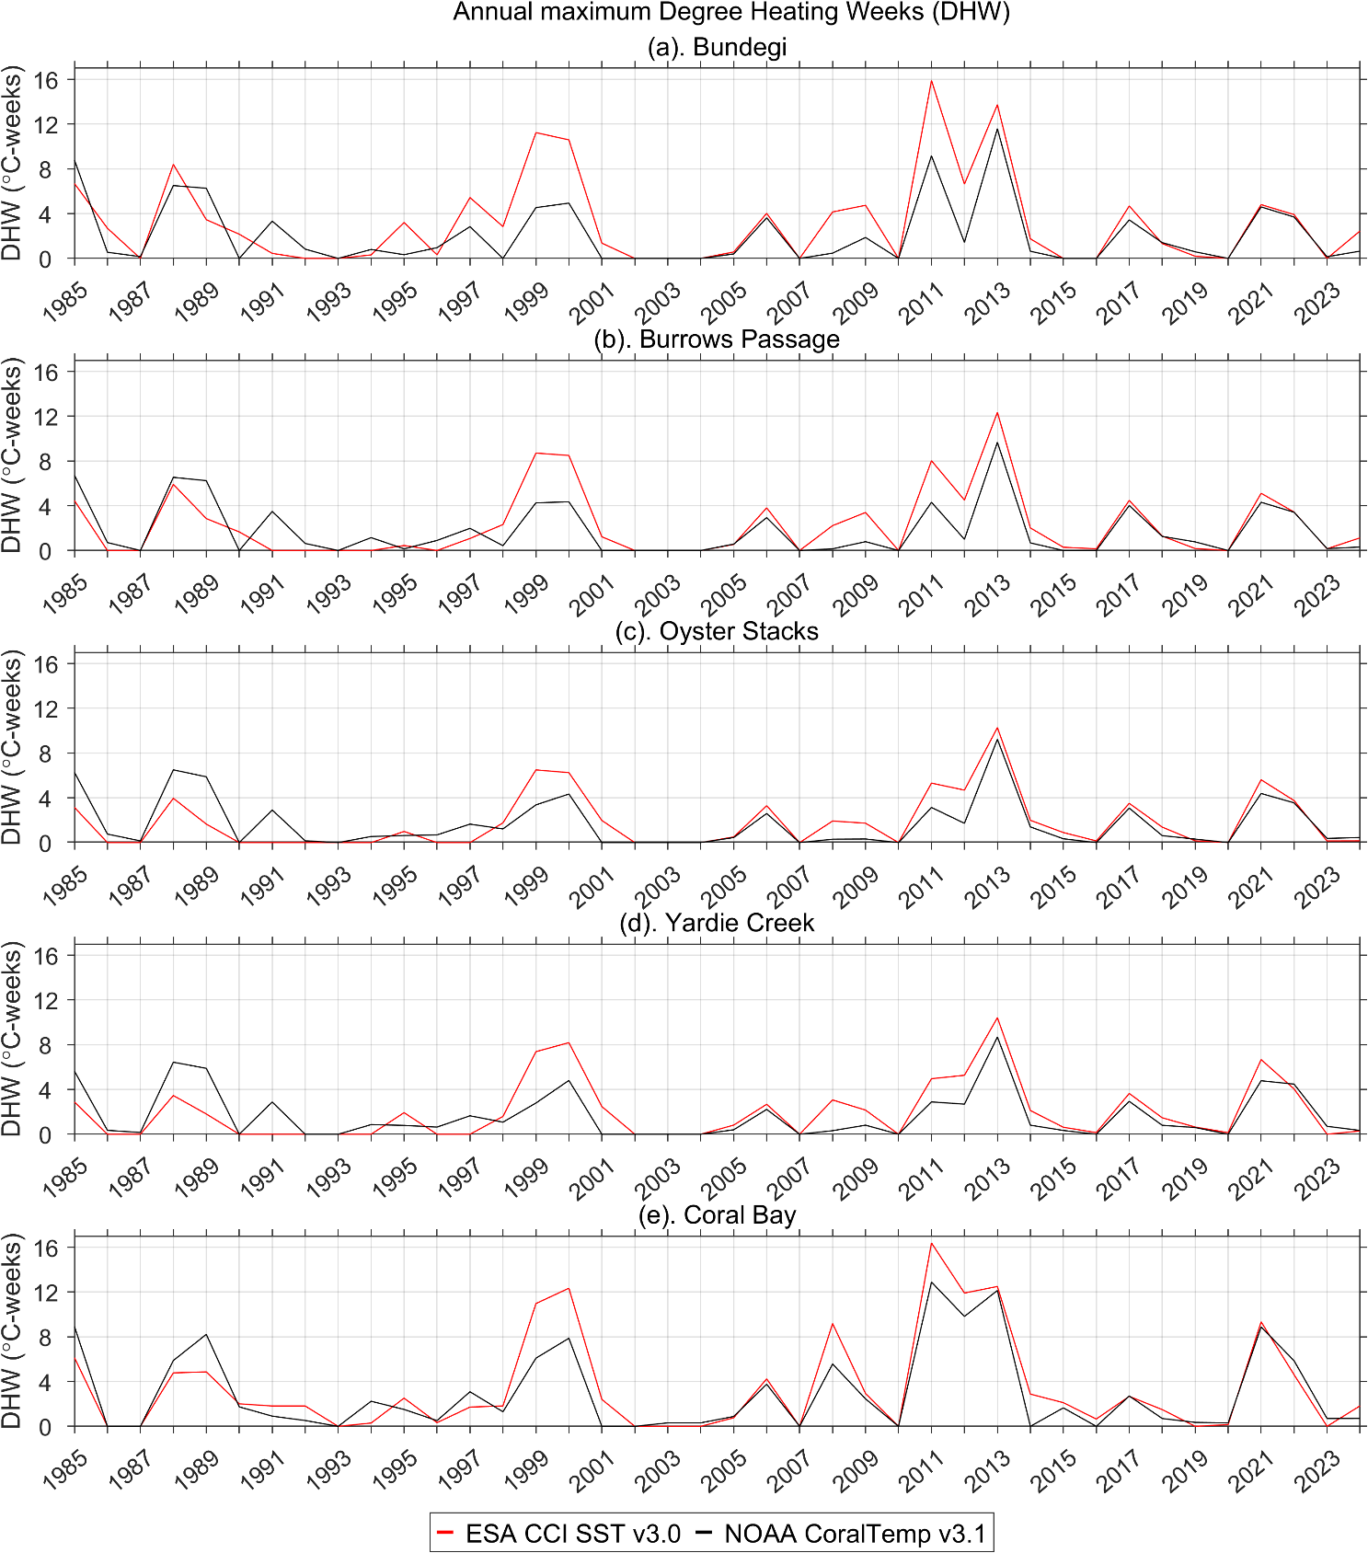
Fig. S9. Comparison of the annual maximum Degree Heating Weeks (DHW) derived from ESA CCI SST v3.0 and NOAA Coral Reef Watch’s CoralTemp v3.1 at the same grid pixels from each of the survey sites, as shown in Fig. S1.

