Supplementary information

Skin-adaptive Nanofiber-based Adhesive Electronics with Octopus-like 3D Suction cups for Enhanced Transdermal Delivery

Minwoo Song†¹, Hyoung-Ki Park†^{1,2}, Minjin Kim¹, Gui Won Hwang¹, Jihun Son¹, Gyun Ro Kang¹, Jihyun Lee*¹, Changhyun Pang*^{1,3}

¹School of Chemical Engineering, Sungkyunkwan University (SKKU), 2066 Seobu-ro, Jangan-gu, Suwon, 16419, Republic of Korea. ²Mimetics Co., Ltd, 2066 Seobu-ro, Jangan-gu, Suwon, 16419, Republic of Korea. ³Samsung Advanced Institute for Health Science & Technology (SAIHST), Sungkyunkwan University (SKKU), 2066 Seobu-ro, Jangan-gu, Suwon, 16419, Republic of Korea.

[†] M. Song, H. -K. Park contributed equally to this work.
* Corresponding authors. jiajia6010@gmail.com (Jihyun Lee), chpang@skku.edu (Changhyun Pang)

Supporting Methods Section

Structure-maintenance analysis depending on the fabricated temperature
Structure-maintenance analysis of CNFs-OIA according to temperature (100 and 150 ℃) was conducted through cross-sectional observation. For an accurate comparison, CNFs-OIA samples prepared at different temperatures were immersed in the same concentration of HA (15 wt%) for the same duration (1 min), and then cross-sectional photographs were obtained using Digibird (MICRO B2B, KOREA). Using the ImageJ software, the initial height was set to h₀, and the height after soaking in HA was set to h. Structure maintenance was calculated as the degree of structural change ($\frac{h}{h_{0}}×100$) at the 10 selected sites.
Analysis of OIA implementation according to imprinting pressure
The implementation of CNFs-OIA according to the imprinting pressure (60–500 MPa) was performed using a confocal microscope (Leica, Germany). To obtain images based on the fluorescence signal, a low-viscosity fluorescence solution was applied to the CNFs-OIA imprinted at the same temperature (150 °C) under various pressure conditions. The fluorescent solution was prepared by dissolving rhodamine B in deionized water (D.W); the mixing ratio of D.W to rhodamine B was set to 10:1.
Properties according to concentrations of HA
HA powder (50 kDa, HAworks, USA) and phosphate-buffered saline (pH 7.4, Sigma-Aldrich, Germany) were used at the desired concentrations (1, 5, 10, 15, and 20 wt%). Vortexing (5 min) and centrifugation (3000 rpm, 10 min) were performed to ensure even dispersion of the HA powder. Viscosity measurements were performed on HA solutions of various concentrations, prepared in the same volume, using a rheometer (ARES-G2, TA, USA).
Analysis of elastic modulus of HA-immersed CNFs
To measure the elastic modulus of CNFs immersed in HA at various concentrations (1, 5, 10, 15, and 20 wt%), CNFs samples of the same size (1×2 cm) were prepared and immersed in the HA solution for the same time (1 min). The elastic moduli were measured using a Universal Testing Machine (UTM, INSTRON, USA).
Structural maintenance analysis compared with commercial
The structural maintenance performance of the CNFs-OIA was compared with that of a patterned commercial CNFs product (Fillimilli, KOREA). For comparison, the CNFs-OIA and commercial products were immersed in various concentrations of HA for the same duration (1 min). Structural maintenance was confirmed through photographs obtained using a Digibird (MICRO B2B, KOREA).
Analysis of adhesion performance on the pigskin
Pigskin sourced from a local butcher in Jidong, Korea was used on the same day to prevent deformation. Adhesion performance was measured at 25°C using a custom-built device (Neo-Plus, Korea). The samples were secured to a jig connected to a force sensor and brought in contact with the pigskin. A preload of 5 kPa was applied to attach the adhesive samples to the substrates, which were detached after 5 s for measurement. Adhesion performance on the substrate was measured at least 10 times, and the average values were plotted. For shear direction adhesion, the adhesive samples attached to the pigskin substrate were detached at a constant velocity (~0.1 mm/s). The adhesion performance was measured at least five times and the average values were plotted.
FEM simulation
A FEM simulation analysis was conducted using commercial software (COMSOL Multiphysics version 6.2a, license number 5094592, Altsoft, South Korea) to validate the structural characteristics of the CNFs-OIA and CNFs-hole. A custom 2D model was designed with a protuberance size of 600 μm, an inner diameter of 1.5 mm, an outer diameter of 2.5 mm, and a height of 1 mm. The model was automatically tangential to a tetrahedral surface. The mesh size ranged from 0.0057 to 0.014 mm. For this model, the elastic modulus was determined from the stress-strain curve (Fig. 2e), and Poisson’s ratio was set at 0.49. All materials were assumed to exhibit linear elastic properties, and a pseudostatic analysis was performed.
Analysis of transdermal delivery efficiency on pig skin
Rhodamine B was dissolved in the HA solution, enabling the detection of a fluorescence signal. (HA: Rhodamine B = 10:1). To observe the improvements in drug delivery, an analysis was conducted while adjusting the application time, structure, and concentration of HA. The penetration of rhodamine B into the pig skin was observed using a confocal microscope (Leica, Germany). Delivery depth was measured at randomly selected 10 sites of cross-sectional images using ImageJ software.
Measurement of electrical resistance of the stratum corneum
The arms of five volunteers were treated with ethanol, dried for 5 min, and then the CNFs-OIAE was applied for a certain period (20 min). A microcurrent was generated using a commercial power supply (MOONCLE, Korea) at a rated voltage of 5 V. The stratum corneum resistance of the subject's skin was measured at 5-min intervals using a multimeter (HIOKI, Japan). Measurements were performed at least five times for each participant, and the average value was calculated based on these measurements. Following school board policies, approval from the Institutional Review Board (IRB) was received for both subject and parental assent (IRB Approval No. SKKU 2024-08-061)
Measurement of skin moisture content
After HA was delivered to the neck area of ​​five volunteers for a set period (20 min) in all groups (CNFs-OIAE, CNFs-OIA, and topical), any remaining residue on the skin was removed. The skin moisture content of the volunteers was measured before application, immediately after application, and 5 and 10 min after application using a commercial skin moisture tester (Welltrade, Korea). Each measurement was repeated at least five times and the average value was calculated. Following school board policies, approval from the Institutional Review Board (IRB) was received for both subject and parental assent (IRB Approval No. SKKU 2024-08-061).
Analysis of skin improvement in volunteers
Antera 3D® (Miravex Limited, Ireland) was used to record and analyze the skin improvement process (roughness, fine lines, pores) of three volunteers. All groups (CNFs-OIAE, CNFs-OIA, and topical) were applied to the neck of the volunteers at the same time (20 min) daily, and 3D morphological images of the volunteers' skin were acquired before application and on days 1, 4, and 7 after application. Data were extracted based on the acquired images, and the degree of skin improvement in each group was quantified using the Antera software. Quantification was performed by setting four randomly selected sites in application area of ​​each group to a constant size (a circle with a diameter of 5 mm), and the average value was calculated. In addition, the skin improvement rate ($\frac{X_{0}-X_{i}}{X_{0}}×100$) for each group was calculated by setting the quantitative data before application as X₀ and the data at day i after application as X_{i}. Following school board policies, approval from the Institutional Review Board (IRB) was received for both subject and parental assent (IRB Approval No. SKKU 2024-08-061).
Quantification of fine line
Using the 3D morphological images acquired with Antera 3D®, various parameters related to fine line were measured. In particular, the fine line length at the selected site represents the total length of all fine lines. The average fine line width represents the average width of fine lines at the selected site. In addition, the counts of the individual fine lines at the selected site were quantified. These data were used to more precisely analyze the improvement in skin condition through the quantitative evaluation of parameters related to each fine line.
Quantification of pore
Pores were visualized and various related parameters were measured using the 3D morphological images acquired with Antera 3D®. The mean pore area (mm²) at the selected site is the average pore area. The maximum pore depth is defined as the maximum depth of the pores in the selected area. Additionally, the number of individual pores was quantified. These data were used to analyze the improvement in skin condition more precisely through quantitative evaluation of the parameters related to each pore.

Supporting Theory Section

Derivation of the adhesion for CNFs-OIA and CNFs-hole

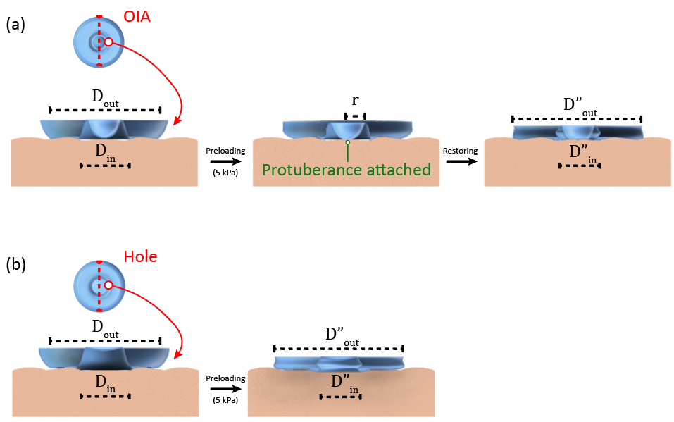
Supplementary Fig. 1 | Schematic of the adhesion process of a) CNFs-OIA and b) CNFs-hole with the same preload (5 kPa).

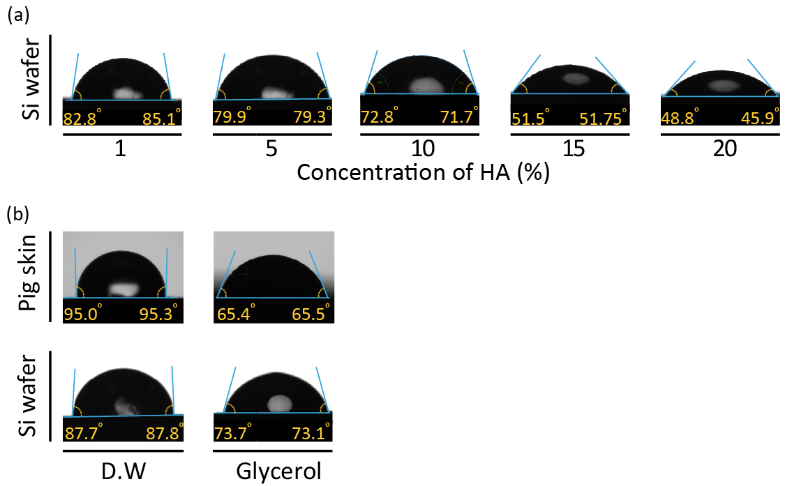
Supplementary Fig. 2 | a) Contact angles of the HA on Si wafer (1, 5, 10, 15, and 20 wt%). b) Contact angles of the distilled water (DW) and glycerol on various substrates (Si wafer and pig skin).
As illustrated in Supplementary Fig. 1, with the application of a preload (5 kPa), the diameter ($D_{out}")$ after attachment increases further compared to the initial diameter of the structure ($D_{out}$). We derived these deformations based on the FEM simulations (Fig. 3e and Supplementary Fig. 9). The total wet adhesion ($σ_{total}$) of hole structure can be expressed by using the capillary force ($σ_{capillrary}$), suction force ($σ_{suction}$), viscous force ($σ_{viscous}$) and their actual contact surface area.^{1, 2, 3, 4}
$σ_{total}=σ_{capillrary}+σ_{suction}+σ_{viscous}$ (S1)
The capillary force can be defined as the sum of the Laplace pressure and surface tension applied to a unit area.
$σ_{capillrary}=\left[\frac{π∙({{D"}_{out}}^{2}-{{D"}_{in}}^{2})}{4}∙γ\left(\frac{\cos{ϑ_{1}}+\cos{ϑ_{2}}}{h}\right)+l∙γ\right]∙n$ (S2)
where $γ$ is the surface tension of HA depends on concentration, $ϑ_{1}$ is the contact angle of cellulose nanofiber and HA (Fig. 2d), $ϑ_{2}$ is the contact angle of HA on the engaged substrate (Supplementary Fig. 2a), h is the liquid gap, $l$ is the outer circumference, and $n$ is the number of structures. The contact surface area of protuberances was not considered in the equation (Supplementary Fig. 1b). The suction stress of a structure under wet conditions is expressed as
$σ_{suction}=\left[\frac{{P_{0}π{D"}_{in}}^{2}}{4}\right]∙n$ (S3)
where $P_{0}$ is atmospheric pressure (∼101.3 kPa), ${D"}_{in}$ is the inner diameter of the contact surface when a preload is applied and the inner chamber is deformed, $n$ is the number of structures. The viscosity of HA caused structural deformations and changes in the chamber volume (Figs. 2g, h). Because the volume scale of the chamber affects the suction force, we additionally considered the volumetric change ratio ($ϵ=(V_{0}-V_{1})/V_{0}$) according to viscosity. The suction force, considering the rate of volume change, can be expressed as:
$σ_{suction}=\left[\frac{{P_{0}π{D"}_{in}}^{2}ϵ}{4}\right]∙n$ (S4)
Finally, the viscous force changed linearly depending on the viscosity of HA. The viscous force, which depends on the viscosity applied to a unit area, is expressed as
$σ_{viscous}=\left[\frac{6v∙\text{η}∙π}{h}∙\frac{({{D"}_{out}}^{2}-{{D"}_{in}}^{2})}{4}\right]∙$n (S5)
where $v$ is the sliding velocity and $\text{η}$ is the viscosity of HA (Fig. 2c). The total wet adhesion, considering all applied forces, can be summarized as:
$σ_{total}=\left[\frac{{P_{0}π{D"}_{in}}^{2}ϵ}{4}+\frac{π({{D"}_{out}}^{2}-{{D"}_{in}}^{2})}{4}∙\left(\frac{6v∙\text{η}}{h}+γ\left(\frac{\cos{ϑ_{1}}+\cos{ϑ_{2}}}{h}\right)+l∙γ\right)\right]∙$n (S6)
Because we analyzed the adhesion performance at the pig skin interface, theoretical values ​​were derived by considering the surface energy of the pig skin. (Supplementary Fig. 2b).

Detailed derivation of the diffusion coefficient
The diffusion coefficient of HA was calculated to evaluate the effect of the CNFs-OIAE on transdermal delivery. The intensity of the fluorescent probe solution delivered to the pig skin was measured, and the solution concentration was calculated based on this intensity. The 2nd Fick's law differential equation for the change in concentration over time for a semi-infinite medium, wherein the initial concentration of $C_{A0}$ is uniform and the surface concentration of is constant is as follws:¹
$\frac{∂_{A0}}{∂_{t}}=D_{AB}\frac{∂^{2}C_{A}}{∂_{Z^{2}}}$ (S7)
where, $t$ is the diffusion time, $D_{AB}$ is the diffusion coefficient, and $z$ is the delivery depth. The 2nd Fick's law differential equation was subjected to the initial conditions.
$t=0, C_{A}\left(z,0\right)=C_{A0} for all z$ (S8)
In addition, boundary conditions are required. The first boundary conditions at the skin surface are as:
$at z=0, C_{A}\left(0,t\right)=C_{As} for t>0$ (S9)
The second boundary condition should be considered in the z-direction to assume that HA penetrates only a small distance over finite time.
$at z=∞, C_{A}\left(∞,t\right)=C_{A0} for all t$ (S10)
The change in dimensionless surface concentration can be expressed as:
$\frac{c_{As}-c_{A}}{c_{As}-c_{A0}}=erf\left(\frac{z}{2\sqrt{D_{AB}t}}\right)$ (S11)
$D_{AB}={\left(\frac{z}{2terf^{-1}\left(\frac{c_{As}-c_{A}}{c_{As}}\right)}\right)}^{2}$ (S12)
To obtain the diffusion coefficient, the intensity of a fixed surface concentration ($C_{As})$ near the skin surface was measured by confocal microscopy.

Quantification of skin roughness
Skin roughness was quantified by the deviation of the actual skin surface from the ideal shape based on the vertical deviation. The larger the deviation, the rougher the surface evaluated. The average roughness was calculated using the roughness plane correction option of Antera software and could be expressed using the following formula:
$R_{a}=\frac{1}{n}\sum_{i=1}^{n}{\left|y_{i}\right|}$ (S13)
where y_{i} is the vertical length of a specific location. The root mean square of the vertical coordinate of the roughness profile is defined as
$R_{q}= \sqrt{\frac{1}{n}\sum_{i=1}^{n}{{y_{i}}^{2}}}$ (S14)
The maximum height (R_{t}), which is the height between the maximum peak and minimum trough of the profile in the evaluation length, can be expressed as
$R_{t}= max y_{i}-min y_{i}$ (S15)

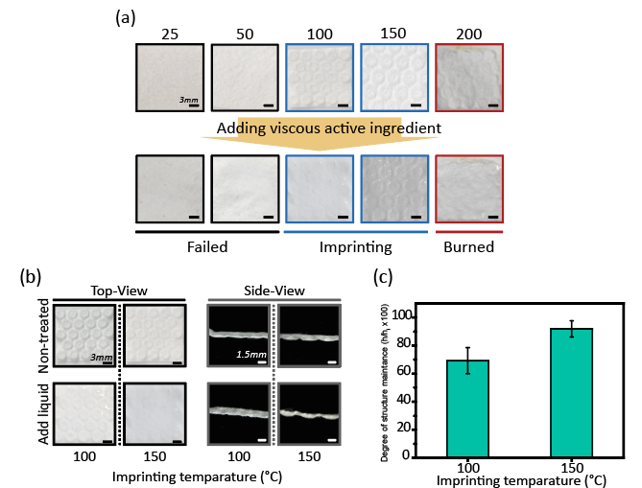

Supplementary Fig. 1 | (a) Photographs of the CNFs-based OIA depending on different fabrication temperatures (25, 50, 100, 150, and 200 ºC). (b) Photographs of the CNFs-based OIA fabricated at imprinting enable temperatures (100 and 150 ºC). (c) Height (h) of OIA compared to the initial SUS mold (h_{i}) by fabrication temperature; N=10.

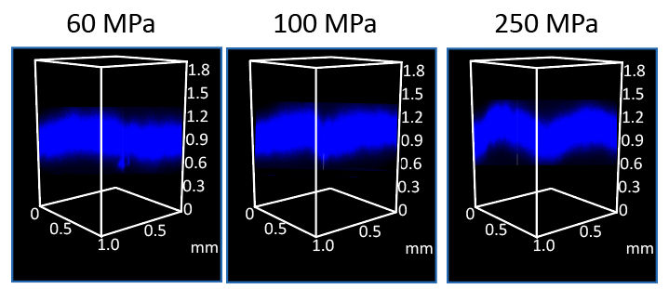

Supplementary Fig. 2 | Structure implementation level under fluorescent solution of the OIA fabricated with various imprinting pressures (60, 100, and 250 MPa) at 150 ºC. This indicates that the structural implementation increases with high imprinting pressure.
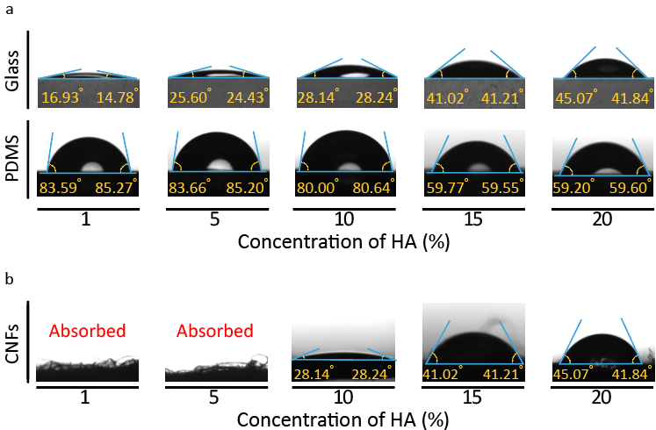

Supplementary Fig. 3 | a) Contact angles of the HA with different concentrations on various (Glass, PDMS). b) The contact angles of deionized water (DW) on CNFs soaked in different concentrations of HA.
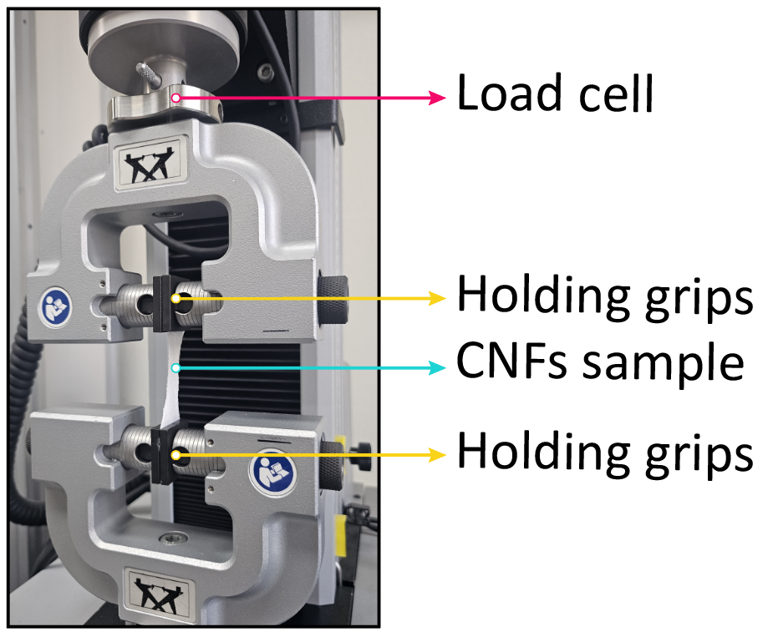

Supplementary Fig. 4 | Measurement of stress-strain curves of the CNFs absorbed with various HA concentrations (w/o, 1, 5, 10, 15, and 20 wt%) using Universal Testing Machine (UTM).

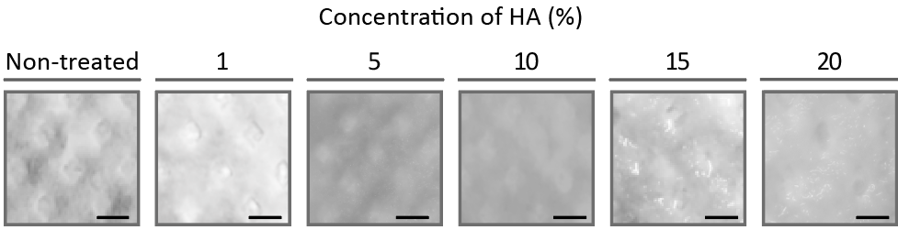

Supplementary Fig. 5 | Photographs depicting the structure-maintenance performance of the commercial product for various concentrations of HA (0, 1, 5, 10, 15, 20 wt%)

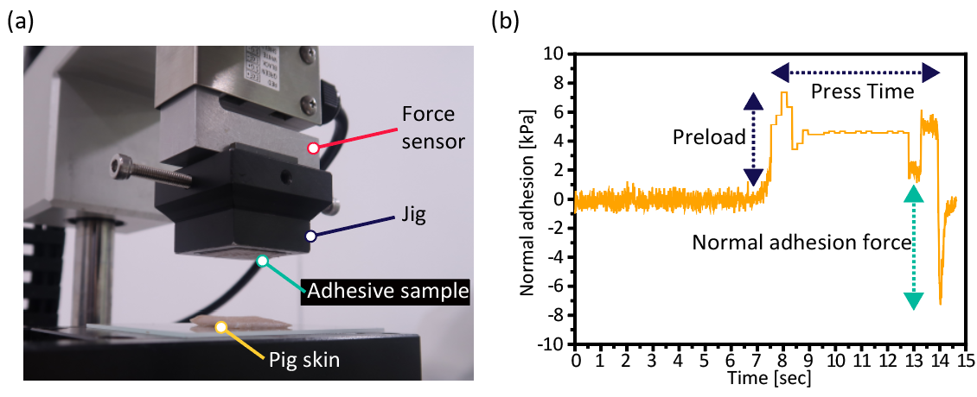
Supplementary Fig. 6 | a) Measurement of normal adhesion on authentic pigskin using custom-built equipment. b) Representative time-dependent profile of normal adhesion.
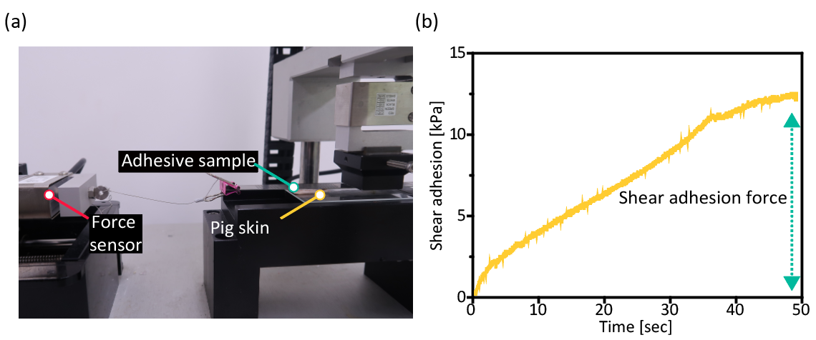

Supplementary Fig. 7 | a) Measurement of shear adhesion on authentic pigskin using custom-built equipment. b) Representative time-dependent profile of shear adhesion

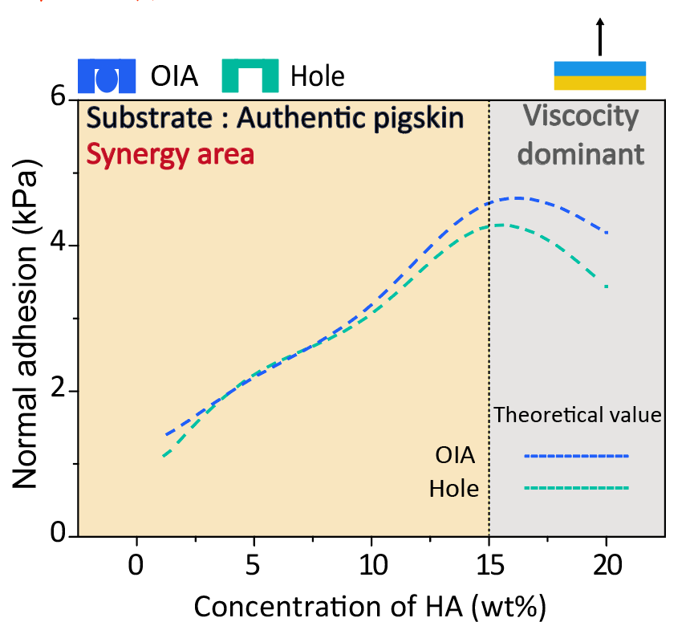

Supplementary Fig. 8 | Normal adhesion at different concentrations of HA (w/o, 1, 5, 10, 15, and 20 wt%) on an authentic pig skin substrate, shown with predicted values for the OIA (blue dotted line) and the hole (green dotted line).

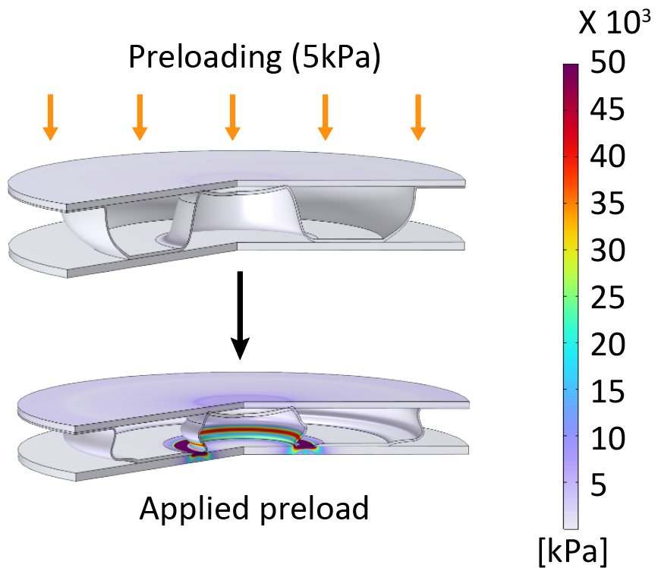

Supplementary Fig. 9 | FEM simulation for stress distribution of deformed single CNFs-hole

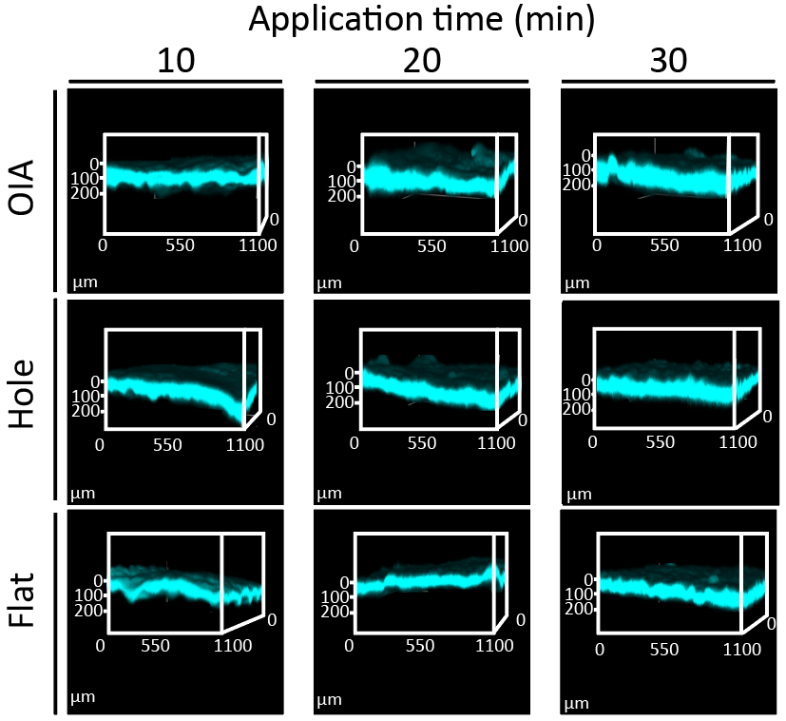

Supplementary Fig. 10 | Images of 3D confocal microscopy analysis of rhodamine B-tagged HA (15 wt%) through pigskin at different application times (10, 20, and 30 min).

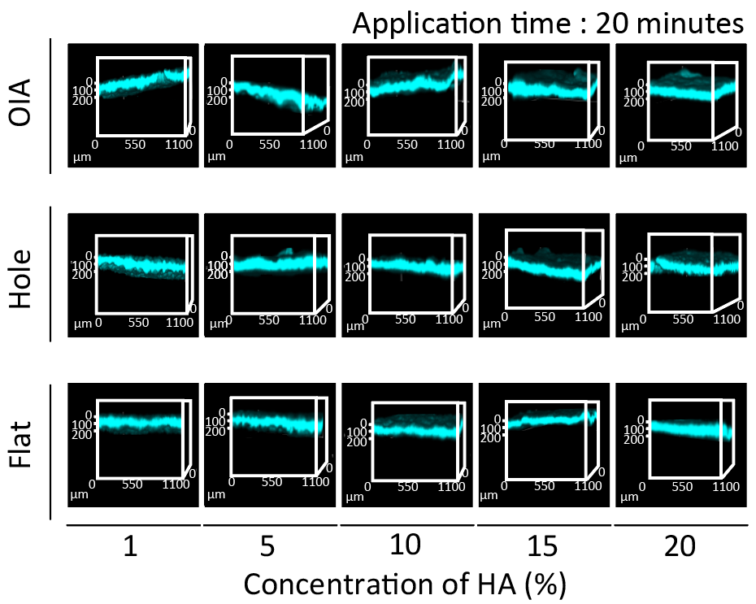

Supplementary Fig. 11 | Images of the 3D confocal microscopy analysis of rhodamine B-tagged HA with various concentrations of HA (0, 1, 5, 10, and 15 wt %) through pigskin at a fixed application time (20 min).

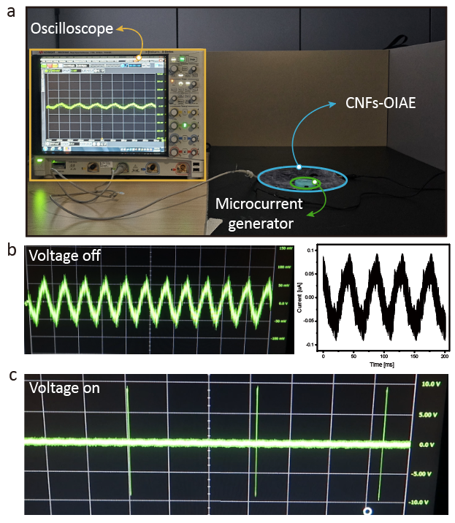

Supplementary Fig. 12 | a) Experimental setup for current generation measurement of CNFs-OIAE. Derived current profiles: (b) voltage-off state and (c) voltage-on state.
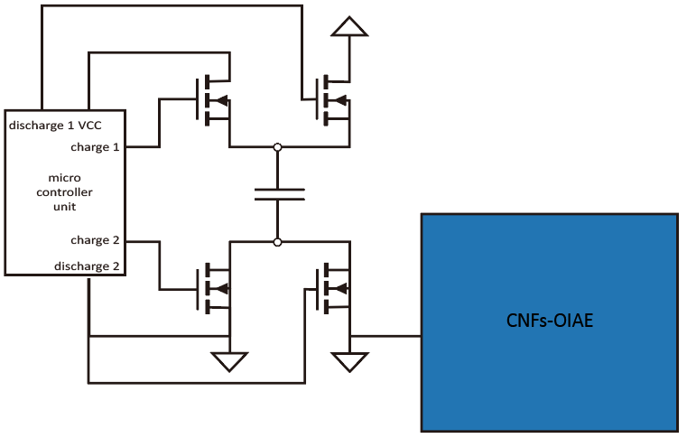

Supplementary Fig. 13 | Current generation measurement environment circuit diagram
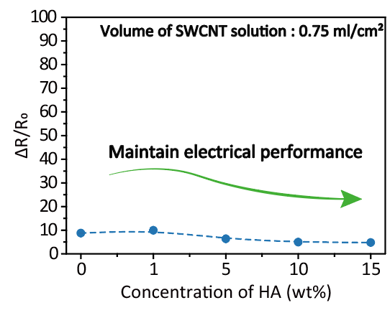

Supplementary Fig. 14 | Evaluation of electrical performance of C-DL OIA according to the concentration of HA (0, 1, 5, 10, and 15 wt%); n=10

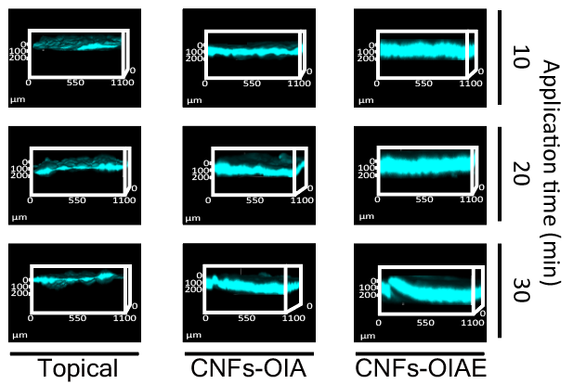

Supplementary Fig. 15 | Images of 3D confocal microscopy analysis of rhodamine B-tagged HA (15 wt%) through pigskin at different application times (10, 20, and 30 min) and various mechanisms (CNFs-OIAE, CNFs-OIA and, topical).

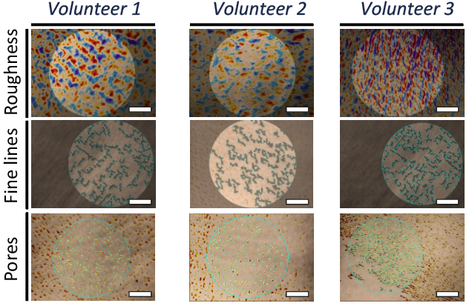

Supplementary Fig. 16 | Representative images of skin roughness, fine lines, and pores of several volunteers before the application of C-DL OIA (day 0), scale: 1 mm.

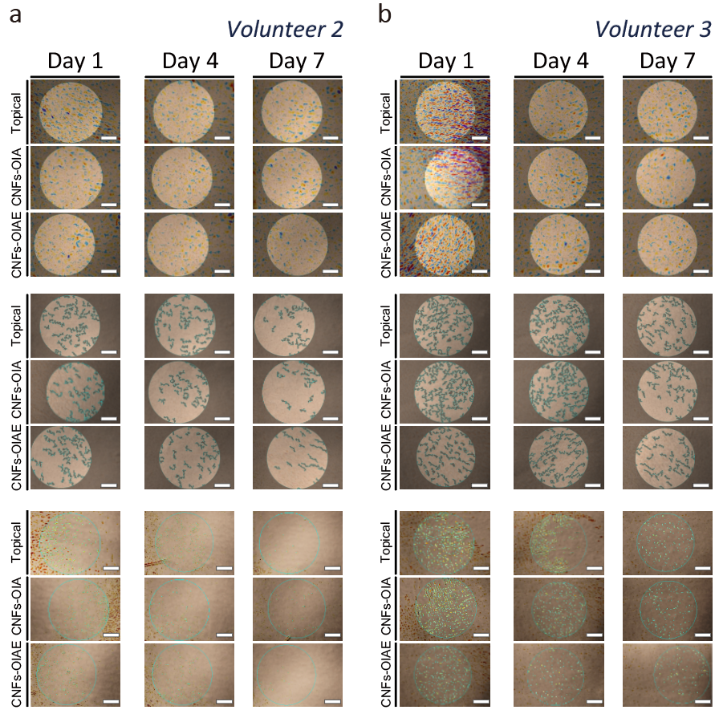

Supplementary Fig. 17 | Representative images of skin roughness, fine lines, and pores of several volunteers at different application times (1, 4, and 7 d): (a) Volunteer 2 and (b) Volunteer 3, scale: 1 mm.
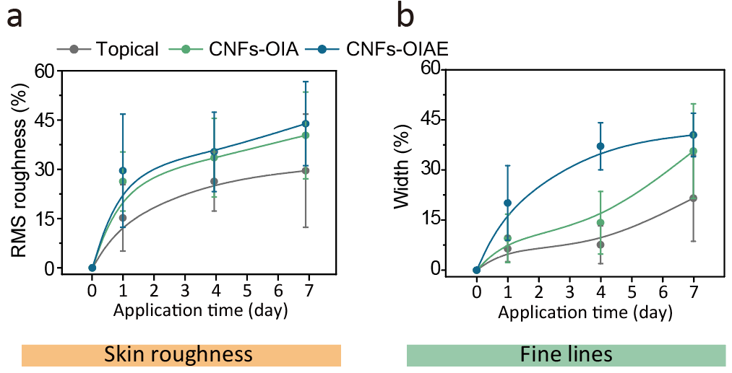

Supplementary Fig. 18 | Changes in (a) root mean square of the roughness profile ordinate and (b) average width of fine lines.

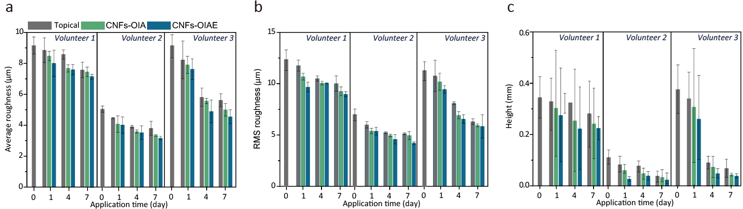

Supplementary Fig. 19 | Quantitative data of skin roughness based on HA delivery mechanisms (blue columns: CNFs-OIAE, green columns: CNFs-OIA, gray columns: topical) at different application times (0, 1, 4, and 7 d) and volunteers: (a) average value of all deviations from a straight line within the evaluation length, (b) root mean square of the roughness profile ordinate, and (c) height between the maximum peak and the minimum point of the profile; N=4

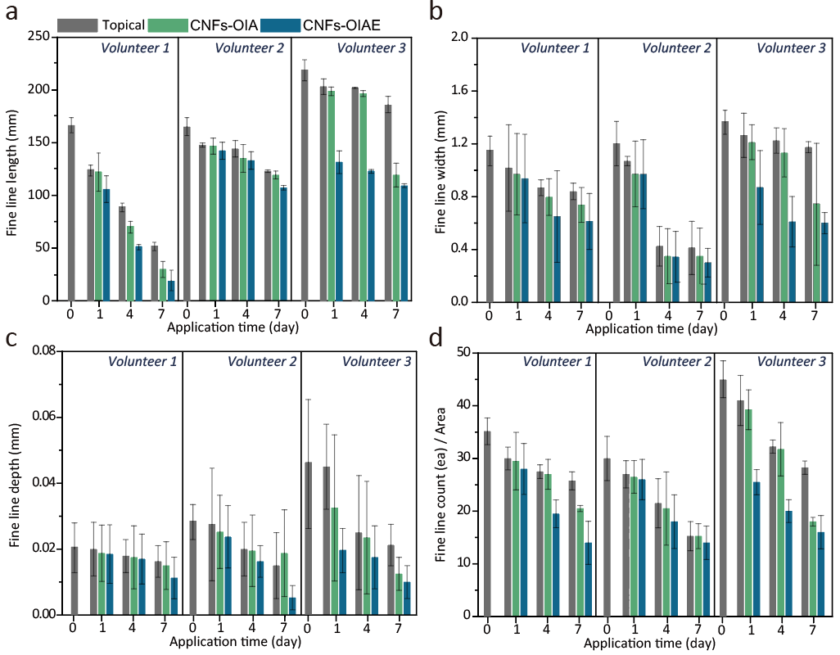

Supplementary Fig. 20 | Quantitative data of fine lines according to the HA delivery mechanisms (blue columns: CNFs-OIAE, green columns: CNFs-OIA, gray columns: topical) at different application times (0, 1, 4, and 7 d) and volunteers: (a) sum of the fine line lengths, (b) average width of the fine lines, (c) average depth of fine lines, and (d) counts of individual fine wrinkles; N=4
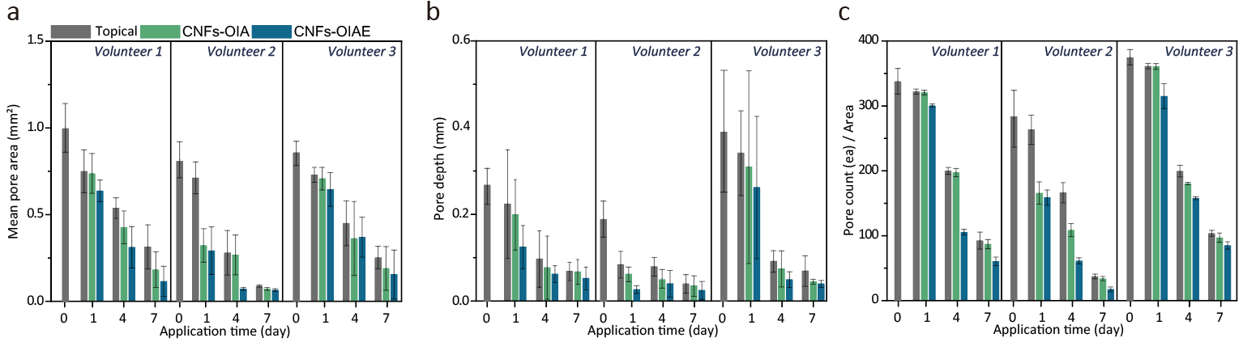

Supplementary Fig. 21 | Quantitative data of fine lines according to HA delivery mechanisms (blue columns: CNFs-OIAE, green columns: CNFs-OIA, gray columns: topical) at different application times (0, 1, 4, and 7 d) and volunteers: (a) mean pore areas, (b) average depth of the pores, and (c) counts of individual pores; N=4.

REFERENCES
1. Lee, J. et al. Artificial Octopus-Limb-Like Adhesive Patches for Cupping-Driven Transdermal Delivery with Nanoscale Control of Stratum Corneum. ACS nano 18, 5311-5321 (2024).
2. Lee. YS., Song, JH., Kim, J., Jeon, SH., Hwang, GW., Pang, C. A biodegradable bioinspired oil-coated adhesive film for enhanced wet adhesion. Surfaces and Interfaces 35, 102415 (2022).
3. Jeon, SH. et al. Super‐adaptive electroactive programmable adhesive materials to challenging surfaces: From intelligent soft robotics to XR haptic interfaces. InfoMat, e12640 (2024).
4. Lee, YS., Kim, M-S., Kim, DW., Pang, C. Intelligent structured nanocomposite adhesive for bioelectronics and soft robots. Nano Research 17, 534-549 (2024).

