Supplement Materials
Content

Measurements 2
Table S1. Subjects’ Province distributions 4
Table S2. Checklist of 14 Questions for Multicenter Clinical Trial Protocols: Cross-Sectional Studies 5
Table S3. Abbreviation, Mean, and Standard Deviation of Psychosis-Risk and Personality Diagnostic symptom 9
Table S4. Coefficients of strength and direction of each symptom in the Bayesian network 10
Figure S1. Stability of strength centrality index. The red, green and blue lines represent the average correlation between betweenness, closeness and strength in the full sample and subsample. 11
Figure S2. Bootstrapped confidence intervals of estimated edge weights for the global network. 12
Figure S3. Bootstrapped difference test between edge weights that were non-zero in the estimated network. Grey boxes indicate edges that do not differ significantly from one another and black boxes represent edges that differ significantly from one another. 13
Figure S4. Bootstrapped difference test between node strength of the network. 14
Figure S5. Histogram of the Residuals of Each Symptom. 15
Figure S6. The Log-Likelihood Loss for both discrete and continuous data sets. 16

This file includes Subjects’ Province distributions, detailed instructions for Abbreviation, Mean, and Standard Deviation of Psychosis-Risk and Personality Diagnostic symptom, Assessment rules for the 14 questions about multicenter-related characteristics, Coefficients of strength and direction of each symptom in the Bayesian network, Bootstrapped confidence intervals of estimated edge weights for the global network, Bootstrapped difference test between edge weights that were non-zero in the estimated network, Bootstrapped difference test between node strength of the network, Stability of strength centrality index, Histogram of the Residuals of Each Symptom and the Log-Likelihood Loss for both discrete and continuous data sets.

Measurements
Prodromal Questionnaire - Brief version
Prodromal Questionnaire - Brief version (PQ-B) is a self-rating scale was used to assess positive symptoms and includes 21 items with a 5-level score based on yes answer (1= strongly disagree, 5= strongly agree, 0= no) (Loewy et al, 2012). The scale consists of the following five dimensions: Delusional Ideas (P1) includes items 1, 4-5 and 11-17; Persecutory Ideas (P2) includes items 8 and 18; Persecutory Ideas (P3) includes item 7, Perceptual Abnormalities (P4) includes items 2-3, 9-10 and 19-20, Perceptual Abnormalities (P5) includes items 6 and 21 (see Table S3 for details). The score for each dimension is the average score for its corresponding items (e.g., the score of Persecutory Ideas (P2) is the mean of the items 8 and 18). In this study, the scale coefficient of internal consistency Cronbach’ s alpha was 0.93, indicating a good questionnaire reliability.
Questionnaire for negative symptoms, disorganization symptoms and general symptoms
This tool is a self-rating scale made by ourselves in this study, which is derived from some questions in the negative symptoms, disorganization symptom and general symptoms of Scale of Psychosis-risk Symptoms (SOPS) (Pontillo et al., 2021). The scale includes 19 items in total with a 3-point Likert scale ranging from 0 (no), 1 (uncertain) to 2 (yes). The negative symptoms (AN) consist of the following six dimensions: Social anhedonia (N1) includes items 1 and 2, Avolition (N2) includes items 3 and 4; Expression of emotion (N3) includes item 5, Experience of Emotions and Self (N4) includes item 6, Ideational Richness (N5) includes items 7 and 8; Occupational Functioning (N6) includes items 9 and 10. The disorganization symptom (AD) consists of the Personal Hygiene (D4) which includes item 11. The general symptoms (AG) consist of the following four dimensions: Sleep Disturbance (G1) includes item 12, Dysphoric Mood (G2) includes item 13-17, Motor Disturbances (G3) includes item 18, Impaired Tolerance to Normal Stress (G4). The score for each symptom is the average score for its corresponding items (e.g., the score of social anhedonia (N1) is the mean of the items 1 and 2, the score of negative symptoms (AN) is the total mean of the items N1-N5). In this study, coefficient of internal consistency Cronbach’ s α = 0.84, indicating a good questionnaire reliability. Exploratory factor analysis showed good structure validity, KMO value of 0.708, the total extract six common factor, can explain 65.6% of the total variance.
Personality Diagnostic Questionnaire for Schizotypal Personality Disorder
We used the Chinese version of the Personality Diagnostic Questionnaire for Schizotypal Personality Disorder (PDQ-SPD) to evaluate the schizotypal personality traits (Yang, Shen, Wang & Yang, 2002). The includes 9 items with a 2-level score based on participant’ s answered “yes” (1 point) or “no” (0 point). The score is the sum of the scores for each item, the higher the total score, the more significant the symptoms of schizoid personality disorder. In this study, the internal consistency coefficient Cronbach’s α of this scale was 0.67.

Loewy R, Pearson R, Bearden C, Zinberg J, Vinogradov S, Cannon T. Longitudinal follow-up of screening for clinical-high-risk for psychosis with the Prodromal Questionnaire, Brief Version (PQ-B). Early Intervention in Psychiatry. 2012;6:2-2.
Pontillo M, Averna R, Tata MC, Chieppa F, Pucciarini ML, Vicari S. Neurodevelopmental Trajectories and Clinical Profiles in a Sample of Children and Adolescents With Early- and Very-Early-Onset Schizophrenia. Frontiers in Psychiatry. 2021;12.https://10.3389/fpsyt.2021.662093
Yang Y, Shen D, Wang J, Yang J. The Reliability and Validity of PDQ-4+ in China. Chinese Journal of Clinical Psychology. 2002(03):165-168.

Table S1. Subjects’ Province distributions
No. | province (%) | University | n (%)
1 | Shanghai  (22.4) | Tongji University | 9450 (20.8)
1 | Shanghai  (22.4) | Shanghai Communications Polytechnic | 1003 (2.2)
2 | Jiangsu  (19.9) | Nanhang Jincheng College | 1606 (3.5)
2 | Jiangsu  (19.9) | Nanjing Tech University | 5708 (12.5)
2 | Jiangsu  (19.9) | Nanjing Information Engineering University | 1808 (3.9)
2 | Jiangsu  (19.9) | Nanjing Normal University | 617 (1.3)
2 | Jiangsu  (19.9) | Nanjing University of the Arts | 991 (2.2)
3 | Jiangxi  (41.8) | East China Jiao tong University | 161 (0.3)
3 | Jiangxi  (41.8) | Jiangxi University of Finance and Economics | 162 (0.3)
3 | Jiangxi  (41.8) | Nanchang modern traffic School | 237 (0.5)
3 | Jiangxi  (41.8) | Nanchang University | 424 (0.9)
3 | Jiangxi  (41.8) | Jiangxi University of Traditional Chinese Medicine | 1038 (2.2)
3 | Jiangxi  (41.8) | Jiangxi Agricultural University | 7461 (16.3)
3 | Jiangxi  (41.8) | Jiangxi Modern polytechnic College | 79 (0.1)
3 | Jiangxi  (41.8) | Nursing School of Nanchang University | 57 (0.1)
3 | Jiangxi  (41.8) | Nanchang Institute of Technology | 676 (1.4)
3 | Jiangxi  (41.8) | Jiangxi Media Vocational and Technical College | 1588 (3.4)
3 | Jiangxi  (41.8) | Jiangxi Vocational College of Foreign Languages and Foreign Trade | 5535(12.2)
4 | Guangdong  (11.9) | Maoming Vocational and Technical College | 5419 (11.9)
5 | Other  (4.0) | The subjects did not disclose the province and school information | 1807 (4.0)
The included 45,420 subjects were distributed in 19 universities in Shanghai, Jiangsu, Jiangxi and Guangdong four provinces, and the total frequency number is 45,420. Thus, this item is based on a total number of 45.

Table S2. Checklist of 14 Questions for Multicenter Clinical Trial Protocols: Cross-Sectional Studies
Question | Specifics | Definition of “yes”  (Scored as “1”) | Example
Q1 | Whether the multicenter design was identified in the title? | It was considered “yes” if the reader can determine from the title that it will be a multicenter trial. Generally, the word “multicenter” was used. In a few cases, phrasing such as “multinational” or “two-center” was used, and this was also as “yes”. | P1 “Symptom network and Bayesian network analyses of positive and negative symptoms in psychotic-like experiences : A multicenter cross-sectional study”
Q2 | Whether the multicenter design was reported in the Abstract? | It was considered “yes” if the multicenter design of a trial was reported in the abstract, e.g., in the “methods” or “objective” sections. | P2 “Abstract: A multicenter cross-sectional study…a sample of 37,443 high school/college students from 19 high schools and universities across three provinces of China...”
Q3 | Whether relevant rationale for using a multicenter design was provided in the protocol? | It was considered “yes” if some introduction of why conduct a multicenter trial was reported in the protocol, either long or short contents. Commonly, this reporting was provided in the section of “Background/Introduction/Objective/Discussion”. | P2“Abstract: A multicenter cross-sectional study.”  P6 “Methods/Procedure: This study used a multicenter design to increase the generalizability of the results. A total of 3 study centers, mainly located in the eastern region, were involved, involving more than 20 vocational, college, high school, and undergraduate students. Researchers at all centers received uniform training to ensure standardization of intervention delivery. The sample size for each center is estimated to be 8,000 individuals (more details show in the supplement). Subject screening criteria and procedures were standardized across centers. Random assignment sequences for questionnaire collection were generated centrally at random and stratified by center. A uniform symptom assessment scale and questionnaire are used across centers, and a central database collects all data. Center effects will be assessed and adjusted in our analyses. Centers will be monitored and audited by the central team on a regular basis to ensure standardized implementation of the study. …..”  P6 “Methods/Procedure: To ensure the representativeness of the research samples, we selected four provinces (Shanghai, Jiangsu, Jiangxi, and Guangdong province) for this study……”
Q4 | Whether the multicenter was specified in the trial design section? | It was considered “yes” if the multicenter design was identified in the “Methods” section of the protocol. | P2“Abstract: …a sample of 37,443 high school/college students from 19 high schools and universities across three provinces of China...”  P6 “Methods/Procedure: This study used a multicenter design to increase the generalizability of the results. A total of 3 study centers, mainly located in the eastern region, were involved, involving more than 20 vocational, college, high school, and undergraduate students...……”  P6 “Methods/Procedure: To ensure the representativeness of the research samples, we selected four provinces (Shanghai, Jiangsu, Jiangxi, and Guangdong province) for this study……”
Q5 | Whether any description of participating center was provided? Such as the name list of study centers or the selection criteria of centers, etc. | It was considered “yes” if the protocol reported the number and names of participating centers. For the center’s name, various format referring to the locations, countries, hospitals, units, etc., can be scored as “1”. Some articles provided this information in the supplementary materials or registry record. Otherwise, if the name list of centers has not finalized in the phase of protocol, it is also considered “yes” if the article reported the eligibility criteria or relevant requirements for participation for trial centers. | P1 “The initiating sponsor and coordinator of this clinical trial is  Department of Psychiatry，Tongji Hospital，School of Medicine, Tongji University (Shanghai, China). The other twelve participants are Psychiatric Department, Zhenjiang Mental Health Center (Jiangsu, China), Department of Psychiatry, Kangning Hospital, Shenzhen (Guangdong, China), Department of Psychiatry, the First Affiliated Hospital of Nanchang University (Jiangxi, China), Department of Psychiatry, Brain Hospital Affiliated to Nanjing Medical University (Nanjing, China), Mental Health Center, Shanghai Jiao Tong University School of Medicine (Shanghai, China)  and School of Psychology, Zhejiang Normal University (Zhejiang, China).”
Q6 | Whether any description of methods used to ensure that interventions will be administered consistent across centers was provided? Or indicated any variations across centers? | It was considered “yes” if the protocol 1) reported that the implementation of the interventions will be the same across centers; or 2) specified and gave the rationale, reasons, or description for any disparity in the interventions across centers. | P6 “Methods/Procedure: Researchers at all centers received uniform training to ensure standardization of intervention delivery. The sample size for each center is estimated to be 8,000 individuals (more details show in the supplement). Subject screening criteria and procedures were standardized across centers. Random assignment sequences for questionnaire collection were generated centrally at random and stratified by center. A uniform symptom assessment scale and questionnaire are used across centers, and a central database collects all data. Center effects will be assessed and adjusted in our analyses. Centers will be monitored and audited by the central team on a regular basis to ensure standardized implementation of the study.”
Q7 | Whether any description of intervention training arrangement across centers? | It was considered “yes” if the protocol reported that some training-related arrangement(s) will be planned for intervention providers from each center. | P6 “Methods/Procedure: Researchers at all centers received uniform training to ensure standardization of intervention delivery. The sample size for each center is estimated to be 8,000 individuals (more details show in the supplement). Subject screening criteria and procedures were standardized across centers. Random assignment sequences for questionnaire collection were generated centrally at random and stratified by center......”  P6 “Methods/Procedure: ......A uniform symptom assessment scale and questionnaire are used across centers, and a central database collects all data. Center effects will be assessed and adjusted in our analyses. Centers will be monitored and audited by the central team on a regular basis to ensure standardized implementation of the study.”
Q8 | Whether any description of methods to ensure consistent outcome measurements across centers was provided? | It was considered “yes” if the protocol reported clearly how the outcome(s) will be measured consistently across centers, especially for the patient-reported and clinician-reported outcome(s). Contents relevant to the quality control of measurements are also scored as “1”. | “P6 “Methods/Procedure: ......A uniform symptom assessment scale and questionnaire are used across centers, and a central database collects all data. Center effects will be assessed and adjusted in our analyses. Centers will be monitored and audited by the central team on a regular basis to ensure standardized implementation of the study.”  P8 “Methods/Data processing and statistical analysis: ......We used the “us” package to screen for response inattentiveness. For the dataset of PLE, we initially had 45420 participants (Figure 1.), but we excluded 4282 participants who did not fill in their age or were outside the age range of 12 to 35 years old. We also excluded 3695 participants who filled in the questionnaire carelessly, based on the reaction time (RT) incorporated into the careless package......”
Q9 | Whether any pre-allocation of sample size in each center was mentioned? | It was considered “yes” if the trial sample size calculation mentioned the following: 1) estimations of sample size in each center; or 2) the minimum sample size of a center. Most trials reported only the total number of sample size and/or sample size in each group. Such reporting was scored as ”0” for this item. | P6 “Methods/Procedure: ......The sample size for each center is estimated to be 8,000 individuals (more details show in the supplement) ......”  P6 “Methods/Procedure: ......We chose 19 universities from these provinces and randomly selected 45,420 college students by the class as a unit......”
Q10 | Whether any description of recruitment strategies across centers was provided? Such as the recruitment ways, schedule, or timeline, etc. | It was considered “yes” if any center-based plan of recruitment were provided in the protocol and/or its supplementary materials. Or provided whether any change(s) of recruitment across centers will be included, such as criteria of any center(s) will be withdrawn, or newly added. | P6 “Methods/Procedure: To ensure the representativeness of the research samples, we selected four provinces (Shanghai, Jiangsu, Jiangxi, and Guangdong province) for this study. We chose 19 universities from these provinces and randomly selected 45,420 college students by the class as a unit…….”  (More details show in the supplement-Table2).”
Q11 | Whether the allocation sequence was specified as centralized or stratified by center? | It was considered “yes” if the protocol reported a specific method of randomization used in multiple centers, including “central randomization”, or “randomization was stratified by center”. | P6 “Methods/Procedure: ……Random assignment sequences for questionnaire collection were generated centrally at random and stratified by center.”
Q12 | Whether any description of methods for data collection across centers was provided? Such as central system used to ensure consistent among centers, or indicated any differences across centers. | It was considered “yes” if the protocol 1) reported that the data collection method will be the same across centers; or 2) indicated any disparity will be included across centers. | P6 “Methods/Procedure: To ensure the representativeness of the research samples, we selected four provinces (Shanghai, Jiangsu, Jiangxi, and Guangdong province) for this study from September 2017 to November 2019. We chose 19 universities from these provinces and randomly selected 45,420 college students by the class as a unit (see Table S1 for more details).”  P6 “Methods/Procedure: This study used a multicenter design to increase the generalizability of the results (see Table S2 for details). A total of 3 study centers, mainly located in the eastern region, were involved, involving more than 20 vocational, college, high school, and undergraduate students. Researchers at all centers received uniform training to ensure standardization of intervention delivery. The sample size for each center is estimated to be 8,000 individuals. Subject screening criteria and procedures were standardized across centers. Random assignment sequences for questionnaire collection were generated centrally at random and stratified by center. A uniform symptom assessment scale and questionnaire are used across centers, and a central database collects all data. Center effects will be assessed and adjusted in our analyses. Centers will be monitored and audited by the central team on a regular basis to ensure standardized implementation of the study. The use of a multicenter design increases the breadth of results, and randomized stratification ensures comparability of results across centers.”
Q13 | Whether any statistical analysis plan for the heterogeneity assessment and adjustment for central effect was provided? | It was considered “yes” if heterogeneity of treatment effects across centers and/or adjustment for center effect were considered (particularly using statistical methods) were reported in the protocol. | P9 “Methods/Network construction: To compare the young (N=3623) and old (N=33820) groups’ networks, we conducted permutation tests on global strength (overall connectivity), network structure (edge weight distribution), and edge strength (strength of connections between specific node pairs).  P11 “Results: We also compared the symptom networks between adolescence group (12-17 years old) and adults’ group (18-35 years old) ......”
Q14 | Whether any description of auditing, such as conducted for each center or centrally was provided? | It was considered “yes” if the protocol reported whether the audit will be planned, such as conducted for each center or centrally; or not intended. | P6 “Methods/Procedure: ......Centers will be monitored and audited by the central team on a regular basis to ensure standardized implementation of the study.”
Note. Zhang, X., Wang, N., Zhang, L., Cheng, C. W., Liu, Z., Liang, F., Xiong, W., Deng, J., Shi, D., Cui, W., Ma, Y., Wu, T., Chan, C. P., Lyu, A., Yao, C., & Bian, Z. (2023). Reporting assessment of multicenter clinical trial protocols: A cross-sectional study. Journal of evidence-based medicine, 16(1), 16–18. https://doi.org/10.1111/jebm.12519

Table S3. Abbreviation, Mean, and Standard Deviation of Psychosis-Risk and Personality Diagnostic symptom
Symptoms | Abbreviation | Mean | SD
Positive Symptoms |  | 1.407 | 1.657
Unusual Thought Content/Delusional Ideas | P1 | 1.069 | 1.547
Suspiciousness/Persecutory Ideas | P2 | 1.725 | 1.745
Grandiosity | P3 | 1.892 | 1.860
Perceptual Abnormalities/Hallucinations | P4 | 0.992 | 1.478
Disorganized Communication | P5 | 1.357 | 1.655
Personality Diagnostic Questionnaire for Schizotypal Personality Disorder | SP | 0.261 | 0.430
Negative Symptoms | AN | 0.574 | 0.805
Social anhedonia | N1 | 0.671 | 0.809
Avolition | N2 | 0.626 | 0.843
Expression of emotion | N3 | 0.358 | 0.700
Experience of Emotions and Self | N4 | 0.605 | 0.844
Ideational Richness | N5 | 0.613 | 0.836
Occupational Functioning | N6 | 0.573 | 0.797
Disorganization symptom | AD | 0.300 | 0.660
Personal Hygiene | D4 | 0.300 | 0.660
General symptoms | AG | 0.483 | 0.790
Sleep Disturbance | G1 | 0.409 | 0.758
Dysphoric Mood | G2 | 0.404 | 0.732
Motor Disturbances | G3 | 0.576 | 0.845
Impaired Tolerance to Normal Stress | G4 | 0.544 | 0.826
Note. SD: Standard Deviation. All symptom scores start at 0.

Table S4. Coefficients of strength and direction of each symptom in the Bayesian network

from | to | strength | direction
P1 | P2 | 1 | 0.9
P1 | P3 | 1 | 1.0
P1 | P4 | 1 | 1.0
P1 | P5 | 1 | 1.0
P1 | SP | 1 | 0.9
P2 | P3 | 1 | 0.9
P2 | P4 | 1 | 1.0
P2 | P5 | 1 | 0.9
P2 | AD | 1 | 0.6
P3 | P4 | 1 | 0.6
P5 | P3 | 1 | 0.7
P5 | P4 | 1 | 1.0
SP | P2 | 1 | 0.7
SP | P3 | 1 | 0.9
SP | P5 | 1 | 0.9
AN | P5 | 1 | 1.0
AN | SP | 1 | 1.0
AN | AG | 1 | 1.0
AD | P4 | 1 | 1.0
AG | P1 | 1 | 1.0
AG | P2 | 1 | 1.0
AG | P3 | 1 | 1.0
AG | SP | 1 | 1.0
AG | AD | 1 | 1.0
Age | P1 | 1 | 1.0
Age | P2 | 1 | 1.0
Age | P3 | 1 | 1.0
Age | SP | 1 | 1.0
Age | AN | 1 | 1.0
Age | AD | 1 | 1.0

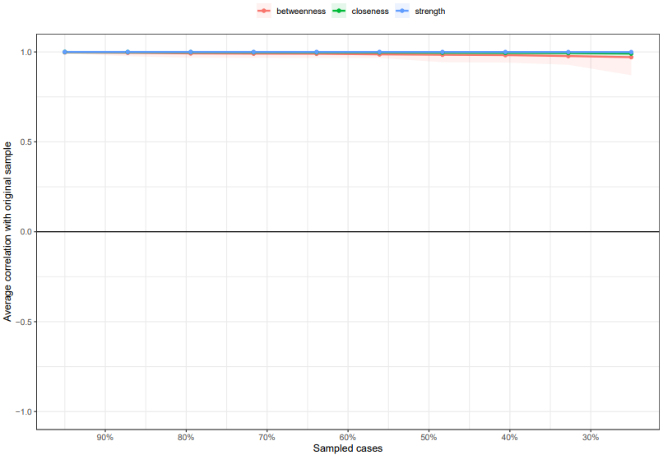

Figure S1. Stability of strength centrality index. The red, green and blue lines represent the average correlation between betweenness, closeness and strength in the full sample and subsample.

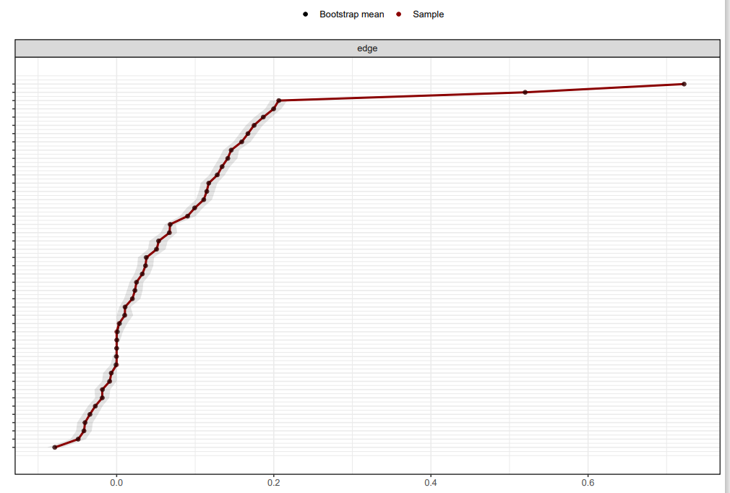

Figure S2. Bootstrapped confidence intervals of estimated edge weights for the global network.
The red line indicates the sample values and the grey area the bootstrapped CIs.

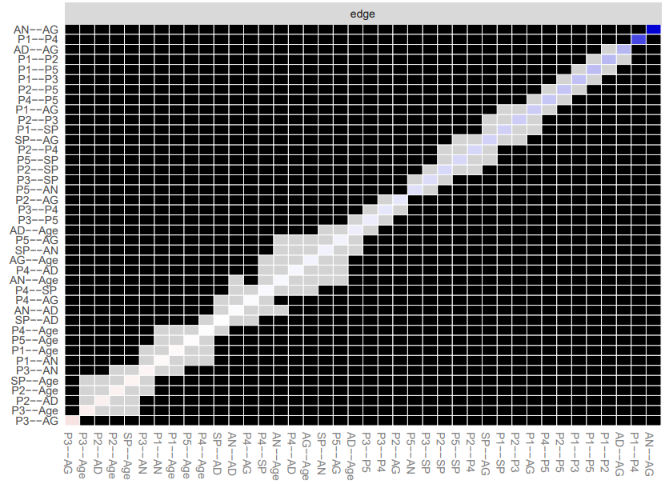

Figure S3. Bootstrapped difference test between edge weights that were non-zero in the estimated network. Grey boxes indicate edges that do not differ significantly from one another and black boxes represent edges that differ significantly from one another.

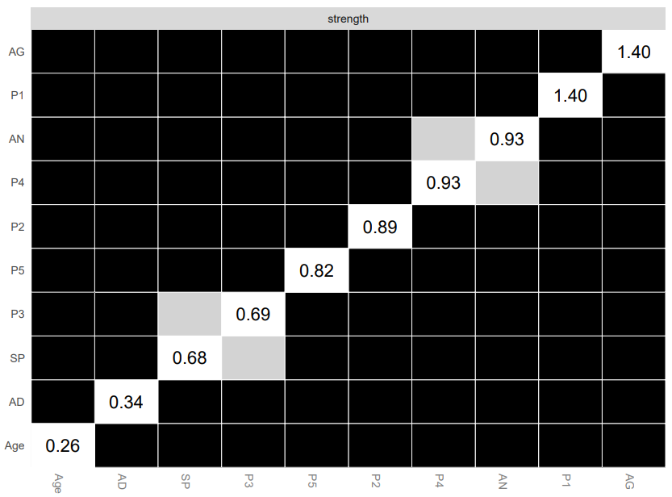

Figure S4. Bootstrapped difference test between node strength of the network.
Grey boxes indicate nodes that do not differ significantly from one another and black boxes represent nodes that differ significantly from one another. The number in the white boxes (i.e., diagonal line) represent the value of node expected influences.
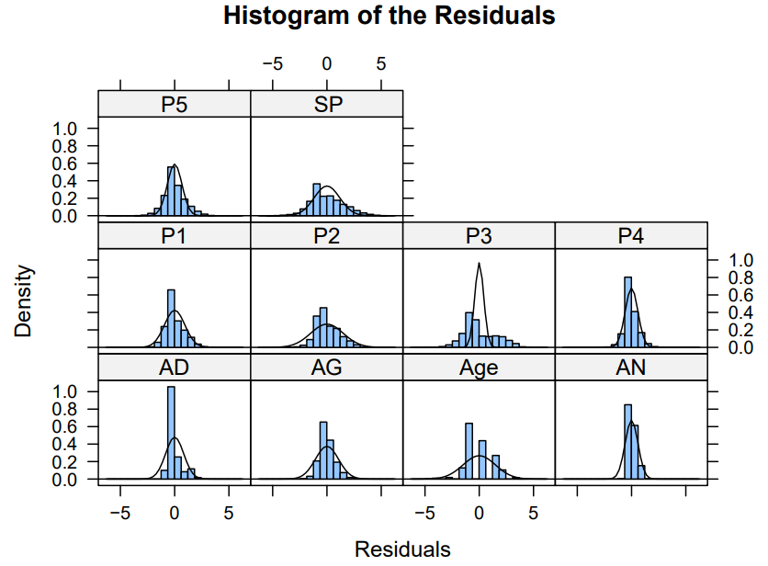

Figure S5. Histogram of the Residuals of Each Symptom.
Residual distribution of subjects in each symptom. Note: Positive Symptoms include P1: Unusual Thought Content, P2: Persecutory Ideas, P3: Grandiosity, P4: Hallucinations and P5: Disorganized Communication; Negative Symptoms include AN: Social anhedonia, Avolition, Expression of emotion, Experience of Emotions and Self, Ideational Richness and Occupational Functioning, AG: Sleep Disturbance, Dysphoric Mood, Motor Disturbances and Impaired Tolerance to Normal Stress and AD: Personal Hygiene; SP is the symptoms of schizotypal personality disorder.

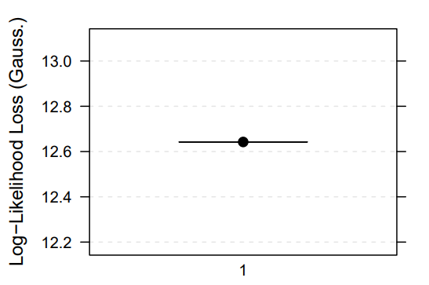

Figure S6. The Log-Likelihood Loss for both discrete and continuous data sets.
Log-Likelihood Loss also known as negative entropy or negentropy, it is the negated expected log-likelihood of the test set for the Bayesian network fitted from the training set. Mean loss = 12.64, SD loss=0.07.

